(Insert Name)

Environmental Management System

Last update _______(Insert)______________

Maintained by _______(Insert)______________

Research Leader/Location Coordinator signature line

___________________(Insert)_______________________________

(Insert Name) Environmental Management System

Table of Contents

CHAPTER 1

1.0 Introduction 1
1.1 What is an Environmental Management System? 1
1.2 Instructions on How to Use This Manual 2

CHAPTER 2

2.0 North Atlantic Environmental Policy and Accountability 4
Appendix 2A: (Insert)Map of Location 5
Appendix 2B: (Insert )Location EMS Environmental Policy Statement 6
Appendix 2C: (Insert Name) Organization Scope and Characteristics 7

CHAPTER 3

3.0 Existing Environmental Management Requirements 8
3.1 Introduction 8
3.2 Environmental Requirements Applicable to Activities Conducted at NAA Locations 8
3.2.1 Facility Construction 8
3.2.2 Energy Management 9
3.2.3 Chemical Resource Management 10
3.2.3.1 Introduction 10
3.2.3.2 Hazardous Laboratory Chemicals 10
3.2.3.3 Radioactive Materials 11
3.2.3.4 Pesticides 11
3.2.3.5 Petroleum Storage/Motor Vehicle Maintenance and Operation 11
3.2.4 Disposal and Release of Waste Products 12
3.2.4.1 Consumption of Office Products 12
3.2.4.2 Hazardous Chemical Waste Management 12

3.2.4.3 Hazardous Biological Waste Management 13

3.2.4.4 Waste Water Discharge 13

3.2.4.5 Air Emissions 13

CHAPTER 4

4.0 Identifying Activities, Aspects and Environmental Impacts 14
4.1 Introduction 14
4.2 List of NAA Location Research Program Activities, Aspects, and their Impacts
on the Environment 14
4.2.1 Activity: Laboratory Research Utilizing Hazardous Chemicals 14

4.2.2 Activity: Laboratory Research Utilizing Radioactive Materials 15

4.2.3 Activity: Laboratory Research Utilizing Biological Agents 15

4.2.4 Activity: Research and Facility Maintenance Involving the Use of

Agricultural Pesticides 15

4.2.5 Activity: Research Involving the Use of Farm Animals 16

4.2.6 Activity: Research Involving the Use of Aquatic Animals 16

4.3 List of NAA Location Facility Operation Activities, Aspects, and their Impacts on
the Environment 16

4.3.1 Activity: Facility Construction Projects 16

4.3.2 Activity: Facility Construction Projects 17
4.3.3 Activity: Use of Computer and Electronic Equipment 17
4.3.4 Activity: Grounds Maintenance, Lawn and Ornamental Care 17

4.3.5 Activity: Production and Maintenance of Drinking Water Supply 17

4.3.6 Activity: Use of Water for Research Purposes (Aquatic Research, Irrigation) 17
4.3.7 Activity: Temperature Control Inside Location Buildings 17

4.3.8 Activity: Government Vehicle and Motorized Equipment Usage 18

4.3.9 Activity: Wastewater Discharges from Location Activities 18

4.3.10 Activity: Facility Maintenance Operations 18

CHAPTER 5

5.0 Setting Your Objectives and Targets 19
5.1 Introduction to Objectives and Targets 19

5.2 Identified Location Activity: Chemical Resources Management 19

5.3 Identified Location Activity: Waste Generation 20

5.4 Identified Location Activity: Air Emissions 20

5.5 Identified Location Activity: Energy Consumption 21

5.6 Identified Location Activity: Green Purchasing 21

Appendix 5A. Green Procurement Requirements and Opportunities 23

CHAPTER 6

6.0 ARS Environmental Management Structure, Responsibility and Resources 24
6.1 NAA Environmental Management Program Structure 24
6.2 NAA Environmental Management System (EMS) Structure 25
6.3 Responsibilities of the NAA EMS Advisory Committee 25
6.4 Responsibilities of the NAA EMS Manager 26
6.5 Responsibilities of the NAA EMS Core Team Leaders 26
6.6 Responsibilities of the NAA Facility EMS Core Team Members 26
6.7 Responsibilities of Third Party EMS Participants 27
6.8 Agency-wide Environmental Responsibility 28
6.9 ARS Administrator Environmental Responsibility 28
6.10 ARS Area Directors Environmental Responsibility 29
6.11 Area Safety and Health Manager’s Responsibilities 30
6.12 Cluster Environmental Protection Specialist’s Responsibilities 31
6.13 Area Administrative Management Functional Responsibilities 33

6.14 Resources for Environmental Management 34

Appendix 6A: Environmental Management Operational Control at Fort Detrick,

Maryland 35

(Delete Appendix 6A if your location is not Frederick, MD)

(Insert Landlord Applicable Resource)
CHAPTER 7

7.0 Corrective, Preventive Actions and Emergency Procedures 36
7.1 Introduction 36

7.2 Corrective Actions Designed to Improve Environmental Management System 36

7.3 Governing Laws and Regulations for Emergency Response 37

7.4 Emergency Response Planning 38

7.5 Environmental Procedures Checklist 39

Appendix 7A: Onsite Assistance Review Checklist 40

Appendix 7B: Small Lab Water Discharge Program Checklists 49

Appendix 7C: Biologically Active Substances and Wastes Program Checklist 50

Appendix 7D: Drinking Water Program Checklist 51

Appendix 7E: Hazardous Waste Management Program Checklist 52

Appendix 7F: Special Waste Program Checklist 55

Appendix 7G: EMS Audit Format 57

CHAPTER 8

8.0 Training, Awareness and Competence 62

Appendix 8A: NAA EMS Training Matrix 63

Appendix 8B: (Insert Location Specific matrix or add other) 65

CHAPTER 9

9.0 Document Control 66

CHAPTER 10

10.0 Continuous Evaluation and Improvement 67
10.1 Measuring the Success of Our Environmental Management System 67

10.2 Management Review of Our EMS 68

CHAPTER 11

11.0 Public Involvement and Community Outreach 70

11.1 External Communication Sources 70

11.2 Internal Communication Procedures 70

CHAPTER 12

- Self Declaration Process
- Location Ranking, Aspects Scoring Sheet (Excel) 71

Chapter 1

1.0 Introduction

Over the past 11 years, the President has signed a number of NEPA Executive Orders (E.O.) that promote and mandate the Greening of the Federal Government. The term “Greening” means that government agencies will commit to protecting the environment through energy efficiency, recycling, pollution prevention, and affirmative procurement. The principal difference embodied in newer executive orders, in particular E.O. 13148, is that federal agencies are expected to shift their orientation from understanding and responding to requirements (a reactive posture) to taking action to improve their internal structures and processes so that the organization can anticipate and prevent adverse effects on the environment and human health, and in other areas, as well (a proactive posture). Federal departments and agencies are required not only to comply with regulations, but also to evaluate all environmental impacts of their operations; integrate environmental accountability into daily decision making and long-term planning; implement formal Environmental Management Systems (EMS); establish compliance auditing programs; and take other measures to transform their existing environmental stewardship approaches to a more comprehensive and dynamic mission-driven model. E.O. 13148 "Greening the Government through Leadership in Environmental Management" signed on April 21, 2000 requires “appropriate” Federal facilities to implement an EMS by December 2005. While many Agricultural Research Service (ARS) locations are small and unlikely to have a significant impact on the environment, the potential for a negative impact is there. Consequently, all ARS locations in the United States have been designated as “appropriate” facilities for implementing an EMS.

1.1 What Is An Environmental Management System?

An EMS is a systematic approach to ensure that environmental activities are well managed each NAA location and ultimately at the Area and Agency level. Environmentally responsible management at NAA locations does not end with traditional programs that manage waste and ensure chemical, biological, or radiation safety. As such, it is useful to think of an EMS as a value-added component to these existing environmental programs. Opportunities exist in facility design and operations to conserve energy and water, and for the affirmative purchase of other environmental preferable products. These programs can result in real cost savings in reduced waste generation, energy consumption, and resource use.

In December 1995, the NAA Safety Office prepared Pollution Prevention (P2) plans for each location in response to E.O. 12856 which required federal facilities to undertake pollution prevention initiatives and to practice source reduction. Each location’s Pollution Prevention plan contained a “Pollution Prevention Implementation / Milestone Worksheet” which listed goals, procedures to accomplish those goals, and a milestone / timeline. Therefore the setting of environmental objectives and targets is not new to any NAA location. Although the 1995 P2 plans were targeted at laboratory activities, rather than location-wide activities, many of those goals and procedures to accomplish them continue to be valid for your location’s EMS.

1.2 Instructions on How to Use This Manual

Listed below are the five major components of an Environmental Management System (EMS). Learning what those components are and how they fit into your facility’s existing environmental management program is essential to implementing a structured management system required under Executive Order 13148 and by ARS that will increasingly protect the environment of the campus, community, and countryside surrounding your facility. The information contained in this manual describes each of these major components and how to implement them at your facility.

(1) Policy - The foundation upon which you are going to build an EMS are environmental policies / procedures and NEPA environmental executive orders issued by the President of the United States. Policies and procedures are issued by the Federal agencies responsible for environmental protection, our ARS Safety, Health, and Environmental Branch, North Atlantic Area Safety Office, university and military facilities where NAA research units are co-located, and by your facility to ensure that your operations and activities have minimal or no impact on our environment. Every NAA facility is expected to abide by the environmental policies and regulations that are outlined in Chapter 2 along with applicable state and local regulations.

(2) Planning - In order to begin developing your Environmental Management System, you must first identify the research, physical plant, maintenance, and office operations that have an impact on the environment. In order to assist our NAA facilities with this task, we have compiled a list of facility activities applicable to most NAA locations and their potential environmental impacts. These are listed in Chapter 3. Review this list and select those activities that are applicable to your location. However, there may be specific operations and activities conducted at your location that are not listed that have an impact on the environment, so be sure to include them.

(3) Implementation and Operation - Once you have selected activities conducted at your location that impact the environment, it is important to develop a plan that will achieve a reduction in those impacts. Chapter 4 provides a number of targets, some of which are mandated, and others that are recommended for your facility to strive for. You may certainly adopt other targets and goals, short-term or long-term, that you believe will reduce your facility’s negative impact on the environment. Every worker at your facility and those responsible for the management of your facility currently has responsibilities for safety, health, and environmental management which are outlined in Chapter 6. Awareness and specific environmental training listed in Chapter 8 should be provided to all staff at your location, so that they are aware of your EMS Targets and Objectives and become knowledgeable about the steps they can take to achieve them.

(4) Checking and Corrective Action - Environmental audits conducted at all NAA facilities are discussed in Chapter 7. These audits are a major component of your EMS since they determine how environmental concerns and non-conformances are handled and investigated and corrective and preventative action is implemented and completed. Records of non-conformance and corrective actions, environmental incidents and follow-up, inspection and maintenance records, and environmental monitoring data are required to demonstrate compliance with any EMS. Guidance plans have been provided to NAA facilities that provide instruction for immediate action to correct impacts. However part of your EMS will be the development of recommended plans for future corrective and preventative action for incorporation into your EMS.

(5) Management Review - Your location must periodically review the effectiveness of your EMS management programs to determine if you are achieving your targets and goals. EMS management review will be conducted both formally as outlined in Chapter 10 and by your EMS Coordinator at your location. This section outlines the questions that should be asked during any EMS review.

2.0 North Atlantic Area Environmental Policy and Accountability

The mission of each North Atlantic Area (NAA) Agricultural Research Service (ARS) location is to conduct research to develop solutions to agricultural problems of high national priority. In conjunction with this mission, NAA is committed to protecting human health and the environment; meeting or exceeding Federal, State, and local laws, regulations, codes and guidelines; and employing sustainable pollution prevention practices. The NAA Environmental Management System (EMS) builds upon the existing ARS Safety, Health and Environmental Management Program and is designed to be an integral part of scientific research activities, project review processes, facility operations, and ARS Policy & Procedures. NAA will strive to minimize impacts and continually improve its environmental performance by:

• Maintaining a policy of commitment to environmental excellence.

• Developing annual objectives, targets, and actions to advance the EMS program performance in terms of both regulated and unregulated impacts.

• Considering environmental impacts in research planning, policy formulation, procurement actions, and operating decisions.

• Adhering to Federal, State, and local laws and regulations, permit requirements, and Departmental and ARS policies and procedures.

• Identifying and requesting the necessary resources to successfully carry out identified objectives and targets.

• Providing personnel with appropriate training, ensuring they are aware of environmental roles and responsibilities, and accountable for their performance and actions including recognizing them for outstanding performance.

• Effectively communicating NAA’s commitment to the environment to employees, partners, stakeholders, customers and the general public, and solicit input in developing and achieving objectives and targets for the EMS program.

• Routinely monitor environmental operations and conduct periodic inspections, audits, and reviews to ascertain that applicable standards are met, and EMS program effectiveness is evaluated.

• Correcting identified deficiencies in a timely manner and taking appropriate steps to prevent their recurrence.

• Clearly documenting and reporting the progress and achievements related to this policy.

Appendix 2A: Map of (Insert Location Map)

Appendix 2B: (Insert Location EMS Environmental Policy Statement (signed by LC or RL if possible)

Appendix 2C: (Insert Name) Organization Scope and Characteristics

(Insert a short description of the organization mission)

Facility Description
Total number of employees: | (Insert number of employees)
Total number of buildings: | (Insert number of buildings)
Square footage of facility: | (Insert facility square footage)
Property acreage: | (Insert property acreage)
Site boundaries | (Insert site boundaries)
Activities that occur outside site boundaries: | (Insert activities conducted outside site boundaries)
Approximate number of employees whose activities may involve significant aspects: | (Insert number of employees whose work functions involve significant aspects)
Size of EMS team: | (Insert number of individuals in EMS team)
Composition of EMS team: | (Insert number of general functions of EMS team members)

Environmental Hazards

(Insert a short description of any activities, work processes, or technologies that might contain environmental risks.)

CHAPTER 3

3.0 Existing Environmental Management Requirements

3.1 Introduction

Many environmental management targets and goals that address executive order requirements (e.g., phasing out of ozone depleting refrigerants, reduction in the use of hazardous substances, purchase of materials with recycled content, etc.) are currently incorporated into existing ARS construction, procurement, and SHEM policies and procedures. The AFM Acquisition and Property Division has issued a Policy Memorandum 23-02A http://www.afm.ars.usda.gov/ppd/pdffiles/Pm-23-02a.pdf that outlines each executive order as it pertains to procurement and provides the action needed to be taken by ARS procurement personnel. ARS adopts all environmental-related standards associated with the rules, regulations, codes and laws that are listed in the Authorities Section of the ARS Safety, Health, and Environmental Management Program Manual 230.0. In addition, ARS adopts, when appropriate, Federal, State, County, and local environmental standards. This chapter describes existing Agency environmental guidance that addresses E.O. requirements and those that significantly impact activities that may be managed under your environmental management system. Voluntary undertakings include environmental principles or “best management practices” that ARS has adopted.

3.2 Environmental Requirements Applicable to Activities Conducted at NAA Locations

3.2.1 Facility Construction
There are four environmental management principles applicable to all ARS facility construction projects that are currently listed in the ARS Facility Design Standards 242.01 Sections 1.7.3 and 3.4.1. The corresponding Executive Orders from which they originated from are listed in parenthesis.

(1) ARS is committed to recycling and buying recycled content and environmentally preferable products. ARS is committed to maximizing the use of recycled and recycled-content materials specified in the construction of Federal building projects. Architecture engineering design shall maximize the use of environmental preferable products (Executive Order 13101). The Resource Conservation and Recovery Act (RCRA) requires that agencies to buy recycled-content products designated by EPA. The greatest opportunity to implement these requirements when new construction or modernization projects are proposed is in the selection of architectural materials. The most common building products incorporating recycled materials that are currently available on the market are fiberboard, laminated paperboard, insulation, carpet, cement, concrete, paint, and resilient flooring. The EPA Comprehensive Procurement Guidelines (CPG) provides extensive information on designated products containing recycled materials for purchase and use by Federal agencies and their contractors. Information on specifying and purchasing recycled-content products can be found on the internet at http://www.epa.gov/cpg.

(2) ARS shall select, where life-cycle cost effective, ENERGY STAR® and other energy efficient products when acquiring energy-using products (E.O. 13123).

(3) ARS shall significantly extend procurement activities related to biobased products and services. Biobased products are made from renewable agricultural, animal, or forestry materials, such as vegetable-based lubricants, biofuels, compost, and construction materials (E.O. 13134).

(4) The A-E’s design shall maximize the use of cost-effective environmentally sound landscaping practices to reduce adverse impacts to the natural environment, prevent pollution and potential future liabilities at ARS facilities (E. O. 13148).

3.2.2 Energy Management
Energy conservation practices recommended in E.O. 13123 "Greening the Government through Efficient Energy Management" have been incorporated into the ARS Energy Management Plan (P&P 134.2). All ARS locations are required to integrate energy conservation measures and projects into their ARS Facility Plan and into their regular operations and maintenance activities. The government’s policy is to acquire supplies and services that promote energy and water efficiency, advance the use of renewable energy products and help foster markets for emerging technologies. This policy extends to all acquisitions including those below the simplified acquisition threshold (FAR Part 23.202). E.O. 13221 entitled “Energy Efficient Standby Power Devices” directs agencies to purchase devices with minimal standby power – at or below one watt where available.

In accordance with E.O. 12902, ARS shall utilize energy efficiency, water conservation, or solar or other renewable energy technologies in the design and construction of new Agency facilities to minimize the life cycle cost of such facilities. This section will apply as well to those buildings constructed for the purpose of leasing to the Agency. ARS adopts the latest edition of ASHRAE Standard 90.1, “Energy Efficient Design of New Buildings Except Low-Rise Residential Buildings,” published by the American Society of Heating, Refrigerating and Air-Conditioning Engineers, Inc. (ASHRAE), for energy conservation. Since it is an industry standard, ASHRAE 90.1 typically uses the verbs “recommended,” “suggested,” etc. Any text phrased as a recommendation in the Standard will be understood as a mandatory requirement. The performance of buildings designed according to ASHRAE 90.1 will be equivalent to those designed to 10 CFR 435.

Existing Facilities - As provided by NECPA, due to the energy intensiveness of ARS research activities, ARS buildings and facilities are exempt from achieving the energy reduction goals established for Federal buildings. In accordance with E.O. 12902, ARS shall improve energy and water efficiency in such exempt facilities by conducting prioritization surveys, comprehensive facility audits, and retrofit measures. To the maximum extent practicable, ARS shall install all
cost effective energy and water conservation measures no later than January 1, 2005.

3.2.3 Chemical Resource Management

3.2.3.1 Introduction
Chemical resource management is addressed under Section 205 of Executive Order 13148 entitled Use Reduction: Toxic Chemicals and Hazardous Substances and Other Pollutants. Under E.O. 13148, each agency is required to reduce its use of selected toxic chemicals, hazardous substances, and pollutants, or its generation of hazardous and radioactive waste types at its facilities by 50 percent by December 31, 2006. This reduction will be achieved through the identification of proven substitutes and established facility management practices, including pollution prevention. If an agency is unable reduce the use of selected chemicals, then that agency will reduce the use of selected hazardous substances or its generation of other pollutants, such as hazardous and radioactive waste types, at its facilities by 50 percent by December 31, 2006. The selected toxic chemicals referred to in E.O. 13148 are those listed in EPCRA section 313 toxic chemicals and, where appropriate, other regulated hazardous substances or pollutants. Included on this list are certain laboratory solvents, herbicides, insecticides, mercury, lead compounds, and heavy metal dusts. The REE Purchase Card Program (Manual 213.3 M) has instituted strict controls over the acquisition of hazardous materials, hazardous biological and radioactive substances. Requests for these materials shall be submitted to the servicing Procurement Office with a copy of the required approvals and licenses.

3.2.3.2 Hazardous Laboratory Chemicals
Each NAA location should have a written policy (Safety Manual, Chemical Hygiene Plan) that outlines procedures to ensure that the least operable quantity of chemicals are maintained in inventory and that all unusable / expired chemicals are disposed of in a timely manner (ARS Manual 230, Chapter 52). Conducting chemical analyses right the first time, preventing a spill in the first place, or preventing pollution are all more cost effective than performing re-work, spill clean-ups, or managing pollution after it has been generated. Users of hazardous chemicals or materials whether it be in the laboratory, office, for facility maintenance, equipment shops, or pesticides utilized in greenhouses or field research should always work toward the goal of source reduction and consider substitutions for less hazardous chemicals. Examples of substitutions would be the use of digital versus film photographic techniques, use of chemiluminescent markers in lieu of radioactive isotopes, mercury thermometer replacement programs, and the use of citrus-based cleaners as a substitute for volatile solvent-based cleaners.

3.2.3.3 Radioactive Materials
The ARS Radiation Safety Program is outlined in ARS P&P 124.1. Every NAA location should have an EMS goal of reducing or eliminating their usage of radioactive materials. The increasingly high cost of radioactive isotope waste disposal for radioisotopes having a half-life greater than 90 days, the availability of less hazardous, non-radioactive molecular or chemical probes (e.g., fluorescent or chemiluminescent probes) and the instrumentation (gel scanning equipment) are making this substitution doable.

3.2.3.4 Pesticides
ARS Policy and Procedure 600.12 entitled “Guidelines and Precautions to be Taken by Personnel in Storing, Using, Handling, and Disposing of Agricultural Chemical Pesticides” states that the quantity of pesticides maintained in storage will be limited to amounts required for annual program use. Stockpiling of pesticides is not allowed. This is an area of hazardous materials procurement where researchers, field or greenhouse managers, and grounds maintenance staff should always consider “less toxic alternatives” when purchasing pesticides and herbicides.

3.2.3.5 Petroleum Storage / Motor Vehicle Maintenance and Operation
On May 13, 2002, President Bush signed the Farm Security and Rural Investment Act of 2002 (the farm bill) into law. Section 9002 establishes a biobased products purchasing program similar to the buy-recycled program under the Resource Conservation and Recovery Act. USDA will designate biobased products for Federal agencies to purchase and provide recommendations for purchasing the products with biobased content. Federal agencies are required to establish affirmative procurement programs for purchasing the USDA-designated products and to purchase the products with biobased content unless there is a price, performance, or availability reason not to do so.

NAA locations may have underground storage tanks (USTs) for the storage of fuel or other types of petroleum products that are regulated by state authorities. EPA regulations for USTs are contained in 40 CFR 280 and contain requirements for tank design, construction and installation, general operation, release detection, release reporting and corrective action and closure. Most storage requirements that apply to NAA locations fall under the RCRA Subtitle I requirements that govern underground storage tanks (USTs). All federally regulated USTs must be registered with the state, meet leak detection requirements, and be in compliance with the 1998 upgrade requirements (spill, overfill, and corrosion protection). Aboveground storage tanks (ASTs) are subject to both federal regulation and stricter state/local regulations. Most ASTs need to meet EPA’s SPCC requirement that apply to facilities with a storage capacity of more than 1,320 gallons. (Spill prevention, control, and countermeasure plan (SPCC) (40 CFR 112)

3.2.4 Disposal and Release of Waste Products

3.2.4.1 Consumption of Office Products
The concept of “Green Purchasing” is outlined in E.O. 13221, E.O. 13148, and E.O. 13101 and encompasses the utilization of recycled content products, environmentally preferable products including biobased products, and energy efficient products. E.O. 13101 is entitled "Greening the Government through Waste Prevention, Recycling, and Federal Acquisition". The federal government discards an estimated 10,000 computers each week that become obsolete which translates to nearly 500,000 computers each year. As one of the largest consumers of electronics products, the federal government has a unique opportunity to set the pace for environmentally sound electronics procurement and end-of-life management. Electronic products are made up of a combination of precious and other metals, engineered plastics, glass, and other materials – all valuable resources that are thrown away without a second thought. Some electronics products contain hazardous or toxic substances. Products containing cathode ray tubes, circuit boards, batteries, and mercury switches can contain lead, mercury, cadmium, chromium, and some types of flame retardants, which can pose serious environmental risks if not properly managed. Procurement can be the front line of defense against pollution and wasteful practices. Everything that goes out as waste from your location came in as a product. Buying less toxic products or those with less packaging can reduce costs related to waste disposal. The purchase, operation, and disposal of electronic equipment is a “significant aspect” that is common to every NAA location as identified during from the North Atlantic Area Location Environmental Management Survey conducted in March 2003.

3.2.4.2 Hazardous Chemical Waste Management
Waste management is addressed under Section 205 of Executive Order 13148 entitled Use Reduction: Toxic Chemicals and Hazardous Substances and Other Pollutants. Under E.O. 13148, each agency is required to reduce its use of selected toxic chemicals, hazardous substances, and pollutants, or its generation of hazardous and radioactive waste types at its facilities by 50 percent by December 31, 2006. If an agency is unable reduce the use of selected chemicals, then that agency will reduce the use of selected hazardous substances or its generation of other pollutants, such as hazardous and radioactive waste types, at its facilities by 50 percent by December 31, 2006.

3.2.4.3 Hazardous Biological Waste Management
This may be a significant aspect for locations that work with microorganisms, select agents, recombinant DNA technologies, lab animals, animal pathogens, human body fluids, or bloodborne pathogens. These materials must be managed so as to reduce the potential for personnel exposure and environmental release.

3.2.4.4 Waste Water Discharge
Federal, state, university, military, and local regulations stipulate both acceptable and prohibited pollutants for discharges to the sewer (NPDES) and surface waters through stormwater discharges. Each NAA location should design and implement programs and practices for properly managing its discharges. Whenever feasible, the location should consider pollution prevention and waste minimization as a first step in these programs. Training is an important component of this aspect to ensure that location employees are properly disposing of their wastewater and are trained on what can and cannot go down the drain.

3.2.4.5 Air Emissions
Under E.O. 13148, Federal facilities are required to phase out the use of ozone-depleting substances such as chlorofluorcarbons (CFCs) and hydrochlorofluorocarbons (HCFCs) used in air conditioning and refrigeration equipment and halons used in fire suppressant systems. Air emissions from small labs are generally subject to little or no regulation with some exceptions such as incinerators, large heating units, and lab processes emitting large quantities of hazardous air pollutants. Still, responsible lab staff should take steps to minimize emissions because even small, unregulated amount of pollutant can be harmful to the environment. Labs can eliminate or reduce air emissions through process change (e.g., use of microscale chemistry) and engineering controls. Air emissions are also a potential occupational health issue that is regulated under the OSHA Laboratory Standard 29CFR 1910.1450.

CHAPTER 4

4.0 Identifying Activities, Aspects and Environmental Impacts

4.1 Introduction

It is important that your location list all activities associated with your facility and research related operations and then identify the significant aspects of those activities that have an impact on the environment. Do they produce waste? Do they impact the land, water, and air? Are hazardous materials involved? Are operations conducted in ecologically sensitive areas? How much water and energy are used? In the sections below, your location will select those activities that have a significant impact and then set objectives and targets to reduce that impact. For example, reducing your hazardous chemical usage would be an important objective for achieving and maintaining compliance and enhancing your location’s environmental performance.

Location activities that have environmental “aspects” or impacts include laboratory research, field research, office work, engineering shop operations, building operations, vehicle or equipment maintenance. These activities may impact the environment through the utilization of chemical resources, radioactive materials or biological substances; waste generation; air emissions; waste water discharges; storm water discharges; energy consumption; water consumption; office product consumption; vehicle fuel consumption and exhaust emissions; or noise.

4.2 List of (Insert Name of Location) Location Research Program Activities, Aspects, and their Impacts on the Environment (Under each subsection, add, delete those that are applicable to your location)

4.2.1 Activity: Laboratory Research Utilizing Hazardous Chemicals
Aspect:

Purchasing Hazardous Chemicals
Impacts:
*Depletion of natural resources in the following ways:
(a) Energy utilized in chemical manufacturing
(b) Energy requirements for chemical storage (e.g., use of electricity for low-temperature refrigeration or ventilation)
*Generation of hazardous waste by the following activities:
(a) Duplicate purchasing of hazardous chemicals already on location inventory
(b) Large-scale purchasing of unusable quantities of chemical
(c) Chemical is not used, resulting in chemical entering hazardous waste stream due to expired use date
*Contamination of land, water, and air

Aspect:

Use of Hazardous Chemicals
Impacts:
*Depletion of natural resources in the following ways:
(a) Energy utilized in laboratory manipulations (e.g., use of electricity for electrophoresis, centrifugation, fume hood operation, etc.)
(b) Use of water, plastic ware, and paper
(c) Increased chemical consumption due to use of macro chemical methodologies rather than employing use of newer microchemistry techniques
*Contamination of land, water, and air
*Generation of hazardous wastes and cost to facility for hazardous waste disposal
*Chemical release or spills and cost to facility for HAZMAT or emergency spill response team clean-up and disposal.

4.2.2 Activity: Laboratory Research Utilizing Radioactive Materials
Aspect:

Use of Radioactive Materials and X-ray Emanating Equipment
Impacts:
*Depletion of natural resources
*Generation of radioactive, mixed, or hazardous wastes from the following sources:
(a) generation of radiographic film waste
(b) radioisotope waste that is not permitted for decay in storage (half-life exceeds 90 days)
*Very high cost to facility for “mixed waste” (radioactive and hazardous waste mixtures) disposal
*Contamination of facilities, land, water, and air
*Radioactive material releases or spills

4.2.3 Activity: Laboratory Research Utilizing Biological Agents
Aspect:

Production of Biological or Medical Waste
Impact:
*Release or spill resulting in contamination of animals, plants, land, water, and air
*Depletion of natural resources (decontamination chemicals, energy required for incineration or offsite shipment)

4.2.4 Activity: Research and Facility Maintenance Involving the Use of Agricultural Pesticides
Aspect:

Application of Agricultural Pesticides
Impacts:
*Pesticide rinsate generation (container and spray equipment cleaning) and spills
*Contamination of surrounding land, surface or groundwater, and air (pesticide drift)
*Pesticide toxicity to wildlife
*Generation of hazardous and universal waste (unused pesticide products) and cost to facility for waste disposal

4.2.5 Activity: Research Involving the Use of Farm Animals
Aspect:

Feed Production for Farm Animals
Impacts:
*Depletion of natural resources (fuel, fertilizer, and pesticide consumption)
*Use of chemicals associated with veterinary care (pesticide and antibiotic use)

Aspect:

Generation of Farm Animal Waste
Impacts:
*Odor from animal wastes
*Depletion of natural resources (fuel for waste removal)
*Nutrient enrichment and contamination of surrounding waterways and watersheds

4.2.6 Activity: Research Involving the Use of Aquatic Animals
Aspect:

Production of Aquatic Animals

Impacts:
*Nutrient enrichment of downstream waterways (animal waste)
*Depletion of groundwater (water use)
*Depletion of natural resources (oxygen enrichment, operation of water pumping and circulation systems, tank cleaning products)

4.3. List of (Insert Name of Location) Location Facility Operation Activities, Aspects, and their Impacts on the Environment (Add/delete those applicable to your location)

4.3.1 Activity: Facility Construction Projects
Aspect:

Construction of New Facilities
Impacts:
*Depletion of natural resources (construction materials, fossil fuels)
*Land and waterway contamination (run-off from construction sites)

4.3.2 Activity: Facility Construction Projects
Aspect:

Renovation of Existing Facilities
Impacts:
*Generation of hazardous waste (PCB containing materials, asbestos containing materials, mercury containing materials)
*Generation of solid waste
*Depletion of natural resources

4.3.3 Activity: Use of Computer and Electronic Equipment
Aspect:

Purchase, Operation, and Disposal of Electronic Equipment
Impacts:
*Depletion of natural resources
*Generation of recyclable waste (electronics waste, lead acid batteries, toner cartridges, paper)

4.3.4 Activity: Grounds Maintenance, Lawn and Ornamental Care
Aspect:

Mowing, Planting, and Mulching
Impacts:
*Depletion of natural resources (pesticide, fertilizer, and water use)
*Depletion of natural resources (fossil fuels for equipment operation)

4.3.5 Activity: Production and Maintenance of Drinking Water Supply
Aspect:

Pumping, Treatment, and Storage of Water
Impacts:
*Depletion of natural resources (ground or surface water)
*Depletion of natural resources (fossil fuels, treatment chemicals)

4.3.6 Activity: Use of Water for Research Purposes (Aquatic Research, Irrigation)
Aspect:

Production and High Volume Usage of Water for Research Purposes
Impacts:
*Depletion of natural resources (surface or groundwater usage requirement)
*Depletion of natural resources (use of fossil fuel for pumping)
*Contamination of land and water (nutrient run-off)

4.3.7 Activity: Temperature Control Inside Location Buildings
Aspect:

Storage and Burning of Fossil Fuels for Facility Heating
Impacts:
*Depletion of natural resources (fossil fuel)
*Air emissions
*Storage tank management
*Ground or surface water contamination

Aspect:

Operation and Maintenance of Air Conditioning Systems
Impacts:
*Ozone depletion (release of refrigerant containing ozone depleting substances)
*Noise caused by chiller units
*Depletion of natural resources (fossil fuel)
*Faulty systems resulting in IAQ concerns

4.3.8 Activity: Government Vehicle and Motorized Equipment Usage
Aspect:

On-site Motor Vehicle Maintenance Activities

Impact:
*Generation of used oil, oil contaminated rags, used antifreeze, tires, batteries
*Generation of hazardous waste (parts cleaners, solvent degreasers)
*Contamination of land and waterways (fuel storage, fuel transfer operations, vehicle washing operations)
*Air contamination from improperly maintained vehicle emission control systems
*Depletion of natural resources (fossil fuel, lubricants, tires,)
*Depletion of natural resources (chemicals)

4.3.9 Activity: Wastewater Discharges from Location Activities
Aspect:

Laboratory Sink and Building Floor Drain Discharge into the Sanitary Sewer
Impact:
*Contamination of land, water, and air
*Eutrophication

4.3.10 Activity: Facility Maintenance Operations
Aspect:

Generation of Waste from Facility Maintenance Activities
Impact:
*Generation of hazardous waste (spent fluorescent lamps, PCB containing lamp ballasts, spent solvents, paints)
*Generation of asbestos-containing waste
*Generation of universal waste (used oils, mercury-containing equipment)
*Ozone depletion (repair or excessing of older refrigerated equipment containing ozone depleting refrigerants)
*Generation of solid waste (excess furniture and equipment)

CHAPTER 5

5.0 Objectives and Targets for (Insert Location Name)

5.1 Introduction

In Chapter 4, the list of activities conducted at (Insert Location Name) and their potential negative environmental impacts have been completed. The next step will be to define Objectives and Targets to address each significant aspect. These objectives and targets are essential to achieve and maintain compliance with current environmental requirements, to ensure that the location’s environmental performance demonstrates continuous improvement in both regulated and non-regulated areas, and most importantly pollution prevention that emphasizes source reduction. Reducing operating costs and improving overall environmental performance are goals.

The following information is provided for the development of objectives and targets that address each applicable activity and significant aspects listed in Chapter 4. While some of the targets listed may be modified by your location, many are mandated under E.O 13148 or by Federal requirements.

5.2 Identified Location Activity: Chemical Resources Management (Insert targets that were developed by the location EMS team or at EMS Conference)

• NAA Location EMS Targets:
- Full compliance with Federal, State, Agency, Army (if applicable), and University (if applicable) regulations.
- Develop strategy per Executive Orders 12873 and 13148 for source reductions and substitutions of existing chemical resources. Strategy includes procedures to ensure least operable quantity of chemicals are kept in inventory and that unusable / expired chemicals are disposed of in a timely manner.
- Ensure that your facility has a Hazard Communication Plan or Chemical Hygiene Plan and that your facility provides chemical hygiene training to employees covering chemical purchasing, hazards, handling, and use.

• Agency Target: Reduce the Use of Selected Toxic Chemical, Hazardous Substances, and Pollution of 50% by 2006 (Executive Order 13148).

Location Activities Affected by This Target

CRIS project planning process
Purchase of research chemicals
Laboratory research techniques employing the use of hazardous chemicals

Laboratory research techniques employing the use of radioactive materials
Purchase of equipment containing hazardous chemicals (mercury thermometers)
Generation, storage, and disposal of hazardous waste
Purchase of facility maintenance chemicals
Facility maintenance operations (water treatment, painting, and degreasing solvent use)
Use of pesticides for research and grounds maintenance

5.3 Identified Location Activity: Waste Generation

• NAA EMS Targets:
- Full compliance with Federal, State, Agency, [Army (if applicable), and University (if applicable)] regulations for hazardous waste, radioactive waste, solid waste, wastewater discharges, and storm water discharges.
- Determine base amounts for recycled materials, hazardous waste and non-hazardous waste for the purpose of developing strategy to implement opportunities for waste reduction.
- Promote awareness and involvement of NAA employees regarding the impacts related to waste generation from their research activities and facility operations.
- Ensure location has written hazardous waste guidance and provides training to employees covering hazardous waste identification, source reduction, and proper waste disposal practices.

• Agency Target: Reduce Releases and Off-site Transfer of Toxic Chemicals by 40% by 2006 (Executive Order 13148)

Location Activities Affected by This Target

CRIS project planning process
Purchase of hazardous materials
Stockpiling of hazardous materials
Wastewater discharge from location activities
Facility construction - renovation of existing facilities (asbestos or lead paint abatement)
Generation of hazardous waste
Generation of solid waste
Generation of used oil

5.4 Identified Location Activity: Air Emissions

• NAA EMS Targets:
- Full compliance with all applicable Air Emission regulations
- Determine whether opportunities exist to implement strategies to reduce facility / laboratory air emissions.
(3) Meet or exceed VOC (volatile organic compound) limits for adhesives, sealants, paints, composite wood products, and carpet system that are purchased to reduce the quantity of indoor air contaminants that are odorous or potentially irritating to occupant health and comfort.

• NAA EMS and Agency Target: Phase Out the Procurement of Class I Ozone-Depleting Substance by 2010 (Executive Order 13148).

Location Activities Affected by This Target

Facility maintenance operations
Government vehicle air conditioning system maintenance

Operation and maintenance of location HVAC systems
Servicing of older laboratory and facility refrigeration equipment

New facility construction projects
Renovation of existing facilities

5.5 Identified Location Activity: Energy Consumption

• NAA EMS Targets:
- Full compliance with CAA requirements requiring type (sulfur content), amount, and use of heating oil fuel.
- Identify electrical energy use areas, ways to reduce consumption, and implement practices to reduce consumption.

Location Activities Affected by This Target

Energy requirements for chemical storage i.e. refrigeration

Temperature control inside location buildings
Construction of new facilities or renovation of existing facilities (compliance with ARS Facility Design Standards 242.01 Sections 1.7.3 and 3.4.1.)

5.6 Identified Location Activity: Green Purchasing

• NAA EMS Target: Increase Use of Recycled Content, also known as the Comprehensive Procurement Guideline (CPG) and Environmentally Preferable Products (refer to Appendix 5A).

• Agency Target: Promote Sustainable Management of Facility Lands through Sound Landscaping Practices: and Promote Environmentally Benign Adhesives (Executive Order 13148).

Location Activities Affected by This Target

Purchase of ENERGY STAR® and other energy efficient products when acquiring energy-using products

Construction of new facilities or renovation of existing facilities
A-E design shall maximize the use of environmental preferable products
Purchase of office products (recycled content paper)
Management of facility grounds
Facility maintenance operations
Petroleum fuel consumption
Vehicle procurement and operation
Procure vehicles with higher fuel economy (compliance with E.O. 13149 “Greening the Government through Federal Fleet and Transportation Efficiency”)
Promote use of alternative fuels (i.e., biodiesel, electricity, ethanol, hydrogen, methanol, natural gas, propane, and “P-series” fuels) and alternative fuels vehicles (AFV)
Purchase re-refined over virgin vehicle lubricating oils, if it is reasonably available and meets recommended performance standards

Appendix 5A: Green Procurement Requirements and Opportunities

EPA CPG Required Items(1) | Other Green Procurement Opportunities
Construction Products
• Floor tiles containing recovered plastic or rubber  • Shower and restroom dividers/partitions containing recovered plastic or steel  • Structural fiberboard containing recovered material  • Laminated paper board containing post-consumer recovered paper  • Patio blocks containing recovered plastic or rubber  • Carpet containing polyester carpet fiber face and PET resin  • Cement and concrete containing coal fly ash  • Cement and concrete containing ground granulated blast furnace slag  • Geotextiles containing recovered materials  • Fiberglass building insulation with recovered content | • Low VOC and less toxic paints  • Water efficient plumbing supplies  • Recovered stone, brick, steel, wood, floor tile, other materials and fixtures from  building deconstruction  • Road building materials with recovered road base, asphalt and other materials  • Non-fiberglass building insulation with recovered material content such as  newspaper or plastic  • Acoustic ceiling tile with recovered mineral wool, plastic, steel mill slag or other  materials  • Plastic lumber with recovered content  • Bricks with recovered fly ash  • Energy efficient windows and doors  • Docks and piers with recovered plastic or wood content
Transportation Products
• Parking stops made from concrete or containing recovered plastic or rubber  • Chanelizers, delineators, and flexible delineators containing recovered  plastic, rubber, or steel  • Traffic barricades containing recovered plastic, steel or fiberglass  • Traffic cones containing recovered plastic or rubber | • Speed bumps made of recovered road material or recovered plastic  • Signs containing recovered metal or plastic
Park and Recreation Products
• Playground surfaces containing recovered plastic or rubber  • Running track containing recovered plastic or rubber  • Plastic snow and sand fencing containing recovered plastic | • Park benches and picnic tables with recovered plastic, rubber, sawdust, and wood  • Playground equipment and bike racks with recovered plastic, rubber, sawdust and  wood  • Signs and signposts of recovered wood or plastic with recovered content  • Boats with recovered material content  • Four cycle rather than 2 cycle motors for boats
Landscaping Products
• Garden and soaker hose containing recovered plastic or rubber  • Lawn and garden edging containing recovered plastic or rubber  • Hydraulic mulch containing recovered wood and/or paper  • Yard trimmings containing composted material | • Hose reels made of recovered plastic  • Wheel burrows, gardening and landscaping tools made of recovered wood, plastic  and other materials  • Hand , electric or four cycle gasoline lawn and gardening equipment  • On-site composting products
Paper Products
• Writing and printing paper with recovered paper content | • Other paper and tissue products (paper towels, napkins, bath and facial tissue  with recovered paper content or are unbleached and do not have unnecessary  dyes, inks or fragrances  • Cardboard with recovered paper content  • Reusable envelops and bags
Non-paper Office Products
• Remanufactured printer ribbons  • Plastic envelops with recovered plastic  • Office recycling containers containing recovered plastic, steel or paper  • Office waste receptacles containing recovered plastic, steel or paper  • Plastic desktop accessories containing recovered plastic  • Remanufactured toner cartridges  • Binders containing recovered plastic, chipboard, paperboard, or pressboard  • Plastic bags containing recovered material  • Energy Star computer equipment (2) | • Efficient, duplex capable, properly sized copy machine  • Energy Star plain paper fax machines  • Fax modems instead of paper fax machines  • Pens and pencils with recovered plastic and wood content  • Erasable and cork boards with recovered plastic and wood
Vehicular Products
• Reclaimed engine coolant  • Retread tires  • Re-refined lubricating oil | • Engine hoses with recovered plastic or rubber  • Rebuilt and reused engines, engine components and other vehicle parts  • Alternative fuel vehicles
Miscellaneous Products/Maintenance Supplies
• Pallets containing recovered wood, plastic or paperboard | • Recycling Bins and trash bins with recovered plastic  • Bubble wrap and other packing materials with recovered plastic content  • Compact fluorescent lighting  • Less toxic, more biodegradable janitorial and equipment cleaners  • CFC recycling equipment  • CFC/HCFC free air conditioning and refrigeration equipment  • Non-halon fire suppression systems  • Reusable rags and rags with recovered material content
(1) Products with recovered material content which must be purchase by Federal Agencies pursuant to RCRA Section 6002 and EO 13101. EPA published Recovered Materials Advisory Notices provide information on the range of recovered material content levels available on the market which will meet the intent of RCRA Section 6002. (2) Energy Star products must be affirmatively procured pursuant to EO 12856.

CHAPTER 6

6.0 Environmental Management Structure, Responsibility and Resources

6.1 NAA Environment Management Program Structure
The NAA Safety, Health, Environmental Office provides safety, health, and environmental consultation to the Director of the North Atlantic Area and to ARS research facilities located in the states of Maryland, West Virginia, Delaware, Pennsylvania, New York, Massachusetts, and Maine. Support is provided by a full time safety manager and two environmental protection officers. In addition, locations co-located with University or Army facilities have environmental support through equivalent landlord services. Field reviews, routine data calls, accident reporting and consultation on biosafety, radiation safety issues and all environmental program support is provided by this Area office.

Formally, the Area Director has supervisory authority over the laboratory directors. The Area Safety & Health Manager and Cluster Environmental Protection Specialist advise the Area Director of environmental requirements, and then directs the laboratory directors to implement them. Please refer to the organizational chart below.
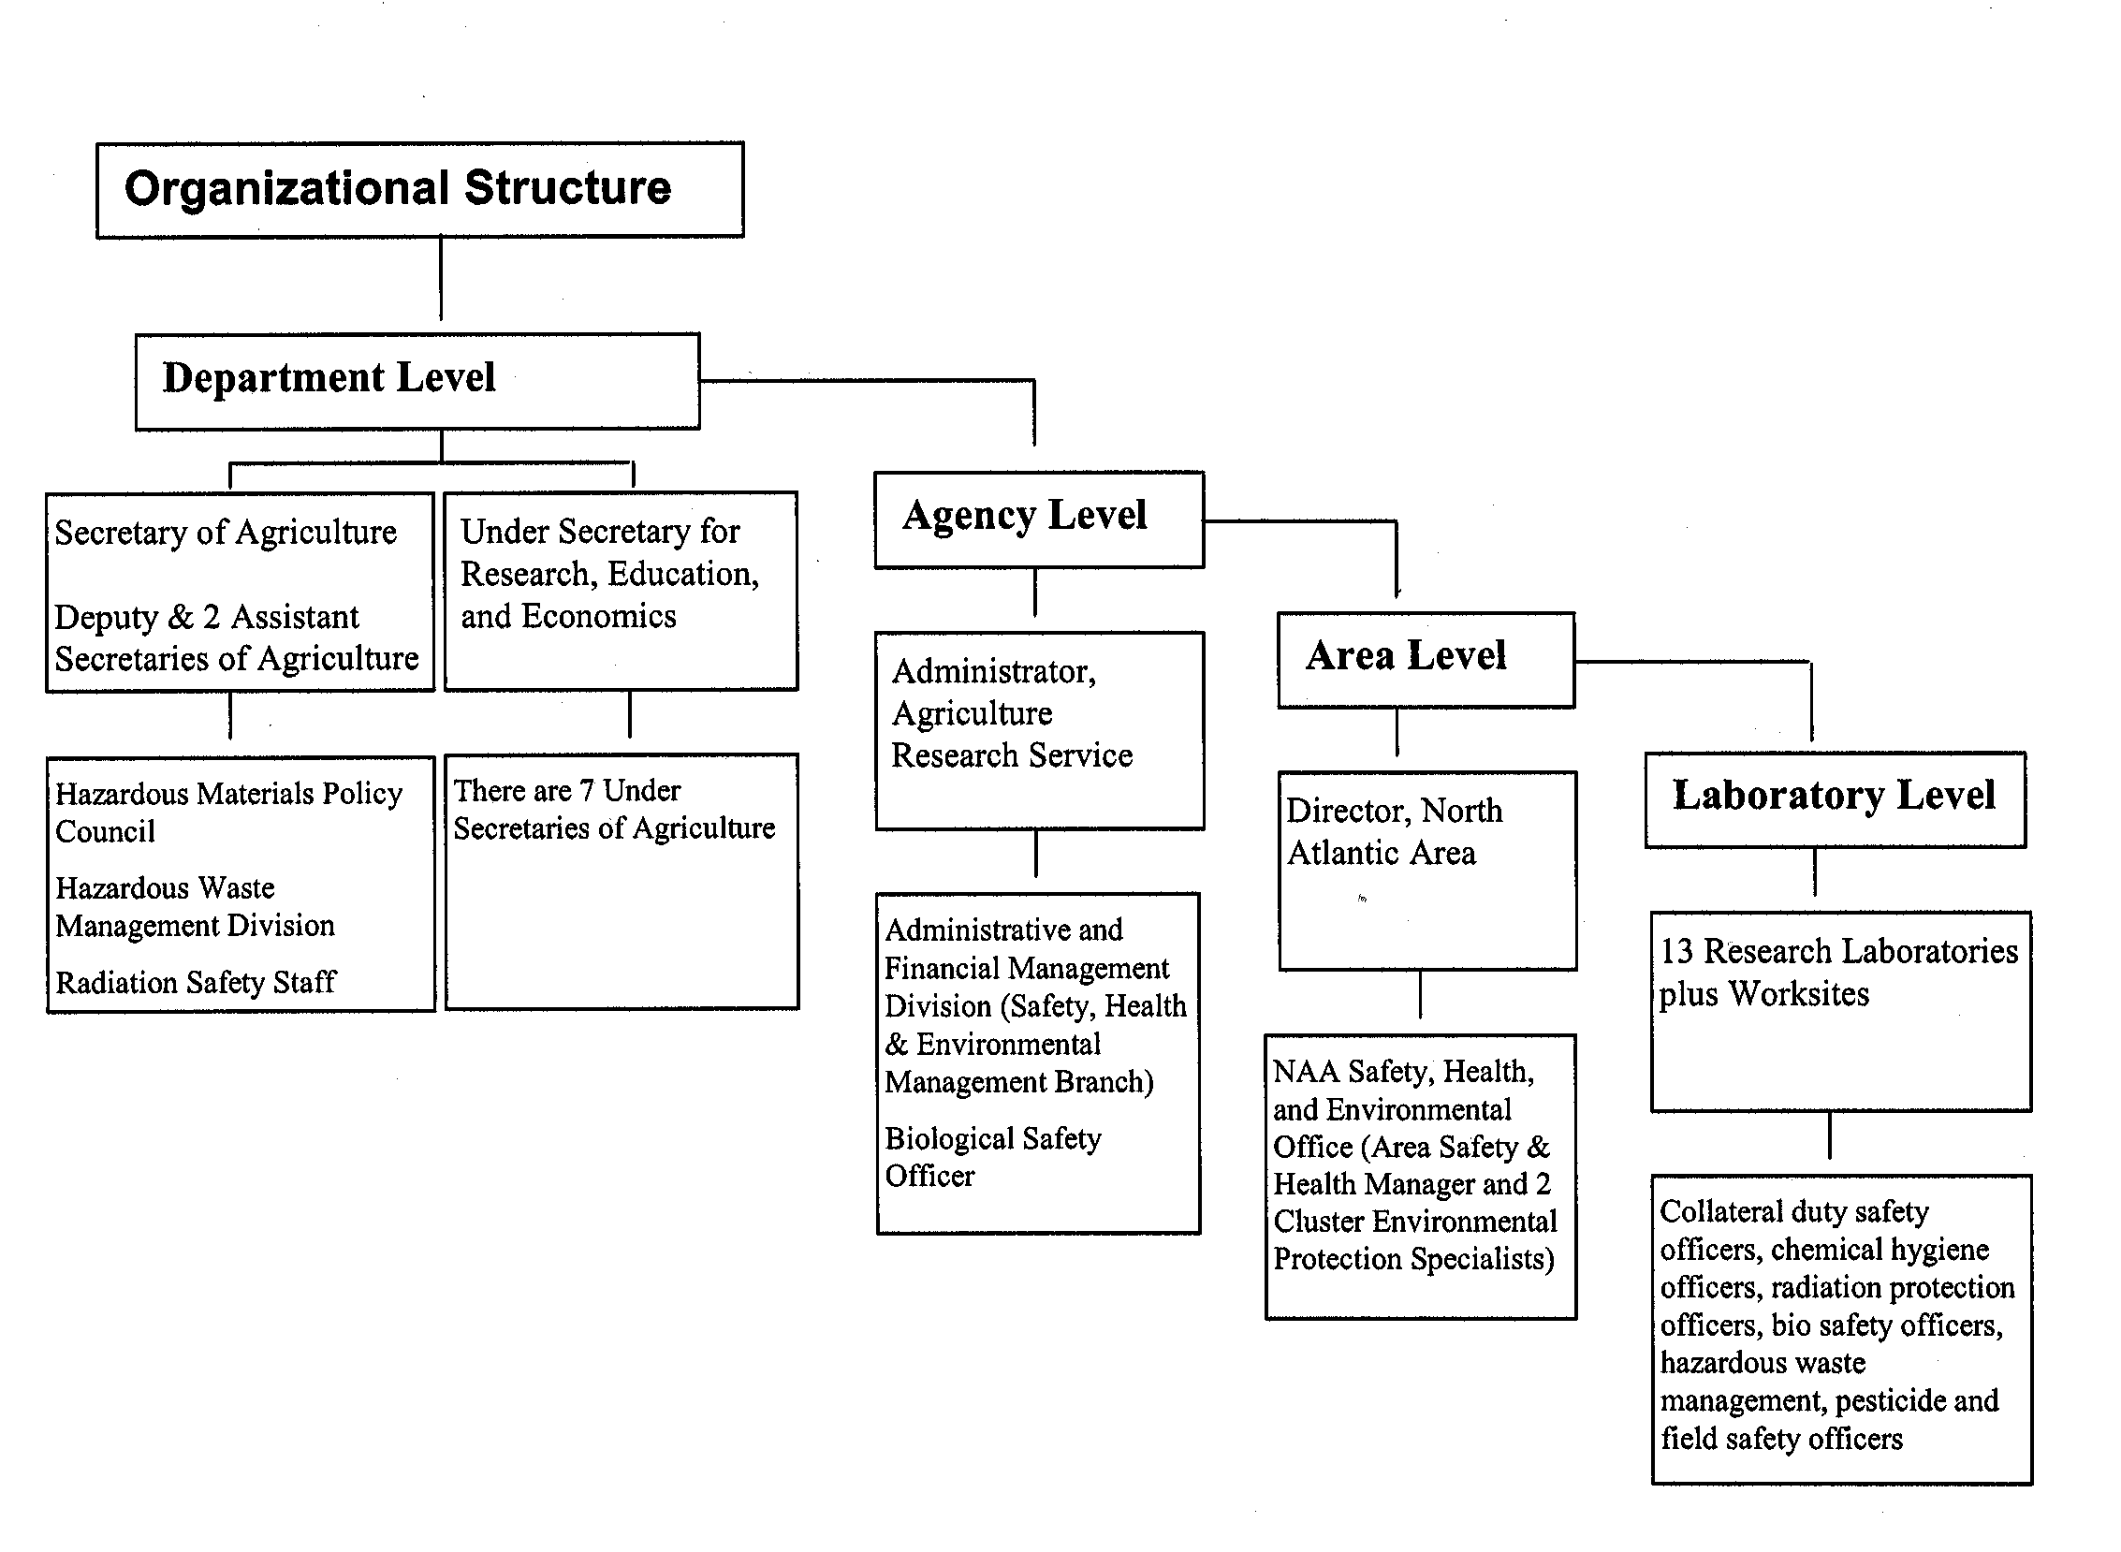
Though not shown, there are informal lines of communication between virtually every level of the organization. Each NAA location has a Safety and Health Committee composed of knowledgeable employees who oversee different location safety program areas. This committee is chaired by a Collateral Duty Safety Officer, appointed by the laboratory director. The function of this committee is to ensure that safety, health, and environmental concerns are brought to the attention of the laboratory director and that applicable safety program areas are managed at the location level.

The environmental program has both a formal and informal position in the structure. Informally, and far more commonly, the Area Safety & Health Manager and Cluster Environmental Protection Specialist work collaboratively with offices and individuals at all levels of the organization to provide environmental support and consultation. This collaborative relationship is irrespective of supervisory chains of authority. The ultimate goal is environmental stewardship at the laboratory and agency level.

6.2 NAA Environmental Management System Structure

ARS has an agency wide integrated system for Safety, Health and Environmental Management (SHEM). The North Atlantic Area (NAA) Environmental Management System (EMS) is embedded into this agency program. For an EMS to be effective, individual roles and responsibilities must clearly be defined as they relate to the achievement of environmental Objectives and Targets, and the overall operation of the EMS. Like any other EMS, our EMS program encompasses all management staff, scientific staff, support staff, facility maintenance personnel, cooperators, stakeholders and student members. Both administrative and research operations have environmental accountability incorporated into them. We all have made a commitment to support and implement the NAA EMS Environmental Policy.

The Location Administrative Officer and Collateral Duty Safety Officer, or the Safety and Health Manager of each location have been selected as EMS Core Team members. The Cluster Environmental Specialists (CEPS) serve as EMS Core Team Leaders to the Core Team. As team leaders, the CEPS will provide detailed program support that meets the uniqueness of each location. The Area Health and Safety Manager will assume the duty of EMS Manager having responsibility for the overall EMS program. The EMS Manager provides leadership to the Core Team Leaders and Core Team. For the purposes of our current NAA Environmental Management System, the EMS Manager is Bonnie DiSalvo, NAA Area Safety and Health Officer and the Cluster Environmental Protection Officers, Glen Davis and Kathie Moh, serve as Area EMS Core team leaders for their respective territories.

6.3 Responsibilities of the NAA Environmental Management System Advisory Committee

• Provide guidance on long range plans that can have possible environmental impact.

• Conduct or coordinate the annual review of EMS against established goals and objectives.
• Provide advice/input on needed improvements.

Role: The EMS Advisory Committee is identified as John Crew, DAD, Wilda Martinez, AD, John Kelly, Area Engineering and the Research Leader of each NAA location.

6.4 Responsibilities of the NAA Environmental Management System Manager

• The EMS project Manager is responsible for EMS development and directs the functional responsibility for environmental matters.

• Ensure effective communication with ARS management regulatory agencies, University liaisons and the public stakeholders on all related EMS matters.

• Establish the NAA EMS Core Team Leaders and Core team that includes collateral Safety Duty Officers, facility managers and all other parties familiar with ARS operations.

Role: The EMS Manager is identified as Bonnie DiSalvo, NAA ASHM.

6.5 Responsibilities of the NAA EMS Core Team Leaders

• Ensure that environmental management system requirements are established, implemented and maintained at NAA facilities.

• Coordinate local level implementation of Environmental Standard Operating Procedures (SOPs).

• Conduct and document periodic environmental compliance inspections with the CEPS or ASHM (EMS Management) at location level.

• Participate in initial and refresher training to ensure execution of duties as assigned.

• Record and file repository oversight as related to EMS program, regulatory parties at Federal, State and Local level.

Role: Glen Davis and Kathie Moh, the Cluster Environmental Specialists, serve as the EMS Core Team Leaders.

6.6 Responsibilities of the NAA Facility EMS CORE Team Members:

• Work with the CORE Team Leaders to ensure that environmental management system requirements are established, implemented and maintained.

• Ensure that all employees at their facility clearly understand their environmental roles and responsibilities, as well as understand the importance of the facility’s environmental Targets and Objectives they can affect.

• Coordinate with the CORE Team Leaders to report on the performance of the environmental management system to top management for review as a basis for improvement of the environmental management system

• Ensure that facility recordkeeping practices (see Section 7.2) are in place to monitor EMS progress toward achieving Targets and Objectives.

• Provide technical guidance and assist in preparation of key operating procedures for achieving Targets and Objectives.

Role: The Location Administrative Officer and Collateral Duty Safety Officer, or the Safety and Health Manager of each location have been selected as EMS Core Team members. (Insert the name of your EMS coordinator and the members of the local EMS team. Your Safety & Health Committee can perform in this role.)

6.7 Responsibilities of Third Party EMS Participants:

• Provide technical guidance or review.
• Assist in preparation of key operating procedures.
• Provide environmentally related services.
• Provides a service that assists in the development or improvement of the EMS.

All contractors, vendors, consultants, and external operators that provide a service, function or otherwise work within the boundaries of ARS facilities, leased buildings and grounds are expected to comply with the requirements of the facility’s EMS program.

• Obey all visitors' policy and procedures, including security
• Ensure activities comply with all applicable environmental regulations
• Monitor accountability of any subcontractors under their change
• Provide safety, health and environmental policy or workplans for site
• Identify and prevent any discharge to environment (includes soil, water, air release or emergencies)
• Ensure contracting and/or procurement documents reflect necessary environmental requirements.
• Keep COR or other ARS liaison informed of environmentally significant.

Role: Third party EMS participants are identified as contractors, University, individuals, agency and special interest groups that have some involvement in the NAA EMS program but are not employees of ARS. An example of a participant is a state regulatory representative available for technical guidance or a vendor is contracted to perform environmental duties at one of our locations.

6.8 Agency-Wide Environmental Responsibility

The objectives of the ARS environmental management function are to develop, implement, manage, and evaluate programs to:

- Protect the human and natural environment;
- Provide stewardship of natural and other resources under the Agency’s control;
- Prevent, control, and abate pollution at/from Agency facilities;
- Protect Agency personnel from administrative, civil and criminal penalties and liability;
- Comply with substantive and procedural environmental requirements associated with environmental and project planning, facility construction, and operation and program execution.

The following sections outline the assignment of authorities and their environmental management responsibilities at all employee’s levels in ARS. It assigns organizational decision making and planning from the Department level to Agency level to the Location level. All ARS employee position descriptions include an element that includes the description of expected environmental, safety and health performance.

6.9 The Administrator will:

• Initiate and maintain/oversee a comprehensive and viable Safety, Health, Radiation, Biological and Environmental Management Program consistent with the requirements set forth in applicable Federal/State/Local legislative and executive mandates.

• Serve or designate a Deputy Administrator to serve as the Agency’s Designated Safety and Health Official and provide the necessary staffing, education/training, equipment, financial resources, and management support to develop and manage a comprehensive and effective Agency wide program.

• Assure that Agency employees are furnished with places and conditions of employment that are free from recognized hazards that may contribute to the occurrence of occupational-related injury, illness or death, or property/environmental damage.

• Assure that periodic inspections of all Agency workplaces are performed by qualified and properly equipped personnel and provide for adequate employee representation during inspections.

• Assure that safety, health and environmental related education and training are provided for all Agency employees (with special emphasis on supervisory personnel, collateral duty safety and health personnel, representatives of employees, members of safety and health committees, employees performing hazardous work assignments and duties, new employees, and employees assigned specific safety, health, and environmental management and operational duties and responsibilities).

• Assure that safety, health, and environmental responsibilities are integrated within the performance standards of all managers, supervisors and employees.

Deputy Administrators, Associate Deputy Administrators, National Program Leaders and Headquarters Staffs and Divisions or Their Subordinate Staffs Will:

• Provide coordination and consultative assistance to subordinates under their jurisdiction to help them develop safety, health, radiation, biological and environmental strategies to meet the requirements of USDA, REE policies and impacting laws, standards, and regulations.

• Include adequate funds for compliance with safety, health, and environmental standards in budgets under their jurisdiction.

• Develop improvement plans and provide follow up reports for corrective action measures to meet standards.

• Participate in Agency wide development of program implementation plans (i.e. goals, objectives, milestones) designed to ensure compliance.

• Provide review and comments, as requested, on safety, health, and environmental issues.

• Immediately notify the appropriate management official responsible for resource allocations whenever unsafe, unhealthful, environmental damage, or potential pollution situations arise so that appropriate actions can be taken.

• Ensure through the Biological Safety Officer that all safety, health, and environmental concerns are addressed during the design/construction of biosafety facilities and are within research procedures and new programs which require compliance with biosafety levels.

• Establish policy to ensure that the Agency’s research operations are in compliance with the NEPA provisions.

6.10 Area Director’s Responsibility:

- Exercise primary responsibility to initiate, operate, and direct a comprehensive and viable Area environmental Management Program;
- provide the necessary staffing, education/training, equipment, financial resources and management support to develop and manage a comprehensive and viable program;

- provide all supervisory personnel and employees immediate access to applicable environmental standards and program elements;

- ensure that all accidents, injuries, illnesses, and environmental releases are properly reported; appropriate forms are prepared; and investigations are performed to identify causes and to determine corrective actions;

- develop environmental duties and responsibilities in position descriptions of line managers, staff officials, and employees;

- comply with all NEPA requirements related to construction and program issues; conduct all required environmental assessments, environmental impact statements, categorical exclusions, etc., and record, sign, forward, and maintain copies of all project documents.

6.11 Area Safety and Health Manager’s Responsibility:

- Coordinate and provide technical oversight to the implementation of the Agency Environmental Management Program for all Area employees, cooperators, and visitors;

- Ensure that all Area/location programs within the Area are consistent with Agency guidelines and with Federal laws and regulations;

- Ensure that known and foreseeable environmental concerns are taken into consideration regarding research activities, construction, repair and maintenance, modernization, and hazardous waste cleanup projects;

- Recommend Area/location goals, objectives, and resource requirements for reducing or eliminating accidents, injuries, illnesses, and damage to the environment;

- Ensure that managers/supervisors arrange for appropriate environmental education/training programs; orientations for new employees; and assistance in such training as priorities permit;

- Ensure that managers/supervisors comply with Federal, State, and local environmental rules, regulation, standards, policies, and guidance issued by the Agency;

- Ensure that periodic inspections, including environmental audits, of all workplaces are performed, and that an abatement program is put in place on an annual basis or as resources permit; through appropriate management/reporting systems, monitor abatement of unsafe and unhealthful working conditions;

- Assist Area/location property personnel in addressing all environmental concerns relating to the acquisition and disposal of real and personal property;

- Provide environmental guidance and assistance to Area/location personnel in their administration of the Area/location program, setting of program priorities, and evaluating program implementation and effectiveness;

- Assist Area/location managers in reporting, as necessary, to the appropriate Federal, State, or local regulatory officials and Area/Headquarters officials any and all environmental releases of a listed hazardous substance in quantities equal to or greater than listed quantities;

- Provide operational environmental project management for under $500,000 for construction and architect-engineer (A-E) requirements under $50,000 or when in receipt of delegation of authority; review design submittals and approve from a safety and health perspective;

- Provide technical support and make formal recommendations for all constructions and all research-related issues to the AD concerning environmental and building permit procedures and issues related to NEPA for Area facility projects under $500,000 for construction and A-E requirements under $50,000;

- Coordinate resolution of environmental issues with appropriate Federal, State, and local environmental regulatory organizations associated with design projects over $50,000 and NEPA issues impacting facility design identified by the A-E;

- Prepare Statements of Work for preliminary assessments/site inspections or other pre-remedial/remedial work for all Area pollution prevention/abatement/remediation projects regardless of dollar value; serve as the Chairperson for the project(s) Technical Evaluation Panel; and serve as the Contracting Officer’s Representative as required.

6.12 Cluster Environmental Protection Specialist’s Responsibilities:

- Recommend actions that enable the Agency to comply with the intent, purposes, and standards of Federal, State environmental laws and regulations;

- assist managers/supervisors in developing and implementing the Environmental Management Program for location employees, cooperators, and visitors;

- assist managers/supervisors in designing all programs at the locations being serviced to be consistent with ARS Environmental Management Program policy;

- assist managers/supervisors in designing environmental compliance into location research operations, construction, repair and maintenance, and modernization projects;

- recommend location/Area goals and objectives for reducing or eliminating accidents, injuries, illnesses, and damage to the environment;

- arrange, conduct, assist the location in obtaining appropriate environmental education/training programs and orientations for present and new employees;

- ensure that managers/supervisors are complying with all applicable Agency, Federal, State, and local environmental rules, regulations, and standards; report all violations to higher levels of management;

- conduct inspections/environmental audits of all workplaces within the locations being serviced on a regular basis;

- provide or recommend prompt abatement of unsafe and unhealthful working conditions, facilities, equipment, and practices;

- assist the Center/Director/Location Coordinator/Research Leader with all environmental-related plans to bring the location/unit into compliance along with cost estimates, reports of violations/corrective actions, training needed, supporting statistics, and/or other information for the locations being serviced;

- provide environmental guidance and assistance to location officials in their administration of the location programs; assist in setting environmental program priorities; and assist in evaluating program implementation/effectiveness;

- assist managers/supervisors in implementing ARS policies/procedures which minimize or eliminate potentially hazardous conditions or adverse personal effects through chemical hygiene management, proper storage and disposal, and by inventorying chemicals and hazardous substances/materials;

- assist Area/location officials in reporting to the appropriate Federal, State, or local regulatory officials and Area/Headquarters officials on any and all environmental releases of a listed hazardous substance in quantities equal to or greater than listed quantities;

- as required, assist in preparing Statements of Work for preliminary assessments/site inspections or other preremedial/remedial work for locations being served; serve as a Technical Evaluation Panel member, if assigned, for pollution prevention/abatement/remediation projects, and serve as the Contracting Officer’s Representative as required;

- as required, provide technical support and make formal recommendations for location construction and research-related issues involving NEPA and building permit procedures for facility projects under $500,000 for construction and A-E requirements under $50,000.

6.13 Administrative Management Functional Responsibilities

Budget: The NAA Budget & Fiscal Officer is responsible for identifying and recommending funding sources for environmental program activities. The majority of these activities are identified and funded in each year’s budget. For unexpected or unfunded activities (usually environmental remediation projects), the Budget & Fiscal Officer recommends NAA-level, ARS-level, and USDA-level sources for funding.

Contracting: The NAA Contracting office has oversight for contracting, property and procurement. This office manages the Green Procurement duties under E.O. 13101.
This office prepares the NAA-wide hazardous waste contract. They also manage a variety of projects (construction, remodeling, remediation) that may have environmental aspects, and they are responsible for ensuring that contractors understand and meet their environmental obligations. If contractor environmental certifications are required, the contracting specialists are responsible for placing the certification requirements in the contract documents and then checking the certifications of bidders prior to awarding contracts.

Engineering: All NAA construction projects undergo a NEPA review prior to approval. Environmental requirements for a variety of construction issues (air quality for ventilation systems, water quality for sewer systems, lead/asbestos/PCB concerns for renovation/demolition projects, etc.) are also implemented through the NAA engineering section. The ARS Construction Project Design Standard, Manual 242.1, includes environmental concerns.

Grants & Agreements: The NAA Extramural Agreements Specialist is responsible for ensuring environmental compliance language is included in grants and agreements documents. In general, NAA requires entities with whom we are entering into a grant or agreement to meet our environmental standards.

Human Resources: All employees have a safety/health/environmental element in their personnel performance appraisal standards. Individuals are held accountable during their performance appraisals for actions with environmental impacts. The NAA Employee Relations Specialist provides consultation to managers on these issues. Collateral duties are included in the performance standards of the individuals and/or charged by memo.

Information Technology: The Area Computer Specialist, who approves acquisition of computer equipment of the NAA office, is responsible for selecting equipment that meets EPA Energy Star requirements. She provides advice on recycling of spent printer cartridges and other computer equipment.

Real Estate: The NAA Property & Procurement Office arranges to have environmental site assessments conducted at properties NAA is either acquiring or transferring. Remediation projects are conducted as recommended by the assessments. The NAA Area Safety & Health Manager is the certifying official that properties being transferred to other entities are free of lead, asbestos, PCB’s, or environmental contamination.

Research: All new scientific research projects receive a National Environmental Policy Act (NEPA) review as part of their approval process. Every five years, the NEPA evaluation is repeated by the agency-level Office of Scientific Quality. If adverse environmental impacts are identified, modifications are made to the research projects, or the project is not approved.

Collateral Duty Safety Officers with part time responsibility: No less than one CDSO and one LRPO. This is location specific as well. All locations have a Safety and Health Committee. Some locations have larger safety and environmental staff such as PIADC and ERRC.

6.14 Resources for Environmental Programs

Management shall provide resources essential to the implementation and control of the environmental management system. Funding for environmental management programs is allocated during the annual budget process. Funding for the Cluster Environmental Protection Specialists and the Area Safety and Health Officer is derived from location and Area level funds. Additional resources are budgeted through indirect research dollars and include equipment, training and environmental program management. Funding sources for environmental remediation projects, which are managed at the Headquarters or Area level will vary depending on the cost. The ARS Hazardous Waste Costs Funding Policy and Procedure describes the process for receiving department level funds.

Funds are allocated in different fashions. For foreseen new environmental initiatives, funding is included in agency, area, or laboratory budgets; for unforeseen new environmental initiatives, funding is either sought at the USDA-level, or funding is obtained from contingency sources (usually “lapsed salary” of employees who have departed before the end of a fiscal year, or from un-obligated funds from projects that were either canceled or completed under budget). If a variety of projects or initiatives are competing for those contingency sources, those with the highest potential for environmental impact are given priority.

Funding approval usually comes at the level where an initiative was developed. ARS initiatives are approved by the Administrator’s Council (consisting of Area Directors and others); NAA initiatives are approved by the NAA Area Director, and laboratory initiatives are approved by the Laboratory Director.

Appendix 6A

Environmental Management Operational
Control at Fort Detrick, Maryland
(Insert Location specific resources such as University, landlord, community, Exhibit of Frederick)

The Department of Defense and the Army require that Fort Detrick implement an installation-wide EMS. Initially the focus will be on the U.S. Army Garrison operations and voluntary tenant organizations. All personnel working on Fort Detrick, including tenants, activities, and contractors (with the exception of NCI) will eventually be required to participate in the Fort Detrick EMS. This participation will be in the form of awareness training, competency training, and through participation in the achievement of environmental targets and objectives as they pertain to individual work areas.

The NAA Foreign Disease Weed Science Research Unit (FDWSRU) is a tenant facility located on the U.S. Army Ft. Detrick campus located in Frederick, MD. Applicable research program activities at the Foreign Disease Weed Science Research Unit subject to the NAA Environmental Management System will be a subpart of the Ft. Detrick Environmental Management System. The EMS Core Team Member at Ft. Detrick will be the location’s Environmental Compliance Officer.

The U.S. Army safety and environmental staff at Ft. Detrick that are listed below, provide policy guidance and management oversight of environmental programs including the EMS mission, that are key activities that fall under the Ft. Detrick Environmental Management System.
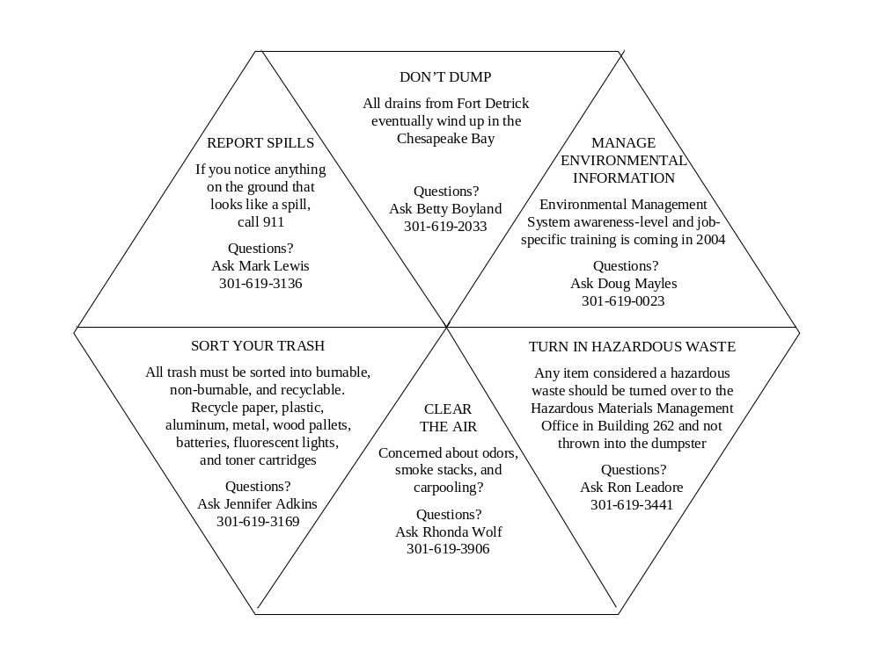

CHAPTER 7

7.0 Corrective and Preventive Action and Emergency Procedures

7.1 Introduction

As part of our commitment to an EMS program, this section will describe the established procedures and plans that define responsibility and authority for conformance, corrective actions and record of those documented plans and procedures. This section will direct the reader to location specific information and resources.

The mission of ARS requires the use of agricultural, industrial and laboratory chemicals, and defined high hazard operations. The potential for causing harm to the environment or endangering public health and safety through an accidental release of toxic, hazardous, or other polluting material must be managed through preventative actions. An example of a preventative action would be maintaining a smaller quantity of hazardous materials on-site that translates into a reduced potential for a significant public health or environmental impact resulting from a chemical spill or accident.

7.2 Corrective Actions Designed to Improve the Environmental Management System

Audit, review, or inspection reports issued from any of the sources below to any NAA location will generally contain corrective action recommendations or suggestions for improving environmental program areas.

Environmental Compliance Audits: NAA facilities are subject to an annual safety, health, and environmental compliance inspection conducted by the NAA Safety Office. Inspections of hazardous materials storage areas where laboratory chemicals, pesticides, maintenance chemicals, and fuels are stored and utilized are routinely conducted. Hazardous chemical and radioactive waste accumulation areas in the research laboratory and waste storage rooms or marshalling buildings are also reviewed for compliance with EPA regulations and location policies for waste storage. The NAA Safety Office periodically conducts Onsite Assistance Reviews utilizing the ARS SHEMB Onsite Assistance Review Checklist (see Appendix 7A).

All organizations at Fort Detrick, including our ARS Foreign Disease / Weed Science Research Unit, are subject to internal environmental assessments conducted by the USAG Environmental Management Office to ensure compliance with environmental regulations and requirements and conformance to the Fort Detrick Environmental Management System.

Every eight years, NAA facilities are subject to a Consolidated Assistance, Review, and Evaluation (CARE) Review under the leadership of the ARS Administrative and Financial Management Division. This review includes a functional review of Safety, Health, and Environmental Management at each facility to ensure that applicable chemical, biological, and radiological agent training; chemical procurement practices,
chemical inventory maintenance, hazardous waste management procedures, records, and disposal documentation are in place.

Federal agencies, just like private parties, are required to comply with all environmental requirements. To ensure that Federal agencies adhere to environmental requirements, EPA monitors Federal agency compliance, issues and assesses fines and penalties, and develops Federal agency enforcement and compliance policy and guidance. All NAA facilities located in EPA Region I, II, and III are subject to environmental compliance inspections. One tool in EPA’s compliance assistance tool kit for federal facilities that is not a regulatory inspection is the Environmental Management Review (EMR). An EMR is a review of an individual facility’s program and management systems to determine the extent to which a facility has developed and implemented specific environmental protection programs.

In previous years under the ARS Pollution Prevention (P2) Program, NAA facilities with Pollution Prevention activities reported their accomplishments annually to the NAA Safety, Health, and Environmental office. That system of reporting will continue with NAA locations being asked to compile their Environmental Management System accomplishments and forward them to the NAA Safety, Health, and Environmental office. These accomplishments will be forwarded to SHEMB so an agency-wide report can be developed for the Environmental Protection Agency as required under E.O. 13148.

7.2.1 Addressing Nonconformance and Conducting Corrective Measures

In all cases of incidents, spills, releases, and emergencies, the emergency response plans will take precidence. In cases of safety and environmental inspections and audits, the 30 day abatement and documentation procedures will be enforced for low hazard/non life threatening infractions.
In cases where human life is threatened; including engineering controls and safety emergency equipment that is not operational; immediate response and repair upon discovery will take place.
The Research leader and/or Location Coordinator will be responsible for ensuring immediate correction/abatement of identified deficiencies. (Location can add any reference to specific plans at location level)

7.3 Governing Laws and Regulations for Emergency Response

There are Federal governing laws and regulations that require NAA locations to have corrective and preventative action and emergency response procedures. These include:

(1) Emergency Planning and Community Right-to-Know Act (EPCRA) (40 CFR 355.30) – Most NAA locations are required to provide annual notice of hazardous material inventories to state and local agencies via TIER reporting notification. Under EPCRA, each covered facility must designate an emergency coordinator who will be the contact person between the facility and the local emergency response committee ( LEPC) and assist in the emergency planning process. Release notification under CERCLA is also a part of this regulation.

(2) RCRA Emergency Planning - NAA locations that are not classified as Large Quantity Generators (LQG) of hazardous waste are not required to prepare a contingency plan. However, they are required to follow emergency response procedures outlined in 40 CFR 262.34(d)(5)(iv), follow modified personnel training requirements under 40 CFR 262.34 (d)(5)iii, and comply with the same preparedness and prevention procedures as LQGs with the following additional requirements (40 CRF 262.34(d)): It is NAA ARS policy that all locations will manage their waste at the state approved RCRA program level or at no less than a small quantity generator level (SQG) at EPA regional level. At least one employee responsible for coordinating all emergency response measures must be either on the premises or on call at all times.

(3) Emergency Response Plan (OSHA) - Under OSHA's Hazardous Waste Operations and Emergency Response rules, five types of operations must have a written emergency response plan (29 CFR 1910.120). Of these five, the only operation that applicable to most NAA locations is that emergency response operations for releases of hazardous substances must comply with emergency response plan requirements of 29 CFR 1910.120(q). All NAA locations that use hazardous substances are required to develop a hazardous communication program under the OSHA Hazardous Communication Standard and/or the equivalent Chemical Hygiene Plan under the OSHA Laboratory Standard (29 CFR 1910.1450).

7.4 Emergency Response Planning

NAA locations maintain and update Emergency Spill Response Plans or operate under the Lessor/Cooperator emergency plans. The documents entitled "Spill Preparedness, Prevention, and Contingency Plan (SPPC)” and all other plans are located at the Location. These documents outline pre-release planning to minimize the occurrence of accidental releases, provide response information and response guidance to emergency response personnel in the event that an accidental hazardous material release occurs. In addition, locations have Emergency Action Plans which detail communication, security, and research protection based on the ARS COOP Master Plans. Please refer to the Emergency Action Plans at the NAA Website or contact your CDSO/CEPS. Note that secure information is not posted on the web site.

Major release containment and remediation is provided by (insert source) based on the location specifics and can include local HAZMAT response team, Hazardous Waste Disposal Services or the services of Federal Occupational Health (FOH). It is policy to follow up emergency response actions with independent third party review/actions. Additional remedial and post incident documentation will be provided by the assigned contractor.

[For a (Insert name of Location ) Emergency Response, Tier II reports, please contact (insert who/where has these reports. Note that copies can be available for review in the Administrative offices)]

  - Environmental Procedures Checklists (series of EPA checklists to follow)

Appendix 7A. Onsite Assistance Review Checklist

Basic Program Review Criteria and Verification Statements for
Safety, Health, and Environmental Management Programs
(Revised January 1995)

Part I

Component A - Safety, Health, and Environmental Management

- Does a written plan for safety, health, and environmental management exist?
To verify, look for:
(a) Annual goals/objectives published by the Area/location;
(b) "State of Location" entry in ARMPS;
(c) Safety/health/environment related performance standards for senior management officials; and
(d) DIRECTIVE and MANUAL 230.0, Safety, Health, and Environmental Management Manual.

- Has an individual been delegated authority and assigned specific responsibility for the program?
To verify, look for:
(a) Charge letter to the individual;
(b) Critical elements in performance standards; and
(c) A response from the individual.

- Has a Safety Committee been established (for locations with fifteen (15) or more employees?
To verify, look for:
(a) Charge letters to the individuals, ARS Form 309;
(b) Safety meetings held every two months; and
(c) Safety inspection checklist.

- Is funding requested and available for program operations and activities?
To verify, look for:
(a) Memos requesting funds for program needs;
(b) Amounts listed in ARMPS documents;
(c) Official requests (i.e., A-106, HPRL, ARMPS, etc.) to Areas/Headquarters for additional funding; and
(d) HWC quarterly reports when Departmental hazardous waste funding is used.

5. Are safety, health, and environmental rules, codes, and regulations present or available?
To verify, look for:
(a) 29 CFR 1910, 1926, 1928, 1960 standards;
(b) Applicable EPA and/or State regulations for:
- the Resource Conservation and Recovery Act (RCRA), if hazardous wastes are generated;
- the Comprehensive Environmental Response, Compensation, and Liability Act (CERCLA), if quantities of petroleum products or hazardous substances, or circumstances of releases, would require reporting;
- Clean Air Act; Clean Water Act; Federal Insecticide, Fungicide, and Rodenticide Act, others as appropriate;
(c) All ARS/Department Directives and Manuals; and
(d) Accessibility of all documents to employees.
    - Is safety/health considered in procurement practices and repair, storage, and salvage operations?
To verify, look for:
(a) Evidence that AD-700's for hazardous substance procurement has been reviewed with regard to possible product/process substitution, quantity verification;
(b) Proper storage of chemicals/supplies;
(c) Evidence that excess chemicals are offered to co-workers prior to disposal as waste; and
(d) Asbestos/lead surveys performed prior to renovations principles.

7. Are safety, health, and environment related documentation, record-keeping, and reporting activities being performed?
To verify, look for:
Inspection/abatement reports;
Reports of unsafe/unhealthful working conditions;
Records of occupational injuries and illnesses;
RCRA 3016 inventories;
Hazardous waste disposal manifests;
Spill notifications/waste site identification reports (CERCLA 103);
Pollution Abatement Project documents (i.e., OMB-A106); and
HWC accounting records.

8. Are safety, health, and environmental permits and approvals being obtained and maintained?
To verify, look for actual permits and compliance records for:
landfills;
hazardous waste disposal (EPA identification number);
underground storage tanks;
operating permits (Clean Air Act);
incinerators;
open burning;
wastewater treatment or disposal systems;
storm water/wastewater discharge (NPDES);
water supply/monitoring wells; and
asbestos removal.

Component B - Safety, Health, and Environmental Education and Training

1. Does a safety, health, and environmental education/training program exist?
To verify, look for:
(a) Education/training related funding amounts listed in ARMPS documents;
(b) Documentation of CDSO training;
(c) Training records for employees; and
(d) Documentation that external agencies (i.e., EPA, OSHA, universities, the State) have been onsite or conducted courses for the location.

2. Are current safety, health, and environmental resource materials maintained?
To verify, look for:
(a) Monthly trade magazines, periodicals, etc.
(b) Safety, health, and environmental related materials posted on the bulletin boards; and
(c) BNA Environment Reporter or other source materials.

3. Do position descriptions/performance elements have safety, health, and environmental related elements?
To verify, look for:
(a) Actual language in the position descriptions/performance elements; and
(b) Delegation of authority/role/responsibility papers/letters for:
CDSOs
Safety Committee members
Others.

4. Are safety, health, and environmental orientation sessions conducted for new or transferred employees?
To verify, look for:
(a) A program outline;
(b) Documents outlining hazardous areas within the facility, standard operating procedures, accident reporting procedures, and hazard reporting procedures;
(c) Employees signatures acknowledging receipt of training;
(d) Training records for part-time/summer employees; and
(e) New employees and discuss their orientation.

5. Is an incentive program for improving safety, health, and environmental performance in place?
To verify, look for:
(a) An "awards" program (i.e., cash, certificates, etc.);
(b) Letters of appreciation;
(c) Safety or environmentally related performance elements; and
(d) An employee's response to the question.

Component C - Safety, Health, and Environmental Services

1. Does an Employee Assistance Program (EAP) exist?
To verify, look for:
(a) Funding amounts in ARMPS;
(b) Formalized documents outlining the program;
(c) The onsite EAP Coordinator (one is required to be in place);
(d) Attendance records; and
(e) An employee's response to the question. (Most locations contract for these services.)

2. Do the Hazard Communication and the Community Right-to-Know Programs exist?
To verify, look for:
(a) Plans for implementing the programs;
(b) Recent chemical inventories;
(c) Material safety data sheets (MSDS');
(d) The availability of MSDS's to employees; and
(e) An employee's response to the question.

3. Is a formalized written facility self-protection plan in place?
To verify, look for:
(a) A written plan outlining emergency procedures (e.g., fire, tornados, releases, etc.);
(b) Posted fire/emergency escape routes (on every floor);
(c) Fire protection/prevention systems (i.e., alarms, sprinklers);
(d) The program's relationship with local fire departments; and
(e) An employee's response to the question.

4. Does an emergency program exist?
To verify, look for:
(a) Emergency care stations (i.e., first aid stations/boxes);
(b) Location personnel qualified in first aid (all shifts);
(c) Evidence of periodic "emergency disaster drills;" and
(d) An employee's response to the question.

5. Does an Occupational Medical Surveillance Program (OMSP) exist?
To verify, look for:
(a) Written procedures/policy statement;
(b) Attendance records;
(c) The amounts listed in the ARMPS; and
(d) An employee's response to the question. (Most locations contract for these services.)

6. Is there a program for solid and hazardous waste management?
To verify, look for:
(a) Policies and procedures;
(b) Hazardous waste determination procedures and records;
(c) Monthly hazardous waste generation and inspection records;
(d) Evidence of proper hazardous waste storage, transportation, and disposal;
(e) Waste disposal training program;
(f) Solid waste disposal facilities or permits; and
(g) Recycling programs for solid waste.

7. Is there a storage tank management program?
To verify, look for:
(a) Above-ground and underground storage tank inventory;
(b) Leak-detection and monitoring devices/equipment;
(c) Corrosion protection, spill prevention, overfill protection;
(d) Inventory control (for fuel dispensing facilities);
(e) Written filling, operation, and maintenance procedures; and
(f) Permits.

Component D - Safety, Health, and Environmental Oversight

1. Has a comprehensive Inspection/Abatement Program been implemented?
To verify, look for:
(a) The frequency of the inspections (one time per year is required);
(b) Inspection reports and abatement activity results (by the location/Area/Headquarters);
(c) Evidence that the "inspectors" are trained; and
(d) Evidence that the identified deficiencies are given to appropriate authorities for corrective action.

2. Are safety, health, and environmental requirements taken into consideration during design/construction of facilities, equipment, and operations?
To verify, look for:
(a) NEPA procedures and documentation;
(b) Review comments for design/construction drawings;
(c) Review comments for contracts; and
(d) Presence of personal protective equipment (PPE) onsite during construction activities.

3. Is applicable personal protective equipment and clothing (PPEC) available and its use mandated?
To verify, look for:
(a) A written program/policy statement;
(b) Standard operating procedures regarding when and how to use PPE to perform tasks;
(c) Proper orientation (training) on the use and maintenance of PPE;
(d) Inclusion in ARMPS; and
(e) An employee's response to the question.

4. Does a sign, label, poster program exist?
To verify, look for:
(a) Evidence that all hazardous areas or areas containing hazardous materials (e.g., biosafety, radiation) are clearly marked;
(b) Exit/means of egress signs;
(c) Areas requiring PPE for chemicals, noise, dusts, mists, gases, vapors;
(d) Intact chemical labels on each container providing the chemical identity, hazard warnings, chemical manufacturer; and
(e) Required posters in place (OSHA 300 statistics, USDA Occupational Safety and Health poster, FECA poster (CA-10).

Component E - Safety, Health, and Environmental Evaluation

1. Is the ARS accident/incident investigation and reporting program in place?
To verify, look for:
(a) Accident/incident records (CA-1, injury; CA-2, illness);
(b) ARS MANUAL 230.0 procedures for investigating and reporting accidents/incidents;
(c) Supervisors trained in accident investigation techniques;
(d) Required OSHA accident posting requirements (log of accidents/illnesses);
(e) Evidence of corrective action; and
(f) Accident/illness frequency and severity rates.

2. Are records of employee exposure to chemical, biological, or hazardous physical agents
maintained?
To verify, look for:
(a) Chemical, biological, or hazardous physical agents inventories;
(b) Written notification of potentially hazardous conditions to employees from management;
(c) Availability of MSDS; inventory standards to the employee; and
(d) OMSP results of employee physical.

3. Is an annual program evaluation conducted?
To verify, look for:
(a) Annual accident reduction goals prepared by locations/Areas (ARS 230 AVI, B); and
(b) Annual inspection plan (ARS 230 AVI, D).

4. Does an Office of Workers Compensation Program (OWCP) exist?
To verify, look for:
(a) Location efforts to compile and analyze OWCP cost data;
(b) Written procedures for submitting claims; and
(c) An individual assigned to perform duties.

Focus Program Review Criteria and Verification Statements
for Safety, Health, and Environmental Management Programs
(Revised January 1995)

Part II - Onsite Assistance Review

A. Hazard Communication Program

1. Has an inventory list of chemical and biological agents been completed?
To verify, look for:
(a) Location-wide or Area-wide inventory list of chemical and biological agents;
(b) Designation of chemical/biological agents in inventories as hazardous or nonhazardous;
(c) Criteria/guidance for designation of chemical/biological agents as hazardous or nonhazardous; and
(d) A coordinator or point of contact for the inventory.

2. Are MSDS files in existence, complete, and accessible to employees?
To verify, look for:
(a) MSDS' available for all hazardous chemical and biological agents in inventory;
(b) Request for MSDS included in procurement of chemical and biological agents;
(c) Procedures in place to determine whether MSDS needed for chemical/biological agents synthesized or acquired through non-commercial channels;
(d) MSDS' are organized and readily accessible to employees; and
(e) Employees know of existence and location of MSDS.

3. Are containers of hazardous chemical/biological agents properly labeled?
To verify, look for:
(a) Hazardous chemical and biological agents have labels; and
(b) Labeling is consistent with hazard criteria and Area or location procedures/guidance.

4. Have employees and supervisors been trained in hazard communication procedures/program?
To verify, look for:
(a) Written training program exists;
(b) Training includes
- provisions of hazard communication standard
- location/availability of the written program
- methods to detect presence or release of agent
- availability of environmental/medical monitoring
- physical and health hazards of agents used
- personal protective equipment
- emergency procedures
- labeling system and information sources; and
(c) Records of employee training, including subjects, dates, and satisfactory completion.

B. Hazardous Chemicals Standard, or Chemical Hygiene Plan

1. Is adequate written chemical hygiene plan (CHP) in existence and available?
To verify, look for:
(a) Plan contains sections on standard operating procedures, exposure determinations, fume hoods and other engineering controls, information and training, medical consultation and exams, designation of chemical hygiene officer, incident response, and additional employee protection for particularly hazardous chemicals;
(b) Copies of plan are available to supervisors and employees;
(c) Supervisors/employees aware of/familiar with CHP contents, their responsibilities; and
(d) A coordinator or point of contact for the CHP.

2. Are employees given information and training on the CHP?
To verify, look for:
(a) Procedures/records of training when first assigned, or when duties/procedures changed;
(b) Information includes CHP regulation, location and availability of the CHP, permissible exposure limits, signs/symptoms of exposure, location and availability of reference material;
(c) Syllabus of training includes methods of detecting releases, physical/health hazards of chemicals, protective measures, personal protective equipment, emergency procedures, and the CHP; and
(d) Employees familiar with plan/program.

3. Is workplace monitoring performed according to CHP?
To verify, look for:
(a) Employee exposure determinations up-to-date;
(b) Criteria to trigger and end incident-specific and periodic monitoring exist; and
(c) Employees receive results of monitoring.

4. Are medical consultation/examinations available and performed per the CHP?
To verify, look for:
(a) Medical attention available if employees develop signs or symptoms of exposure, if monitoring indicates potential for overexposure, or after spill;
(b) Licensed occupational health or preventive health physician performs exams and gives opinions;
(c) Physician gets information on chemicals employee may be exposed to, work description, descriptions of signs and symptoms of exposure; and
(d) Employees know of services available, rights, and triggers for medical consultation/examinations.

5. Are chemical hazards in the workplace identified/evaluated?
To verify, look for:
(a) Chemical containers are labeled with hazards;
(b) Provisions for evaluating chemicals developed in laboratory or obtained from noncommercial sources exist and are followed; and
(c) Supervisors and employees familiar with/aware of hazards and procedures for identifying or evaluating.

6. Does a respirator program exist?
To verify, look for:
(a) Written plan;
(b) Selection/maintenance criteria established;
(c) Selection/maintenance training provided;
(d) Equipment in plan in stock, good condition; and
(e) Supervisors and employees familiar with respiratory program.

7. Are records kept in accordance with CHP?
To verify, look for:
(a) Monitoring results records;
(b) Medical records; and
(c) Training records.

C. Community Right-To-Know (CTK) Program

1. Have notifications and MSDS' been provided to State/local emergency planning committees (EPCs), when applicable (40 CFR 355 and 40 CFR 370)?
To verify, look for:
(a) Chemical inventory identifies extremely hazardous chemicals present at location in excess of threshold planning quantity and reportable quantity;
(b) Up-to-date lists/MSDS' provided to EPCs, if applicable;
(c) Coordinator or point of contact for CTK program; and
(d) Notifications of releases from (entire) facility (40 CFR 355.40).

2. Have annual submissions (Tier I (March 1) or Tier II (30 days after requested)) been filed, when applicable or requested (40 CFR 370.20)?
To verify, look for:
(a) Requests, correspondence, and transmittals; and
(b) Coordinator or point of contact for CTK program.

3. Is public access and availability provided for required information?
To verify, look for:
(a) Written list of information for public access/availability requests from State/local EPC or fire department; and
(b) Procedures/records showing responsiveness to access/availability requests/public use.

D. Hazardous Waste (HW) Generator Standards

1. Do written plans/procedures for HW determination and waste analysis (40 CFR 262.11) exist, and is HW generator classification under both Federal and State regulations documented?
To verify, look for:
(a) Written plans/procedures;
(b) Records of HW determinations, waste analyses;
(c) Documentation of monthly HW generation and generator classification; and
(d) Employee familiarity with procedures.

**Remainder of questions applies only if hazardous waste is/was generated.**

- Does location have EPA/State HW identification number (40 CFR 262.12)?

To verify, look for:
(a) Up-to-date EPA Form 8700-12 and/or State equivalent; and
(b) EPA identification number.

3. Are HW shipments manifested, if required (40 CFR 262, Subpart B)?
To verify, look for:
(a) Manifest records; and
(b) Manifest records are complete and up-to-date.

4. Are hazardous wastes properly accumulated and stored (time and quantity limits) (40 CFR 262, Subpart C)?
To verify, look for:
(a) Written procedures for accumulation of HW, use/management/marking/labeling of containers, handling, and removal/treatment/disposal;
(b) Facility meets standards for accumulation, temporary storage;
(c) Inspections are performed and records are kept;
(d) Personnel involved in HW determination, accumulation, manifesting, inspection, shipment, and record-keeping are formally assigned responsibility and have at least basic training in RCRA requirements;
(e) Hazardous waste labels with accumulation start dates, etc., on containers, and containers are properly selected and managed;
(f) No hazardous wastes present for more than 90, 180, or 270 days, as applicable;
(g) Records of inspections, training, generation, and accumulation are up-to-date and accurate; and
(h) Employees familiar with HW accumulation and temporary storage requirements and location/Area procedures for HW determination and management.

5. Are required records kept (40 CFR 262, Subpart D)?
To verify, look for:
(a) Manifest records;
(b) Biennial reports, if applicable; and
(c) Exception or other reports.

6. Are hazardous waste requirements for exporters or importers of hazardous waste met, if applicable (40 CFR 262, Subparts E and F)?
To verify, look for:
Manifests showing non-U.S. destination or origin of hazardous waste.

7. Are preparedness/prevention and emergency/contingency plans, procedures, and equipment in place, to the extent applicable?
To verify, look for:
(a) Facility emergency plans;
(b) Lists of equipment/supplies; and
(c) Availability of equipment/supplies.

8. Is hazardous waste properly transported (off-site), treated, stored, or disposed (i.e. permitted)?
To verify, look for:
(a) Transportation and treatment, storage, and disposal parts of location/Area's hazardous waste management plans/procedures; and
(b) Consistency between generation and manifest records.;

9. Are there written plans/procedures for minimizing generation and/or recycling of hazardous waste?
To verify, look for:
(a) Pollution prevention plans/procedures; and
(b) Recycling/recovery/reclamation plans/procedure.

Inspector _______________________________ Date ________________

Appendix 7B: Small Lab Water Discharge Program Checklist

EMPs/SOPs

ACTION | NOTES
- Determine if the discharge meets with general pretreatment prohibitions for:
- Fire or explosion hazards
- Corrosive characteristics
- Viscous obstructions which could plug sewer
- Sludge discharges; and
- Heat sufficient to inhibit biological activities (> 104⁰F).

- Verify the POTW is aware of the discharge.

- Ensure the lab has a sewer use discharge permit or letter of acknowledgment from the POTW.

- Ensure that the lab has a copy of the POTW’s sewer use discharge requirements.

- Verify there is a system in place to routinely monitor the discharge of the POTW.

- Determine when samples are taken:
- A certified sampling/analytical lab handles them
- Proper sample containers, preservation techniques, holding times, and quality control are used;
- There is a designated employee responsible for making sure that sampling is performed according to permit requirements;
- Sampling results are reviewed and compared with permit requirements. Ensure that deviations are noted and investigated; and
- Reports are maintained on site for three (3) years.
- Verify that all lab personnel have been trained to understand the types of pollutants prohibited from discharge to the POTW.

- Verify that direct discharges to surface water are permitted.
- Ensure discharges to on-site waste disposal systems are permitted.

- Verify that copies of state, tribal, or local water pollution regulations are available.

Appendix 7C: Biologically Active Substances and Wastes Program Checklist

ACTION | NOTES
- Verify the lab has all applicable EPA, OSHA, CDC/NIH, DOT, and NRC regulations and guidelines available.

- Determine if the lab established an effective biosafety program that includes the following:
- An assessment to identify employees with biohazard exposure potential;
- Designation of a Biological Safety Officer;
- Development of a biosafety plan (to include an Exposure Control Plan);
- Employee training;
- Application of appropriate controls;
- Development of decontamination and waste handling procedures;
- Inspections of work practices and engineering controls;
- Medical surveillance program;
- Recordkeeping program; and
- Development of a bloodborne pathogen program.

- Verify that the universal biohazard symbol is placed prominently on all bags, sharps containers, containers of contaminated laundry, refrigerators, and freezers used to store, transport or ship blood or OPM.
- Ensure biohazard signs are posted at the entrance to all labs using or storing biohazards. The signs should include:
  - The universal biohazard symbol;
  - The agent in use;
  - The criteria for entry; and
  - The biosafety level.

- Verify employee training occurred prior to working with biologically active substances and whenever there is a change in the work task or operations that create new exposure situations.

- Ensure the lab developed and implemented an infectious waste management program that includes the following elements:
  - Guidelines to separate infectious waste from general trash;
  - Labeling requirements (use the universal biological hazard symbol on all containers);
  - Guidelines on selecting the appropriate type of packaging material to contain the infectious waste and to maintain its integrity during storage and transportation;
  - Requirements that do not allow for the compaction of infectious waste prior to treatment;
  - Procedures in place to minimize storage time; and
  - Guidelines for selection of the most appropriate treatment option for the waste.

- Determine if lab staff and management developed or studied opportunities for pollution prevention or waste management.

Appendix 7D: Drinking Water Program Checklist

ACTION | NOTES
- If the lab maintains a public drinking water system, verify that lab tests the system for MCL’s and SMCL’s and reports the results to the state.

- Determine if the lab is certified by the state to perform drinking water sampling.

- Verify that the lab is using EPA approved analytical methods for testing. If not, verify that the lab has, in writing, permission from the state and EPA to use an alternative analytical method.

- If the lab maintains an underground injection well, ensure that the lab:
- Determined the class;
- Permitted the well; and
- Has records of manifests, discrepancy reports, an Operating record, annual reports, and personnel training.

- Verify that the lab has a certificate of closure for all abandoned underground injection wells it operated.

Appendix 7E: Hazardous Waste Management Program Checklist

ACTION | NOTES
Hazardous Waste Identification
- Verify waste has been properly characterized to determine that (1) it is hazardous waste and (2) proper EPA identification code numbers have been assigned.

Generator Status
- Ensure the facility has a system to determine the generator rate and quantity of hazardous waste accumulated on-site and uses this data to ascertain generator status.

- Determine, if required (e.g., SQG or LQG), that the facility has an EPA identification number.

Satellite Accumulation
- Verify each satellite accumulation area (SAA) is at or near the point of waste generation for each waste and is under the control of the operator of the process that generated the waste.

- Verify waste containers are labeled “Hazardous Waste” and/or with words to indicate their contents.

- Verify waste containers are kept closed and are in good condition.

- Verify wastes are compatible with containers.

Verify wastes in any given SAA do not exceed 55 gallons of hazardous waste or one quart of acutely hazardous waste.
Central Accumulation Area
- Ensure every hazardous waste container is marked “Hazardous Waste” and with its accumulation start date.

- Verify waste is stored <90 days for LQGs and <180 days for SQGs, or 270 days if transported more than 200 miles.

- Ensure incompatible wastes and/or materials are separated or protected by physical means (e.g., wall, cabinet).

- Determine if internal communications equipment is available (e.g., two-way radio, telephone).

- Ensure floor drains are covered to prevent a spill from entering.

- Verify that fire extinguishers are in place and that a water supply is available.

- Determine if decontamination equipment is available (emergency shower, eyewash).

- Verify aisle spaces are unobstructed.

- Verify containers are inspected for leakage and/or corrosion at least weekly and inspections are recorded.
- Ensure the storage area provides secondary containment.

- Ensure personal safety equipment is available and usable.

- Determine if ignitable and reactive wastes are handled and stored in a manner to prevent fires and/or explosives.
- Verify containers are arranged on shelving so that the heavy containers are on the lower shelves and smaller containers on higher shelves.
- Ensure the shelving supporting hazardous wastes is in good condition and sturdy enough to support the load.
- Verify any hazardous waste treated or disposed on-site (e.g., neutralized and/or discharged down the drain) is done so in accordance with all applicable regulations.

- Ensure any hazardous waste leaving the site is sent to an appropriately permitted TSDF.

- Verify the hazardous waste transporter/broker is licensed, insured and reputable.

- Determine if employees responsible for shipping hazardous waste have been trained in accordance with DOT regulations.

Recordkeeping and Reporting
- Verify the following records are retained on-site for at least three (3) years:
  - Manifests;
  - Waste analyses results;
  - Inspection records;
  - Training records; and
  - Land disposal restrictions notifications.

- Determine if hazardous waste manifests signed by the transporter and designated TSDF have been received by the facility within the appropriate time period (e.g., 35 days for LQG and 60 days for SQG).

Emergency Preparedness
- Ensure an emergency coordinator who is familiar with response procedures at the facility has been designated and is on site or on call at all times.

- Verify emergency phone numbers (Fire Department, Police Department and Local Hospital) have been posted.

- Ensure the Fire Department is aware of the types and quantities of hazardous materials stored in the facility.
- For LQG’s, determine if a written contingency program has been developed and distributed.

- Verify that spill cleanup materials and equipment (e.g., absorbents, neutralizers, and personal protective equipment) are available.
Management System
- Ensure copies of current Federal, state, tribal, or local hazardous waste regulations are available.

- Ensure an individual has been designated to manage hazardous waste at the facility (e.g., tracking, accumulation, disposal, minimization and recordkeeping).

- Ensure a formal training program (e.g., waste management and Emergency response) is in place.
- Determine if a system to track the quantities of chemicals and Hazardous wastes on-site is in place.
- Determine if the lab has investigated and, where feasible, Implemented P2 opportunities.

Appendix 7F: Special Waste Program Checklist

ACTION | NOTES
- Verify that the lab properly identified all the universal waste streams.

- Confirm the lab does not generate and store more than 5000 kg of universal waste at any time.

- Check the storage containers to make sure they are in good condition and compatible with waste.

- Confirm that the containers or individual items are labeled as “Universal Waste”.

- Verify universal waste is not stored for greater than one year and the label maintains support documentation.

- Determine whether or not the employees received proper training on handling universal waste.

- Verify the lab transports all universal waste to a universal waste handling facility.

Battery Management
- Verify alkaline batteries manufactured after 1992 are disposed of in quantities of one or two.

- Confirm the lab recycles unsealed spent lead acid batteries.

- Verify the lab manages Ni-Cd and SSLA as universal waste.

Used Oil
- If lab operations result in the generation of used oil ensure the separation of used oil and hazardous waste.

- If used oil is mixed with hazardous waste, ensure the lab is managing the mixture as a hazardous waste.

- Verify that used oil storage areas are properly maintained and regularly inspected to ensure:
- Containers or tanks are in good condition;
- Containers & fill pipes are labeled “Used Oil”;
- Flammable & No Smoking signs are posted;
- Container lids and bungs are closed and secured when not in use; and
  - Containers or tanks have secondary containment.

- Confirm the used oil transporter has an EPA ID number, or if the lab transports the oil, confirm it is going to a licensed recycler and transported in less than 55 gallon quantities.

- Verify that the records of off-site transfers are maintained:
  - Transporter’s EPAID number;
  - Quantity shipped;
  - Date shipped; and
  - Name of the receiving facility.

Appendix 7G: EMS Audit Format

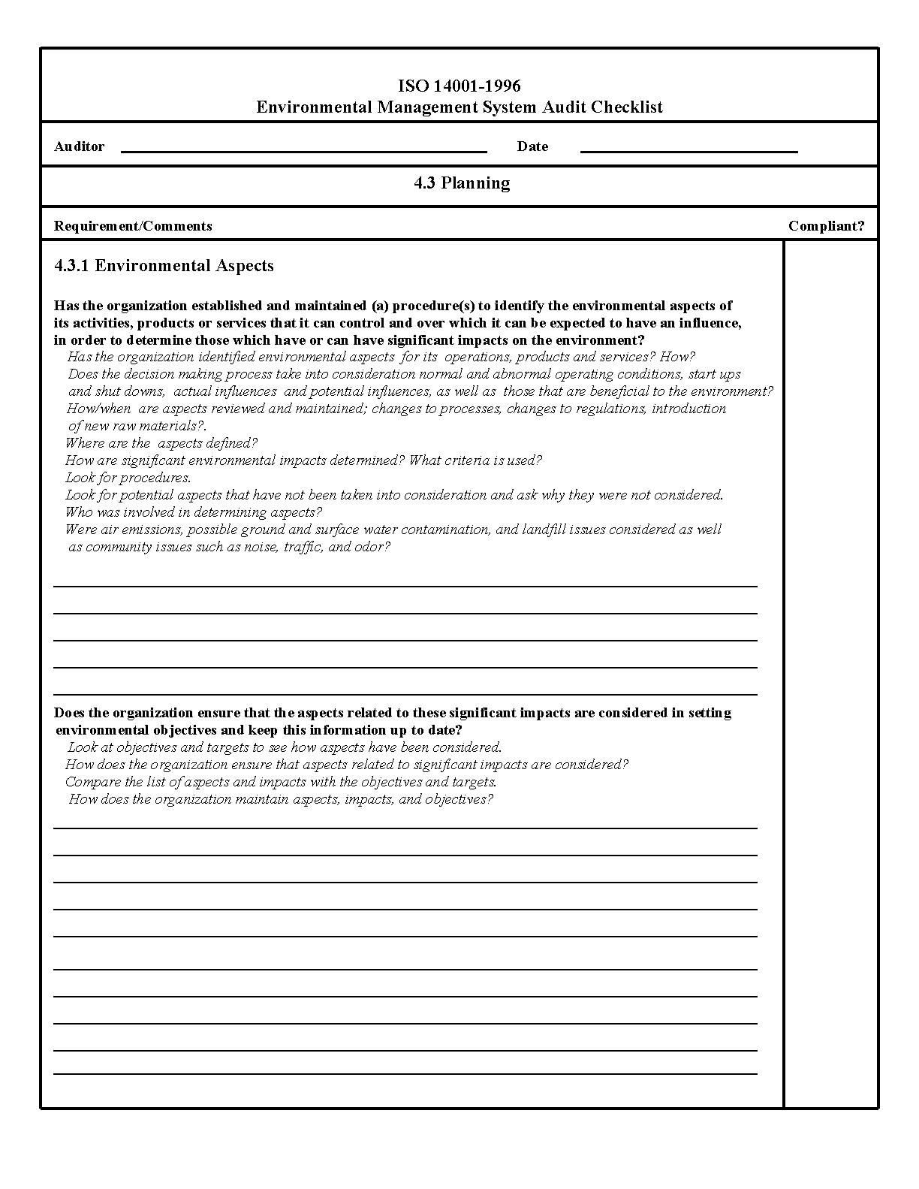

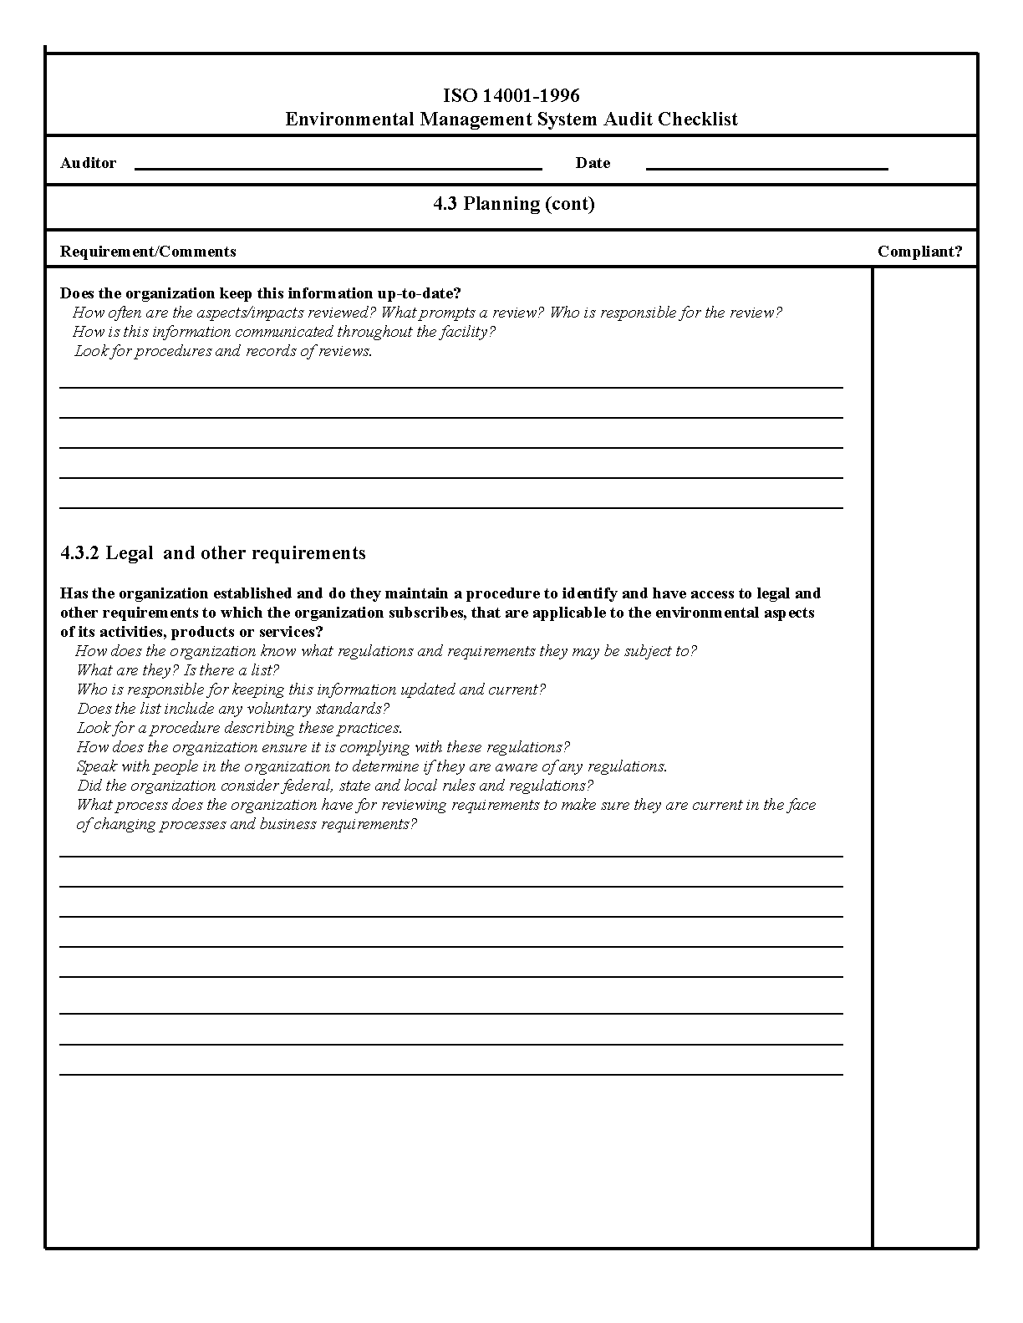

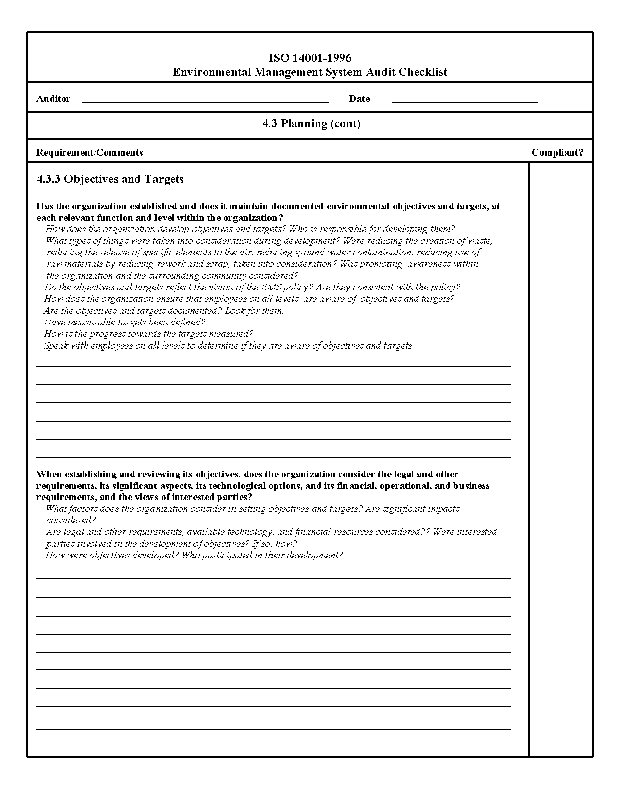

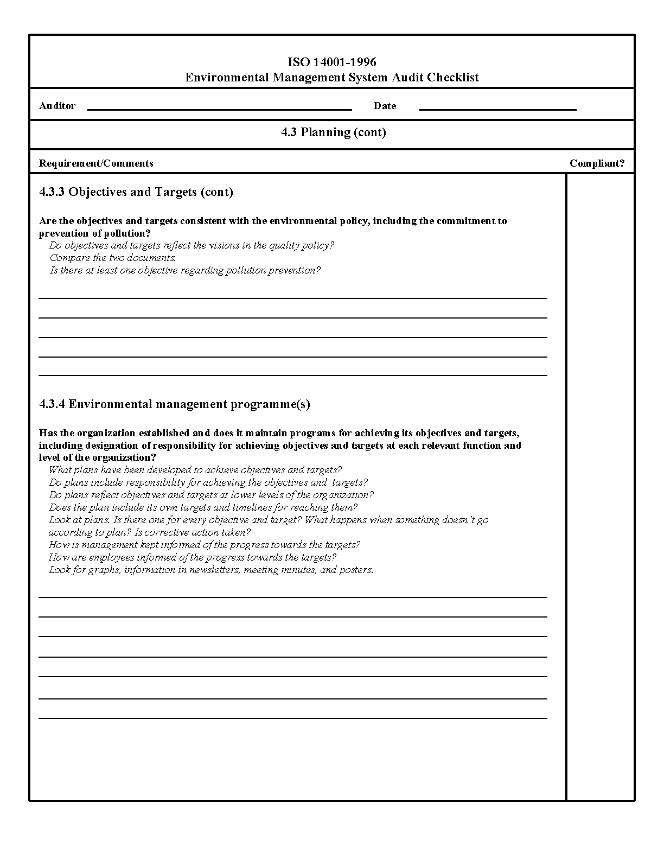

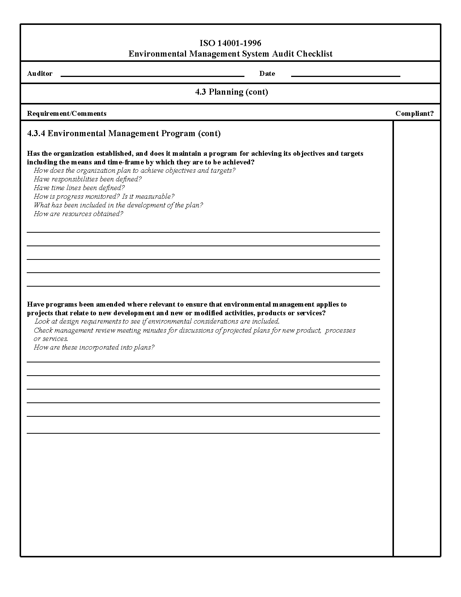

CHAPTER 8

8.0. Training, Awareness and Competence

Training is important for two reasons (1) employee action might have an impact on the environment and (2) employees are a useful resource for generating ideas about establishing operational control for a process, defining environmental aspects, or defining structural responsibilities. Research, office, and maintenance staff should be trained in their specific environmental responsibilities that are directly related to Significant Aspects, Targets and Objectives in the EMS. Many of these training courses are listed and described in Appendix 8A.

Four important goals of EMS training are to ensure that employees are aware of:

(1) The importance of conformance with environmental policy and procedures and with the requirements of the environmental management system

(2) The significant environmental impacts, actual or potential, of their work activities and the environmental benefits of improved personal performance

(3) Their roles and responsibilities in achieving conformance with the environmental policy and procedures and with the requirements of the environmental management system, including emergency preparedness and response requirements

(4) The potential consequences of departure from specific operating procedures.

The ARS 230 Manual, Chapter 10, establishes and outlines the responsibilities regarding training under the EMS program. The Location level, CEPS and ASHM maintain and update Safety, Health and Environmental training records.

In addition to the training requirements outlined in Appendix 8A, our Collateral Duty Safety Officers, Environmental Protection Officers and full time Safety Professionals attend, and provide ARS coordination to University, Regulatory and /or Host facility operators.

Appendix 8A: NAA Environmental Management Systems – Training Matrix

TRAINING TOPIC | EMPLOYEES  REQUIRING TRAINING | FREQUENCY | SOURCE OF TRAINING
Hazard Communication or Chemical Hygiene Training | All employees working with or exposed to hazardous chemicals | Initial hire and whenever changes in work assignment occur. | Refer to your local CEPS or Safety Manager
Hazardous Waste Management  (Generator) | All employees generating/disposing of hazardous chemicals | Initial hire and annually thereafter | Refer to your local CEPS or Safety Manager
Hazardous Waste Management  (advanced) | CEPS, disposal officer at location | Initial hire and updated as required | Several- refer to CEPS or ASHM
Safe Use and Disposal of Hazardous Materials/Wastes for Facilities Operations, Maintenance Personnel, and Contractors | Facilities and Maintenance and contractors that work with hazardous materials/wastes | Initial hire or entry to work site and annual thereafter | Refer to your local CEPS or Safety Manager
Hazwoper 8 hour Refresher | Emergency Response and IRT teams | Annual | Refer to CEPS or Safety Manager
40 hour Hazwoper | Upon initiation of new emergency response teams and/or members | Initial hire or entry into an Emergency Response Team | Refer to ASHM, CEPS or local Safety Manager
Fire Department and location Emergency Response Drills | Specific to location , includes county and local response team drills at ARS facility | 1- 4 times per year | Refer to Location Safety Manager, CEPS or Facility Maintenance
New Employee Safety, Environmental Training/Orientation | New Hires, visiting scientists or any individual that is assigned at discretion of supervisor | Initial hire or entry into building and no less than 30 days within time of same | Coordinated with the ASHM, CEPS or Safety Manager of location
Biological Safety  (may include Select Agent) | Lab Personnel who work with biohazardous materials and/or specialty S.A training | Initial Hire | Refer to your local CEPS or Safety Manager
Biological Safety Refresher  (may include Select Agent) | Lab Personnel who work with biohazardous materials and have previously received training in this area | Annual | Refer to your local CEPS or Safety Manager
Blood borne Pathogens | Personnel who work with blood borne pathogens or may have potential for exposure as first aid team/IRT members | Initial Hire/Annual Thereafter | Refer to your local CEPS or Safety Manager
USA/RSS Radiation Safety  Location Radiation safety Officer  ( LRPO) | Designated LRPO , ASHM or CEPS, Employees responsible for program. who work with radioactive materials or radiation emanating equipment | Initial Hire | Contact your Location Radiation Protection Officer
Radiation Safety Awareness level  (modified version available for all employees under Hazcom/CHP) | Employees who work with radioactive materials or radiation emanating equipment | Initial Hire  Annual refresher | Contact your Location Radiation Protection Officer
EPA Worker Protection Standard “Worker” Training (Pesticide Safety) | All employees categorized as “Workers” that are assigned cultural management tasks in areas where pesticides are applied. | Upon initial hire or within 5 working days of entering any treated area. Repeat training required every five years | Contact your location WPS or pesticide safety officer
EPA Worker Protection Standard “Handler” Training (Pesticide Safety) | All employees categorized as “Handlers” that handle, mix, load, transfer, or apply pesticides | Upon initial hire and prior to conducting any “Handler” task. Repeat training required every five years | Contact your location WPS or pesticide safety officer
Pesticide Safety  Refer to P&P 600.12, “Guidelines and Precautions to Be Taken by Personnel in Storing, Using, Handling, and Disposing of Agricultural Chemical Pesticides,” | Employees who use farm chemicals or enter application areas | Upon initial hire, as needed | Use P&P, 230 manual  WPS Officer, ASHM/CEPS  And AG Extension services
Public Water Supply Operator Certification | Employees assigned to oversee ARS-owned facility water supply operations | Initial certification and continuing education hours every two year renewal period | Contact your state public health service
Acquisition and Procurement | Employees assigned for procurement/affirmative procurement | Per DR-5001-1 | Contact your Procurement Specialist
PCMS Credit Card Training | Credit Card holders | Upon delegation of authority | LAPC and on line (see Green procurement appendix)
Facility Design and Construction | Employees assigned the responsibility for design and construction or renovation of NAA facilities | Ongoing | Refer to Engineering Contact, Facility Manager or Area Engineer
Environmental Management Policies/ EMS Awareness | New hire, all current employees | Initial hire, and updates | Refer to NAA EMS  Contact CEPS, ASHM, Safety Manager
EMS Technical Training | Core team leaders and ASHM  Local Teams | Ongoing and specific to need | Contact EMS Project Manager (ASHM) or Core Team Leaders (CEPS), see NAA safety website

Appendix 8B: (Insert Location Specific matrix or add other)

CHAPTER 9

9.0 Document Control (Insert Location specific information in this section)

EMS documents can and should be integrated with other NAA and location safety, health, and environmental management documents wherever possible. Cross-references with your location safety manuals, safety plans, and standard operating procedures are examples of this. Certainly, ARS policy and procedures, existing location safety manuals, plans, and standard operating procedures have environmentally related information in them. At your location, operational processes and procedures (e.g., chemical procurement, waste management, etc.) shall be defined, documented and updated, especially those that establish operational control over significant environmental aspects.

Information such as energy savings, fuel consumption, purchase of energy efficient equipment, water usage, hazardous waste generation, hazardous material purchases, hazardous material consumption, recycled-content material purchases or green purchasing, and the implementation of new processes that result in reducing negative impacts on our environment should be documented and utilized to measure your success.
It is the proper management of ARS records that verifies implementation of the EMS system which is incorporated in the Safety, Health and Environmental Management Program.

ARS has a procedure for document management that ensures documents can be located periodically revised and approved, and are legible and dated. Obsolete records are removed unless otherwise preserved for knowledge or legal purposes. Refer to REE policy and procedures “REE Administrative Issuances System” located on the AFM website for document management guidelines.

ARS Manual 230.0, Chapter 4 provides guidance for SHEM records management. In addition, the Area Safety Office, CEP’s and Location Collateral Safety Officers maintain documentation in various electronic formats.

Requests and Release of Information to third parties that fall outside routine practice shall be directed to the Information Staff, refer to Freedom of Information Act and Privacy Guidelines for more detail (P& P 158.1).

The EMS manual shall be updated no less than every three years.

CHAPTER 10

10.0 Continuous Evaluation and Improvement

One of the key components of your environmental management system will be management review. It is important that each location continually evaluate whether or not methods of minimizing negative impacts associated with significant aspects of location activities are effective. Questions such as “Are researchers aware of new lab techniques or equipment that utilize less hazardous materials and generate less hazardous waste?”, “Would modernization or equipment replacement increase the energy efficiency of our facility?”, “Are there current employee practices (e.g., green purchasing, hazardous material usage) that could be modified to reduce our negative impact on the environment?” For budgetary purposes, improvement to your environmental management systems should be part of your ARMPS planning process and modernization plans. For research purposes, environmental management will be part of your CRIS planning process through completion of the CRIS safety evaluation check sheet that is attached to every CRIS project plan.

10.1 Measuring the Success of Your Environmental Management System

Information such as energy savings, fuel consumption, purchase of energy efficient equipment, water usage, hazardous waste generation, hazardous material purchases, hazardous material consumption, recycled-content material purchases or green purchasing, and the implementation of new processes that result in reducing negative impacts on our environment can be obtained to measure your success. However, we realize that the dynamic and changing nature of scientific research may influence year-to-year comparisons of environmental performance. Increases in scientific research staff at a location would likely be accompanied by the purchase of new chemicals and equipment that may increase hazardous material inventories and hazardous waste generation. In addition because of the unpredictability of agricultural field research, there may be years where it may not be valid to compare one year’s pesticide usage to a prior year’s usage, due to changes in the type or number of pests, the type of pest control strategy being researched, the weather, or other factors. That being the case, environmental performance under these circumstances can usually be measured only in the grossest of fashions, with results from one year not being comparable to other years.

We have observed declining hazardous material inventories at our NAA research facilities, with the decline beginning in the early 1990's. The decline is attributable to, among other things, (1) the pursuit of non-chemical-intensive solutions (e.g., biocontrol agents, particle film technology) for pest control in agriculture production, (2) the development of research protocols employing less hazardous chemicals, (3) the high cost of maintaining appropriate storage space for large chemical stocks (4) safety issues associated with maintaining large chemical stocks, (5) increasingly high cost of disposing of dated unusable chemical stocks (6) the desire to avoid the burdensome regulatory or reporting requirements associated with large chemical stocks, (7) the development of “micro experimentation” techniques that replace older processes that used large quantities of chemicals with newer processes that use minute quantities. These are all measures of a successful environmental management system and should be included in annual reports of your progress.

Agricultural pesticides, which include insecticides, fungicides, and herbicides, are commonly utilized at NAA locations for greenhouse and field plant production. Factors such as the high cost of pesticide registration, public demand for less toxic pesticides, and the desire to reduce pesticide residues in the human foods have resulted in significant changes to the products that are currently marketed for commercial pest management. As such, researchers and pesticide applicators responsible for purchasing pesticides should always evaluate and select products that are not only effective, but also have reduced toxicity. Pesticide inventories should reflect a trend toward the use of Category 3 or 4 pesticides and away from Category 1. The added benefit of utilizing reduced toxicity pesticides is the corresponding shorter re-entry interval which places less restriction on research. Users should also be aware of constantly changing crop registrations for pesticide products and whether products on inventory are acceptable for research at NAA locations.

Chemical wastes at NAA facilities have also declined since the early 1990's, for many of the same reasons that chemical inventory declined. Because monthly waste inventories are kept, it would be possible to measure annual waste generation.

10.2 Management Review of Your EMS

The following are questions that you should ask as you continually review the effectiveness of your EMS.

● Did we achieve our objective and targets? (If not, why not?) Should we modify our objectives?

● Is our environmental policy still relevant to what we do?

● Are roles and responsibilities clear and do they make sense?

● Are we applying resources appropriately?

● Are our procedures clear and adequate? Do we need others? Should we eliminate some?

● Are we monitoring our EMS (e.g. system audits)? What do the results of those audits tell us?

● What effects have changes in materials, operations, or services had on our EMS and its effectiveness?
● Do changes in policy and procedures, laws or regulations require us to change some of our approaches?

● What campus, community, state, ARS, or USDA concerns have been raised since our last review?

● Is there a better way? What else can we do to improve?

CHAPTER 11

11.0 Public Involvement and Community Outreach

The North Atlantic Area (NAA) Agricultural Research Service (ARS) has been committed to a pro-active and constructive relationship with our stakeholders, local residents, employees, students, and regulators. Individuals or interest groups with an interest in the ARS’s environmental stewardship are a vital part of our outreach and risk communication program.

Our commitment is documented in many sources such as:

• ARS P&P 158.1, “Freedom of Information Act and Private Act guidelines

• ARS Manual 230.0, Chapter 10

In an effort to build upon our established partnerships, this section will describe the process for communication with internal and external parties.

11.1. External Communication Sources (Insert Location specific/unique programs)

• ARS and USDA websites

• Agricultural Research Magazine

• E-mail news products

• Outreach activities and services (Schools)

• National Agricultural Library

• Visitor Information Centers

• LEPC, County HAZMAT teams and fire/emergency services are invited into ARS facilities for planning, training sessions and facility reviews.

• Farm or Ag-farm Day Events

In addition, the Cluster Environmental Protection Specialist and full time safety officer has a requirement to maintain and participate in outside agency memberships, and committees which includes membership in local, regional environmental planning boards or interest groups.

11.2. Internal Communication Methods/Sources (Location can insert brief description of internal communication methods)
CHAPTER 12

12.0 Agency Self-Declaration Protocol for Appropriate Federal Facilities (Final Version September 10, 2003)

Introduction and Purpose:

The process used by federal agencies and their facilities or organizations to self-declare conformance with their selected environmental management systems (EMS) must ensure credibility. In order to meet this goal, agencies must develop a process that provides for effective and objective assessment of these systems in a manner that not only ensures the system is conformant, but is also designed for ongoing evaluation and continual improvement. Such a process must not only verify that appropriate documentation is developed, but affirm that the facility or organization is actually implementing their EMS as defined in their documentation and doing what they say they are doing. This process must also include the degree of transparency and objectivity necessary to make the self-declaration credible.

This protocol outlines procedures for federal agencies developing processes that will ensure the credibility of self-declaration of EMS for their appropriate facilities as set forth in Executive Order 13148. Specifically, this protocol is designed to satisfy the following principles:
- Result in accurate and reliable information on federal facilities’ progress as they adopt improved business practices associated with EMS implementation.
- Focus responsibility for initial EMS verification and on-going quality assurance at the agency / bureau level.
- Provide agencies / bureaus flexibility to implement EMS in ways that support their overall public mission.
- Provide an independent basis for verifying the status of a facility or organization EMS, and appropriately communicating that status to internal and external stakeholders.
- Ensure that system verification is more than a documentation review, and that the effectiveness of implementation is also reviewed.
- Use existing EMS elements where possible so that self-declaration becomes an integral part of the organization’s EMS.

Protocol:

Agencies / bureaus shall direct their facilities or organizations to use one or more EMS evaluation guide(s) in conducting EMS self-declarations. Examples of evaluation guides are included in:
- Appendix A, The Global Environmental Management Initiative (GEMI), “ISO 14001 Environmental Management System Self-Assessment Checklist”
- Appendix B, “Oregon Green Permits Program Guide -- Attachment B: EMS Description and References.”
- Appendix C, The National Aeronautics and Space Administration’s “Environmental Functional Review Checklist.”
- In directing use of the selected evaluation guide, agencies / bureaus shall establish a procedure including the following:
  - direction on the use of the chosen evaluation guide(s).

  - direction on the frequency of self-declaration internal evaluations; the frequency of agency / bureau independent reviews, makeup of the independent review team (e.g., Headquarters, other facility, other agency, or contractor), and qualifications of independent reviewers, a requirement for facility or organization management to make a self-declaration statement that the EMS is in place when that conclusion is reached.

  - direction on documenting and using the results of EMS evaluations. This shall include steps for acknowledging adequate facility EMSs, follow-up actions to address inadequacies in the EMSs, and reporting results of evaluations for inclusion in agency-wide annual EMS reviews.

  - a schedule for reviewing agency / bureau EMS Self-Declaration Procedures. This review shall consider changes in agency / bureau programs and missions when appropriate but on a schedule that does not exceed five years. This is designed to allow a phased approach and continual improvement. An example of an agency EMS Self-Declaration Procedure is included in Appendix D, The National Aeronautics and Space Administration’s “Environmental Functional Review Standard Operating Procedure.”

- Agencies / bureaus shall communicate their choice of guide(s) and procedures described above in accordance with their internal and external EMS communication procedures.

- Agencies / bureaus shall establish their procedures for EMS self-declaration as soon as practical but not later than NLT December 31, 2004.

- Agencies / bureaus shall include appropriate guidance to ensure that facilities desiring to participate in a Federal or state EMS recognition program (e.g., National Environmental Performance Track, Oregon Green Permits Program, New Jersey Silver Track Program) reflect the respective requirements in their self declaration procedures.
- Facilities or organizations that wish to self declare their EMS before agency procedures are in place may:
  - adopt a recognized independent review process such as third-party registration to ISO 14001 or

document the information described in protocol item1(b), (c) and (d) above and communicate that information to external parties in accordance with their EMS communication procedures.

Chapter 13 is left blank

