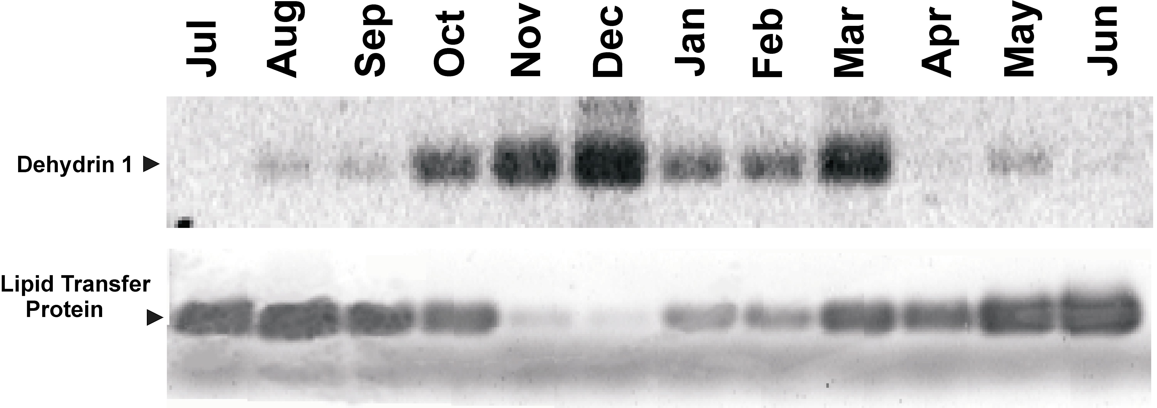

Figure 1. The separation of negatively-charged DNA fragments in a gel using an electrical current is shown. The intensity of each band is proportional to the expression of the gene. Expression of Dehydrin 1 and a Lipid Transfer Protein is shown in peach bark during a single year in the orchard. Dehydrin 1 is responsive to cold, as shown by increased band intensity in November and December. The Lipid Transfer Protein is responsive to long days, as seen by an increase in its expression during the summer months. Patterns of gene expression help us understand how specific genes contribute to important traits like cold hardiness.

