Diseases Caused by Viruses

Virus Diseases Overview
Viruses are obligate, acellular agents that reproduce inside living cells, spread between tissues, and frequently cause diseases in plants. They are a significant production constraint in chickpea and lentil. Virus diseases are often misdiagnosed as physiological, toxicological, or nutritional disorders because symptoms are similar and no pathogen is visible, except under an electron microscope.

In chickpea and lentil, many types of viruses are involved with genomes comprised of either single-stranded RNA or single-stranded DNA. Viruses that naturally infect chickpea include at least 25 species and 14 candidates (isolates that are potentially species) in 16 genera and 9 families. Viruses that infect lentil include at least 15 species and 3 candidates in 12 genera and 6 families.

Entry of viruses into chickpea and lentil crops (primary infection) is by vectors or infected seed. Spread from plant to plant within crops (secondary infection) is by vectors, predominantly aphids (Hemiptera: Aphididae). The pea aphid (Acyrthosiphon pisum Harris), cowpea aphid (Aphis craccivora Koch), green peach aphid (Myzus persicae Sulzer), and bean aphid (Aphis fabae Scopoli) are particularly important. For chickpea, leafhoppers are vectors for important viruses of genus Mastrevirus and also phytoplasmas, and thrips are vectors of less important viruses of genus Tospovirus and genus Ilarvirus.

An understanding of dissemination mechanisms and reservoir hosts is important in developing strategies for virus control. Viruses infecting chickpea and lentil are different in terms of dissemination, even though the same virus species, aphid species, and reservoir hosts are involved. Chickpeas are colonized poorly or not at all by aphids. There are few apterae (wingless aphids) that walk from plant to plant unless colonizable weeds are present, Infection is by migrant alatae (winged aphids) that fly that alight on individual chickpea plants and then fly on to others, producing a scattered field distribution that is characteristic for virus diseases in chickpea (Fig. 1). Plants with symptoms are solitary or have only one or a few symptomatic plants adjacent. Viruses acquired from hosts other than chickpea are generally most damaging although secondary spread from chickpea has been shown to occur for one virus species (Cucumber mosaic virus). Consequently, control strategies that aim to reduce buildup of aphids, establishment of early infection foci, or spread from these foci have limited benefit for chickpea. Examples are use of virus-free seed, seed-applied insecticide, and early aphicide sprays. In contrast, these same strategies are commonly benefical for lentil, which is colonized extensively by legume-feeding aphids that can walk as apterae to adjacent plants or fly as alatae to other areas of crops. Secondary spread in lentil is evident from patches of many infected plants (Fig. 2). Heavy aphid populations within lentil fields are often evidenced by numerous molt cases under the plants at the soil surface (Fig. 3).

Losses in both chickpea and lentil can be minimized by optimizing cultural practices. Sowing time, seeding rate, and fertilizer should aim to give vigorous growth and early canopy closure. Broadleaf weeds in and around crops should be controlled, as they can be sources of virus. Poorly-established, weedy crops are most vulnerable to damaging infestations (Fig. 4). Retention of standing stubble can deter flying aphids. Sources of resistance to specific virus species have been identified in lentil but are not widely available in commercial cultivars. Chickpeas exhibiting low incidence of infection (tolremicity) for a range of viruses have been identified in California, USA and Australia, and released as cultivars.

The descriptions and illustrations that follow should be a useful for distinguishing diseases caused by viruses from those caused by other agents. However, the different virus species cannot be distinguished reliably by symptoms in chickpea and lentil and infection by mixtures of species is common. Identification of viruses by serological and nucleic acid-based techniques is important for making informed decisions on disease management strategies.

Selected References
Bosque-Perez, N. A., and Buddenhagen, I. W. 1990. Studies on epidemiology of virus disease of chickpea in California. Plant Dis. 74:372-378.
Bos, L., Hampton, R. O., and Makkouk, K. M. 1988. Viruses and virus diseases of pea, lentil, faba bean, and chickpea. Pages 591-615 in: World crops: cool season food legumes. R. J. Summerfield, ed. Kluwer Academic Publishers, The Netherlands.
Eastop, V. F. 1983. The biology of the principal aphid virus vectors. in: Plant virus epidemiology. The spread and control of insect-borne viruses, R. T. Plumb and J. M. Thresh, eds. Blackwell Scientific Publications, Oxford, UK.
Klein, R. E., Larsen, R. C., and Kaiser, W. J. 1991. Virus epidemic of grain legumes in eastern Washington. Plant Dis. 75: 1186.
Kumar, P. L., Kumari, S. M. G., and Waliyar, F. 2008. Virus diseases of chickpea. Pages 213-234 in: Characterization, diagnosis & management of plant viruses. Vol. 3: Vegetable and pulse crops, G. P. Rao, P. L. Kumar and R. J. Holguín-Peña, eds. Studium Press LLC, Houston USA.
Latham, L. J., and Jones, R. A. C. 2001. Incidence of virus infection in experimental plots, commercial crops, and seed stocks of cool season crop legumes. Aust. J. Agric. Res. 52:397-413.

(Prepared by R.C. Larsen and M.W. Schwinghamer)

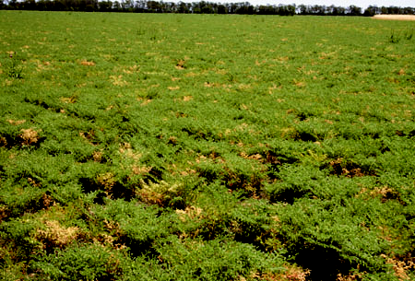
Fig. 1. Scattered distribution of symptomatic plants, characteristic of virus infection in chickpea crops. In chickpea there is little spread between adjacent plants. (Courtesy M. W. Schwinghamer).

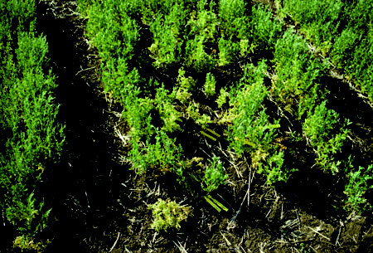
Fig. 2. Cucumber mosaic virus (CMV)-infected lentils showing secondary spread from first-infected (most stunted) plant at center. (Courtesy M. W. Schwinghamer).

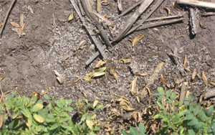
Fig. 3. White aphid molt casts are evident in lentil fields with high aphid populations. (Courtesy R. C. Larsen)

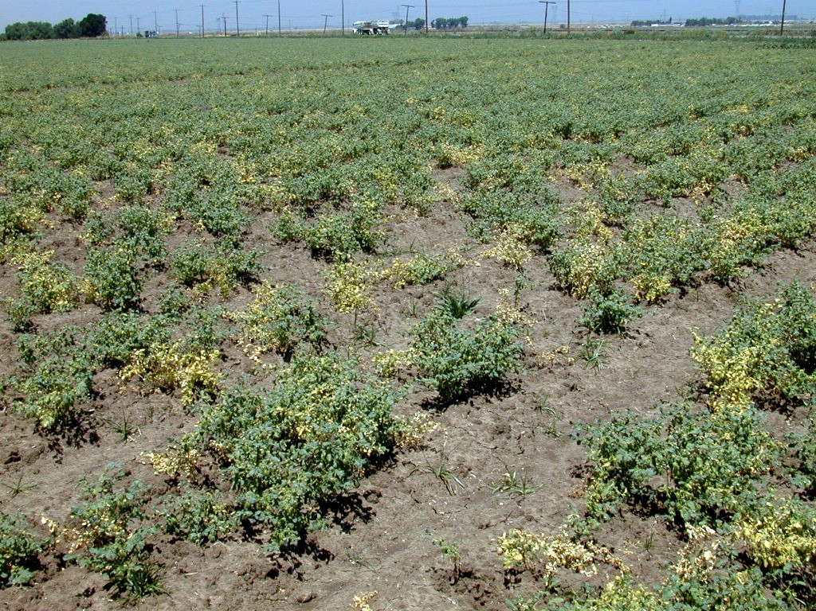
Fig. 4. Poorly-established crops are most vulnerable to virus infection. (Courtesy R.C. Larsen)
Alfalfa mosaic virus
Alfalfa mosaic virus (AMV) was first described in alfalfa (Medicago sativa L.) in 1931 and later in pea (Pisum sativum L.) in 1933. The virus has a natural and experimental host range that includes nearly 700 plant species in 70 families and is currently found worldwide. AMV is a significant pathogen of chickpea and lentil in Australia, but apparently not elsewhere.

Symptoms
Lentil. Infected plants exhibit a mild chlorosis with leaves reduced in size, and are frequently malformed. Necrosis often occurs along leaflet margins. Plants are usually stunted and may die prematurely. Flowering and pod formation are reduced and seeds are small and shriveled.

Chickpea. Both Kabuli and Desi type chickpeas become chlorotic and stunted, and often with necrotic shoots and tips (Fig. 1). Plants often die prematurely, especially when infected early. Desi chickpeas also may exhibit marginal reddening of leaflets.

Causal Agent
AMV consists of a tripartite genome containing three single-stranded RNA species, and a fourth sub-genomic RNA from which the coat protein is translated. Virions vary in size and shape from spherical to bacilliform measuring 18 nm in diameter and up to 56 nm in length. Transmission requires the presence RNA-1 consisting of 3644 nucleotides (nt), RNA-2 (2593 nt), and RNA-3 (2037 nt) together with the coat protein or RNA-4 (881 nt). The coat protein has a molecular mass of 24.25 kDa. AMV is serologically unrelated to any other known virus species.

Epidemiology
The natural host range of AMV includes approximately 150 plant species. When combined with the experimental host range, the list of susceptible plants is increased to over 600 species in 70 families. The virus is transmitted in a non-persistent manner by at least 14 different aphid species, of which the pea aphid (Acyrthosiphon pisum) is particularly important [See pea aphid under Insect pests]. AMV may be introduced into chickpea and lentil fields from infected weed or crop sources but this can vary with geographical location and vector species. One other source of infection is infected seed. AMV is seed-transmitted at levels up to 5% in lentil and 2% in chickpea. Although secondary loci infections can occur in lentil colonized by aphids, transmission is more sporadic in chickpea as the aphid visits random plants in search of a suitable host.

Management
An effective strategy for reducing incidence of AMV is to avoid plantings near established alfalfa in which virus incidence can reach near 100% after three years. Application of an approved insecticide may be beneficial in lentil when high aphid populations occur. Insecticides are not effective on chickpea. Use of certified virus-free lentil seed eliminates seed-infected plants that can be a source of secondary spread. The only resistant cultivar is the Australian chickpea cultivar Gully which has tolremicity (low infection incidence) against aphid transmitted virus species including AMV.

Selected references

Bol, J. E. 2003. Alfalfa mosaic virus coat protein-dependent initiation of infection. Mol. Plant Pathol. 4:1–8.
Bosque-Perez, N. A., and Buddenhagen, I. W. 1990. Studies on epidemiology of virus disease in chickpea in California. Plant Dis. 74:372-378.
Jones, R. A. C., and Coutts B. A. 1996. Alfalfa mosaic and cucumber mosaic virus infection in chickpea and lentil: incidence and seed transmission. Ann. Appl. Biol. 129:491-506.
Kaiser, W. J., and Danesh, D. 1971. Etiology of virus-induced wilt of Cicer arietinum. Phytopathology 61:453-457
Kaiser, W. J. 1973. Etiology and biology of viruses affecting lentil (Lens esculenta Moench.) in Iran. Phytopathol. Mediterr. 12:7-14.
Kaiser, W. J. 1981. Disease of chickpea, lentil, pigeonpea and tepary bean in continental United States and Puerto Rico. Econ. Botany, 35:300-320.
Kaiser, W. J. 1987. Disease problems on dry peas, lentils, chickpea and faba beans. Pages 157-174. In: Grain Legumes as Alternative Crops: A Symposium. Centre for Alternative Crops and Products, University of Minnesota, USA.
Latham, L.J., and Jones, R.A.C. 2001. Alfalfa mosaic and pea seed-borne mosaic viruses in cool season crop, annual pasture, and forage legumes: susceptibility, sensitivity, and seed transmission. Aust. J. Agri. Res. 52:771-790
(Prepared by R.C. Larsen and M.W. Schwinghamer)

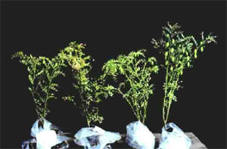
Fig. 1. Shoot tip symptoms caused by late infection with Alfalfa mosaic virus (AMV) in Desi chickpea (three plants at left). (Courtesy M. W. Schwinghamer).
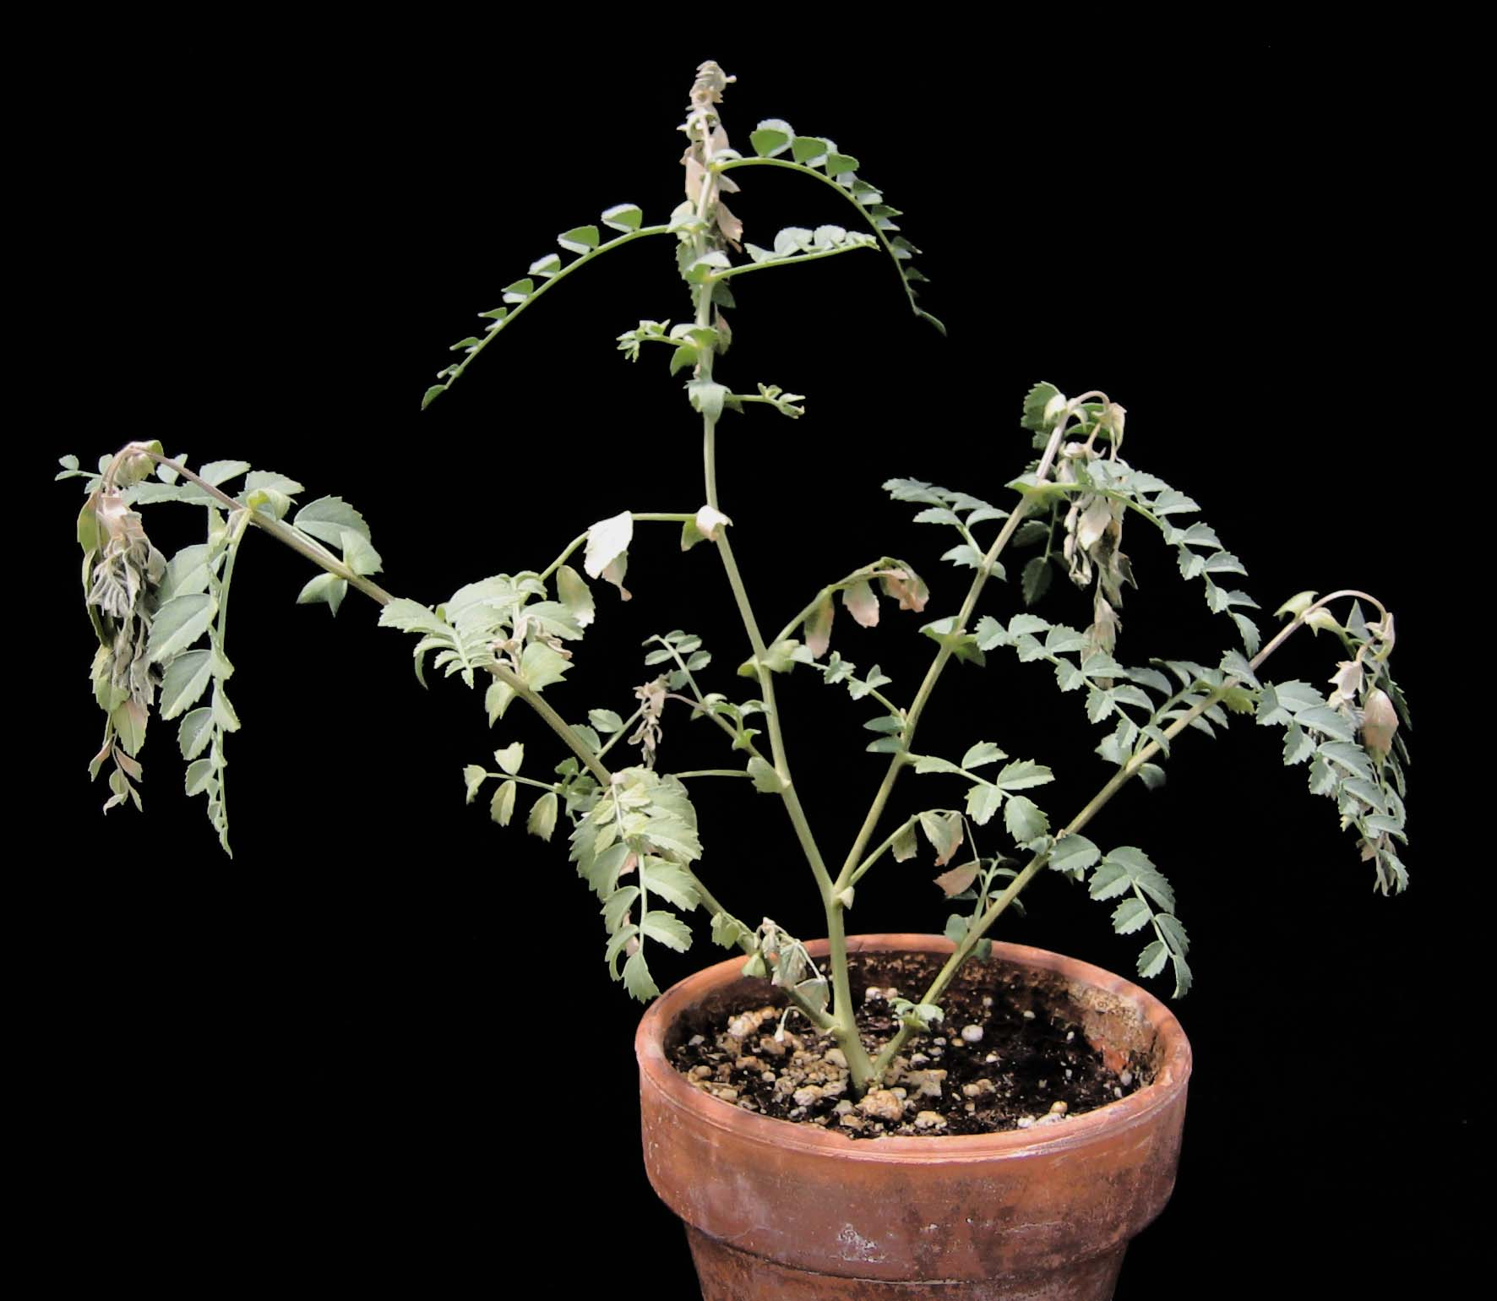
Fig.2. Shoot tip necrosis on chickpea caused by early infection with Alfalfa mosaic virus (AMV). (Courtesy R. C. Larsen)
Bean yellow mosaic virus
Bean yellow mosaic virus (BYMV) (Family Potyviridae; Genus Potyvirius) was previously known as bean virus 2 and Phaseolus virus 2. It was discovered in common bean (Phaseolus vulgaris L.) in 1925 and was the first virus reported to cause disease in chickpea in 1956. Many different isolates of the virus occur in several important crops throughout the world. It causes significant losses in lentil, common bean, and faba bean, but is generally of minor importance in chickpea.

Symptoms
Lentil. Symptoms on lentil include chlorosis, mild mosaic or mottling, and stunting. Leaves are often twisted or curled with necrosis along margins as the effects of the virus infection progress. Flowering and pod formation are reduced and consequently little seed is produced.

Chickpea. Chickpea is susceptible to BYMV, but has a much lower incidence of natural infection than lentil. However, when infected, both Kabuli and Desi type chickpeas develop apical necrosis (Figs. 1 and 2), reddening of leaf margins, plant stunting and premature senescence. Plants that are infected early but do not die may develop leaves that are filiform (having very narrow leaflets) and sometimes distorted.

Causal Agent
BYMV is a flexuous rod-shaped virion 750 nm in length containing single-stranded RNA and a coat protein with 282 amino acids. The genome is monopartite with 10,000 nucleotides. BYMV is serologically related to Clover yellow vein virus (ClYVV) which also infects many legume species. The coat protein of BYMV is 68-76% identical at the amino acid level with the coat protein of ClYVV. BYMV is more distantly related to the legume-infecting potyviruses Bean common mosaic virus, Bean common mosaic necrosis virus, Pea seed-borne mosaic virus and Soybean mosaic virus. In chickpea, a number of Potyvirus isolates have been described that are similar biologically to BYMV. These include Chickpea yellow mosaic virus and Chickpea bushy dwarf virus which are distinct serologically from BYMV, and Chickpea distortion mosaic virus and Chickpea filiform virus which are related serologically to, and may be a strains of BYMV. These appear to be of only minor or localized importance, along with the recognized potyvirus species Lettuce mosaic virus and Turnip mosaic virus (Fig. 2) that have also been reported in chickpea.

Disease Cycle and Epidemiology
BYMV has a broad host range of over 200 plant species, predominantly legumes. The virus is acquired from infected weed and perennial plant sources by more than 20 aphid species and transmitted in a non-persistent manner. The most common aphids associated with transmission of BYMV to legume crops are Acyrthosiphon pisum, Macrosiphum euphorbiae (Thomas), Myzus persicae, Aphis gossypii (Glover) and Aphis fabae, but other species including cereal aphids may be important if present in high numbers. Common sources for the virus in the field include clover (Trifolium spp. and Melilotus albus), vetch (Lathyrus spp.), and alfalfa (Medicago sativa). Consistent with other potyviruses, BYMV is mechanically transmissible. Faba bean (Vicia faba) and pea (Pisum sativum) are common pulse crops that are generally susceptible to BYMV and are also suitable hosts for colonization by aphids, thus providing a ready source of inoculum. A significant reduction in yield can occur in lentil fields when the incidence of BYMV is high.

Management
BYMV is transmitted by seed at levels of up to 1% in lentil but is not reported to be seed-borne in chickpea. Use of lentil seed certified to be free of BYMV will aid in reduction of the virus within the crop. Maintaining low levels of the virus in surrounding crops and weed hosts can be difficult because of the wide host range of BYMV but spread of the virus can be managed by eliminating local weed hosts. As with other non-persistently transmitted viruses, application of insecticides to control spread of the virus by aphids is ineffective except where the vector has built up large populations in lentils. No resistance has been identified in chickpea and only a few sources of tolerance have been identified in lentil. Lentil accession ILL7163 has been reported in Australia to be resistant to BYMV.

Selected References

Cheng, Y., and Jones, R. A. C. 2000. Biological properties of necrotic and non-necrotic strains of bean yellow mosaic virus in cool season grain legumes. Ann. App. Biol. 136:215-227.
Kaiser, W. J., and Danesh, D. 1971. Etiology of virus-induced wilt of Cicer arietinum. Phytopathology 61:453-457.
Larsen, R. C., Kaiser, W. J., Wyatt, S. D., Buxton-Druffel, K. L., and Berger, P. H. 2003. Characterization of a new potyvirus naturally infecting chickpea. Plant Dis. 87:1366-1371.
Makkouk, K. M., Kumari, S. G., and Al-Daoud, R. 1992. Survey of viruses affecting lentil (Lens culinaris Med.) in Syria. Phytopathol. Mediterr. 31:188-190.
Mali, V. R., Polajiwar, B., Nirmal, D. D., and Patil, F. S. 1988. Purification and properties of a virus causing distortion mosaic of chickpea. Indian Phytopath. 41:336-343.
McKirdy, S. J., Jones, R. A. C., Latham, L. J., and Coutts, B. A. 2000. Bean yellow mosaic potyvirus infection of alternative annual pasture, forage, and cool season crop legumes: susceptibility, sensitivity, and seed transmission. Aust. J. Agric. Res. 51:325-345.
Schwinghamer, M. W., Thomas, J. E., Parry, J. N., Schilg, M. A., and Dann, E. K. 2007. First record of natural infection of chickpea by Turnip mosaic virus. Australasian Plant Disease Notes 2:41-43.
Shukla, D. D., Ward, C. W., and Brunt, A. A. 1994. The Potyviridae. CAB International, Wallingford, UK.
Snyder, W. C., Paulus, A. O., and Gold, A. H. 1956. Virus yellows of garbanzo bean. Phytopathology 46:27.
(Prepared by R.C. Larsen and M.W. Schwinghamer)

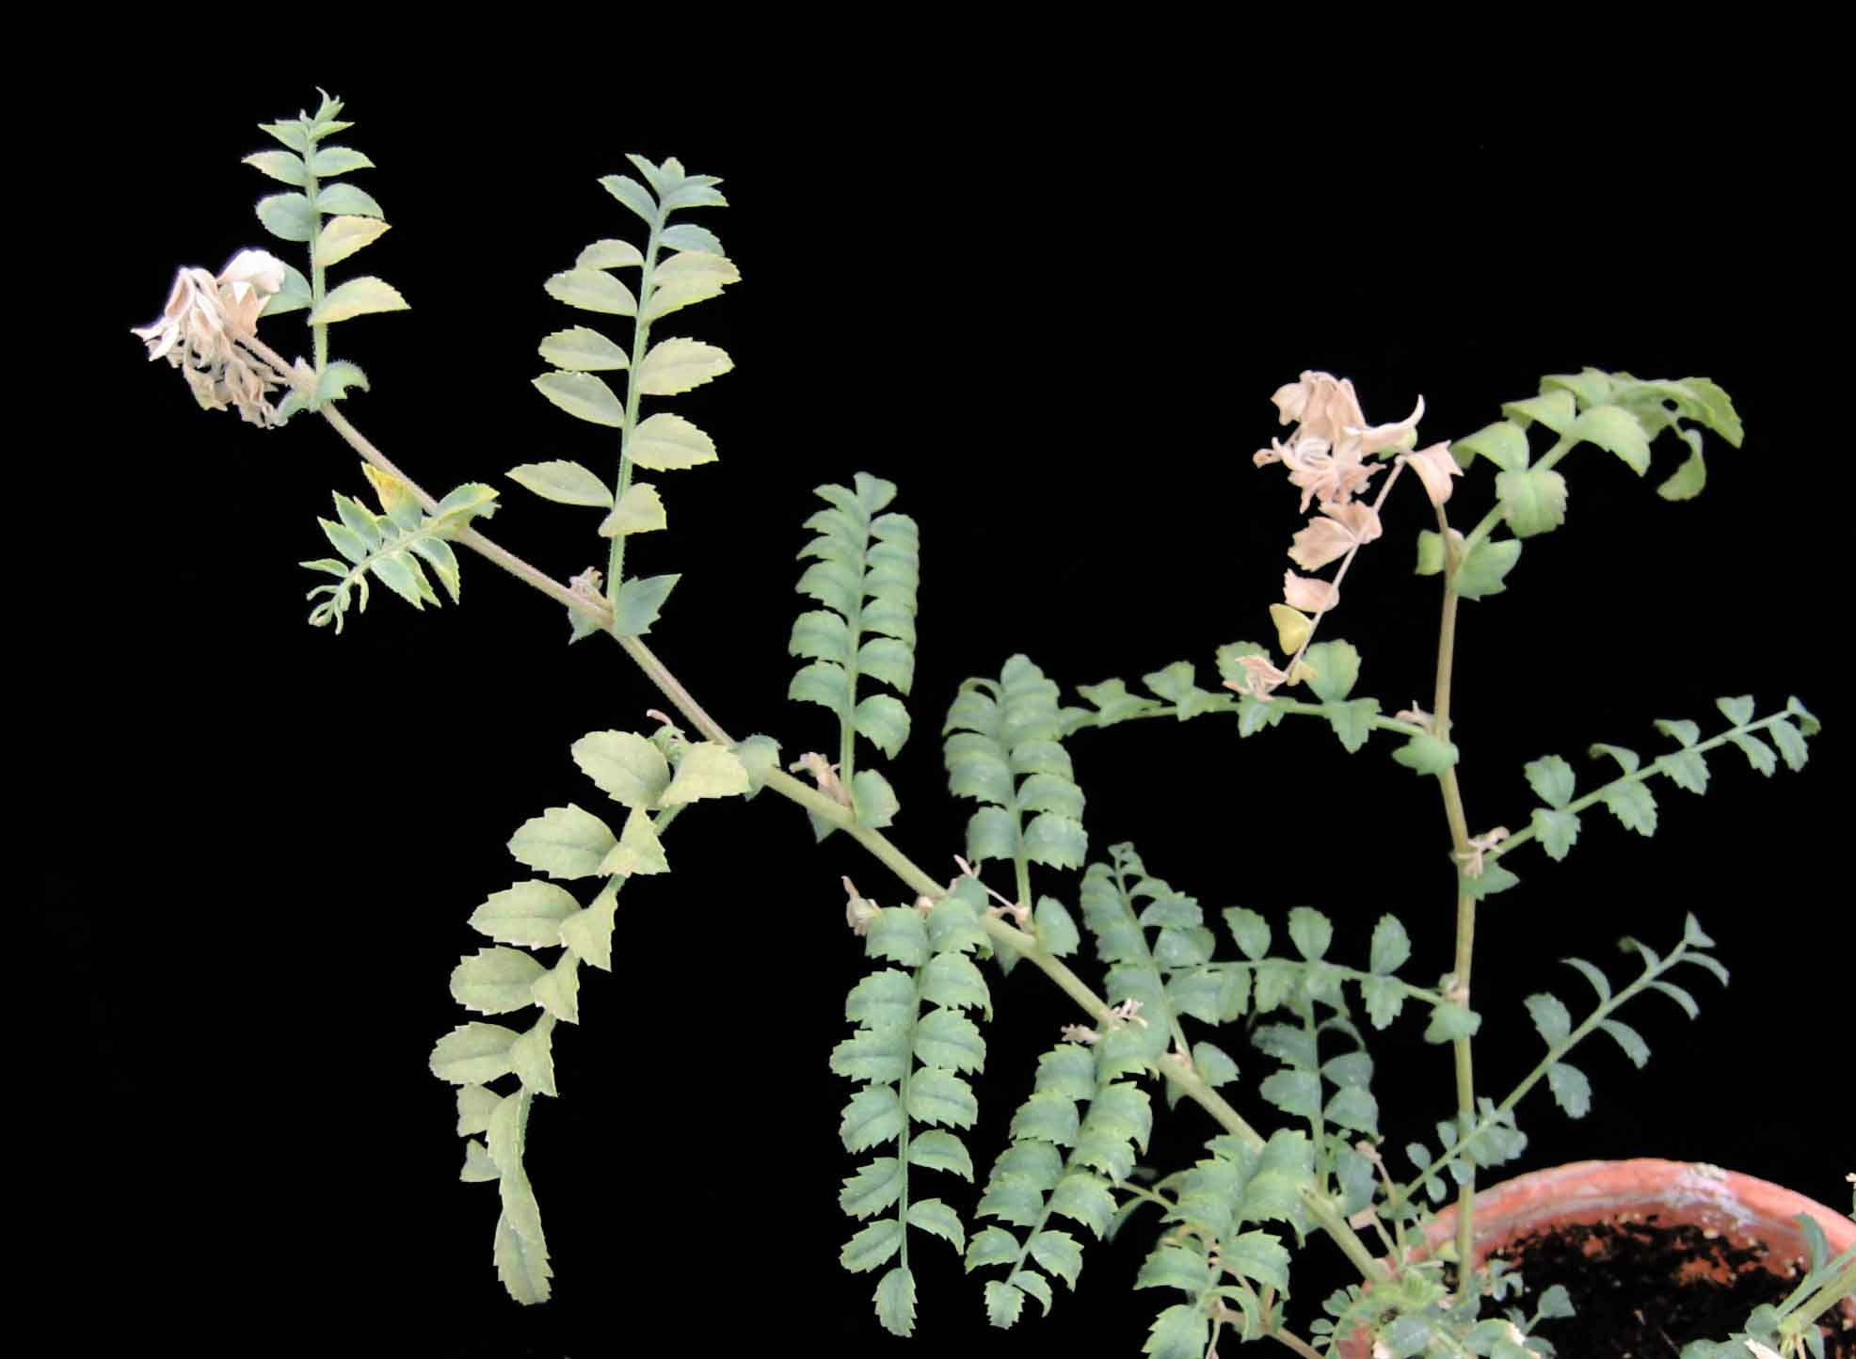
Fig. 1. Shoot tip necrosis in chickpea caused by early infection with Bean yellow mosaic virus (BYMV). (Courtesy R. C. Larsen)

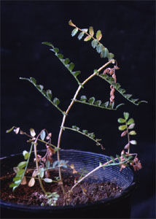
Fig. 2. Shoot tip necrosis in seedling chickpea caused by early infection with a chickpea isolate of Turnip mosaic virus (TuMV), a Potyvirus species related to Bean yellow mosaic virus (BYMV). (Courtesy M. W. Schwinghamer)
Cucumber mosaic virus
Cucumber mosaic virus (CMV) was first described in 1916 and has a large host range that includes over 1000 plant species in 85 families. It can cause severe losses in lentil during seasons of high aphid populations when infection incidences exceed 50%, but rarely causes significant damage in commercial chickpea crops.

Symptoms
Lentil. Symptoms in lentil include a general chlorosis of the plant, leaf malformation and stunting (See Fig. 2 in Virus Diseases Introduction), often followed by premature death (Fig. 1). Leaflets may show a mild mosaic or reddening of leaf margins. A reduction in pod number or filling of pods generally occurs resulting in yield loss.
Chickpea. For many CMV isolates and chickpea genotypes, symptoms are more distinctive than for other virus species in chickpea. The most distinctive feature is internode reduction (Fig. 2), shoot proliferation, and slight stem kinking that can be described as bushy stunting (Fig. 3). Leaflets show pale chlorosis, reduction in size, and sometimes narrowing and pale mosaic (Fig. 4). Reddening may also occur on leaf margins of Desi chickpea lines. Chickpea seedlings may show necrosis of shoot tips. Plants sometimes die prematurely, but mortality is generally less than for other viruses and small groups of infected plants may persist after surrounding uninfected ones mature due to less use of soil moisture. Even when plants survive, seed yield is reduced greatly through failure of seed set.

Causal Agent
CMV is a member of the Family Bromoviridae, Genus Cucumovirus. It has a tripartite genome encapsidated in isometric particles ca. 29 nm in diameter that contain RNA-1 (3389 nucleotides), RNA-2 (3035 nucleotides), or RNA-3 (2197 nucleotides). A sub-genomic RNA-4 is also encapsidated in the particles that contain RNA-3. The coat protein consists of 218 amino acids with a molecular weight of 24.2 kDa. The species has been divided into distinct serogroups called subgroups I and II, with the latter comprising 70% of isolates. Phylogenetic analyses have shown that subgroup I can be divided into subgroups IA and IB both of which are distantly related to isolates belonging to subgroup II. CMV is distantly related to other Cucumovirus species Peanut stunt virus and Tomato aspermy virus.

Epidemiology
CMV can survive from year to year in many weed species, or in green vegetation and crops in temperate areas. Perennial legumes such as clover and alfalfa are ready sources of inoculum and many of these hosts may remain symptomless. The virus is transmitted in a non-persistent manner by many different aphid species. A number of these species including cereal aphids may be important in the case of lentil, but Acyrthosiphon pisum (pea aphid), where present, is likely to be the most important for chickpea. Aphids can acquire the virus within a few seconds and transmission can occur in an equally short time period. Infectiveness is lost after brief probing but can be retained for hours by alate aphids if they do not probe. CMV is seed transmitted in lentil and chickpea, forage legumes, and in may weed species. Transmission by seed is erratic in lentil and chickpea but can average 0.1% to 1%, occasionally reaching 2% or higher within seed lots. In chickpea, infected seed does not appear to lead to major losses in commercial crops but major losses have been demonstrated in experimental plots. There is more secondary spread in lentil than in chickpea, and consequently lentil seed infected with CMV can lead to major losses in commercial crops.

Management
CMV in lentil can be controlled by planting certified virus-free seed in localities where other sources of infection are not present. Application of systemic insecticides to lentil may be useful in reducing aphid populations, especially if colonization is observed. However, insecticides are not effective in chickpea and sometimes they increase infection incidence on colonizable crops such as lentil, due to increased movement of alate aphids. Allowing standing stubble to remain from the previous cereal crop is partially effective in deterring alate aphids in chickpea and lentil crops. Lentil lines L-4, PAK 3598, ILL1983, Mizia, Medovina 1-G, ILL788, ILL7700, ILL7163, and ILL5405 have been identified with tolerance or partial resistance to CMV. Some tolerance in lentil may exist in ILL590 and the red lentil cultivar Cobber. The Australian chickpea cultivar Gully has a reduced incidence of infection by CMV and other aphid transmitted viruses.

Selected References
Chalam, T. V., Reddy, M. V., Nene, Y. L., Beniwal, S. P. S., and Subbayya, J. 1986. Some properties of a strain of cucumber mosaic virus isolated from chickpea in India. Plant Dis. 70:128-130.
Fletcher, J. D. 1993. Surveys of virus disease in pea, lentil, dwarf and broad bean crops in South Island, New Zealand. N. Z. J. Crop Hortic. Sci..21:45-53.
Fletcher, J. D., Russell, A. C., and Butler, R. C. 1999. Seed-borne cucumber mosaic virus in New Zealand lentil crops: yield affects and disease incidence. N. Z. J. Crop Hortic. Sci. 27:197-204.
Hsu, H. T., Barzuna, L., Hsu, Y. H., Bliss, W., and Perry, K. L. 2000. Identification and subgrouping of Cucumber mosaic virus with mouse monoclonal antibodies. Phytopathology 90:615-620.
Jones, R. A. C., and Coutts, B. A. 1996. Alfalfa mosaic and cucumber mosaic virus infection in chickpea and lentil: incidence and seed transmission. Ann. Appl. Biol. 129:491-506.
Jones, R. A. C., B. A. Coutts, L. J. Latham, and S. J. McKirdy. 2008. Cucumber mosaic virus infection of chickpea stands: temporal and spatial patterns of spread and yield-limiting potential. Plant Pathology 57:842-853.
Kaiser, W. J., and Danesh, D. 1971. Etiology of virus-induced wilt of Cicer arietinum. Phytopathology 61:453-457.
Latham, L. J., and Jones, R. A. C. 2001. Incidence of virus infection in experimental plots, commercial crops, and seed stocks of cool season crop legumes. Aust. J. Agric. Res. 52:397-413.
Makkouk, K. M., Bashir, M., Jones, R. A. C., and Kumari, S. G. 2001. Survey for viruses in lentil and chickpea crops in Pakistan. Z. Pflanzenkr. Pflanzenschutz 108:258-268.
Moury, B. 2004. Differential selection of genes of Cucumber mosaic virus subgroups. Mol. Biol. Evol. 21:1602-1611.
(Prepared by R.C. Larsen and M.W. Schwinghamer)

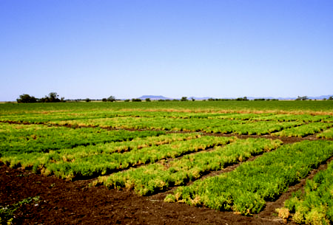
Fig. 1. Symptoms of viruses (predominantly Cucumber mosaic virus) in experimental plots of lentil. (Courtesy M. W. Schwinghamer)
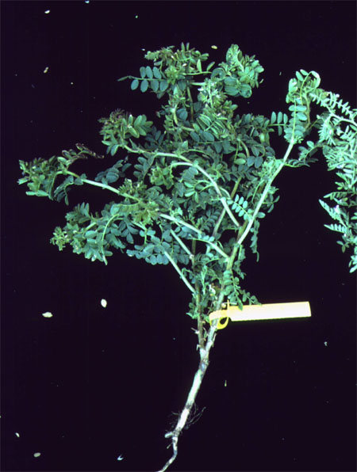
Fig. 2. Internode reduction at shoot tips and kinking of stems in chickpea caused by Cucumber mosaic virus (CMV). (Courtesy M. W. Schwinghamer)
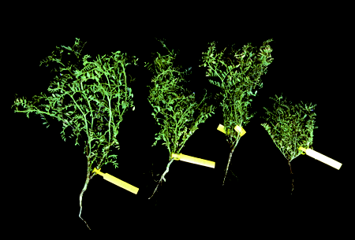
Fig. 3. Symptoms of bushy stunting caused by Cucumber mosaic virus (CMV) in desi chickpea (three plants at right). (Courtesy M. W. Schwinghamer)

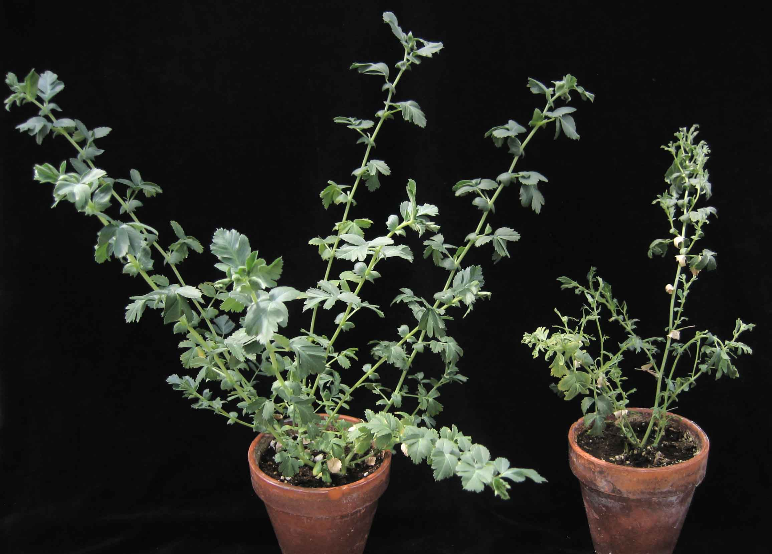
Fig 4. Symptoms of early infection with Cucumber mosaic virus including stunting, necrosis of primary shoot top and reduction and narrowing of leaves on earliest growth. Healthy plant is at left. ( Courtesy R. C. Larsen)
Faba bean necrotic yellows virus
Faba bean necrotic yellows virus (FBNYV) is the causal agent of a destructive disease of chickpea, lentil and other food and fodder legumes in some arid regions of the Old World, such as countries of North Africa, West Asia (Near East) and southern Europe. From chickpea and/or lentil it was first reported in Syria in 1991 and subsequently in Egypt (1993), Jordan (1998), Pakistan (1998), Ethiopia (1999), Iraq (1999), Spain (2000), Iran (2001), and Sudan (2003). Viruses closely related to FBNYV and Milk vetch dwarf virus from Japan, but clearly distinct from typical FBNYV isolates from Syria and Egypt, occur in Ethiopia, Morocco, and China.

Symptoms.
Chickpea. Characteristic symptoms of infection in chickpea include leaf rolling, yellowing (or reddening) and stunting. Symptoms on chickpea are similar to those caused by luteoviruses and mastreviruses.

Lentil. Field symptoms in lentil include stunting with leaf malformation, yellowing, twisting and mottle. Flower formation is reduced and pods are also reduced in number or size. Seed from affected pods are significantly reduced in size.

Causal Agent
FBNYV is a nanovirus (Family: Nanoviridae). Its isometric virus particles measure approximately 18 nm in diameter and contain a multipartite single-stranded DNA genome. The nanovirus genome is thought to be comprised of eight circular DNA components ranging in size from 985 to 1005 nucleotides. Each component is individually encapsidated and encodes a different protein that is required for replication, encapsidation, cell-to-cell transport or various other functions within the nanovirus life cycle. In addition to the eight genomic DNAs, up to five (additional) DNAs that encode different replication initiator proteins (Rep) have been found in plants infected with nanoviruses. Since these DNAs occur only erratically in nanovirus infections, they are regarded as non-integral (satellite-like) DNAs, which depend on their helper virus for various functions.
FBNYV is serologically unrelated to luteoviruses, such as Bean leafroll virus, Beet western yellows virus (or Beet western yellows-like species), and Soybean dwarf virus. Hence, FBNYV can be easily differentiated from luteoviruses using available monoclonal or polyclonal antibodies. However, members of the genus Nanovirus are serologically related. The serological relationships of FBNYV to the nanoviruses Milk vetch dwarf virus (MDV; from Japan) and Subterranean clover stunt virus (SCSV; from Australia) are close and distant, respectively. This difference is reflected by the coat protein amino acid sequence identities between the pairs FBNYV/MDV (83 %) and FBNYV/SCSV (54 %). For the differentiation and specific detection of closely related nanoviruses, species-specific monoclonal antibodies or primers for use with RT-PCR are required.

Epidemiology
FBNYV was first described infecting faba bean (Vicia faba L.). Now it is known to infect more than 50 legume species and only few non-legume species (Stellaria media, Arabidopsis thaliana, Amaranthus, and Malva spp.) under experimental and/or natural conditions. In addition to faba bean, lentil, and chickpea, major legume crops naturally infected by FBNYV are common bean (Phaseolus vulgaris L.), cowpea (Vigna unguiculata), medicago (Medicago spp.), pea (Pisum sativum), clover (Trifolium spp.), soybean (Glycine max), and vetch (Lathyrus spp.). Some wild Malva spp. may serve as a reservoir host of the virus.
The cowpea aphid (Aphis craccivora) appears to be the major natural vector of FBNYV as it is the most abundant aphid species on legume crops in the afflicted areas and is among the most efficient vectors under experimental conditions. Other aphid vectors of FBNYV are the black bean aphid (Aphis fabae) and the pea aphid (Acyrthosiphon pisum) but in no case were Myzus persicae and Aphis gossypii able to transmit this virus. FBNYV is transmitted in a persistent manner by aphids but does not replicate in them. While the minimum access feeding periods for FBNYV acquisition and inoculation range from 15 to 30 min, longer acquisition access feeding periods render many individuals viruliferous throughout their life (about 30 days). The median latency period (LP₅₀) is about 105 hours. The virus is retained through aphid moults, and aphids acquiring FBNYV as nymphs are much more efficient vectors than adults. In infected plants FBNYV is confined to phloem tissues, rendering it non-transmissible by sap (or contact) and through seed or pollen.

Management
Applications of systemic insecticides to lentil crops may reduce primary and secondary infection and may reduce primary infection in chickpea under high aphid population pressure. Because the aphid vectors do not colonize chickpea, application of insecticides for control of the virus is not cost effective. Although no cultivars of chickpea or lentil with resistance to FBNYV are commercially available, screening for FBNYV resistance with viruliferous aphids at ICARDA, Aleppo, Syria, identified a number of promising lentil genotypes with high levels of resistance. The same screening approach resulted in very inefficient FBNYV transmission rates for chickpea, indicating the need for an improved screening methodology before progress in identifying resistant chickpea lines can be made. The resistant lentil genotypes include ILL 74 (PI 612870), ILL 75 (PI 612871), ILL 85 (PI 612872), ILL 213(PI 612873), ILL 214 (PI 612874), and ILL 6816 (PI 612875).
Selected References
Franz, A., Makkouk, K. M., Katul, L., and Vetten, H. J. 1996. Monoclonal antibodies for the detection and differentiation of Faba bean necrotic yellows virus isolates. Ann. App. Biol. 128:255–68.
Franz, A., Makkouk, K. M., and Vetten, H. J. 1998, Acquisition, retention and transmission of Faba bean necrotic yellows virus by two of its aphid vectors, Aphis craccivora (Koch) and Acyrthosiphon pisum (Harris). J. Phytopathol. 146:347-355.
Katul, L., Maiss, E., and Vetten, H. J. 1995. Sequence-analysis of a Faba bean necrotic yellows virus-DNA component containing a putative replicase gene. J. Gen. Virol. 76:475-479.
Katul, L., Timchenko, T., Gronenborn, B., and Vetten, H. J. 1998. Ten distinct circular ssDNA components, four of which encode putative replication-associated proteins, are associated with the Faba bean necrotic yellows virus genome. J. Gen. Virol. 79:3101-3109.
Katul, L., Vetten, H. J., Maiss, E., Makkouk, K. M., Lesemann, D. E. and Casper, R. 1993. Characterisation and serology of virus-like particles associated with faba bean necrotic yellows. Ann. App. Biol. 123, 629-647.
Makkouk, K. M., Bashir, M., Jones, R. A. C., and Kumari, S. G. 2001. Survey for viruses in lentil and chickpea crops in Pakistan. Z. Pflanzenkr. Pflanzenschutz 108:258-268.
Makkouk, K. M., Kumari, S. G., Shahraeen, N., Fazlali, Y., Farzadfar, S. Ghotbi, T., and Mansouri, A. R. 2003. Identification and seasonal variation of viral diseases of chickpea and lentil in Iran. Z. Pflanzenkr. Pflanzenschutz 110: 157-169.
Makkouk, K. M., Bashir, M., and Jones, R. 1998. First record of faba bean necrotic yellows virus and beet western yellows luteovirus affecting lentil and chickpea in Pakistan. Plant Dis. 82: 591.
Tadesse, N., Ali, K., Gorfu, D., Yusuf, A., Abraham, A., Ayalew, M., Lencho, A., Makkouk, K. M. and Kumari, S. G. 1999. Survey for chickpea and lentil virus diseases in Ethiopia. Phytopathol. Mediterr. 38:149-158.
Ortiz, V., Navarro, E., Castro, S., Carazo, G., and Romero, J. 2006. Incidence and transmission of Faba bean necrotic yellows virus (FBNYV) in Spain. Span. J. Agric. Res. 4:255-260.
(Prepared by H. J. Vetten and R. C. Larsen)

(No Figures, photos will be added when become available)

Luteoviruses (Bean leafroll virus, Soybean dwarf virus, Beet western yellows virus, and related viruses)

Luteoviruses probably cause greater losses in chickpea than any other group of viruses, and are among the most damaging to lentil. They and their aphid vectors are common in virtually all regions of the world where chickpea and lentil are grown and infection is commonly lethal. The first report of a legume disease ascribed now to a luteovirus was for Bean leafroll virus (BLRV) in faba bean in Germany in 1954. It was followed in the 1960s and 1970s by Beet western yellows virus (BWYV) in several food legumes and Soybean dwarf virus (SbDV syn. Subterranean clover red leaf virus) in soybean and subterranean clover. The first reports for chickpea were BLRV syn. Pea leaf roll virus in Iran in 1971, BWYV in California in 1979, and SbDV in California in 1990. At least six species three to five isolates that are candidates for species have now been reported as infecting chickpea and/or lentil.

Symptoms
Luteovirus symptoms, illustrated for chickpea in Figs. 1-5 and lentil are essentially the same as for other phloem-limited viruses including mastreviruses and Faba bean necrotic yellows virus. Infection causes degeneration or necrosis of phloem cells, disrupting movement of assimilates in plants.

In chickpea, phloem necrosis can often be seen as brown discoloration at the collar, revealed by making a shallow cut near ground level (Fig. 1). Foliage shows yellowing (Figs. 2) or reddening (Fig. 3) that is most pronounced at the margins of leaflets. The yellowing symptom gave rise to the name ‘legume yellows’ in chickpea and other legumes in California in the 1970s. Reddening occurs in cultivars that have highest anthocyanin content. Kabuli type chickpeas usually turn yellow, whereas many Desi types turn red. Leaves have a stressed appearance with leaflets folded upward along the rachis and midveins (Fig. 2). Affected leaves frequently are thickened and brittle, and may produce an audible snap when folded. Topmost leaves of shoots often show particularly strong epinasty, yellowing, or reddening, but necrosis of the top does not precede that of the whole plant. Reduction of yield results from premature cessation of flowering and pod fill (Fig. 4) and reduction of seed size. Plants that survive the onset of symptoms are stunted, hence the name ‘chickpea stunt’ disease used originally in Asia. Plants die prematurely (Fig. 5), whether or not they are stunted, unless plants become infected late in the podding stage.

Foliar symptoms in lentil are similar to those in chickpea and include yellowing or bronzing (Fig. 6), with leaflets that become leathery and brittle. Leaf margins may exhibit a reddish color and entire leaflets can become red usually under cool temperatures (Fig. 7). Plants are severely stunted or may die if infected early (Fig. 8). Internode lengths become shortened on upper portions of plants infected later in the growth stage. Pods are reduced in size and are poorly filled or not at all, resulting in significant losses in yield.

Causal agents
Luteoviruses are literally “yellowing viruses”. They were recognized in 1976 as a group that included BLRV, BWYV, SbDV, Barley yellow dwarf virus isolates, and other tentative members. The group was divided in 1997 into genus Luteovirus (BLRV, SbDV, and others) and genus Polerovirus (Potato leafroll virus, BWYV and others). These two genera were assigned to family Luteoviridae together with Pea enation mosaic virus-1 (PEMV-1; genus Enamovirus) and a number of unassigned species. In present usage, “luteoviruses” usually applies to species in family Luteoviridae but excluding PEMV-1 which is distinct biologically and does not occur naturally in the absence of its symbiotic Umbravirus, PEMV-2.

Luteovirus characteristics are: icosahedral particles 25-30 nm in diameter that appear hexagonal in outline under the electron microscope; a monopartite genome consisting of single-strand, positive sense RNA (5,600-5,900 nucleotides) containing 5-6 open reading frames; infection specifically of phloem; and transmission by aphids in a persistent (circulative, non-propagative) manner. RNA sequences have been determined for some chickpea or lentil isolates, including the complete sequence of one isolate of the proposed species Chickpea chlorotic stunt virus (CpCSV), partial sequence of two BWYV-like isolates, and partial sequence of one isolate each of proposed species Chickpea stunt disease associated virus (CpSDaV), Chickpea yellows virus (CpYV), and Lentil Stunt virus (LStV).

Luteovirus species have most often been distinguished by serological tests including ELISA and tissue blot immunoassay (TBIA). There is an element of doubt in these identifications, however, because all legume (Fabaceae)-infecting luteoviruses apart from PEMV-1 show some degree of serological relatedness. Monoclonal antibody (MAb) B-2-5G4 reacts with all of them and polyclonal antisera (PAs) to BRLV, SbDV, and BWYV often cross react weakly. On the other hand, some MAbs and that were reported to be species-specific have sometimes failed to detect all isolates of a target species. Nucleic acid-based techniques including reverse transcription polymerase chain reaction (RT-PCR) and membrane hybridization are presently the most reliable way to distinguish luteovirus species. Serological tests are still valuable for processing large numbers of samples due to ease of sample preparation and specificity should improve as a better range of MAbs becomes available.

BLRV, BWYV, and SbDV are regarded as important chickpea and lentil pathogens. However, BWYV is best considered as a group of assigned or likely poleroviruses (genus Polerovirus) that will be referred to here as BWYV-like luteoviruses. The latter include BWYV and at least seven other species or isolates that cross-react substantially with each others’ PAs and could not be distinguished until recently. BWYV-like species and their diverse biological properties are detailed below under Epidemiology. Poleroviruses distinct from BWYV including Cucurbit aphid-borne yellows virus and Potato leafroll virus may also infect chickpea and lentil based on serological identifications. LStV from lentil is probably a polerovirus, but it and CpYV, which is more SbDV-like, are not assigned yet to a particular genus or group as they are known only from serology and partial RNA sequence.

Epidemiology
Acyrthosiphon pisum (pea aphid), Aphis craccivora (cowpea aphid), and Myzus persicae (green peach aphid) are considered to be important vectors of chickpea and lentil luteoviruses worldwide. A few other aphid species that feed on legumes may be important in some situations. Chickpea is not colonized by aphids apart from minor or sporadic occurrences of A. pisum and A. craccivora, but lentil is colonized by A. pisum, A. craccivora, M. persicae, and at least three other species.

Aphids need to feed for an extended period (usually several hours) to acquire luteoviruses from an infected plant. They do not transmit during latent periods of about 12 hours after acquisition feeding, but can then transmit repeatedly by feeding for approximately 10 minutes and remain transmissive for weeks or even months. This persistent manner of transmission, which is essentially the same for Faba bean necrotic yellows virus (FBNYV) and PEMV, may account for why luteoviruses, FBNYV, and PEMV are relatively important viruses in chickpea. Migrant flying aphids carry viruses into chickpea crops after acquiring them from other hosts. Each migrant can infect numerous plants with persistent viruses (multiple primary infections) rather than just the first plant visited as is likely with nonpersistent viruses. Lentil is a better acquisition host than chickpea and supports large populations of colonizing aphids as well as migrants. This leads to secondary infection and more opportunity than in chickpea for spread of nonpersistent viruses including Pea seed-borne mosaic virus and Cucumber mosaic virus that can be introduced through infected seed.

Migrant aphids carrying luteoviruses can reach such high numbers that the primary infection sites in chickpea or lentil crops, i.e. individual plants on which flying aphids land, reach high numbers. Infection incidences of 50-100% occur occasionally in the USA, Australia (Fig. 5), and possibly in other countries. This can lead to yield losses up to 100% alone or in combination with other viruses, although such occurrences are sporadic.

Luteoviruses are not transmitted in seed, and none that infect legumes can infect grasses. Their survival requires dicotyledonous host plants (mostly legumes) that act as ‘green bridges’ between crops and ‘reservoirs’ during cropping. The most important reservoirs are plant species that are plentiful, tolerant of luteovirus infection, and colonized by aphids that visit chickpea and lentil. Perennial species are particularly important, but in sub tropical and tropical latitudes, annual weeds and food and forage crops are potentially important as well.

BLRV occurs worldwide. Its main vector is considered to be A. pisum and hosts include many legumes but very few non-legumes. Known reservoirs include alfalfa (Medicago sativa) and white clover (Trifolium repens).

SbDV occurs worldwide and is biologically diverse. Four (D, P, S and Y) biotypes of SbDV are recognized. Isolates that are vectored primarily by pea aphid A. pisum are P biotype, and those by foxglove aphid Aulacorthum solani are S biotype. Isolates that are severe, cause yellowing in soybean (Glycine max), and infect white clover are Y biotype as distinct from D biotype which is commonly milder, causes dwarfing in soybean, and infects red clover (Trifolium pratense). Y and D biotypes are also distinct in their infection of other legumes and Y biotype at least can infect some non-legumes. For chickpea and lentil, Y and D biotypes have not been distinguished but P biotype is probably more common than S biotype due to prevalence of pea aphid in these crops. White clover and red clover are recognized reservoirs of Y and D biotypes, respectively. Alfalfa does not appear to be an important reservoir for SbDV although experimental and natural infections have been recorded.

BWYV-like luteoviruses are even more diverse than SbDV. Broadly they can be considered as two biotypes: one transmitted by M. persicae and infecting many hosts including legumes, the other transmitted by A. craccivora and restricted almost entirely to certain legumes. Virus species of the M. persicae/many host biotype occur worldwide. They include Turnip yellows virus (TuYV), Chickpea luteovirus (CpLV), and BWYV which infect legumes and potentially Beet chlorosis virus (BChV) and Beet mild yellowing virus (BMYV) which have not yet been shown to infect legumes. A. craccivora appears to be a non-vector. TuYV and CpLV are distinct from BChV, BWYV, and BMYV in that they do not infect beet (Beta vulgaris). BWYV, TuYV, CpLV, BChV, and BMYV all infect at least some Brassicaceae that are potential reservoirs. Virus species of the A. craccivora/legume biotype are known only from West Asia and North Africa. They include CpCSV, a luteovirus designated as A24 isolate, and possibly CpSDaV for which there is limited vector/host information. M. persicae is a non-vector of CpCSV and an inefficient vector of A24 isolate and CpSDaV. Naturalized or cultivated legumes are likely reservoirs for the A. craccivora/legume biotype, but the particular legume species are not known. A generalization for BWYV-like luteoviruses of both biotypes is that alfalfa and white clover are not known to be reservoirs although natural infection has been recorded.

Mixed infection between BLRV, SbDV, and BWYV-like luteoviruses is common in legumes including chickpea. In seasons and localities where this occurs (e.g. BLRV and SbDV in Australia), its incidence is higher than would be expected if the individual species were acquired and transmitted independently. Reservoir hosts may contain such luteovirus combinations. Transencapsidation, as is known to occur between cereal luteoviruses, has potential to broaden the range of aphid vectors or increase transmission efficiency.

Management
Optimizing cultural practices as described above in the beginning section (Virus Diseases Overview) is beneficial for commercial crops of both chickpea and lentil. Insecticides applied as sprays or seed treatment are effective against secondary spread in lentil but not in chickpea. Roguing out early-infected plants can also be effective for high value crops or germplasm collections of lentil. Germplasm lines of lentil that are resistant to BLRV and SbDV, and for some lines FBNYV as well, are available from the Genetic Resources Unit at ICARDA, Aleppo, Syria. A trait identifiable by low or delayed infection incidence (tolremicity) is available in chickpea cultivars from Australia (cv. Gully and cv. Garnet in Fig. 5) and California. In cv. Gully this trait appears to be effective against aphid-transmitted viruses of several families.

Selected references
Abraham, A. D., Verrelmann, M., and Vetten, H. J. 2008. Molecular evidence for the occurrence of two new luteoviruses in cool season food legumes in Northeast Africa. Afr. J. Biotechnol.:414-420
Bosque-Perez, N. A., and Buddenhagen, I. W. 1990. Studies on epidemiology of virus disease in chickpea in California. Plant Dis. 74:372-378.
D’Arcy, C. J., and Domier, L. L. 2005. Family Luteoviridae. Pages 891-900 in: Virus Taxonomy. Classification and Nomenclature of Viruses. Eighth Report of the International Committee on the Taxonomy of Viruses. C. M. Fauquet, M. A. Mayo, J. Maniloff, U. Desselberger, and L. A. Ball, eds. Elsevier Academic Press, San Diego, CA.
Domier, L. L., McCoppin, N. K., Larsen, R. C., and D'Arcy, C. J. 2002. Nucleotide sequence shows that Bean leafroll virus has a Luteovirus-like genome organization. J. Gen. Virol. 83:1791-1798.
Duffus, J. E. 1979. Legume yellows virus, a persistent aphid-transmitted virus of legumes in California. Phytopathology 69:217-221.
Makkouk, K. M., Damsteegt, V., Johnstone, G. R., Katul, L., Lesemann, D.-E, and Kumari, S. G. 1997. Identification and some properties of soybean dwarf luteovirus affecting lentil in Syria. Phytopathol. Mediterr. 36:135-144.
Makkouk, K. M., Kumari, S. G., Sarker, A., and Erskine, W. 2001. Registration of six lentil germplasm lines with combined resistance to viruses. Crop Sci. 41:931-932.
Makkouk, K. M., Kumari, S. G., Shahraeen, N., Fazlali, Y., Farzadfar, S., Ghotbi, T., and Mansouri, A. R. 2003. Identification of seasonal variation of viral diseases of chickpea and lentil in Iran. Z. Pflanzenkr. Pflanzenschutz 110:157-169.
Naidu, R. A., Mayo, M. A., Reddy, S. V., Jolly, C. A., and Torrance, L. 1997. Diversity of coat proteins among luteoviruses associated with chickpea stunt disease in India. Ann. Appl. Biol. 130:37-47.
Reddy, S. V., and Kumar, P. L. 2004. Transmission and some properties of a new luteovirus associated with chickpea stunt disease in India. Curr. Sci. (Bangalore) 86:1157-1161.
Schwinghamer, M. W., Johnstone, G. R., and Johnson-Lord, C. F. 1999. First records of bean leafroll luteovirus in Australia. Australas. Plant Pathol. 28:260.
(Prepared by M. W. Schwinghamer and R.C. Larsen)
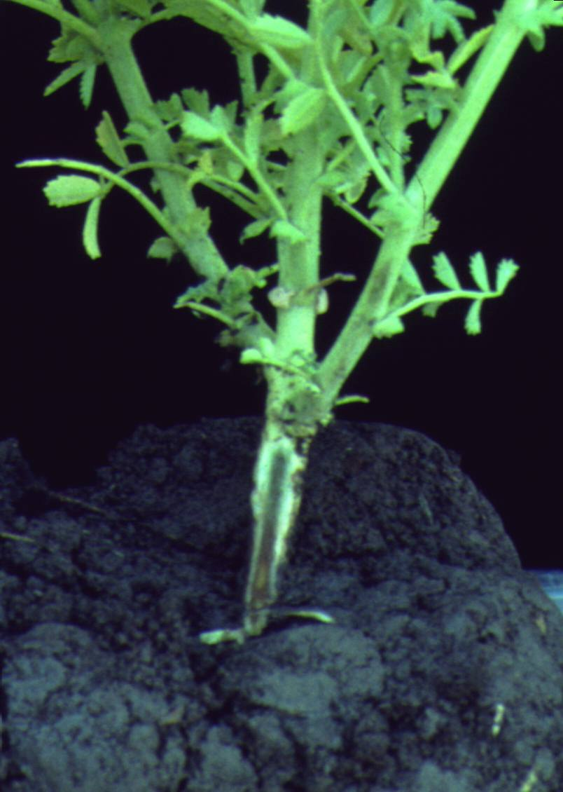
Fig. 1. Phloem browning symptom in chickpea infected with the luteovirus Soybean dwarf virus (SbDV). A shallow cut was made at the collar to reveal the discoloration. (Courtesy M. W. Schwinghamer)
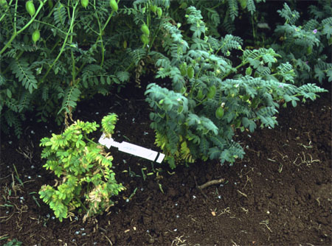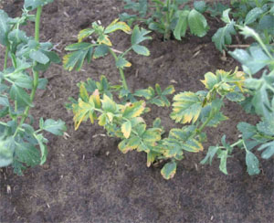
Fig. 2. A. Stunting and yellowing in a chickpea breeding line inoculated (left) with an isolate of Bean leafroll virus (BLRV, a luteovirus) compared with an uninfected plant (right). (Courtesy M. W. Schwinghamer). B. Stunting and yellowing of leaf margins in chickpea infected with Bean leafroll virus. (Courtesy R. C. Larsen)
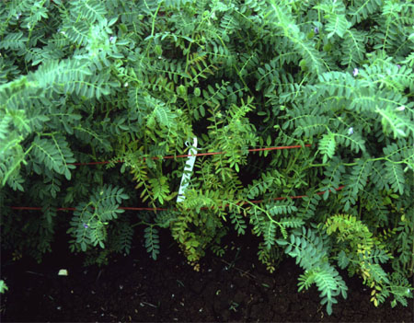
Fig. 3. Symptoms of yellowing, reddening of leaf margins, epinasty, leaf folding, and stunting in desi chickpea cv. Amethyst inoculated with an isolate of Bean leafroll virus (BLRV, a luteovirus). Two infected plants are surrounded by uninfected ones. (Courtesy M. W. Schwinghamer)
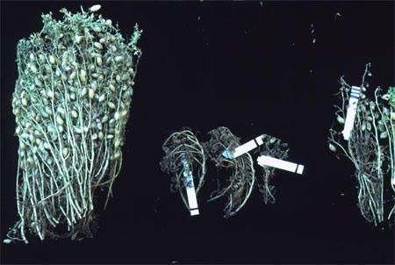
Fig. 4. Effects at harvest of earlier inoculation with Bean leafroll virus (BLRV, a luteovirus) on chickpea: uninfected/symptomless (left), and plants for which symptoms were first noted at 28 days post inoculation (center) and 55 days (right) post inoculation. (Courtesy M. W. Schwinghamer)

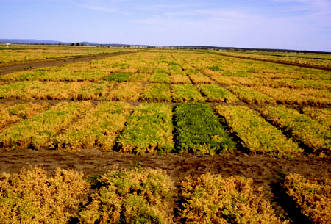
Fig. 5. Natural infection of chickpea at podding with the luteoviruses Soybean dwarf virus (SbDV) and Bean leafroll virus (BLRV). Plots of all genotypes except cv. Gully (3 near green plots) and cv. Garnet (3 distant green plots) died prematurely due to a higher incidence of infected plants. Gully and Garnet are resistant (tolremic) and do not mature later than other genotypes in the absence of viruses. (Courtesy M. W. Schwinghamer)

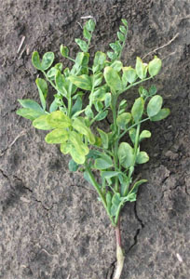
Fig. 6. Leaf mottling and yellowing in lentil caused by infection with Bean leafroll virus (BLRV, a luteovirus). (Courtesy R. C. Larsen)

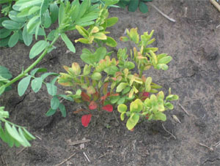
Fig. 7. Stunting, yellowing and reddening of leaves in lentil infected with Bean leafroll virus (BLRV, a luteovirus). (Courtesy R. C. Larsen)
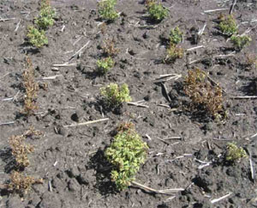
Fig. 8. Severe stunting and plant death of lentil field caused by infection with Bean leafroll virus (BLRV, a luteovirus). (Courtesy R. C. Larsen)

Mastreviruses including Chickpea chlorotic dwarf virus

Mastreviruses (genus Mastrevirus) are DNA-containing viruses that are transmitted by leafhoppers (Hemiptera: Cicadellidae). Most infect grasses, but a group of serologically interrelated species infects dicotyledonous plants including legumes. The first report of a dicot-infecting mastrevirus was in 1980 for Tobacco yellow dwarf virus (TYDV syn Bean summer death virus) in tobacco (Nicotiana tabacum) and bean (Phaseolus vulgaris) in Australia where it was found subsequently in chickpea. In 1993 a mastrevirus named Chickpea chlorotic dwarf virus (CpCDV) was identified in chickpea in India where it and several luteoviruses were shown to cause chickpea stunt disease in India. At least six additional mastreviruses from chickpea in North Africa, Central and West Asia, and Australia have been distinguished recently by DNA sequencing. Collectively they are common in chickpea but uncommon in lentil.

Symptoms
Chickpea. Symptoms of mastrevirus infection are like those for other phloem-limited viruses. In chickpea they include yellowing of foliage in Kabuli type cultivars, reddening in Desi types (Figs. 1 and 2), phloem browning at the collar, and stunting and premature death of plants. Phloem browning is not always evident for mastrevirus infection in Australia as it reportedly is for CpCDV in Asia and Africa.
Lentil. Stunting and yellowing have been recorded as symptoms.

Causal agents
Mastreviruses are members of the family Geminiviridae (geminiviruses), so called because the virus particles appear as twinned isometric particles under the electron microscope (from Latin gemini, ‘twins’). They have a monopartite genome of single-stranded circular DNA comprised of 2,600-2,800 nucleotides and encoding four proteins. Physico-chemical and biological properties have been determined for bean and tobacco isolates of TYDV from Australia and chickpea isolates of CpCDV from India and Syria. Complete DNA sequences have been determined for chickpea isolates from Sudan (Chickpea chlorotic dwarf Sudan virus), Pakistan (Chickpea chlorotic dwarf Pakistan virus and Bean yellow dwarf virus), and Australia (TYDV and three other unnamed species with less than 80% overall sequence identity to other mastreviruses). All dicot-infecting mastrevirus species identified so far react with CpCDV and/or TYDV antiserum. Consequently, CpCDV is best interpreted as “Mastrevirus sp.” in reports from North Africa, Western Asia, and Central Asia wherever identification was limited to serological tests with CpCDV antiserum.

Epidemiology
Mastreviruses infect many legume crop species naturally: chickpea and lentil in Western and Central Asia, faba bean in North Africa and West Asia, chickpea, faba bean, bean (Phaseolus vulgaris), pigeon pea (Cajanus cajan), and lablab (Dolichos lablab) in North Africa, and chickpea and bean in Australia. Other natural hosts include legume and non-legume wild plants in Sudan and subterranean clover (Trifolium subterraneum), Datura stramonium, coriander (Coriandrum sativum), tobacco and Brassicaceae weeds in Australia. Experimental inoculation with viruliferous leafhoppers indicates a wide range of dicotyledonous hosts, including families Chenopodiaceae and Solanaceae for CpCDV isolates and at least seven families of plants for TYDV.

The vectors of mastreviruses are leafhoppers of the family Cicadellidae, subfamily Deltocephalinae. These are small (2-7 mm), flying, cicada-like insects that feed on the phloem of a wide range of plants. For CpCDV, two species are vectors: Neolimnus aegyptiacus (Matsumura) in Sudan and Orosius albicinctus (Matsumura) (Fig. 3, top) in India and Syria. The vector of CpCDV in India was reported as Orosius orientalis (Matsumura) but this was probably a misidentification of O. albicinctus. O. orientalis (Fig. 3, bottom) is recorded from East Asia, Oceania, and Australia. It has been known in Australia as Orosius argentatus (Evans) which is reported to be a vector of TYDV and likely to be a vector of other mastreviruses. None of the above three species occurs in North America or South America. The geographical range of chickpea mastreviruses is consistent with that of the known vectors, and is mainly subtropical to tropical, extending sometimes to temperate regions.

Leafhoppers probably acquire mastreviruses from wild Fabaceae, Chenopodiaceae, or Solanaceae plants, crop legumes, or forage legumes. Acquisition requires minimum feeds of only a few minutes. After a latent period of several hours, mastreviruses persist and continue to be transmitted by leafhoppers for most of their life during feeds lasting several hours or longer. The insects alight and feed on individual plants, producing a scattered pattern of primary infection. On chickpea, they are not known to produce offspring or walk to adjacent plants. Leafhoppers of subfamily Deltocephalinae are also vectors of the phytoplasmas that cause phyllody, described in a separate section.

Mastreviruses often account for a substantial proportion of virus-like symptoms when overall infection incidence (including aphid-transmitted viruses) is low. It is unusual for mastreviruses to exceed 5% infection in chickpea crops in most countries. However, in Sudan CpCDV incidence reportedly reaches 60-70%, causing major losses. In India,seed yield losses for individual CpCDV-infected plants were estimated at 75-100% with crop losses nearly equivalent to infection incidence at medium plant densities (10-20 plants/m²). Little or no yield compensation by healthy plants occurred at these densities.

In lentil, mastreviruses are less common than in chickpea and do not appear to cause significant losses.

Management
There are no reliable management options for mastreviruses. Resistance due to decreased replication or in-plant virus movement of CpCDV has been identified among chickpea and wild Cicer genotypes in India. However, it is not clear whether this resistance is available or promoted for farmers, or whether it is effective across the geographic range of CpCDV. There is no evidence for control by insecticides. In Sudan, reduced incidence of CpCDV has been reported in one chickpea cultivar, in late-sown experimental plots, and frequently-irrigated experimental plots.

Selected references
Hammed, A. A., and Makkouk, K. M. 2002. Occurrence and management of Chickpea chlorotic dwarf virus in chickpea fields in northern Sudan. Phytopathol. Mediterr. 41:193-198.
Horn, N. M., Reddy, S. V., Roberts, I. M., and Reddy, D. V. R. 1993. Chickpea chlorotic dwarf virus, a new leafhopper-transmitted geminivirus of chickpea in India. Ann. Appl. Biol. 122:467-479.
Horn, N. M., Reddy, S. V., van den Huevel, J. F. J. M., and Reddy, D. V. R. 1996. Survey of chickpea (Cicer arietinum L.) for chickpea stunt disease and associated viruses in India and Pakistan. Plant Dis. 80:286-290.
Kumari, S. G., Makkouk, K. M., Attar, N., and Ghulam, W. 2004. First report of Chickpea chlorotic dwarf virus infecting spring chickpea in Syria. Plant Dis. 88:424
Kumari, S. G., Makkouk, K. M., and Attar, N. 2006. An improved antiserum for sensitive serologic detection of Chickpea chlorotic dwarf virus. J. Phytopathol. 154:129-133.
Makkouk, K. M., Kumari, S. G., Shahraeen, N., Fazlali, Y., Farzadfar, S., Ghotbi, T., and Mansouri, A. R. 2003. Identification of seasonal variation of viral diseases of chickpea and lentil in Iran. Z. Pflanzenkr. Pflanzenschutz 110:157-169.
Nahid, N., Amin, I., Mansoor, S., Rybicki, E. P., van der Walt, E., and Briddon, R. W. 2008. Two dicot-infecting mastreviruses (family Geminiviridae ) occur in Pakistan. Arch. Virol. 153:1441-1451.
Nault, L. R., and Ammar, E. D. 1989. Leafhopper and planthopper transmission of plant viruses. Annu. Rev. Entomol. 34:503-529
Stanley, J., Bisaro, D. M., Briddon, R. W., Brown, J. K., Fauquet, C. M., Harrison, B. D., Rybicki, E. P., and Stenger, D. C. 2005. Family Geminiviridae. Pages 301-326 in: Virus Taxonomy. Classification and Nomenclature of Viruses. Eighth Report of the International Committee on the Taxonomy of Viruses. C. M. Fauquet, M. A. Mayo, J. Maniloff, U. Desselberger, and L. A. Ball, eds. Elsevier Academic Press, San Diego, CA.
Thomas, J. E., and Bowyer, J. W. 1984. Tobacco yellow dwarf virus. CMI/CAB Descr. Pl. Viruses No. 278, 4pp.

(Prepared by M. W. Schwinghamer, J. E. Thomas, and M. J. Fletcher)
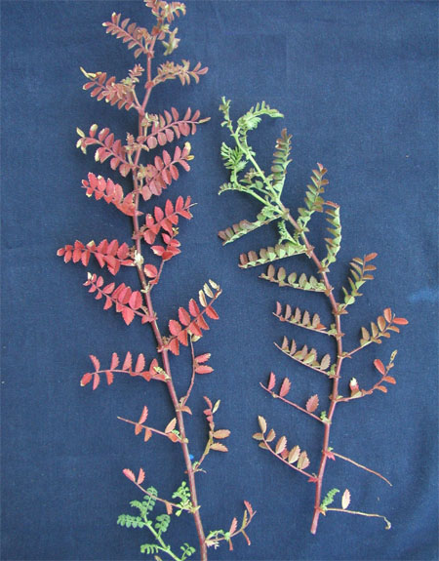
Fig. 1. Reddening in a Desi chickpea variety caused by an unnamed Australian mastrevirus. (Courtesy J. E. Thomas).
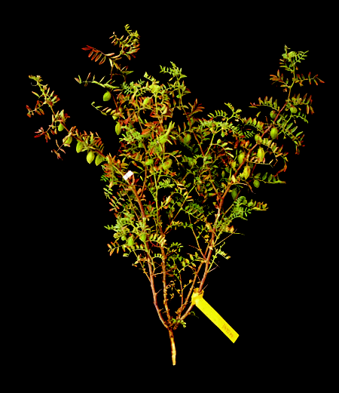
Fig. 2. Symptoms of late infection with an unnamed Australian mastrevirus in a desi chickpea cultivar. (Courtesy M. W. Schwinghamer)
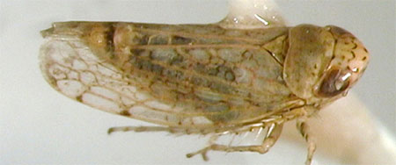
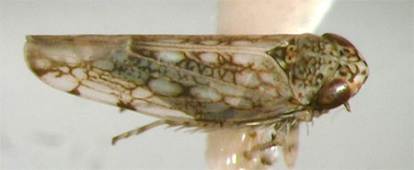
Fig. 3. Leafhoppers that are vectors of mastreviruses and phytoplasmas: Orosius albicinctus (top), a vector of Chickpea chlorotic dwarf virus, and Orosius orientalis (bottom), vector of Tobacco yellow dwarf virus (TYDV), actual length 2.0 to 2.9 mm. (Courtesy M. J. Fletcher)
Pea enation mosaic virus
Pea enation mosaic virus (PEMV) is one of the most important and destructive virus diseases of lentil in temperate zones of the world. It has been reported in the Pacific Northwest states and California in the U.S, Canada, Europe, West Asia, North Africa, Egypt, and Iran but is not known to occur in New Zealand and Australia. Severe epidemics occurred in the Pacific Northwest region in 1983, 1990, 1996 and 2005. The host range of PEMV is primarily limited to members of the Fabaceae including chickpea, lentil, pea (Pisum sativum), faba bean (Vicia faba), common vetch (Vicia sativa), and crimson clover (Trifolium incarnatum) although it can also be propagated on non-legume hosts such as Gomphrena globosa, Chenopodium spp. and Nicotiana spp.

Symptoms
Chickpea. Chickpea plants infected with PEMV typically are severely stunted showing twisted and malformed leaves (Fig. 1). Pods also are misshapen, poorly filled and often show outgrowths that appear as bumps on the surface (Fig. 2). Plants infected at an early growth stage may die. Infected plants rarely yield seed of any quality.
Lentil. Infected lentil plants typically show a reduction in growth. Plants infected at an early growth stage may die, especially if co-infected with another virus such as Bean leafroll virus. Leaves frequently exhibit leaf rolling and mottling, severely malformed leaves and tip growth (Fig. 3), vein clearing and translucent flecks. Pods are also malformed or misshapen. The most characteristic symptom of PEMV infection is the development of enations (hyperplastic outgrowths) on leaf and pod surfaces. While this is common in pea, it rarely occurs on lentil or chickpea.

Causal Agent
The disease is caused by a symbiotic co-infection of two single-stranded RNA viruses: PEMV-1 (genus Enamovirus, family Luteoviridae) and PEMV-2 (genus Umbravirus, not assigned to a family). The monopartite ssRNA genome of PEMV-1 is 5.7 kb, while that of PEMV-2 is 4.35 kb. A third small RNA of 717 nucleotides has been identified as a satellite RNA whose replication is controlled by PEMV-2. The genome of PEMV-1 contributes the encapsidating coat protein gene required for aphid transmissibility and the PEMV-2 genome enables systemic movement in the plant. The genomes are encapsidated separately in icosohedral virion particles 25 and 28 nm in diameter with three structural proteins of 54 kDa, 21 kDa, and 17.5 kDa. The two particle types are transmitted together, naturally by aphids or experimentally by mechanical inoculation.

Epidemiology
PEMV is transmitted in a persistent manner by aphids, most commonly the pea aphid (Acythosyphon pisum), cowpea aphid (Aphis craccivora), green peach aphid (Myzus persicae), potato aphid (Macrosiphum euphorbiae), and foxglove aphid (Aulacorthum solani). The pea aphid can acquire the virus after a minimum of 15 min and transmit after a latent period of 10-12 hr. Transmission is very efficient, as susceptible hosts can become infected after a 1 min feeding period. Transmission efficiency is enhanced with longer acquisition and inoculation access periods. The virus is circulative in aphids but not propagative and not tranmitted transovarially or parthenogenically. Only one strain of the virus has been reported. PEMV is not transmitted by seed in lentil or chickpea.

Management
No resistant varieties are known for chickpea or lentil although lentil Plant Introduction (PI) accessions PI 472547 and PI 472609 have been identified with tolerance to PEMV. Aphids can be controlled in lentils by carefully timed applications of appropriate insecticides to reduce colonization and resulting population build-up. Due to their transient feeding behavior on chickpea plants, aphids are rarely seen on these plants in the field even though infection may be widespread. Control of aphids is best done by eliminating them in other nearby crops such as pea or faba bean where unchecked, populations are subject to increase. Although alfalfa is not a known host of PEMV, avoid planting lentils near these fields, as alfalfa also is one of the primary host plants of the pea aphid.

Selected references

Aydin, H., Muehlbauer, F. J., and Kaiser, W. J. 1987. Pea enation mosaic virus resistance in lentil (Lens culinaris). Plant Dis. 71: 635-638.
Demler, S. A., and De Zoeten, G. A. 1989. Characterization of a satellite RNA associated with Pea enation mosaic virus. J Gen Virol. 70:1075-1084.
Demler, S. A., and de Zoeten, G. A. 1991. The nucleotide sequence and luteovirus-like nature of RNA1 of an aphid non-transmissible strain of Pea enation mosaic virus. J. Gen. Virol. 72:1819-1834.
Demler, S. A., Rucker, D. G., and de Zoeten, G. A. 1993. The chimeric nature of the genome of Pea enation mosaic virus: the independent replication of RNA2. J. Gen. Virol. 74, 1-14.
Edwardson, J. R., and Christie, R. G.. 1986. Viruses infecting forage legumes. Agricultural Experiment Station, Institute of Food and Agricultural Sciences, University of Florida, Gainesville. 3 volumes, 742 pp.
Kaiser, W. J. 1987. Disease problems on dry peas, lentils, chickpea and faba beans. Pages 157-174. In: Grain Legumes as Alternative Crops: A Symposium. Centre for Alternative Crops and Products, University of Minnesota.
Klein, R. E., Larsen, R. C., and Kaiser, W. J. 1991. Virus epidemic of grain legumes in eastern Washington. Plant Dis. 75:1186.
Larsen, R. C., Kaiser, W. J., and Klein, R. E. 1996. Alfalfa, a non-host of pea enation mosaic virus in Washington State. Can. J. Plant Sci. 76: 521-524
Makkouk, K. M., Kumari S. G., and Bayaa, B. 1999. First report of Pea enation mosaic virus affecting lentil (Lens culinaris Medik.) in Syria. Plant Dis. 83:303.
Makkouk, K. M., and Kumari, S. G. 2001. First record of Pea enation mosaic virus naturally infecting chickpea and grasspea crops in Syria. Plant Dis. 85:1032.
(Prepared by R. C. Larsen and M. W. Schwinghamer)

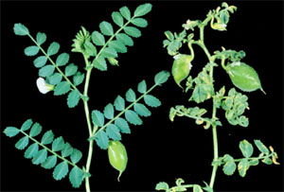
Fig. 1. Prominent leaf malformation and mosaic caused by Pea enation mosaic virus (PEMV) on chickpea. Healthy plant is on the left. (Courtesy W. J. Kaiser)

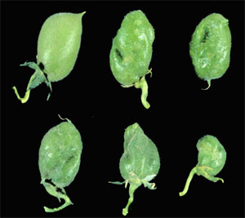
Fig. 2. Malformed seed pods from chickpea infected with Pea enation mosaic virus (PEMV). Healthy pod is at upper left. (Courtesy W. J. Kaiser)

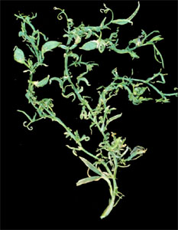
Fig. 3. Severe twisting and malformation of leaves stems and pods in lentil infected with Pea enation mosaic virus (PEMV). (Courtesy W. J. Kaiser)
Pea seed-borne mosaic virus
Pea seed-borne mosaic virus (PSbMV) was first identified in Europe in 1966 and then in Japan in 1967. It was subsequently discovered in the U.S in 1969 and in New Zealand in 1980. PSbMV is now found throughout the world. The virus naturally infects lentil, chickpea, pea, faba bean, and other legumes, but is only a minor problem in chickpea. PSbMV continues to be a highly significant disease in many pulse crops because of potentially high rates of transmission by seed and the ease of international dissemination of breeding lines and cultivars. Losses in these crops can be severe under conditions of high infection levels.

Symptoms
Chickpea. Symptoms resemble those of other Potyvirus species including BYMV. Severity varies with isolate and stage plants are infected, but symptoms can include very narrow (filiform) leaflets (Fig. 1) that may be twisted or turned down, indistinct mosaic, mottling, or necrotic lesions on leaflets, necrosis of shoot tips, stunting of plants, proliferation of stems, and abortion of podding.
Lentil. Symptoms may vary in lentil due to cultivar differences, virus strain and environmental effects. Leaves are narrowed, reduced in size with mosaic and mottling, and chlorosis or necrosis of shoot tips may occur. A downward leafroll is common and plants are usually stunted (Fig. 2). Seed pods may be abnormal in shape and size with reduced fewer seed. Necrotic line patterns that are common on infected pea and faba bean seed are rare on seed of lentil.

Causal Agent
PSbMV is a member of the family Potyviridae, Genus Potyvirus and consists of flexuous rod-shaped particles with a modal length of ca. 770 nm containing a monopartite genome of single-stranded RNA. The genome size is 9924 nucleotides and the coat protein has a molecular mass of 34 kDa. PSbMV has a distant serological relatedness to Bean yellow mosaic virus. Four pathotypes designated P-1, P-2 (also called lentil strain), P-3, and P-4 have been distinguished by susceptibilities of differential lines of pea and differences in sequence in two coding regions of the RNA. All isolates tested so far on lentil and chickpea, including pathotypes P-1, P-2, and P-3 have been found to infect both hosts.

Epidemiology
The primary source of inoculum in lentil fields is infected seed. Once present in the field, the mechanism of plant to plant spread is by aphids which transmit the virus in a non-persistent manner. PSbMV is also mechanically transmissible. Other significant pulse crops that may serve as inoculum sources for the virus include pea, faba bean, and vetch. At least 22 different aphid species are known to transmit PSbMV but the pea aphid (Acyrthosiphon pisum), cowpea aphid (Aphis craccivora), green peach aphid (Myzus persicae), bean aphid (Aphis fabae), and the foxglove aphid (Aulacorthum solani) are probably the most common vectors. Seed transmission up to 44% has been reported in lentil seed lots. Seed production is severely reduced in infected lentil, with losses over 77% when plants are infected at the pre-flower stage, and germination of infected seed can be reduced by nearly 50%. Seed transmission in chickpea is generally less than 1% and secondary spread is minor. A major contributing factor to the persistence of PSbMV is the continuous use of contaminated seed collected at the end of a season and then used in subsequent plantings.

Management
Because infected seed is the primary source of PSbMV, the use of certified virus-free seed is the most effective method for control of the virus. Chemical control of the aphid vector is generally ineffective because of the transient nature and non-persistent manner by which the virus is transmitted,. However, pesticide applications can reduce secondary spread of the virus in lentil crops where large aphid vector populations have become established. Avoid planting near established fields where known infection sources may exist. No lentil cultivars have been developed with complete resistance to PSbMV, although some plant introduction (PI) accessions that include PI 212610, PI 251786, PI 207745, and PI 368648 have been identified that were immune to the virus. The cultivars Crimson, Palouse and Red Chief, and Ill 6198 are reported to be tolerant to PSbMV. Resistance to PSbMV in lentil is controlled by a single recessive gene for which the symbol sbv has been proposed. No chickpea cultivars have been developed with resistance to PSbMV.

Selected references
Alconero, R., Provvidenti, R., and Gonsalves, D. 1986. Three pea seedborne mosaic virus pathotypes from pea and lentil germ plasm. Plant Dis. 70:783-786.
Haddad, N. I., Muehlbauer, F. J., and Hampton, R. O. 1978. Inheritance of resistance to pea seed-borne mosaic virus in lentils. Crop Sci. 18:613-615.
Hampton, R. O. 1982. Incidence of the lentil strain of pea seedborne mosaic virus as a contaminant of Lens culinaris germplasm. Phytopathology. 72:695-698.
Hampton, R. O., and Muehlbauer, F. J. 1977. Seed transmission of the pea seedborne mosaic virus in lentils. Plant Dis. Rep. 61:235-238.
Iqbal, S. M., Tahir, M. H. N., Asghar A., and Anjum, M. S. 2005. Evaluation of lentil genotypes for resistance to Pea seed-borne mosaic virus. Int. J. Agric. Res. Gov. Ecol. 7:148-149.
Johansen, E., Rasmussen, O. F., Heide, M., and Borkhardt, B. 1991. The complete nucleotide sequence of Pea seed-borne mosaic virus RNA. J. Gen. Virol. 72:2625-32.
Hjulsager, C. K., Lund, O. S., and Johansen, I. E. 2002. A new pathotype of Pea seedborne mosaic virus explained by properties of the P3-6k1- and viral genome-linked protein (VPg)-coding regions. Mol. Plant-Microbe Interact.15:169-171.
Johansen, I. E., Keller, K. E., Dougherty, W. G., and Hampton, R. O. 1996. Biological and molecular properties of a pathotype P-1 and a pathotype P-4 isolate of Pea seed-borne mosaic virus. J. Gen. Virol. 77:1329-1333.
Latham, L.J., and Jones, R. A. C.. 2001. Incidence of virus infection in experimental plots, commercial crops and seed stocks of cool season crop legumes. Aust. J. Agric. Res. 52: 397-41.
Makkouk, K. M., Kumari, S. G., and Bos, L. 1993. Pea seed-borne mosaic virus: occurrence in faba bean (Vicia faba) and lentil (Lens culinaris) in West Asia and North Africa, and further information on host range, transmission characteristics, and purification. Eur. J. Plant Pathol. 99:115-124.
Makkouk, K. M., Bashir, M., Jones, R. A. C., and Kumari, S. G. 2001. Survey for viruses in lentil and chickpea crops in Pakistan. Z. Pflanzenkr. Pflanzenschutz 108:258-268.
(Prepared by R. C. Larsen and M. W. Schwinghamer)

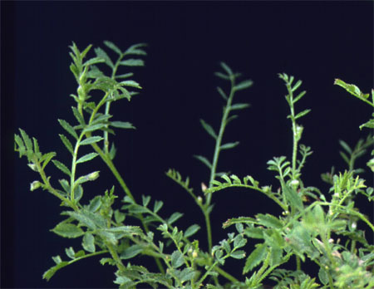
Fig. 1. Filiform leaves (with small, narrow leaflets) in chickpea infected with Pea seed-borne mosaic virus (PSbMV). (Courtesy M. W. Schwinghamer).

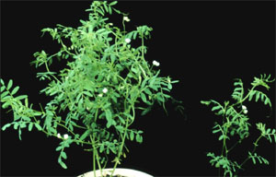
Fig. 2. Stunting and downward cupping of leaflets of lentil plant on the right infected with Pea seed-borne mosaic virus (PSbMV). (Courtesy W. J. Kaiser)

Pea streak virus

Pea streak virus (PeSV) was first reported causing a streak disease of pea (Pisum sativum L.) in 1938 and 1940 in Virginia and Wisconsin, respectively. It occurs in the Pacific Northwest region of the U.S., Canada, and Eurasia and New Zealand. The virus was first detected in chickpea in the Palouse region of eastern Washington in 1979. PeSV has since been involved in severe epidemics in 1983, 1990, 1996, and 2005 in lentil and chickpea crops in the Pacific Northwest states. PeSV is also known by several synonyms such as Alfalfa latent virus, Wisconsin pea streak and pea streak New Zealand virus.

Symptoms
Chickpea. Typical symptoms in chickpea caused by PeSV include yellowing of the foliage, stunting, necrosis of leaflets, wilting of terminal shoots and phloem discoloration (Fig. 1). Infected seedlings wilt and die prior to pod formation, and seed in infected mature plants are small, discolored and misshapened. Wilted chickpea plants infected with PeSV resemble symptoms caused by common root rotting fungi (Fig. 2). PeSV has not been reported to be seed transmitted, but germination is poor with seed collected from infected plants.
Lentil. Infection in lentil results in wilting of the terminal shoots. Vascular discoloration may be observed, a condition that contributes to plant death, especially at the seedling stage. Infected plants exhibit stunting, yellowing of leaflets, and wilting. Pods that do form usually are poorly filled, seed shape is misshapen, and yield losses can be significant.

Causal Agent
PeSV is a member of genus Carlavirus in the family Flexiviridae consisting of flexuous rod-shaped particles 630 nm in length. The monopartite viral genome consists of single-stranded RNA of approximately 8100 nucleotides. The 294 amino acid coat protein has a predicted molecular size of 33 kDa although the size estimate on polyacrylamide gels is 28 kDa. The genome is comprised of five open reading frames compared to all other known carlaviruses which have six. PeSV is serologically indistinguishable from Alfalfa latent virus although it has long been contended to be a distinct virus. A coat protein amino acid comparison of the two viruses resulted in 95% identity which strongly suggests that Alfalfa latent virus is only a strain of PeSV.

Epidemiology
PeSV is transmitted in North America primarily by the pea aphid (Acyrthosiphon pisum) in a non-persistent manner and transmission is inefficient, at least under experimental conditions. In experiments conducted on pea (Pisum sativum), only about 3% of test plants became infected after a 24 hr acquisition feeding period and a 24 hr inoculation period. The virus is easily transmitted mechanically to other legume hosts including faba bean (Vicia faba), and fenugreek (Trigonella foenum-graecum). It is symptomless in alfalfa (Medicago sativum), the most important reservoir host from which the pea aphid acquires the virus in the spring and transmits it to lentil and chickpea crops. PeSV is less prevalent and more sporadic in chickpea fields because of the transient behavior of aphids on that host. Consistent with other carlaviruses, PeSV is not seed or pollen transmitted.

Management
No known resistance to PeSV is available in current chickpea varieties. Management options include avoiding proximity to crops such as pea, faba bean and alfalfa which are hosts for both the virus and aphids. As with other viruses transmitted in a non-persistent manner, control of the virus by insecticide application is not effective.

Selected references

Hagedorn, D. J., and Walker, J. C. 1949. Wisconsin pea streak. Phytopathology, 39:837–847.
Hampton, R. O. 1983. Pea streak virus. In: Brunt, A.A., Crabtree, K., Dallwitz, M.J., Gibbs, A.J., Watson, L. and Zurcher, E.J. (eds.) (1996 onwards). `Plant Viruses Online: Descriptions and Lists from the VIDE Database. Version: 20th August 1996.
Kaiser, W. J., Klein, R. E., Larsen, R. C., and Wyatt, S. D. 1993. Chickpea wilt incited by pea streak carlavirus. Plant Dis. 77:922-926.
Kaiser, W. J. 1987. Disease problems on dry peas, lentils, chickpea and faba beans. Pages 157-174. In: Grain Legumes as Alternative Crops: A Symposium. Centre for Alternative Crops and Products, University of Minnesota, USA.
Virus Taxonomy. Classification and Nomenclature of Viruses. Eighth Report of the International Committee on the Taxonomy of Viruses. C. M. Fauquet, M. A. Mayo, J. Maniloff, U. Desselberger, and L. A. Ball, eds. Elsevier Academic Press, San Diego, CA.
(Prepared by R. C. Larsen)

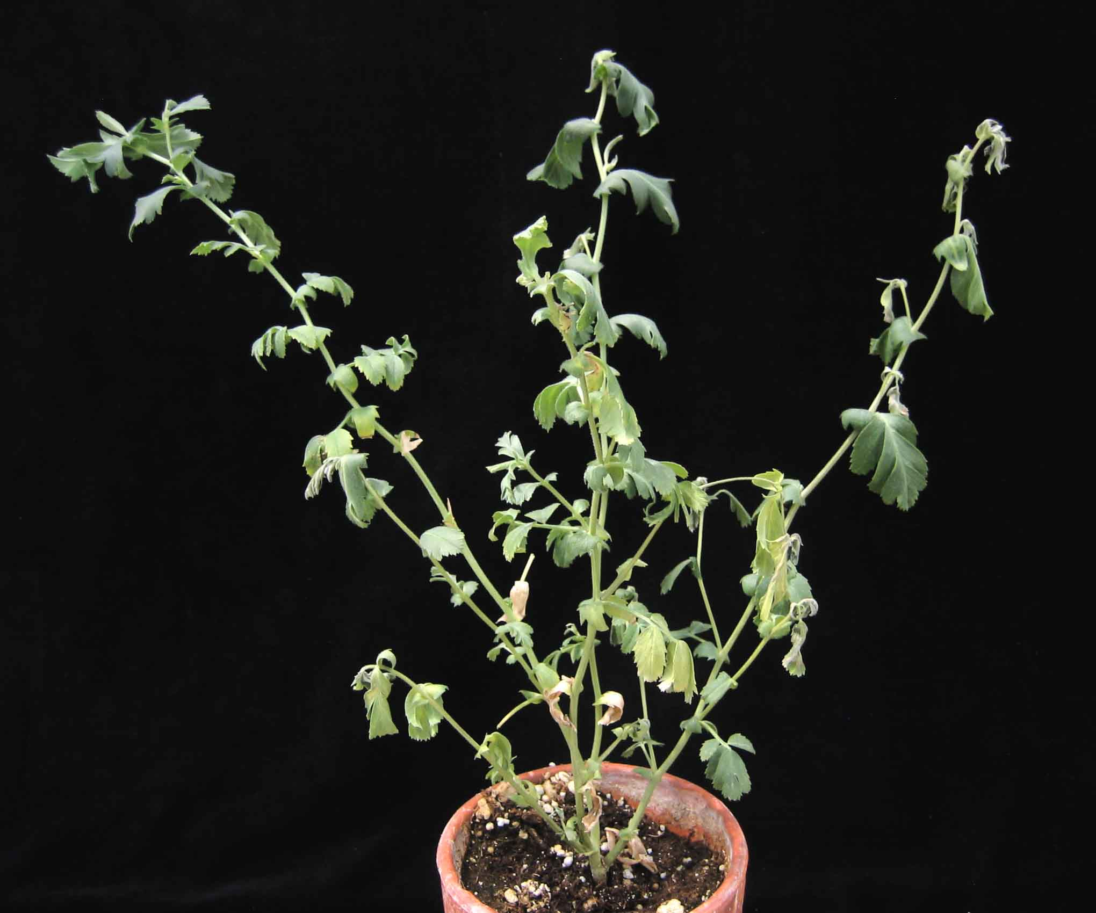
Fig 1. Foliar wilt symptoms on chickpea caused by Pea streak virus (PeSV). (Courtesy R. C. Larsen)

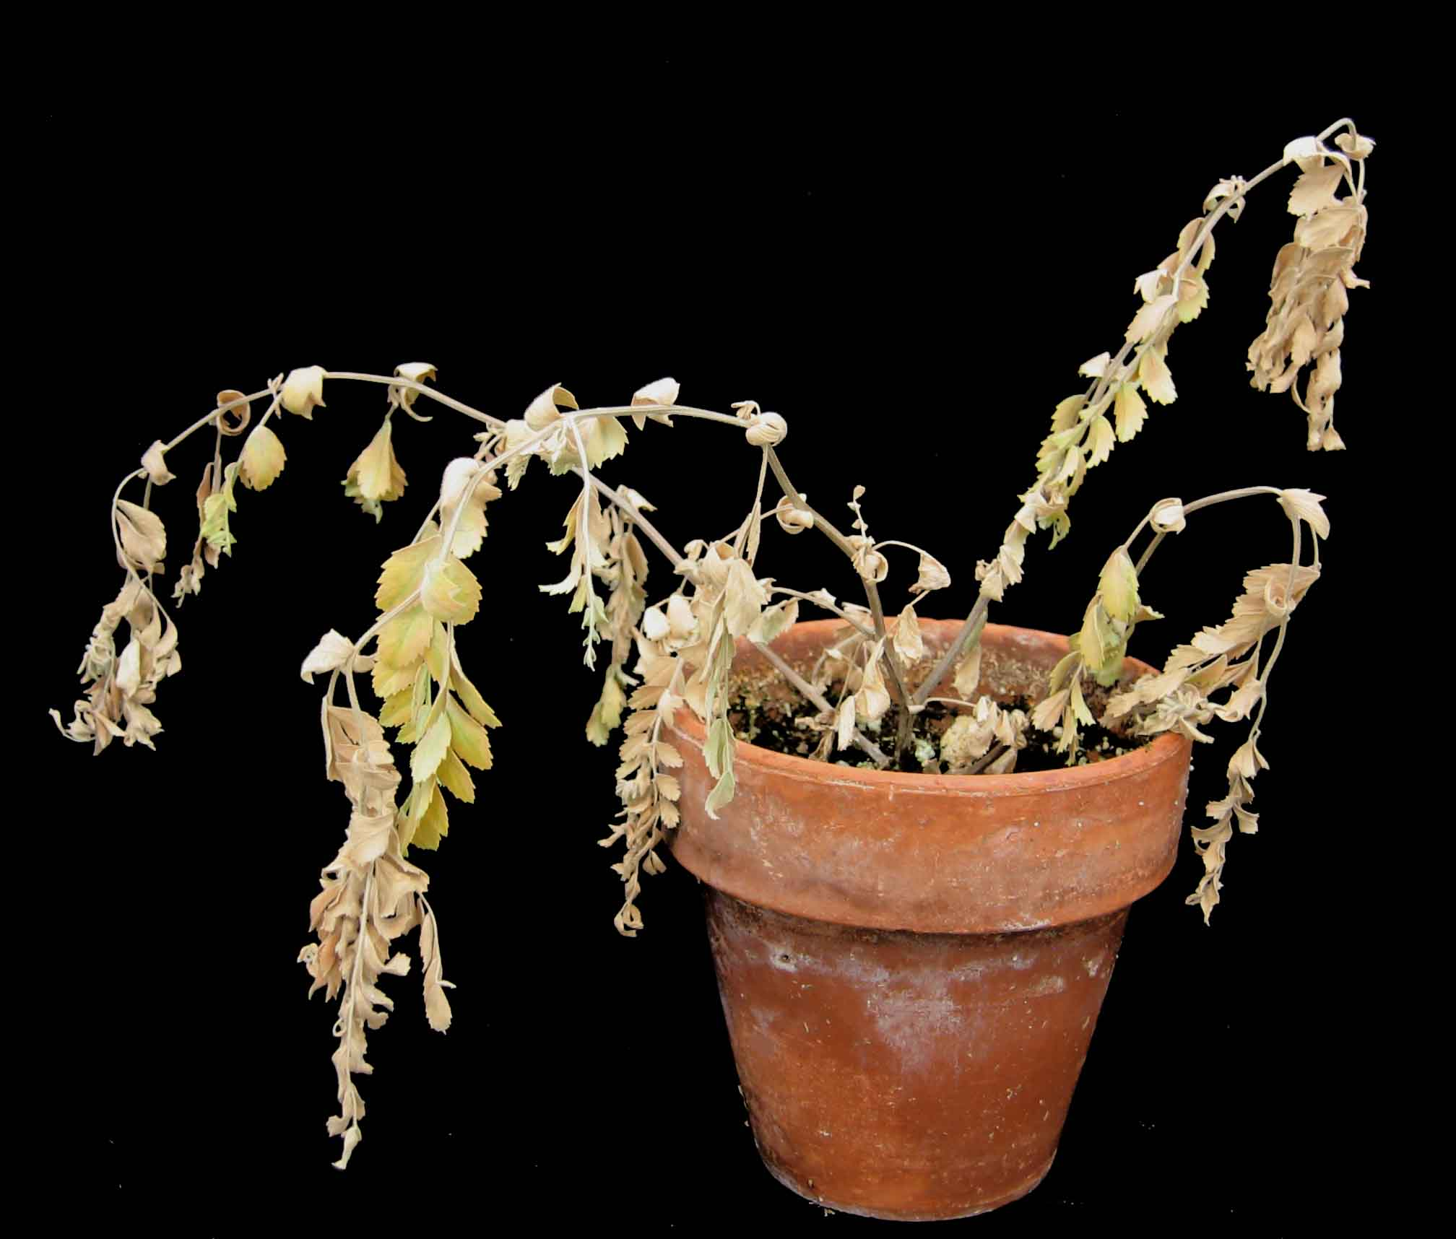
Fig 2. Advanced symptoms in chickpea infected with Pea streak virus (PeSV). (Courtesy R. C. Larsen)

At A Glance: Viruses reported to infect chickpea and/or lentil naturally*

Virus family or other group/ genus | Virus species** | Acronym | Synonyms applied to chickpea and lentil | Country | Reference | Transmission | Cross reactions***
Family Bromoviridae/
Alfamovirus | Alfalfa mosaic virus | AMV |  | Australia  Ethiopia  India  Iran  Jordan  New Zealand  Pakistan  Syria  USA | Jones and Coutts 1996  Bekele et al. 2005  Makkouk et al. 2001  Kaiser and Danesh 1971; Makkouk et al. 2003b  Al-Mabrouk and Mansour. 2000  Fletcher 1993  Makkouk et al. 2001  Mouhanna et al 1994  Bosque-Perez and Buddenhagen 1990, Kaiser 1981 | Aphids, seed | Nr
Bromovirus | Broad bean mottle virus | BBMV |  | Ethiopia  Morocco | Bekele et al. 2005  Fortass and Diallo 1993 | Beetles,  seed | Nr
Cucumovirus | Cucumber mosaic virus | CMV | Chickpea leaf reduction virus | Australia  Ethiopia  India  Iran  Morocco  New Zealand  Pakistan  Spain  Syria  USA | Jones and Coutts 1996  Tadesse et al. 1999  Dhingra et al 1979; Chalam et al. 1986  Rangaraju and Chenulu 1981  Kaiser and Danesh 1971; Makkouk et al. 2003b;  Kaiser 1973  El Maataoui and Ameziane-El Hassani 1984  Fletcher 1993  Bashir and Malik 1993; Bahsir et al. 1994;  Makkouk et al. 2001  Carazo et al. 1993  Mouhanna et al 1994  Bosque-Perez and Buddenhagen 1990 | Aphids, seed | Nr
Ilarvirus | Tobacco streak virus | TSV |  | Australia  USA | Sharman et al. (unpublished)  Kaiser et al. 1991 | Thrips, pollen, seed | Nr
Family Bunyaviridae/
Tospovirus | Tomato spotted wilt virus | TSWV |  | Australia  Brazil | Thomas et al. 2004  Boiteux et al. 1995 | Thrips | Nr
Family Comoviridae/
Comovirus | Broad bean stain virus | BBSV |  | Ethiopia  Europe  Iran  Jordan  Pakistan  Syria  Turkey | Tadesse et al 1999  Bos et al. 1988  Makkouk et al. 2003b  Al-Mabrouk and Mansour 2000  Bashir et al. 2005  Mouhanna et al. 1994  Bayaa et a. 1998 | Weevils, seed | Nr
Fabavirus | Broad bean wilt virus | BBWV | Broad bean wilt virus 1  Broad bean wilt virus 2 | Ethiopia  Syria | Tadesse et al. 1999  Makkouk et al. 1992 | Aphids | Nr
Nepovirus | Tobacco ringspot virus | TRSV |  | India | Dhingra 1981 | Unknown | Nr
Family Flexiviridae/
Carlavirus | Pea streak virus | PeSV |  | USA | Kaiser et al. 1993 | Aphids | Nr
 | Red clover vein mosaic virus | RCVMV |  | USA | Larsen et al. 1996 | Aphids | Nr
Family Geminiviridae/
Mastrevirus | Bean yellow dwarf virus | BeYDV |  | Pakistan | Nahid et al. 2008 | Leaf-hoppers? | TYDV, CpCDV
 | Chickpea chlorotic dwarf virus | CpCDV | Chickpea chlorotic dwarf Sudan virus  Chickpea chlorotic dwarf Pakistan virus | India  Iran  Iraq  Pakistan  Sudan  Syria | Horn et al. 1993  Makkouk et al. 2003b  El-Muadhidi et al. 2001  Horn et al. 1996; Nahid et al. 2008  Hamed and Makkouk 2002  Kumari et al. 2004 | Leaf-hoppers | TYDV
 | Mastrevirus spp.  (four distinct unnamed species) |  |  | Australia | Thomas et al. (unpublished) | Leaf-hoppers? | CpCDV, TYDV
 | Tobacco yellow dwarf virus | TYDV | Bean summer death virus | Australia | Thomas et al.(unpublished) | Leaf-hoppers
Family Luteoviridae (luteoviruses)/
Luteovirus | Bean leafroll virus | BLRV | Pea leafroll virus  Legume yellows virus | Australia  Bangladesh  Ethiopia  Iran  India  Pakistan  Spain  Syria  Turkey  USA | Schwinghamer et al. 1999  Bakr 1993  Tadesse et al. 1999  Kaiser and Danesh 1971; Makkouk et al. 2003b  El-Muadhidi et al. 2001  Horn et al. 1996  Carazo et al. 1993  Kumari et al. 2004  Horn and Van den Heuvel 1994  Duffus 1979; Bosque-Perez and Buddenhagen 1990 | Aphids | Nr
 | Soybean dwarf virus | SbDV | Subterranean clover red leaf virus | Australia  Ethiopia  Iran  New Zealand  Syria  USA | Schwinghamer et al. 1999  Tadesse et al.1999  Makkouk et al. 2003b  Fletcher 1993  Makkouk et al. 1997  Bosque-Perez and Buddenhagen 1990 | Aphids | BLRV, BWYV
Polerovirus
(including likely poleroviruses)
 | A24 isolate |  | Chickpea stunt disease associated virus? | India | Reddy and Kumar 2004 | Aphids | BWYV
 | Beet western yellows virus  (one to four serologically related species, not distinguished) | BWYV | Includes  Turnip yellows virus  May also include:  Beet chlorosis virus  Beet mild yellowing virus  Beet western yellows virus | Australia  Ethiopia  Iran  Morocco  New Zealand  Pakistan  Spain  Sudan  Syria  Turkey  USA | Schwinghamer et al. 2003  Tadesse et al. 1999  Makkouk et al. 2003b  Fortass et al. 1997  Fletcher 1993  Makkouk et al. 2001  Carazo et al. 1993  Hamed and Makkouk 2002  Kumari et al. 2004; Makkouk et al. 1992  Horn et al. 1995; Bayaa et al. 1998  Duffus 1979 ; Bosque-Perez and Buddenhagen 1990 | Aphids | BLRV
 | Chickpea chlorotic stunt virus | CpCSV |  | Ethiopia  Syria | Abraham et al. 2006  Kumari et al. 2007 | Aphids | BWYV
 | Chickpea luteovirus | CpLV |  | India  Pakistan  Syria  Turkey | Horn et al. 1996  Horn et al. 1996  Horn et al. 1995  Horn et al. 1995 | Aphids? | Nr
 | Chickpea stunt disease-associated virus | CpSDaV | A24 isolate? | India | Naidu et al. 1997 | Aphids | BWYV  CpLV
 | Cucurbit aphid-borne yellows virus | CABYV |  | Pakistan | Makkouk et al. 2001 | Aphids | Nr
 | Lentil stunt virus | LStV |  | Ethiopia | Abraham et al. 2008 | Aphids | Nr
 | Potato leafroll virus | PLRV |  | India  Iraq  Syria | Horn and Van den Heuvel 1994  El-Muadhidi et al. 2001  Makkouk et al. 1992 | Aphids | Nr
Unassigned | Chickpea yellows virus | ChYV |  | Sudan | Abraham et al. 2008 | Aphids | Nr
Family Nanoviridae
Nanovirus | Faba bean necrotic yellows | FBNYV |  | Ethiopia  Iran  Jordan  Lebanon  Pakistan  Spain  Sudan  Syria  Turkey | Tadesse et al. 1999 ; Bekele et al. 2005  Makkouk et al. 2003b  Al-Nsour et al. 1998  Horn et al. 1995  Makkouk et al. 2001  Ortiz et al. 2006  Makkouk et al. 2003a  Kumari et a. 2004  Horn et al. 1995 | Aphids | Nr
Family Potyviridae/
Potyvirus | Bean yellow mosaic virus | BYMV |  | Australia  Bangladesh  Egypt  Ethiopia  India  Iran  Iraq  Jordan  New Zealand  Syria  Turkey | Jones and Coutts 1996; McKirdy et al. 2000  Bakr 1993  Russo et al. 1981  Tadese et al. 1999; Bekele et al. 2005  Chalam et al. 1985  Kaiser and Danesh 1971; Makkouk et al. 2003b  El-Muadhidi et al. 2001  Al-Mabrouk and Mansour 2000  Fletcher 1993  Makkouk et al. 1992  Bayaa et al 1998 | Aphids | Nr
 | Chickpea bushy dwarf virus | CpBDV |  | India | Anjaiah et al. 1989 | Aphids? | ABMV, PeMoV, SMV
 | Chickpea distortion mosaic | CpDMV |  | India | Mali et al. 1988 | Aphids | BYMV, BCMV, and four other potyviruses
 | Chickpea filiform virus | CpFV | Bean yellow mosaic virus? | USA | Kaiser et al. 1988 | Aphids | BYMV, BlCMV, CAMV
 | Chickpea yellow mosaic virus | CpYMV |  | Bolivia | Larsen et al. 2003 | Aphids? | Nr
 | Lettuce mosaic virus | LMV |  | USA | Bosque-Perez and Buddenhagen 1990 | Aphids | Nr
 | Pea seed-borne mosaic virus | PSbMV |  | Algeria  Australia  Egypt  Ethiopia  Iran  Jordan  Morocco  New Zealand  Pakistan  Syria  Tunisia  Turkey  USA | Makkouk et 1993  Latham and Jones 2001  Russo et al. 1981; Makkouk et 1993  Tadesse et al. 1999 ; Bekele et al 2005  Makkouk et al. 2003b  Al-Mabrouk and Mansour. 2000  Makkouk et al. 1993  Fletcher 1993  Makkouk et al. 2001  Makkouk et al 1992; Mouhanna et al 1994  Makkouk et 1993  Bayaa et al 1998  Hampton and Muehlbauer, 1977; Hampton 1982 | Aphids, seed | Nr
 | Turnip mosaic virus | TuMV |  | Australia | Schwinghamer et al. 2007 | Aphids | Nr
Family Rhabdoviridae/
Cytorhabdovirus | Lettuce necrotic yellows virus | LNYV |  | Australia | Behncken 1983 | Aphids | Nr
Symbiotic infection/
Enamovirus (Luteoviridae)  +  Umbravirus  (Unassigned to family) | Pea enation mosaic virus | PEMV | Pea enation mosaic virus-1  +  Pea enation mosaic virus-2 | Ethiopia  Iran  Italy  Syria  USA | Tadesse et al. 1999  Makkouk et al. 2003b  Vovlas and Rana 1972  Kumari et al 2001  Larsen et al. 1996a ; Klein et al 1991 | Aphids | Nr

*AMV, BBMV, BLRV, BWYV, BYMV, BBWV, CABYV, CMV, CpCDV, CpLV, FBNYV, PEMV, PLRV, PSbMV, SbDV have been recorded naturally infecting chickpea and lentil. BBSV and LStV have been recorded only in lentil. All other species and isolates in the Table have been recorded only in chickpea.

**Species recognized by the International Committee on Taxonomy of Viruses (ICTV) are shown in italics; isolate and proposed species names are not italicized. Many identifications, especially older ones, were based on limited methodologies which probably distinguished genus but not necessarily species.

***Heterologous antisera that cross react with lentil or chickpea isolates. Nr denotes ‘none reported’. Virus species not listed in columns 1 and 2 are: ABMV, Azuki bean mosaic virus = Bean common mosaic virus; BlCMV, Blackeye cowpea mosaic virus = Bean common mosaic virus; CABMV, Cowpea aphid-borne mosaic virus; PeMoV, Peanut mottle virus; SMV, Soybean mosaic virus = Watermelon mosaic virus.

References
Abraham, A. D., Menzel, W., Lesemann, D.-E, Varrelmann, M., and Vetten, H. J. 2006. Chickpea chlorotic stunt virus: A new polerovirus infecting cool-season food legumes in Ethiopia. Phytopathology 96:437-446.
Abraham, A. D., Varrelmann, M., and Vetten, H. J. 2008. Molecular evidence for the occurrence of two new luteoviruses in cool season food legumes in Northeast Africa. Afr. J. Biotechnol. 7:414-420.
Al-Mabrouk, O., and Mansour, A.N. 2000. Viruses affecting lentil in Jordan. Arab Journal of Plant Protection, 18(2): 103-104.
Al-Nsour, A., Mansour, A., Al-Musa, A., and Salem, N. 1998. Distribution and incidence of faba bean necrotic yellows virus in Jordan. Plant Pathol. 47:510515.
Anjaiah, V., Reddy, D. V. R., Manohar, R. A., Naidu, R. A., Nene, Y. L., and Ratna, A. S. 1989. Isolation and characterization of a potyvirus associated with bush dwarf symptom in chickpea, Cicer arietinum, in India. Plant Pathol. 38:520-526.
Bakr, M.A. 1993. Plant Protection of lentil Bangladesh. Pages 177-184. In: Lentil in South Asia. Proceedings of the Seminar on lentils in South Asia, 11-15 March 1991, New Delhi, India. W. Erskine and M.C. Saxena (eds.). International Center for Agricultural Research in the Dry Areas (ICARDA), Aleppo, Syria. 236 pp.
Bashir, M., and Malik, B. A. 1993. Natural occurrence of cucumber mosaic virus in chickpea in Pakistan. International Chickpea Newsletter 29:10.
Bashir, M., Tahir, M., and Malik, B.A. 1994. Natural occurrence of cucumber mosaic virus in lentil in Pakistan. Lens Newsletter, 21(1): 44-45.
Bashir, M. , Azeem, T., Ali, A., and Ijaz, M. 2005. Variation in lentil germplasm for reaction to virus infection. Pak. J. Bot. 37:53-60
Bayaa, B., Kumari, S. G., Akkaya, A., Erskine, W., Makkouk, K. M., Turk, Z., and Ozberk, I. 1998. Survey of major biotic stresses of lentil in South-East Anatolia, Turkey. Phytopathol. Mediterr., 37: 88-95.
Behncken, G. M. 1983. A disease of chickpea caused by lettuce necrotic yellows virus. Australas. Plant Pathol. 12:64-65.
Bekele, B., Kumari, S. G., Ali, K., Yusuf, A., Makkouk, K. M., Aslake, M., Ayalew, M., Girma, G., and Hailu, D. 2005. Survey for viruses affecting legume crops in Amhara and Oromia Regions in Ethiopia. Phytopathol. Mediterr, 44: 235-246.
Boiteux, L. S., De Ávila, A. C., Giordano, L. B., Lima, M. I., and Kitajima, E. W. (1995). Apical chlorosis disease of chickpea (Cicer arietinum) caused by tomato spotted wilt virus. J. Phytopathol. 143:629-631.
Bos, L., Hampton, R. O., and Makkouk, K. M. 1988. Viruses and virus diseases of pea, lentil, faba bean and chickpea. Pages 591-615. In: World Crops: Cool Season Food Legumes. R.J. Summerfield (ed). Kluwer Academic Publishers, Dordrecht, The Netherlands.
Bosque-Perez, N. A., and Buddenhagen, I. W. 1990. Studies on epidemiology of virus disease in chickpea in California. Plant Dis. 74:372-378.
Carazo, G., de Blas, C., Sáiz, M., Romero, J., and Castro, S. 1993. Virus diseases of chickpea in Spain. Plant Dis. 77:210
Chalam, T. V., Reddy, M. V., Nene, Y. L., Beniwal, S. P. S., and Subbayya, J. 1986. Some properties of a strain of cucumber mosaic virus isolated from chickpea in India. Plant Dis. 70:128-130.
Chalam, T. V., Reddy, M. V., Subbayya, J., Nene, Y. L., and Beniwal, S. P. S. 1985. Narrow leaf disease of chickpea (Cicer arietinum L.) caused by bean yellow mosaic virus. Indian Phytopath. 38:708-713.
Dhingra, K. L. 1981. A red leaf disease of chickpea in India, caused by a strain of tobacco ring spot virus. Page 91 (Abstr.) in: Proc. 3rd Intnt. Symp. Plant Path., New Delhi
Dhingra, K. L., Chenulu, V. V., and Varma, A. 1979. A leaf reduction of Cicer arietinum in India, caused by a cucumo virus. Curr. Sci. (Bangalore) 48:486-488.
Duffus, J. E. 1979. Legume yellows virus, a new persistent aphid-transmitted virus of legumes in California. Phytopathology 69:217-221.
El Maataoui, M., and Ameziane-El Hassani, A. 1984. Cucumber mosaic virus of chickpea in Morocco. International Chickpea Newsletter 10:14-15.
El-Muadhidi, M. A., Makkouk, K. M., Kumari, S. G., Jerjess, M., Murad, S. S., Mustafa, R. R., and Tarik, F. 2001. Survey for legume and cereal viruses in Iraq. Phytopathol. Mediterr. 40:224-233.
Fletcher, J. D. 1993. Surveys of virus disease in pea, lentil, dwarf and broad bean crops in South Island, New Zealand. N. Z. J. Crop Hortic. Sci., 21: 45-53.
Fletcher, J. D., Russell, A. C., and Butler, R. C.. 1999. Seed-borne cucumber mosaic virus in New Zealand lentil crops: yield affects and disease incidence. N. Z. J. Crop Hortic. Sci., 27: 197-204.
Fortass, M., and Diallo, S. 1993. Broad bean mottle virus in Morocco; curculionid vectors, and natural occurrence in food legumes other than faba bean (Vicia faba). Neth. J. Plant Path. 99:219-226.
Fortass, M., van der Wilk, F., van den Heuvel, J. F. J. M., and Goldbach, R. W. 1997. Molecular evidence for the occurrence of beet western yellows virus on chickpea in Morocco. Eur. J. Plant Path. 103:481-484.
Hamed, A. A., and Makkouk, K. M. 2002. Occurrence and management of Chickpea chlorotic dwarf virus in chickpea fields in northern Sudan. Phytopathol. Mediterr. 41:193-198.
Hampton, R. O. 1982. Incidence of the lentil strain of Pea seed-borne mosaic virus as a contaminant of Lens culinaris germplasm. Phytopathology, 72: 695-698.
Hampton, R. O., and Muehlbauer, F.J. 1977. Seed transmission of pea seed-borne mosaic virus in lentils. Plant Dis, Rep., 61: 235-238.
Horn, N. M., Reddy, S. V., Roberts, I. M., and Reddy, D. V. R. 1993. Chickpea chlorotic dwarf virus, a new leafhopper-transmitted geminivirus of chickpea in India. Ann. Appl. Biol. 122:467-479.
Horn, N. M., and Van den Heuvel, J. F.J. M. 1994. Luteovirus isolates from a single stunted plant of chickpea (Cicer arietinum L.) in India and their possible role in the etiology of chickpea stunt. Pages 55-62 in: Viruses involved in chickpea stunt/Nico M. Horn. Thesis, Agricultural University of Wageningen, Netherlands. ISBN 90-5485-233-X.
Horn, N. M., Makkouk, K. M., Kumari, S. G., Van den Heuvel, J. F. J. M., and Reddy, D. V. R. (1995). Survey of chickpea (Cicer arietinum L.) for chickpea stunt disease and associated viruses in Syria, Turkey, and Lebanon. Phytopathol. Mediterr. 34:192-198.
Horn, N. M., Reddy, S. V., van den Heuvel, J. F. J. M., and Reddy, D. V. R. 1996. Survey of chickpea (Cicer arietinum L.) for chickpea stunt disease and associated viruses in India and Pakistan. Plant Dis. 80:286-290.
Jones, R. A. C., and Coutts, B. A. 1996. Alfalfa mosaic and cucumber mosaic virus infection in chickpea and lentil: incidence and seed transmission. Ann. Appl. Biol 129: 491-506.
Kaiser, W. J. 1973. Etiology and biology of viruses affecting lentil (Lens esculenta Moench.) in Iran. Phytopathol. Mediterr., 12:7-14.
Kaiser, W. J., and Danesh, D. 1971. Etiology of virus-induced wilt of Cicer arietinum. Phytopathology 61:453-457.
Kaiser, W. J., Wyatt, S. D., Hannan, R. M., and Cody, Y. 1988. Chickpea filiform, a new viral disease of Cicer arietinum. Plant Dis. 72:70-74.
Kaiser, W. J., Klein, R. E., Larsen, R. C., and Wyatt, S. D. 1993. Chickpea wilt incited by pea streak carlavirus. Plant Dis. 77:922-926.
Kumari, S. G., Makkouk, K. M., and Bayaa, B. 2001. Pea Enation Mosaic Virus-1 infecting lentil in Syria, and further information on its host range, purification, serology and transmission characteristics. Arab Journal of Plant Protection, 19 (2): 65-72.
Kumari, S. G., Makkouk, K. M., Attar, N., and Ghulam, W. 2004. First report of Chickpea chlorotic dwarf virus infecting spring chickpea in Syria. Plant Dis. 88:424
Kumari, S. G., Makkouk, K., Assad, N., Attar, N., and Loh, M. H. 2007. Chickpea chlorotic stunt virus affecting cool-season food legumes in West Asia and North Africa. Page 128 (Abstr.) in: 10th International Plant Virus Epidemiology Symposium. Program and abstracts compiled by P. Lava Kumar, R. A. C. Jones, and F. Waliyar. ICRISAT, India.
Larsen, R. C., Kaiser, W. J., and Klein, R. E. 1996a. Alfalfa, a non-host of pea enation mosaic virus in Washington State. Can. J. Plant Sci. 76:521-524.
Larsen, R. C., Kaiser, W. J., and Wyatt, S. D. 1996b. First report of a virus disease of chickpea caused by a strain of red clover vein mosaic carlavirus. Plant Dis. 80:709.
Larsen, R. C., Kaiser, W. J., Wyatt, S. D., Buxton-Druffel, K. L., and Berger, P. H. 2003. Characterization of a new potyvirus naturally infecting chickpea. Plant Dis. 87:1366-1371.
Latham, L. J., and Jones, R. A. C. 2001. Incidence of virus infection in experimental plots, commercial crops, and seed stocks of cool season crop legumes. Aust. J. Agric. Res. 52:397-413.
Makkouk, K. M., Kumari, S. G., and Al-Daoud, R. 1992. Survey of viruses affecting lentil (Lens culinaris Med.) in Syria. Phytopathol. Mediterr. 31: 188-190.
Makkouk, K. M., Kumari, S. G., and Bos, L. 1993. Pea seed-borne mosaic virus: occurrence in faba bean (Vicia faba L.) and lentil (Lens culinaris Med.) in West Asia and North Africa, and further information on host range, purification, serology, and transmission characteristics. Neth. J. Plant Path. 99: 115-124.
Makkouk, K. M., and Kumari, S. G. 2001. First record of Pea enation mosaic virus naturally infecting chickpea and grasspea crops in Syria. Plant Dis. 85:1032.
Makkouk, K. M., Damsteegt, V., Johnstone, G. R., Katul, L., Lesemann, D.-E, and Kumari, S. G. 1997. Identification and some properties of soybean dwarf luteovirus affecting lentil in Syria. Phytopathol. Meditter. 36:135-144.
Makkouk, K. M., Bashir, M., Jones, R. A. C., and Kumari, S. G. 2001. Survey for viruses in lentil and chickpea crops in Pakistan. Z. Pflanzenkr. Pflanzenschutz 108:258-268.
Makkouk, K. M., Hamed, A. A., Hussein, M., and Kumari, S. G. 2003a. First report of Faba bean necrotic yellows virus infecting chickpea (Cicer arietinum) and faba bean (Vicia faba) crops in Sudan. Plant Pathol. 52, 412.
Makkouk, K. M., Kumari, S. G., Shahraeen, N., Fazlali, Y., Farzadfar, S., Ghotbi, T., and Mansouri, A. R. 2003b. Identification of seasonal variation of viral diseases of chickpea and lentil in Iran. Z. Pflanzenkr. Pflanzenschutz 110:157-169.
Mali, V. R., Polajiwar, B., Nirmal, D. D., and Patil, F. S. 1988. Purification and properties of a virus causing distortion mosaic of chickpea. Indian Phytopath. 41:336-343.
McKirdy, S. J., Jones, R. A. C., Latham, L. J., and Coutts, B. A. 2000. Bean yellow mosaic potyvirus infection of alternative annual pasture, forage, and cool season crop legumes: susceptibility, sensitivity, and seed transmission. Aust. J. Agric. Res. 51:325-345.
Mouhanna, A. M., Makkouk, K. M., and Ismail, I. D. 1994. Survey of virus disease of wild and cultivated legumes in the coastal region of Syria. Arab Journal of Plant Protection, 12(1):12-19.
Nahid, N., Amin, I., Mansoor, S., Rybicki, E. P., van der Walt, E., and Briddon, R. W. 2008. Two dicot-infecting mastreviruses (family Geminiviridae ) occur in Pakistan. Arch. Virol. 153:1441-1451.
Naidu, R. A., Mayo, M. A., Reddy, S. V., Jolly, C. A., and Torrance, L. 1997. Diversity of coat proteins among luteoviruses associated with chickpea stunt disease in India. Ann. Appl. Biol. 130:37-47.
Rangaraju, R. and Chenulu, V. V. 1981. Occurrence of intervienal chlorosis of lentil in India. Curr. Sci. (Bangalore) 50: 191-192.
Reddy, S. V., and Kumar, P. L. 2004. Transmission and some properties of a new luteovirus associated with chickpea stunt disease in India. Curr. Sci. (Bangalore) 86:1157-1161.
Russo, M., Kishtah, A. A., and Tolba, M. A. 1981. A disease of lentil caused by bean yellow mosaic virus in Egypt. Plant Dis. 65: 611-612.
Saqib, M., Bayliss, K. L., Dell, B., Hardy, G. E. St J., and Jones, M. G. K. 2005. First record of a phytoplasma-associated disease of chickpea (Cicer arietinum) in Australia. Australas. Plant Pathol. 34:425-426.
Schwinghamer, M. W., Johnstone, G. R., and Johnson-Lord, C. F. 1999. First records of bean leafroll luteovirus in Australia. Australas. Plant Pathol. 28: 260.
Schwinghamer, M. W., Thomas, J. E., Parry, J. N., Schilg, M. A., and Dann, E. K. 2007. First record of natural infection of chickpea by Turnip mosaic virus. Australasian Plant Disease. Notes 2:41-43.
Tadesse, N., Ali, K., Gorfu, D., Yusuf, A., Abraham, A., Ayalew, M., Lencho, A., Makkouk, K. M., and Kumari, S. G. 1999. Survey for chickpea and lentil virus diseases in Ethiopia. Phytopathol. Mediterr. 38:149-158.
Thomas, J. E., Schwinghamer, M. W., Parry, J. N., Sharman, M., Schilg, M. A., and Dann, E. K. 2004. First report of Tomato spotted wilt virus in chickpea (Cicer arietinum) in Australia. Australas. Plant Pathol. 33:597-599.
(Prepared by M. W. Schwinghamer and R. C. Larsen)

