Insect Pests of Chickpea and Lentil

Pod Borers: Helicoverpa armigera and Helicoverpa punctigera

Nearly 60 insect species are known to feed on chickpea, of which the pod borers Helicoverpa armigera and Helicoverpa punctigera (Lepidoptera: Noctuidae) are the major pests. The former is a major pest of chickpea in Asia, Africa, and Australia, while the latter is confined to Australia. Helicoverpa-inflicted losses to chickpea crops in the semi-arid tropics are estimated at over US $328 million annually. Pod borers rarely become a serious pest on lentil. Worldwide, losses due to Heliothis/Helicoverpa in cotton, legumes, vegetables, cereals, etc., exceed $2 billion, and the cost of insecticides used to control these pests is over $1 billion annually. There are several common names for pod-borers, namely cotton bollworm, corn earworm, African cotton bollworm, native budworm, old world bollworm, legume pod borers, gram pod borer, and tomato fruit worm.

Geographic distribution
Helicoverpa armigera is widely distributed in Asia, Africa, Australia, and the Mediterranean Europe, while H. punctigera is restricted to southern regions of Australia. Additionally, there are reports of H. armigera outbreaks in Hungary, Italy, Romania, Slovakia, Spain, Sweden, Switzerland, and the United Kingdom.

Host range

Helicoverpa armigera and H. punctigera are major pests of cotton, pigeonpea, chickpea, sunflower, tomato, maize, sorghum, pearl millet, okra, Phaseolus spp., vegetables, tobacco, linseed, a number of fruits (Prunus, Citrus, etc.), and forest trees. In recent years, H. armigera damage has been reported in carnation, grapevine, apple, strawberries, finger millet, etc. Helicoverpa punctigera is a major pest of cotton, corn, sorghum, tomato, chickpea and other grain legumes.

Nature of damage

Helicoverpa females lay eggs singly on leaves, flowers, and young pods. The larvae initially feed on the foliage (young leaves) in chickpea and a few other legumes (Fig. 1), but mostly on flowers and flower buds in cotton, pigeonpea, etc. The young seedlings of chickpea may be destroyed completely, particularly under tropical climates in southern India. Larger larvae bore into pods/bolls and consume the developing seeds inside the pod (Fig. 2). In Australia where the climate is cooler, the Helicoverpa populations build up in spring, attacking chickpea in late spring before moving on to summer crops growing in the sub-tropical regions.

Life cycle
The oviposition period lasts for 5 to 24 days, and a female may lay up to 3,000 eggs, mainly at night on leaves, flowers, and pods (Fig. 3). The egg incubation period depends on temperature, and varies between 2 to 5 days (usually 3 days). Duration of larval development depends not only on the temperature, but also on the nature and quality of the host plant, and varies between 15.2 days on maize to 23.8 days on tomato (Fig. 4). The number of larval instars varies from 5 to 7, with six being most common. The larvae pupate in the soil (Fig. 5). The pre-pupal period lasts for 1 to 4 days. The larvae spin a loose web of silk before pupation. In non-diapausing pupae, the pupal period ranges from about 6 days at 35°C to over 30 days at 15°C. The diapausing period for pupae may last several months. Pale colored adults are produced from pupae exposed to temperatures exceeding 30°C. In captivity, longevity varies from 1 to 23 days for males and 5 to 28 days for females (Fig. 6).
Helicoverpa armigera exhibits a facultative diapause, which enables it to survive adverse weather conditions in both winter and summer. The winter diapause is induced by exposure of the larvae to short photoperiods and low temperatures. In China and India, H. armigera populations are comprised of tropical, sub-tropical, and temperate ecotypes. In subtropical Australia, H. armigera undergoes diapause during winters when the temperatures are low. High temperatures can also induce diapause. It enters a true summer diapause when the larvae are exposed to very high temperatures (43°C for 8 h daily), although the proportion of females entering diapause is nearly half compared to that of males. At these temperatures, non-diapausing males are sterile. In Australia, H. punctigera has been observed to enter a diapause in spring when temperatures are quite high and plant hosts are scarce.

Management

Economic thresholds. Monitoring of Helicoverpa populations is necessary to determine if threshold has been exceeded and control measures are required. Action thresholds based on egg numbers have been used to make control decisions. One larva per meter row in chickpea causes economic loss. A simple rule of thumb based on monsoon rains and November rainfall has been developed to forecast H. armigera populations in India. Models for long-range forecasts of H. armigera and H. punctigera populations in Australia have also been developed. These population-forecasting models may be incorporated into crop production models for pest management. In Australia, three crops, cotton, tomato and maize, have high levels of Helicoverpa attack and require multiple sprays of pesticides. Of the legume crops, field peas and chickpeas are spring flowering crops grown in the southern regions of Australia, and usually suffer sporadic damage from H. punctigera, requiring a single pesticide application only.

Host plant resistance. The development of crop cultivars resistant or tolerant to H. armigera and H. punctigera has considerable potential for use in integrated pest management, particularly under subsistence farming conditions in developing countries. Several chickpea germplasm accessions (ICC 506EB, ICC 10667, ICC 10619, ICC 4935, ICC 10243, ICCV 95992, and ICC 10817) with resistance to H. armigera have been identified, and varieties such as ICCV 7, ICCV 10, and ICCL 86103 with moderate levels of resistance have been released for cultivation (Fig. 1). However, most of these lines are highly susceptible to Fusarium wilt. Therefore, concerted efforts have been made to break the linkage by raising a large population of crosses between Helicoverpa- and wilt-resistant parents. Several wild relatives of chickpea have shown high levels of resistance to H. armigera, and efforts are underway to transfer resistance from the wild relatives into high yielding varieties of chickpea

Genetically modified crops. In recent years, genetic engineering has enabled the introgression of genes from distantly related organisms (i.e., Bacillus thuringiensis) into crops such as cotton, corn, pigeonpea, and chickpea. Chickpea cultivars ICCV 1 and ICCV 6 have been transformed with cry IAc gene. Insect feeding assays indicated that the expression level of the cry IAc gene was inhibitory to the development and feeding by H. armigera. Efforts are underway at ICRISAT to develop transgenic chickpeas for resistance to pod borer. A resistance management strategy has been developed for transgenic cotton growing in Australia to prevent undesirable side effects, including the development of resistance to Bt, which will also be applicable to chickpea in case transgenic chickpeas are released for cultivation.

Cultural manipulation of the crop and its environment. A number of cultural practices such as time of sowing, spacing, fertilizer application, deep ploughing, interculture, and flooding have been reported to reduce the survival and damage by Helicoverpa species. Inter-cropping or strip-cropping with marigold, sunflower, linseed, mustard, or coriander can minimize the extent of damage to the main crop. Strip-cropping also increases the efficiency of chemical control. Hand-picking of large larvae can reduce Helicoverpa damage. However, the adoption of cultural practices depends on the crop husbandry practices in a particular agro-ecosystem. An area-wide management strategy has been implemented in regions of Queensland and New South Wales, Australia, to suppress local population densities of H. armigera, with chickpea trap crops playing an important role in this strategy. The chickpea trap crop is planted after the commercial crops to attract H. armigera emerging from winter diapause. The trap crops are destroyed before larvae commence pupation. As a result, the overall H. armigera pressure on summer crops is reduced, resulting in greater opportunity for adoption of soft control options, reduced insecticide use, and greater activity of the natural enemies.

Natural enemies. The importance of biotic and abiotic factors on the seasonal abundance of H. armigera and H. punctigera is poorly understood. Some parasitic wasps avoid chickpea due to dense layers of trichomes and their acidic exudates. Trichogramma egg parasitoids are seldom present in high numbers in chickpea crops in India. The ichneumonid wasp, Campoletis chlorideae is an important larval parasitoid of H. armigera on chickpea in India. The dipteran parasitoids Carcelia illota, Goniophthalmus halli, and Palexorista laxa have been reported to parasitize up to 54% of the larvae on chickpea. Predators such as Chrysopa spp., Chrysoperla spp., Nabis spp., Geocoris spp., Orius spp., and Polistes spp. are common in India. Provision of bird perches or planting of tall crops that serve as resting sites for insectivorous birds such as Myna (Acridotheris tritis) and Drongo (Dicrurus macrocercus) helps to reduce the numbers of H. armigera larvae.

Biopesticides and natural plant products. The use of microbial pathogens such as H. armigera nuclear polyhedrosis virus (HaNPV), entomopathogenic fungi, Bacillus thuringiensis (Bt), nematodes, and natural plant products such as neem, custard apple, and karanj (Pongamia pinnata) kernel extracts have shown some potential to control H. armigera. HaNPV has been reported to be a viable option to control H. armigera in chickpea in India. Jaggery (locally made brown sugar from sugarcane juice) (0.5%), sucrose (0.5%), egg white (3%), and chickpea flour (1%) increase the activity of HaNPV. In Australia, the efficacy of HaNPV in chickpea has been increased by the addition of milk powder, and more recently the additive Aminofeed® (Farma-Chem, Australia). The entomopathogenic fungus Nomuraea rileyi (10⁶ spores per ml) resulted in 90 to 100% mortality of the larvae. Another entomopathogenic fungus, Beauveria bassiana (2.68 x 10⁷ spores per ml) resulted in 10% reduction in damage by H. armigera over the control plants. Bt formulations are also used as sprays to control Helicoverpa. Spraying Bt formulations in the evening results in better control than spraying at other times of the day.

Chemical control. Management of Helicoverpa in India and Australia in chickpea and other high-value crops relies heavily on insecticides. There is substantial literature on the comparative efficacy of different insecticides against Helicoverpa. Endosulfan, cypermethrin, fenvalerate, methomyl, thiodicarb, profenophos, spinosad, and indoxacarb have been found to be effective for controlling H. armigera. Spray initiation at 50% flowering has been found to be most effective. Development of resistance to insecticides is a major problem in H. armigera, but not in H. punctigera because of its high mobility. Helicoverpa armigera populations in several regions have developed resistance to pyrethroids, carbamates, and organophosphates. Introduction of new compounds such as thiodicarb, indoxacarb, and spinosad has helped in overcoming development of resistance in H. armigera to conventional insecticides.

Integrated pest management (IPM). Several management tactics have been investigated, which provide a framework for improved management of pod borers in chickpea and lentil cropping systems worldwide. For example, crop cultivars with resistance to Helicoverpa (derived through conventional plant breeding or biotechnological approaches) can play an important role. Cultural practices such as deep ploughing, interculture, flooding, and intercropping could potentially reduce the intensity of Helicoverpa. Although the role of natural enemies as biological control agents is unclear, their impact could be improved by reducing pesticide applications, and adopting cropping practices that encourage their activity. Most studies have shown that insecticide applications are more effective than neem kernel extracts, Bt, HaNPV, or augmentative releases of natural enemies. However, biopesticides and synthetic insecticides, applied alone, together, or in rotation, are effective for Helicoverpa control in chickpea. Moreover, scouting for eggs and young larvae is critical for initiating timely control measures. Insecticides with ovicidal action, and/or systemic action are effective against Helicoverpa during the flowering stage. Finally, the development of transgenic plants with different insecticidal genes, molecular marker assisted selection, and exploitation of the wild relatives of Cicer and Lens species should be pursued to develop comprehensive programs for Helicoverpa management on chickpeas and lentils.

Selected References
Commonwealth Agricultural Bureau International (CABI). 1993. Distribution Maps of Plant Pests, No. 15. Commonwealth Agricultural Bureau International, Wallingford, UK.
Fitt, G. P. 1989. The ecology of Heliothis species in relation to agro-ecosystems. Annu. Rev. Entomol. 34:17-52.
Fitt, G. P., and Cotter, S. C. 2005. The Helicoverpa problem in Australia: Biology and Management. In: Heliothis/Helicoverpa Management: Emerging Trends and Strategies for Future Research (Sharma, H.C., ed.). Oxford and IBH Publishing, New Delhi, India. pp. 45-61.
King, A. B. S. 1994. Heliothis/Helicoverpa (Lepidoptera: Noctuidae). In: Insect Pests of Cotton (Matthews, G.A., and Tunstall, J.P., eds.). CAB International, Wallingford, UK. pp. 39-106.
Maelzer, D.A., and Zalucki, M.P. 2000. Long range forecasts of the numbers of Helicoverpa punctigera and H. armigera (Lepidoptera: Noctuidae) in Australia using the Southern Oscillation Index and the sea surface temperature. Bull. Entomol. Res. 90:133-146.
Matthews, M. 1999. Heliothine Moths of Australia. A Guide to Pest Bollworms and Related Noctuid Groups. Monograph on Australian Lepidoptera, Volume 7. CSIRO Publishing, P O Box 1139, 150 Oxford Street, Callingford, Victoria, 3066, Australia, 320 pp.
Romeis, J., and Shanower, T.G. 1996. Arthropod natural enemies of Helicoverpa armigera (Hübner) (Lepidoptera: Noctuidae) in India. Biocontr. Sci. Tech. 6:481-508.
Sharma, H. C. (ed.). 2005. Heliothis/Helicoverpa Management: Emerging Trends and Strategies for Future Research. Oxford and IBH Publishers, New Delhi, India, 469 pp.

(Prepared by H. C. Sharma, T. J .Ridsdill-Smith and S. L. Clement)
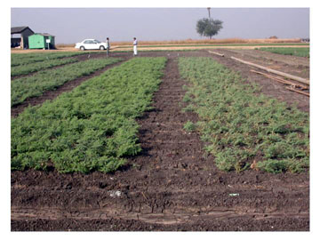
Fig. 1. Leaf damage by Helicoverpa armigera in chickpea (Left – Resistant line ICC 506EB, and Right - Susceptible line ICC 3137). (Courtesy ICRISAT)
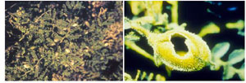
Fig. 2. Pod damage by Helicoverpa armigera. (Courtesy ICRISAT)
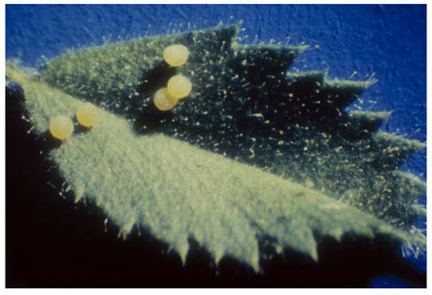
Fig. 3. Eggs of Helicoverpa armigera on chickpea. (Courtesy ICRISAT)
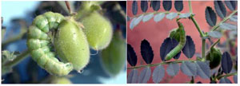
Fig. 4. A) Larva of Helicoverpa armigera (Photo: ICRISAT), and B) H. punctigera. (Courtesy Richard Lloyd)
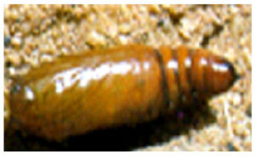
Fig. 5. Pupa of Helicoverpa armigera. (Courtesy ICRISAT)
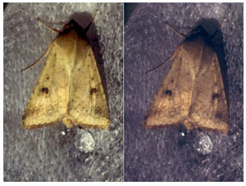
Fig. 6. Adult of Helicoverpa armigera. (Courtesy ICRISAT)

Pea moth: Cydia nigricana
Pea moth Cydia (Laspeyresia) nigricana (Lepidoptera: Tortricidae) is mainly found on wild and cultivated peas, but it also feeds on lentils. It is commonly known as Erbsenwickler (DE), tordeuse du pois (FR), polilla del guisante (ES), tortrice dei piselli (IT), traça da ervilha (PT), ärtvecklare (SE) or pea moth. The lack of efficient control methods, together with a low damage threshold in green peas, makes pea moth an economically important insect in Europe.

Geographic distribution
Pea moth, C. nigricina has a Paleoarctic distribution, ranging from Europe to China and Japan. It is widespread in colder climates, and is found up to 64° latitude in Scandinavia. It has been introduced to North Africa, and also to Canada and USA, where it is most abundant in the northeastern part of the country.

Host plants
Various wild and cultivated Leguminosae, especially species of Vicia and Lathyrus, garden pea, clover, and lentil. It also feeds on chickpea and lupine.

Nature of damage
The larvae attack the seeds inside the pods (Fig. 1). Damage is detected only when the pods are opened. Larval feeding spoils the pods with excrement and silk (Fig. 2). One larva damages up to 6 seeds, but usually only 1 to 2 are severely damaged. Seed damage, presence of larvae, and stains lead to rejection of consignments by the processors.

Life cycle
The adult moth is small (15 mm wingspan) and delicate. It is distinguished by grey-brown forewings with traces of ocherous, and conspicuous black and white costal strigulae and interspaces. The ocellus, which is otherwise typical for Cydia, is poorly developed (Fig. 3).
Adults appear during the flowering stage and lay eggs on plants (Fig. 4). A female may lay up to 200 eggs. Embryonic development is completed in 6 to 10 days. Egg-laying occurs 5 to 11 days after eclosion. The female deposits 1 to 3 eggs on the stipules or the leaflets (Fig. 5). The larva is yellowish white with dark spots and short hairs, measures 13 to 18 mm, and has a light brown head (Fig. 2). Larval development is completed in 18 to 30 days, and there are five instars. The larva leaves the pod and migrates to the ground where it spins a cocoon containing particles of soil. Larvae hibernate in the soil and pupate in spring. There is one generation per year.
Moth eclosion is influenced by soil temperatures and photoperiod. Temperatures between 21 to 25° C, and 70 to 90% R.H. are favorable. The sum of effective temperatures for insect development is 442°C. Hot and dry weather is unfavorable to the insect.

Mating behavior and chemical ecology
Male moths become active during the late afternoon in broad sunlight and are seen to actively fly over host plants. They readily orient to pheromone-releasing females or synthetic pheromone lures over a distance. After landing, the male starts wingfanning and rhythmically extrudes its genital claspers at the tip of the erect abdomen. The female then walks towards the male, touching him with her antennae, and the male then attempts copulation. The female response to the male courtship is largely mediated by volatile chemicals released from androconial scent organs on the male hindwing. Male-produced pheromones are, however, active only at close distance, while female-produced sex pheromone attracts the males over 50 m or more.
Pea moth females are attracted to peas for oviposition. The eclosion of adults is tightly correlated with flowering of pea. The females are attracted to pea fields from a long distance. However, the chemicals encoding host plant attraction have not been elucidated. One open question is whether the pea moth females mate on the host plant or at the site of emergence, before reaching a suitable host plant. Better knowledge of the role of host plant cues in pea moth reproductive behavior is the key to integrated management strategies.

Management
Cultural control. Low cropping intensity and area wide separation of grain peas from vegetable peas are key factors in reducing pea moth infestations. Pea fields of the previous year are the main source of infestation. The distance to newer fields should exceed the flight range of pea moths, which has been estimated to be 2 km or more. High pea moth populations have also been found in grasslands and natural habitats where wild Leguminosae grow.
Early-sowing in combination with short-duration genotypes reduces the availability of peas at the susceptible phenological stages, i.e. flowers and young pods, during the main season. Intercropping with barley, deep plowing of fields with overwintering larvae, and eradication of weeds are other methods to reduce pea moth damage.

Natural enemies. The egg parasitoid, Trichogramma evanescens, can be used for biological control of this pest, although under practical conditions, efficacy needs to be improved. Naturally- occurring hymenopterous parasitoids, though abundant, are apparently not capable of reducing pea moth populations to below economic thresholds.

Microbial control. The granulosis virus of the codling moth, Cydia pomonella, is reported to be effective under laboratory and small scale field experiments. However, efficacy was unsatisfactory in several large-scale field tests, even when high dosages were applied.

Chemical control. Pyrethroids or carbamates are commonly used, but the control efficacy of insecticide sprays is often limited. Pheromone-baited traps are efficient tools to time such insecticide sprays.
Chemical control of C. nigricana is difficult, since the pea moth is protected from insecticide sprays in soil or in pods during most of its life cycle. Only the neonate larvae are susceptible to insecticides, before they penetrate the pods. Timing of insecticide sprays is achieved by pheromone-baited monitoring traps. In spite of optimized timing of pesticide application, it is often not possible to reduce pea moth infestations below the low damage threshold of 0.5 to 1% in green peas, and likely in lentils.

Pheromones. The pea moth pheromone is codlemone acetate, (E,E)-8,10-dodecadienyl acetate. The geometric isomers of this compound, which are quickly formed on pheromone lures, are strong attraction antagonists. Isomerization of peromone lures within few days makes it impossible to use synthetic pheromone for monitoring in fields traps. A less attractive pheromone mimic is used instead.
Isomerization of the main pheromone compound is, on the other hand, not an obstacle for pheromone-mediated mating disruption. A repellent blend of pheromone and antagonistic isomers was efficient for population control by mating disruption in isolated pea fields. Main obstacles to a more widespread use of mating disruption in pea moth control are the availability of a suitable dispenser material and the cost of dispenser application in pea fields. In comparison, mating disruption has been successfully used against codling moth, a closely related species.

Integrated pest management. Early-sowing, short-duration genotypes, and intercropping can be combined with insecticide treatments. Pheromone-baited monitoring traps are an inexpensive and efficient tool to time sprays. Further development of pheromone-mediated mating disruption, resistant cultivars, and identification of plant volatile cues that attract gravid females for oviposition would be a significant step towards sustainable and more efficient control of pea moth.

Selected References
Bengtsson, M., Karg, G., Kirsch, P. A, Löfqvist, J., Sauer, A., and Witzgall, P. 1994. Mating disruption of pea moth Cydia nigricana F. (Lepidoptera: Tortricidae) by a repellent blend of sex pheromone and attraction inhibitors. J. Chem. Ecol. 20:871-887.
Beniwal, S. P. S., Bayaa, B., Weigand, S., Makkouk, K. H., and Saxena, M. C. 1993. Field guide to lentil diseases and insect pests. http://www.icarda.org/Publications/Field_Guides/Lentil/Lentil.htm.
Darty, J. M., and Wimmer, F. 1983. Lentil: Control of the pea midge and the peamoth (Contarinia lentis). Phytoma 347:29-31.
Gould, H. J., and Legowski, T. J. 1964. Spray warnings for pea moth (Laspeyresia nigricana) based on its biology in the field. Entomol. Exp. Appl. 7:131-138.
Payne, C. C. 1981. The susceptibility of the pea moth, Cydia nigricana, to infection by the granulosevirus of the codling moth, Cydia pomonella. J. Invert. Pathol. 38:71-77.
Witzgall, P., Bengtsson, M., Unelius, C. R., and Löfqvist, J. 1993. Attraction of pea moth Cydia nigricana F. (Lepidoptera: Tortricidae) to female sex pheromone (E,E)-8,10-dodecadien-1-yl acetate, is inhibited by geometric isomers (E,Z), (Z,E) and (Z,Z). J. Chem. Ecol. 19:1917-1928.
Witzgall, P., Bengtsson, M., Karg, G., Bäckman, A. C., Streinz, L., Kirsch, P. A., Blum, Z., and Löfqvist, J. 1996. Behavioral observations and measurements of aerial pheromone concentrations in a mating disruption trial against pea moth Cydia nigricana F. (Lepidoptera, Tortricidae). J. Chem. Ecol. 22:191-206.
Wright, D. W., and Geering, Q. A. 1948. The biology and control of the pea moth Laspeyresia nigricana Stephh. Bull. Entomol. Res. 39:57-48.

(Prepared by G. Thöming, H. Saucke and P. Witzgall)

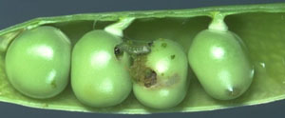
Fig. 1. Cydia nigricana larvae damage the lentil seeds inside a pod. (Courtesy P. Witzgall)
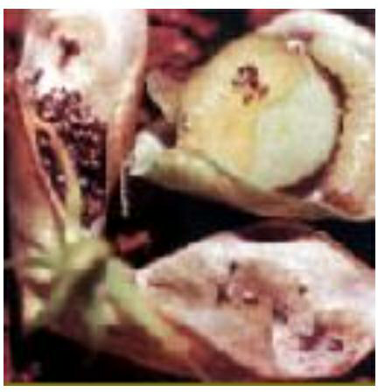

Fig. 2. Cydia nigricana larval feeding spoils pods with excrement and silk. (Courtesy P. Witzgall)

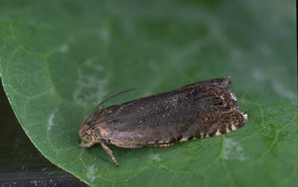

Fig. 3. Adult of Cydia nigricana. (Courtesy P. Witzgall)

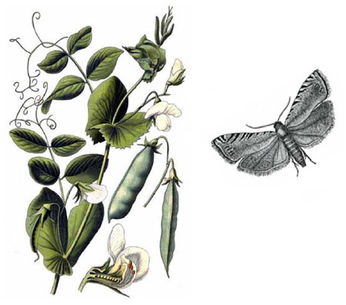

Fig. 4. Adults of Cydia nigricana appear during the flowering stage and lay eggs on plants. (Courtesy P. Witzgall).

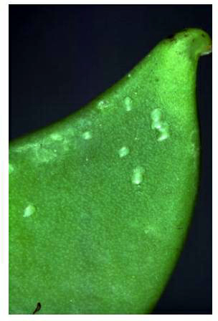

Fig. 5. Eggs of Cydia nigricana. (Courtesy P. Witzgall)

Lima Bean Pod Borer, Etiella zinckenella
Lima bean pod borer, Etiella zinckenella (Lepidoptera: Pyralidae) is an important insect pest of several pulse crops, including lentil. It is commonly known as lima bean pod borer, spiny pod borer, or pea pod borer. It is an occasional pest of lentil, and is not a pest of chickpea.
Geographical distribution
The lima bean pod borer, E. zinckenella is widely distributed in Asia, Africa, and Europe. It is also a serious pest in Australia, New Caledonia, Papua New Guinea, and Solomon Islands. In the American continent, it is present in Canada, USA, West Indies, and Central America.

Host range
It feeds on several leguminous species, especially lima bean, cowpea, pigeonpea, lentil, horse gram, green gram, field pea, and sunhemp.

Nature of damage
The presence of a hole on the pod surface, dry light-colored frass, and webbing in the pod are indications of infestation by the lima bean pod borer, E. zinckenella. As a result of insect damage, the pods are poorly developed. Individual seeds have holes and internal portions are gutted out (Fig. 1). The pods are partially or completely consumed inside. Externally, the pods give shrunken appearance, with small surface punctures. Larvae generally feed on maturing pods. Lima bean pod borer population builds up by the end of the season, when the temperature is high. The caterpillar is greenish or pinkish red, with a yellow head. It moves violently when disturbed. The adults are small, brown, and active at night (Fig. 2). Its infestation can be detected by the presence of small punctures on the surface of the pods, and the larvae can be observed by splitting the pods.

Life cycle
The adult moths are 10 to 12 mm long with a wingspan of 22 to 28 mm. The forewings are brown-gray with a white anterior margin (Fig. 3). Mating takes place at night or in dark places, and the females lay eggs on young pods in clusters of 2 to 12. A female lays 47 to 178 eggs in 5 to 6 days. Eggs are laid near the calyx of the flowers or on pods. The larva immediately bores into the pods and feeds internally. Larvae attain a maximum length of 15 mm, and are greenish with a brown line (Fig. 4). The larvae often move from one pod to another. The average egg, larval, pre-pupal, and pupal periods on lentil have been reported to be 5.4, 17.2, 2.3, and 13.8 days, respectively. The larvae enter diapause in winter. Pupation normally takes place in the soil, but sometimes on pods (Fig. 5). One generation is completed in about 4 weeks under favorable conditions, and there are 3 to 5 generations per year. The adults survive for one week, and the females live longer than the males.

Management
Host plant resistance. Host plant resistance can play a major role in reducing the losses due to E. zinckenella in lentil. Short-duration genotypes are more susceptible than the medium- and long-duration genotypes. The line LH 90-39 is resistant, while LL 147 is tolerant to E. zinckenella damage. Lines P 927 and P 202 have been reported to be resistant, and yield 52.9 and 43.5% more than L 9-12, respectively.

Natural enemies. Several natural enemies have been reported to control E. zinckenella. These include Bracon etiellae, B. pectoralis, Phanerotoma planifrons, Pigeria piger, P. hendecasisella, Exorista roborator, and Tetrastichus spp. (Fig. 6). However, there are no reports on use of natural enemies for classical biological control of the lima bean pod borer.
Chemical control. This is an occasional pest of lentil, but insecticide application may be necessary under heavy infestation. Sprays of methidathion (0.5 kg ai ha⁻¹), deltamethrin (38 g ai ha⁻¹), or endosulfan (6 ml L⁻¹) at flowering and early pod setting have been reported to provide effective control of this pest. Abamectin 1.8% EC (1 ml 20 L⁻¹), α-cypermethrin 10% (1.5 ml 2 L⁻¹), and cyhalothrin 2.5% (2 ml 2 L⁻¹) have also been found to provide effective control.

Integrated pest management. The Lima bean pod borer infestations quite often are low, and do not warrant control. There is a positive relationship between moths caught in sweep nets during flowering and pod-formation and seed damage, and therefore, rough predictions of damage can be made based on moth catches to undertake control measures. Under heavy infestations, application of insecticides with a strong contact and systemic action may be effective. Varieties that are less susceptible to the pod borer may be recommended for cultivation in areas endemic to this pest.
Selected References
Brar, J. S., Verma, M. M., Sandhu, T. S., Singh, B., and Gill, A. S. 1989. LL 147 variety of lentil (Lens culinaris L.). J. Res. Punjab Agric. Univ. 26:170.

CABI (Commonwealth Agricultural Bureau International). 2002. Crop Protection Compendium. Commonwealth Agricultural Bureau International, Wallingford, UK.
Jaglan, M. S., Sucheta, Khokhar, K. S., and Kumar, S. 1995. Biology of lentil pod borer, Etiella zinckenella Treitschke on lentil and pea. Ann. Biol. 11:224-228.

Nair, M. R. G. K. 1975. Insects and Mites of Crops in India. Indian Council of Agricultural Research, New Delhi, India. 405 pp.

Sandhu, G. S., and Verma, G. C. 1968. Etiella zinckenella Treitschke (Lepidoptera: Phyticidae) as a pod borer of lentil in Punjab. J. Bombay Nat. Hist. Soc. 65:799.
(Prepared by C.P. Srivastava and H.C. Sharma)

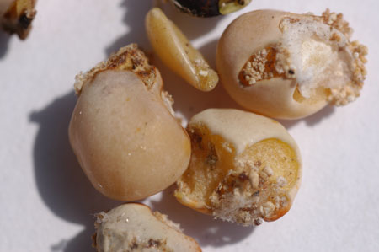

Fig. 1. Lentil seed damage by pod borer, Etiella zinckenella. (Courtesy ICRISAT)

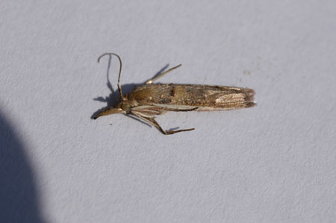

Fig. 2. Adult of pod borer, Etiella zinckenella. (Courtesy ICRISAT)

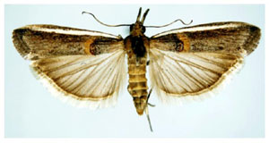

Fig. 3. Wing span and coloration of pod borer, Etiella zinckenella adult. (Courtesy ICRISAT)

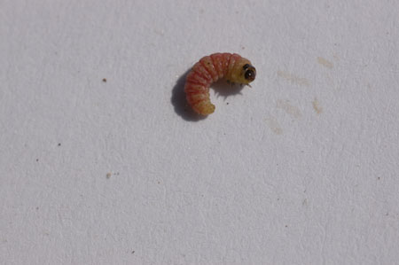

Fig. 4. Larva of pod borer, Etiella zinckenella. (Courtesy ICRISAT)

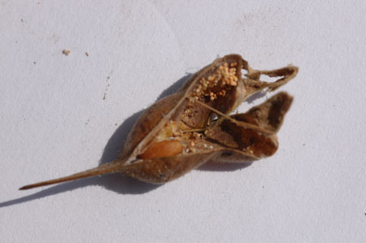

Fig. 5. Pod borer, Etiella zinckenella pupation in the pod. (Courtesy ICRISAT)

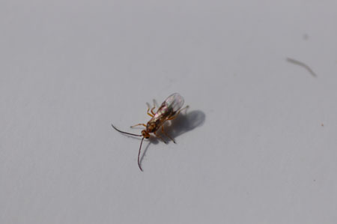

Fig. 6. Pod borer, Etiella zinckenella larval parasitoid, Tetrastichus spp. (Courtesy ICRISAT)

Leaf Weevils: Sitona crinitus

Leaf weevil, Sitona crinitus (Sitona macularius) (Coleoptera: Curculionidae) is one of the main insect species attacking lentil. The adults feed on the foliage, but larvae cause the main damage. The larvae are a serious pest on N₂ fixing nodules of lentils in West Asia. They are commonly known as lead leaf weevil or Sitona weevil.

Geographical distribution
Sitona crinitus is one of the main insect species attacking lentil in West Asia (Turkey, Syria, Lebanon, and Jordan), southern Europe, North Africa, and the former USSR.

Host range
Sitona crinitus shows a distinct feeding preference among the grain legumes. Vicia sativa is more preferred than Medicago polymorpha, Lathyrus sativus, L. ochrus, and L. cicera. Lens culinaris is the next most severely damaged species, followed by Trifolium angustifolium. Lathyrus ochrus is the least damaged species. Both chickpea and faba bean are non-host plants of S. crinitus.

Nature of damage
Both adults and larvae of S. crinitus damage (Fig. 1) the lentil crop, but larvae are the main damaging stage. The adult weevils feed on foliage in a characteristic manner, making semicircular notches from the leaf edges early in the season. The adult feeding usually does not affect yields, unless populations are very high and/or unfavorable environmental conditions limit the growth of the lentil seedlings, and the plants cannot compensate the damage to foliage quickly. The larvae are a serious pest on N₂ fixing nodules of lentils in West Asia and North Africa. Nodule damage is higher in early-sown than in late-sown lentils. There is a positive correlation between visual damage score and nodule damage by S. crinitus. Visual damage can be used for evaluating a large number of genotypes for Sitona resistance under field conditions. The white Sitona larvae can be seen inside the nodules in uprooted lentil plants. Damage by Sitona reduces the nitrogen-fixing ability of the crop. Mineral nitrogen does not compensate for the damaged nodules, and fails to supplement fixed nitrogen for yield increase. The foliage of damaged plants assumes a yellow appearance similar to nitrogen deficiency characteristics. At times, the infestation of leaflets may be >90% and the larvae destroy most of the nodules. At high infestation levels (>90% nodule damage), the insect caused 17.7 and 14.1% loss in straw and grain yields, respectively. Sitona crinitus is also an efficient vector of broad bean stain cosmovirus (BBSV) in lentil.

Life cycle
The adult weevils have a grey-brown and elongated body of 3 - 4 mm length. The pronotum has three straight longitudinal light lines, and the elytra have three rows of dark and white spots. The females lay spherical yellow eggs (Fig. 2), which later turn black. The larvae are cream-white, with a brown head capsule, legless, while the pupae are white.
Overwintered adults of S. crinitus appear in the second half of March and feed on young shoots and leaves, while the larvae (Fig. 3) appear when the climatic conditions are suitable, and have root nodules to feed upon. The spring migration of adults and the number of months spent in hibernation have a significant effect on adult lifespan. In the Mediterranean region, where hot and dry summers prevail, the adults (Fig. 5) aestivate in the soil, and start emerging in December/January. Sometimes, the adults emerge in May, when the lentil matures. The adults of the previous generation die in April/May. There is only one generation per year, and the adults live for almost one year. After copulation, the females start laying eggs on the soil around the lentil plants or loosely on the leaves, which later fall to the ground. The oviposition period lasts for several months, and each female lays several hundred eggs. Temperatures <10°C induce quiescence in eggs of S. crinitus. The neonate larvae move into the soil and infest the nodules. Each larva may consume many nodules during development until pupation. It pupates in the soil. Depending upon temperatures, the larval and pupal period may last for 5 - 6 and 3 - 4 weeks, respectively.

Management
Cultural control. Crop rotation can reduce the infestation to some extent, as the weevils emerge from the soil after aestivation. They are, however, strong fliers and can migrate long distances. Weedy fields are more prone to Sitona damage. Delaying planting by about two weeks reduces Sitona infestation. However, early sowing combined with the control of Sitona and weeds, and P application gives higher net returns with virtually no risk of economic loss to the farmers.

Host plant resistance. Previous research on host plant resistance against S. crinitus did not produce conclusive results, but recent studies indicated that eight accessions of wild lentils (ILWL 110, ILWL 136, ILWL 166, ILWL 203, ILWL 207, ILWL 245, ILWL 254, and ILWL 258) have high level of resistance to Sitona (≤10% nodule damage). The resistant accession ILWL 245 belongs to L. culinaris subsp. orientalis, the progenitor of the cultivated lentil, and can be crossed with the cultivated lentils. This line is being used to understand the inheritance of Sitona weevil resistance, and to introgress resistance genes to cultivated lentils (Fig. 5). Isoflavone reductase levels can be used to select lentils for resistance to Sitona. The cryIII toxin expression in nodules has been found to result in significant reduction in nodule damage by S. lineatus on Pisum sativum, and S. hispidulus on Medicago sativa, and could be used as strategy to produce Sitona-resistant lentils.

Chemical control. Carbofuran and aldicarb reduce nodule damage significantly (Solh et al., 1986), and yield increases due to carbofuran application are generally greater in early than in late-sown crop. Lentil seeds can be treated with furathiocarb (12 ml kg⁻¹ seed) or apply granular insecticides such as carbofuran 5% G 10 kg⁻¹ ha) at planting. Use of carbofuran improves both nodulation and grain production. Rhizobial inoculation and phosphorus application increase lentil productivity in arid locations under Mediterranean environments. If no preventive control is taken, and a high infestation is observed in the field, spray with phosmet (1 kg a.i.⁻¹ ha). This is less effective than granular application and seed treatment. Alternatively, chlorpyriphos, malathion, or oxy-demeton methyl can also be applied in case of severe infestation. The water extract of Melia azedarach kernels (50 g⁻¹liter) significantly reduced S. crinitus adult damage on lentil leaves for one week.

Integrated Pest Management. Crop rotation, delaying planting date by about two weeks than the normal sowing, planting resistant varieties, and development of Bt-transgenic lentils having cryIII toxin expression in nodules could be used to manage Sitona damage in lentils. Seed treatment with furathiocarb (12 ml kg⁻¹ seed) or application of granular insecticide (carbofuran 5% G @ 10 kg⁻¹ ha) reduces nodule damage significantly. The water extract of neem kernels (@ 50 g⁻¹liter) significantly reduces S. crinitus damage. Chlorpyriphos, malathion, or oxy-demeton methyl can be sprayed in case of severe infestation.

Selected References

Bezdicek, D. F., Quinn, M. A., Forse, L., Heron, D., and Kahn, M. L. 1994. Insecticidal activity and competitiveness of Rhizobium spp. containing the Bacillus thuringiensis subsp. tenebrionis –endotoxin gene (cryIII) in legume nodules. Soil Biol. Biochem. 26:1637-1646.
El Damir, El Bouhssini, M., and Al Salty, M. N. 2000. Effect of Melia azedarach (L.) (Meliaceae) fruit extracts on Sitona crinitus (H.) (Coleoptera: Curculionidae) adults feeding. Arab J. Plant Prot. 18:64-67.
El Damir, M., Al-Salti, M. N., and El Bouhssini, M. 2001. Ecology and biology of Sitona crinitus H. in northern Syria. Bassel Al-Assad J. Engin. Sci. 14:109-119.
Islam, R., and Afandi, F. 1982. Effect of some insecticides on nodulation and yield of two lentil cultivars. Lentil Exp. News Serv. 9:24-25.
Perez Andueza, G., Mozos Pascual de los, M., and Portillo Rubio, M. 2004. Main pests of lentil (Lens culinaris Medikus) in Castilla La Mancha (central Spain): crop losses and influence on yield parameters. Boletin de Sanidad Vegetal, Plagas 30:763-772.
Tahhan, O., and Hariri, G. 1983. The feeding and chemical control of Sitona maculatus (Marsham) (Coleoptera: Curculionidae) on lentils in northern Syria. Lens Newslett. 10:32-34.
Weigand, S., Lateef, S. S., El Din, N. E. S., Mahmoud, S. F., Ahmed, K., and Ali, K. 1994. Integrated control of insect pests of cool season food legumes. Pages 679-694 in: Expanding the Production and use of Cool Season Food Legumes, Proceedings of the Second International Food Legume Research Conference on Pea, Lentil, Faba Bean, Chickpea, and Grasspea, 12-16 April 1992, Cairo, Egypt. Kluwer Academic Publishers Group, Dordrecht, Netherlands.
(Prepared by M. El Bouhssini)

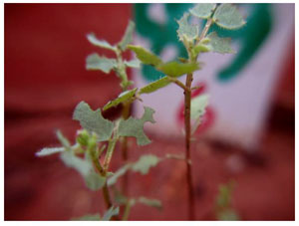
Fig. 1. Chickpea leaf damage by Sitona crinitis. (Courtesy ICARDA)

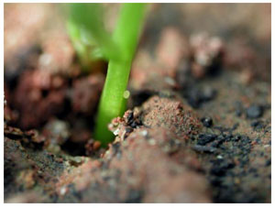
Fig. 2. Egg of Sitona crinitis. (Courtesy ICARDA)

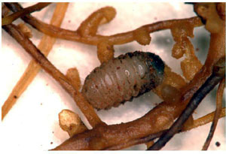
Fig. 3. Larva of Sitona crinitis. (Courtesy ICARDA)
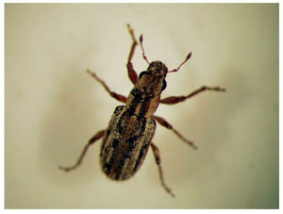
Fig. 4. Adult of Sitona critinis. (Courtesy ICARDA)

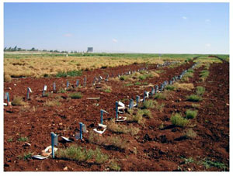
Fig. 5. Reaction of chickpea genotypes to damage by Sitona crinitis. (Courtesy ICARDA)

Armyworms: Spodoptera spp.
The beet armyworm, Spodoptera exigua (Noctuidae: Lepidoptera), is a pest of chickpea in Mexico and north India, and became a serious pest of chickpea (vegetative stage) in some regions of southern India in the latter part of the 20th century. Although chickpea is susceptible to attack by S. exigua, it is not a pest of chickpea in the U.S. Pacific Northwest. The western yellow-striped armyworm, S. praefica (Grote) (Noctuidae: Lepidoptera), is a sporadic pest of chickpea and other grain legumes in the U.S. Pacific Northwest.

Geographic distribution
Native to the Orient, the beet armyworm has become established in much of the world, including Europe, Asia, Russia, Africa, Australia, India, Pacific Islands, North America, and the West Indies. It is common in the United States, but rarely overwinters where frost kills its host plants. Spodoptera praefica is known only from the western United States, principally California, Oregon and Washington.
Host range
The beet armyworm has a wide host range, occurring as a serious pest of vegetable crops (asparagus, bean, beet, broccoli, cabbage, cauliflower, celery, chickpea, corn, cowpea, eggplant, lettuce, onion, pea, pepper, potato, radish, spinach, sweet potato, tomato, and turnip) in many parts of the world. On field crops, it is of economic concern on alfalfa, corn, cotton, peanut, safflower, sorghum, soybean, sugarbeet, and tobacco. The western yellow-striped armyworm is a pest of several crops, including lentil and chickpea in the U.S. Pacific Northwest.

Nature of damage
The young larvae of S. exigua initially feed gregariously on chickpea foliage. As the larvae mature, they become solitary and eat large irregular holes in foliage (Fig. 2). As a leaf feeder, beet armyworm consumes much more chickpea tissue than the chickpea pod borer Helicoverpa armigera, but has not been reported as a serious pest on pods. Infestations of S. praefica usually appear late in the chickpea growing season in the U.S. Pacific Northwest, with potential to inflict economic damage by consuming foliage and pods.

Life cycle
The S. exigua females lay eggs in clusters of 50 to 150 eggs (Fig. 1). A female lays 300 to 600 eggs on the lower surface of the leaves, near the blossoms, and the terminal branches. The eggs are greenish white in color, and covered with a layer of whitish scales, which gives the egg mass a fuzzy or cottony appearance. Eggs hatch in 2 to 3 days during warm weather. There are normally five instars, although additional instars have also been reported. Duration of the instars I to V has been observed to be 2.5, 1.5, 1.2, 1.5, and 3.0 days, respectively. The larvae are pale green or yellow in color during the first and second instars, but acquire pale stripes during the third-instar (Fig. 2). During the fourth-instar, the larvae become darker dorsally, and possess a dark lateral stripe (Fig. 3). Fifth-instar larvae are quite variable in appearance, and tend to be green dorsally with pink or yellow color ventrally, and a white stripe laterally. Sometimes, the larvae assume a dark color. The body is practically devoid of hairs and spines. Pupation occurs in the soil (Fig. 4). The pupal chamber is constructed from sand and soil particles held together with an oral secretion, which hardens upon drying. The pupa is light brown in color and measures 15 to 20 mm in length. Duration of the pupal stage is 6 to 7 days during warm weather. The moths are of moderate size, with wingspan of 25 to 30 mm. The forewings are mottled gray and brown, and have irregular banding pattern, and a light bean-shaped spot (Fig. 5). The hindwings are of uniform gray or white color, and trimmed with a dark line at the margins. Mating occurs soon after emergence, and oviposition begins within 2 to 3 days. Oviposition extends over a 3 to 7 day period, and the adults live for 9 to 10 days. Seasonal activity varies considerably according to climate. The life cycle can be completed within 24 days. There are several generations in a year, which vary across regions, depending upon the climate.
The life cycle of S. praefica on chickpea in the U.S. Pacific Northwest has not been studied, although its movement from weed hosts to cultivated lentil and its economic impact on this crop in this region has been described.

Management
Economic thresholds and population monitoring. Pheromone traps can be used to detect the presence of beet armyworm adults. Visual sampling for damage and larvae, combined with an action threshold of 0.3 larvae per plant has been used in cabbage. However, there is no information on action thresholds in chickpea. Regular monitoring of crops is recommended because adult moths frequently invade the crops from adjacent crops and weeds. Pheromones can also be used to disrupt mating and inhibit or eliminate reproduction. Saturation of the atmosphere around beet armyworm-susceptible crops might reduce mating by 97%. Economic thresholds for S. praefica on chickpea have not been established. However, a population of one larva per 1,000 cm² on lentils with green pods will cause 10% loss. Sweep-netting of larvae will establish the presence of larvae in agricultural crops and a sex attractant for trapping male S. praefica could potentially be used to monitor male flights in chickpea.
Host-plant resistance. There is no published information on resistance of chickpea varieties to S. exigua and S. praefica. However, several progenies from interspecific hybridization involving cultivated chickpea (Cicer arietinum) and a wild relative (C. reticulatum) have exhibited high levels of resistance to S. exigua (Fig. 6).
Natural enemies. Common natural enemies of S. exigua in U.S. agricultural crops are braconids (Chelonus insularis, Cotesia marginiventris, and Meteorus autographae) and a tachinid (Lespsia archippivora). Also, predators like minute pirate bugs (Orius spp.), big-eye bugs (Geocoris spp.), damsel bugs (Nabis spp.), and the predatory shield bug (Podisus maculiventris) attack eggs and small larvae. Red imported fire ant (Solenopsis invicta) attack pupae. In India, S. exigua is a host of Campoletis chlorideae (Hymenoptera: Ichneumonidae), an important parasitoid of the chickpea pod borer Helicoverpa armigera. Natural enemies of S. praefica include many parasitic insects and predators, but their impact on this insect in U.S. chickpea crops is unknown.
Biopesticides and natural plant products. Nuclear polyhedrosis virus isolated from beet armyworm is fairly effective as a bioinsecticide under greenhouse conditions, where inactivation by ultraviolet light of sunlight is not a severe problem. The nuclear polyhedrosis virus is highly specific to beet armyworm, and is considered to be an important mortality factor under natural conditions. The fungi Beauveria bassiana and Nomuraea rileyi are pathogenic to S. exigua and larvae are susceptible to neem products. A nuclear polyhedrosis virsus has been found in S. praefica.
Chemical control. Information on insecticidal control of the beet armyworm comes from publications on U.S. crops other than chickpea. For example, eggs and young larvae can be controlled with foliar applications of 5% cottonseed oil, but this concentration is damaging to some plant species. Moreover, development of resistance to insecticides is a major problem in the management of S. exigua because it attacks several crops, which results in frequent insecticide applications and status as a secondary or induced pest in some crops. Insecticides have not been evaluated for control of S. praefica on chickpea, although they are used against damaging populations in the U.S. Pacific Northwest.
Integrated pest management. Improving the prospects for protecting chickpea crops from Spodoptera infestations requires the development of integrated pest management control and management tactics that would include, in large part, adult monitoring with pheromone traps, field sampling to estimate damaging populations, and the use of biopesticides and natural plant products that are compatible with natural enemies. In India, insecticides (endosulfan, fenvalerate, cypermethrin) can be used to control outbreaks of S. exigua. In the absence of integrated pest management programs for most of the grain legume insect pests in North America, including S. praefica, the present control strategy involves insecticides. The development and deployment of Bt-transgenic chickpea has received attention, and could be a promising tool for protecting chickpea crops from damage by Spodoptera infestations.

Selected References
Capinera, J. L. 2001. Handbook of Vegetable Pests. Academic Press, San Diego, USA.
Commonwealth Agricultural Bureau (CABI). 1972. Distribution Maps of Plant Pests. Map 302. CAB International, Wallingford, Oxfordshire, UK.
Clement, S. L., Wightman, J. A., Hardie, D. C., Bailey, P., Baker, G., and McDonald, G. 2000. Opportunities for integrated management of insect pests of grain legumes. Pages 467-480 in: Linking Research and Marketing Opportunities for Pulses in the 21st Century, Knight, R., ed. Kluwer Academic Publishers, Dordrecht, The Netherlands.
Eveleens, K. G., van den Bosch, R., and Ehler, L. E. 1973. Secondary outbreak induction of beet armyworm by experimental insecticide applications in cotton in California. Environ. Entomol. 2:497-503.
Gutierrez, P. E., Cortez, M. E., and Ayala, O. J. L. 1986. Population dynamics of arthropod pests and beneficial animals in chickpea planted on six dates and the effects on yield and grain quality. Revista Chapingo (Mexico) 11-12:63-68.
Ruberson, J. R., Herzog, G. A., Lambert, W. R., and Lewis, W. J. 1994. Management of the beet armyworm (Lepidoptera: Noctuidae) in cotton: role of natural enemies. Florida Entomol. 77:440-453.
Sharma, H. C., Gowda, C. L. L., Stevenson, P. C., Ridsdill-Smith, T. J., Clement, S. L., Ranga Rao, G. V., Romies, J., Miles, M., and Bouhssini, M. 2007. Host plant resistance and insect pest management in chickpea. Pages 520-537 in: Chickpea Breeding and Management, S. S.Yadav, R. J. Redden, W. Chen, and B. Sharma, eds. CAB International, Oxfordshire, UK.
Todd, E. L., and Poole, R. W. 1980. Keys and illustrations for the armyworm moths of the noctuid genus Spodoptera Guenée from the Western Hemisphere. Annals. Entomol. Soc. Amer. 73:722-738.
Wakamura, S., and Takai, M. 1992. Control of the beet armyworm in open fields with sex pheromone. Pages 115-125 in: Diamondback Moth and other Crucifer Pests, Talekar, N. S., ed. Asian Vegetable Research and Development Center (AVRDC), Taipei, Taiwan.
(Prepared by R. Ahmad, P. Durai Murugan, P. Arjuna Rao and S.L. Clement)

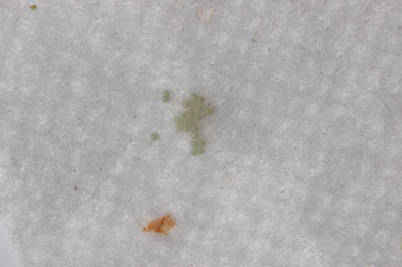
Fig. 1. Eggs of Spodoptera exigua. (Courtesy ICRISAT)

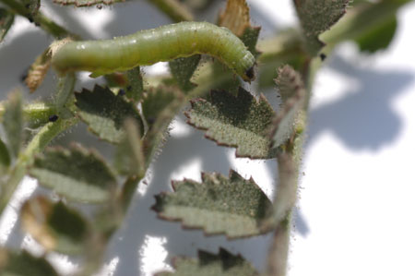
Fig. 2. Larva of Spodoptera exigua feeding on chickpea. (Courtesy ICRISAT)

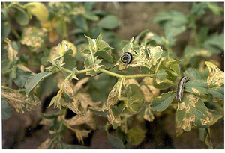
Fig. 3. Fourth instar larvae of Spodoptera praefica feeding on chickpea. (Courtesy W. Kaiser)

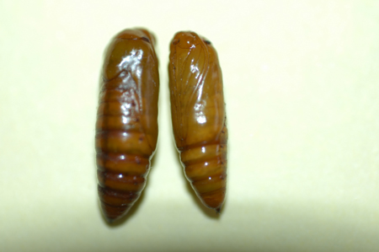
Fig. 4. Eggs of Spodoptera exigua. (Courtesy ICRISAT)

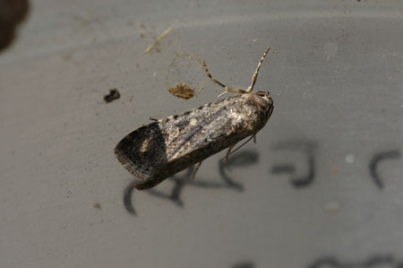
Fig. 5. Adult of Spodoptera exigua. (Courtesy ICRISAT)

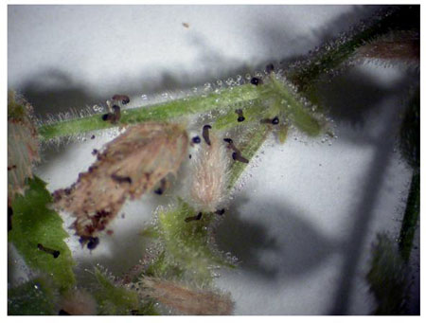
Fig. 6. Dead first instar larvae of Spodoptera exigua on resistant hybrid chickpea. (Courtesy L. Elberson).

The Black Cutworm: Agrotis ipsilon
The black cutworm, Agrotis ipsilon (Lepidoptera: Noctuidae) is a polyphagous pest on several field crops. The other two species, Agrotis flammatra and A. spinifera are of minor importance.

Geographic distribution
Agrotis species are widely distributed world over, and are pests of several crops in different agro-ecosystems. Agrotis ipsilon is widely distributed in Europe, North Africa, Syria, Japan, China, Indonesia, Australia, New Zealand, Hawaii, Sri Lanka, Myanmar, and India. In Europe, it is found in almost all countries extending from Ireland and Portugal in the west to Bulgaria and Romania in the east, and from Norway and Finland in the north to Sicily in the south. It is widespread, and more damaging in the northern hemisphere than in the southern hemisphere. It annually reinvades temperate areas, overwintering in warmer or subtropical regions. Long distance dispersal of adults has long been suspected in Europe, China, and North America. The cutworms move north in the spring and south in autumn. Studies in the United States demonstrated northward displacement of moths during the spring in the range of 1,000 km in two to four days when assisted by northward wind. Similar displacement to south and southwest has been documented in the autumn.

Host range
It feeds on chickpea, pea, lentil, potato, and other crops in North India. It also damages cauliflower, cotton, maize, strawberry, tomato, grapevine, alfalfa, rice, sorghum, sweet potato, tobacco, wheat, mustard, linseed, sugarcane, cucurbits, poppy, beet, soybean, cabbage, clover, sunflower, artichoke, pepper, vegetables, and several weeds. Among weeds suitable for larval development are Poa pratensis, Rumex crispus, Chenopodium album, Barbarea vulgaris, and Amaranthus retroflexus.

Nature of damage
The larvae feed on leaves, stems, and roots of many field crops, including chickpea and lentil. Up to 10% plant damage has been recorded at 40 days after crop emergence in chickpea. The older larvae cut the plant above the root crown (Fig. 1). Most of the plant is not consumed after cutting, and larvae move to another plant leaving the earlier one to wither and dry. Some species feed on the upper leaves before moving to the soil surface (Fig. 2). Heavy damage of cutworms occurs in areas that remain flooded during the rainy season.

Life cycle
The moths are grey-brown with a wingspan of 40 to 50 mm (Fig. 3). Forewings are light brown, patterned with an ipsilon shape, and the hindwings are creamy white with brown edges. The moths appear in the plains in October and come out at dusk and fly until darkness sets in. After mating for 4 to 6 days, the female begins to oviposit at night and lay creamy-white, dome shaped eggs in clusters. These are laid singly or in small groups on moist soil, weeds, or leaves of host plants. Oviposition continues for 5 to 11 days. The pre-oviposition and oviposition periods vary from 3.9 to 5.5 and 5.8 to 8.3 days, respectively. A female may lay 639 to 2252 eggs. Eggs are sub-spherical usually dome shaped with 30 to 40 longitudinal ribs and about 0.5 mm in diameter. The freshly laid eggs are cream colored and turn reddish yellow and finally blackish before hatching. The egg, larval, and pupal periods vary from 2.7 to 5.1, 18.2 to 39.5, and 31.4 to 69.8 days, respectively. Larval mortality is as high as 70% during the early instars. In summer, it survives on the weeds in wastelands. The young larvae are nocturnal, pale yellowish green with a blackish head, and pro-notal shield. The larva is covered with small dusky tubercles, each bearing a seta. When full grown, the larva is 40 to 50 mm long, slate grey or dark green in color with shiny and greasy skin. Each body segment has four or more distinct spots on each side. On the dorsal surface, along the median lines, two bright lines run longitudinally. The ventral surface is light grey. Larvae remain below the surface of the ground, under clods of soil, or other shelters during the day. The first two larval stages feed on the foliage. The third and later stages often become cannibalistic and adopt solitary habits. They grow as much as 50 mm in length and can be found coiled round a damaged plant. Mature larvae burrow deeply into the ground and pupate within cells (Fig. 4), from which the adults emerge. Depending on the climate, there may be one or several generations in a year.

Management
Population monitoring. Control measures can be undertaken based on economic thresholds. The economic threshold is 1.0 larva per 10 plants in northern plains of India. Light traps can be very effective for monitoring as well as managing the cutworms. However, light traps are not consistently efficient. In USA, light traps are most effective in the summer and autumn. Pheromone traps are more effective during the spring flight, when the larvae present the greatest threat to young plants. The yellow white traps captured significantly more male moths. Large larvae burrow in the soil, and are difficult to observe. However, larvae can be sampled with bait traps and this is the most effective means for monitoring cutworms prior to crop emergence or planting of seedlings. The trap has a container, which is baited with fresh plant material and/or bran with vermiculite so that the larvae can take shelter. Larvae are captured in baited containers more effectively if the vermiculite is not too near the surface. Trapping efficiency is enhanced if a screen cylinder, which provides a visual stimulus to the cutworms, is suspended above the baited container. If plants are present in the field, they compete with the bait in the traps and trap efficiency declines markedly.

Cultural control. Deep plowing of the fields before planting and after crop harvest reduces cutworm damage, which turn up the larvae and pupae to the soil surface, making them susceptible to predators and sunshine. The plants at times are able to recover from cutworm damage. The abundance of A. ipsilon in some areas is partly affected by rainfall. In the drier areas (e.g., Syria) infestations are higher in years with high rainfall. In fact, flooding fields is recommended as a control measure in some cases. Weed hosts in outlying areas are often preferred sites of oviposition and serve as food for the cutworms during the off-season.

Natural enemies. In India, the braconids; Microgaster sp., Bracon kitcheneri, and Fileanta ruficanda. parasitize the cutworm larvae, while Broscus punctatus and Liogryllus bimaculatus are common predators. Apanteles ruficrus is another important parasitoid. In USA, among the wasps known to attack this cutworm are braconids: Apanteles marginiventris, Microplitis feltiae, Microplitis kewleyi, Meteorus autographae, and Meteorus leviventri; ichneuminids: Campoletis argentifrons, Campoletis flavicincta, Hyposoter annulipes, and Ophion flavidus. Larvae parasitized by M. leviventris consume about 24% less foliage and cut about 36% fewer seedlings. Overall parasitism could be as high as 69%. Amara impuncticollis and Philonthus sp. predate on all instars of A. ipsilon.

Biopesticides. Metarhizium anisopliae and nuclear polyhedrosis virus have been found to be effective in reducing the population of cutworm. An entomopathogenic nematode, Steinernema carpocapsae strain has also been found to be effective. In central USA, another entomopathogenic nematode, Hexamermis arvalis is known to parasitize 60% larvae.

Chemical control. Cutworms are often difficult to control, especially when populations are epidemic in proportion. Large populations may cause severe crop damage with indications that the pest is the black cutworm. Unfortunately, by the time the pest is identified, the cutworms would have already developed into a life stage, which is not as susceptible to insecticides as the early larval stages. The sporadic nature of cutworm populations can make preventive treatments futile. Their soil-dwelling habits beneath foliage make the control difficult with insecticides since they do not reach the target. One way to control cutworms is to broadcast a poison bait prepared with wheat bran, cotton or groundnut cake, moistened with water, and trichlofon, carbaryl, or parathion at 10 kg ha⁻¹ in the evening. Endosulfan dusts or sprays, and endosulfan bait have also been found to be effective for cutworm control. Carbaryl, phosalone, chlorpyriphos, quinalphos, phorate and carbofuran are the other effective insecticides.

Selected References

Ahmad, R. 2003. Insect pests of chickpea and their management. Pages 229-260 in: Chickpea Research In India. Indian Institute of Pulses Research, M. Ali, S. Kumar, and N. B. Singh, eds. Kanpur, Uttar Pradesh, India.
Amitava, K., Paul, S., Basu, A., and Chettri, M. 2003. Field evaluation of bio-pesticides and insecticides against cutworm in plains of West Bengal. Indian J. Potato 30:155-156.
Chaudhary, J. P., and Malik, V. S. 1981. Extent of damage and screening of dust formulations of insecticides against gram cutworm Agrotis ipsilon Hufn. on gram, Cicer arietinum L. Indian J. Entomol. 43:153-157.
Hill, D. S. 1983. Agrotis ipsilon (Hfn.). Pages 357-358 in: Agricultural Insect Pests of the Tropics and Their Control. 2nd Ed. Cambridge University Press, Cambridge, UK.
Kumar, K., Sinha, R. B. P., and Sinha, P. K. 1983. Testing of different insecticidal formulations against greasy surface caterpillars, Agroris ipsilon Rutt. J. Soil Biol. Ecol. 3:35-38.

Nair, M. R. G. K. 1975. Insects and Mites of Crops in India. Indian Council of Agricultural Research, New Delhi, India. 405 pp.
(Prepared by R. Singh and S.K. Singh)

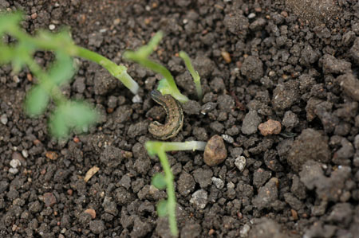
Fig 1. Nature of damage and the larvae of black cutworm, Agrotis ipsilon. (Courtesy ICRISAT)
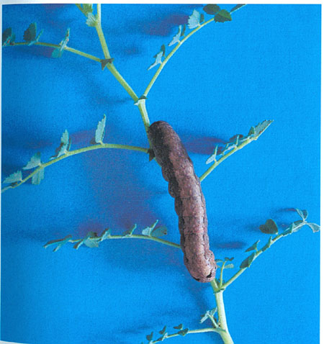
Fig. 2. Black cutworm, Agrotis ipsilon larva feeding chickpea foliage. (Courtesy ICRISAT)
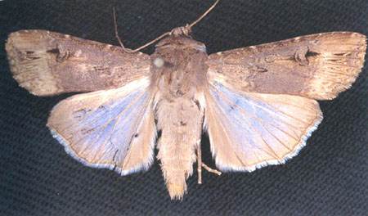
Fig. 3. Adult of black cutworm, Agrotis ipsilon. (Courtesy ICRISAT)

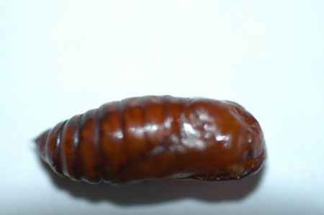
Fig. 4. Pupa of black cutworm, Agrotis ipsilon. (Courtesy ICRISAT)
Leafminers: Liriomyza cicerina and Chromatomyia horticola

Chickpea leafminer, Liriomyza cicerina (Diptera: Agromyzidae) is an important pest of chickpea in West Asia, North Africa, and southern Europe. Chromatomyia horticola is a polyphagous pest and feeds on greenhouse plants in Italy, and United Kingdom. It also attacks chickpea in Spain and India.

Geographical distribution
Liriomyza cicerina causes heavy losses to chickpea in West Asia, North Africa, and southern Europe. In the Mediterranean region, the chickpea leafminer occurs in high densities every year. Chromatomyia horticola is widely distributed in Europe, Asia, Africa, North America, Australia, Pacific Islands, and New Zealand.
Host range
Liriomyza cicerina is a major pest of chickpea in West Asia and North Africa. It has also been reported to feed on lentil, pea, faba bean, groundnut, beet, capsicum, Brassica spp., Allium spp., and several other crop and weed hosts. Chromatomyia horticola has been reported to feed on chickpea, field beans, alfalfa, faba bean, field beans, lablab, lentil, and mung bean.

Nature of damage
The females puncture the upper surface of chickpea leaflets with the ovipositor and feed on the exudates, which results in a stippled pattern on the leaflets. In some feeding punctures, the eggs are inserted just under the epidermis. The leafminer larvae feed in the leaf mesophyll tissue forming a serpentine mine, which later becomes a blotch (Fig. 1). The mining activity of the larvae reduces photosynthetic capacity of the plant, and under heavy infestation, may cause desiccation and premature leaf fall. Leafminer damage at times may destroy young seedlings, resulting in leaf drop and reduces the crop yield. Up to 30% yield losses have been reported in chickpea due to leafminer damage in Syria. The larvae of C. horticola make tunnels in the leaves. The second generation of C. horticola has been reported to damage sunflower in Hungary. Although the damage is very conspicuous, most of the time it is not economically significant.

Life cycle
The wingspan of L. cicerina varies from 1.3 to 1.6 mm. Legs are normally brown and striated, but several specimens may have yellowish legs (Figs. 2 and 3). It completes the life cycle in 20 to 30 days. For egg laying, the female makes a tubular leaf puncture to deposit the eggs singly. Some punctures are without eggs, which are considered as feeding punctures. The larva begins feeding immediately after eclosion and feeds on the mesophyll tissue until it is ready to emerge from the leaf after four larval moults (Fig 2). When the larva is ready to pupate, it cuts a semicircular slit in the leaf surface at or near the end of the mine and falls down from the leaf to the ground to pupate in the soil (Fig. 2). It has an obligatory diapause. There are 3 to 4 generations in a year, and the larvae are present throughout the vegetative period of host plants. Maximum damage has been recorded during pod formation causing 31 to 86% loss in leaf mass, and 33% yield loss in grain yield. In Syria, the first generation emerging from diapause appears in late March, and the second-generation reaches peak in the mid May. With the maturity of the chickpea plants, the leafminers disappear. Leaf mining at times does not influence yield, but reduces seed weight.
The C. horticola is active from December to April-May in India, and is believed to pass the rest of the period in the pupal stage in the soil. The adults emerge in the beginning of December. A female may lay 290 to 353 eggs singly, in the leaf tissues. The eggs hatch in 2 to 4 days and the larvae feed between the lower and upper epidermis by making zigzag tunnels. The larvae complete development in about 3 to 6 days, and pupate within the galleries. The larvae are minute, slender, and can be seen feeding within the tunnels. The adults emerge from the pupae in 6 days and life cycle is completed in 13 to 16 days. There are 4 to 5 generations from December to May, and maximum incidence has been observed in March in India. Longevity of the males is longer when fed on sugar or honey. On the other hand, sugar or honey-fed females lived shorter lives than those fed on the host plant. The fecundity increases with an increased availability of sugar or honey. Females of C. horticola prefer to lay eggs on leaves already infested with the same species than the un-infested leaves.

Management
Cultural manipulation, scouting, monitoring of insect pest populations and their natural enemies, use of natural plant products, bio-pesticides, and need-based insecticide application can be taken up for management of agromyzid flies. Integrated pest management approaches have been evaluated for controlling leafminers, especially L. cicerina with minimum effects on natural enemies of the pest. Yellow moistened traps are more effective in capturing adults of L. cicerina than the Tullgren funnels or net sweeps.

Cultural control. Early-plantings of chickpea in winter are less damaged by the leafminer compared to the spring-sown crop. The second generation of the leafminer coincides with young seedlings of the spring-sown chickpea plants (in contrast to the winter-sown crop); hence the higher level of infestation in spring-sown chickpea. Different combinations of fertilizers have no effect on the leafminer incidence. Spreading of harvested plants on plastic sheets to facilitate collection of pupae and deep plowing are safe control methods against the pupae.

Host plant resistance. Varieties with larger leaflets are more preferred by the leaf miner than those with small leaflets. Oxalic acid content in chickpea leaves has been reported to be correlated with the level of resistance to leafminer (Fig. 4). Over 200 accessions of eight wild Cicer species have been evaluated for resistance to L. cicerina under natural infestation. Two accessions of C. cuneatum (ILWC 40 and ILWC 187) and 10 accessions of C. judaicum were found to be highly resistant to leafminer damage. Another 18 lines of C. judaicum, four of C. pinnatifidum, and C. reticulatum showed moderate levels of resistance. ILWC 39, ILC 3800, ILC 5901, and ILC 7738 are resistant to leafminer damage. These sources of resistance have been used successfully at the International Center for Agricultural Research in Dry Areas (ICARDA) in breeding chickpea cultivars with resistance to leaf miner. Seven of these lines (FLIP 2005-1C, FLIP 2005-2C, FLIP 2005-3C, FLIP 2005-4C, FLIP 2005-5C, FLIP 2005-6C, and FLIP 2005-7C) have good agronomic background, seed size, and plant type, and have been distributed to national programs for evaluation under local conditions.

Biological control. Six braconids and 12 eulophids parasitize L. cicerina of which, Diglyphus isaea is the most common parasitoid. It has been commercialized in China for the management of leafminers on other crops. Opius monilicornis parasitized up to 29.8% larvae of L. cicerina in chickpea fields (Fig. 5). In Spain, O. monilicornis and D. isaea are major parasitoids of chickpea leafminer. In Syria, O. monilicornis has been found to be the most effective parasitoid of leafminer in chickpea, parasitizing up to 70% larvae. The majority of the larval parasitoids (D. isaea, Hemiptarsenus zilahisebessi, Chrysonotomyia sp., Pnigalio sp., and Cirrospilus sp.) emerge during the active season of leafminers, including L. cicerina, and a good synchronization has been observed between the time of host emergence and abundance of the larval parasitoid, D. isaea.
Pseudopezomachus masii, Aphidius sp., Chrysocharis pubicornis, Neochrysocharis formosa, C. lyonitae, D. isaea, Pediobius acanthi, and Sphegigaster spp. have been reported parasitizing C. horticola. Dacnusa rodriguezi has been found to be an important parasitoid of C. horticola. Dacnusa sibirica and D. isaea have also been reported parasitizing larvae of C. horticola in chickpea. The parasitism of C. horticola is greater in the sub-humid than in the sub-arid regions. The hymenopteran parasitoids, D. horticola, Hemiptarsenus indicus and Pediobius indicus are associated with C. horticola in India.

Chemical control. To control L. cicerina in chickpea, application of monocrotophos or endosulfan at the flowering stage has been found to be most effective. Neem seed kernel extract (3 and 4 kg per 10 L water) has been found to be effective against the larvae of L. cicerina for 15 days. Neem oil (azadirachtin 0.03% w/w) (40 ml per 20 L water), sprayed 3 to 5 times at weekly intervals, starting at about flowering stage, effectively reduced the mining caused by the chickpea leafminer. Neem sprays had little effect on the level of parasitism. The plots sprayed with deltamethrin (50% EC) (25 ml per 100 L water) reduced the level of parasitism by about 50%. Methamidaphos is quite effective against L. cicerina on chickpea.
Chromatomyia horticola could be effectively controlled by dimethoate, monocrotophos, methyl-parathion, phosphamidon, and promecarb. Phosphamidon and dimethoate also reduced the numbers of pupae. Oxy-methyl demeton (0.025%) and dimethoate (0.03%) are very effective in checking the leaf infestation and maggot population. Decamethrin 0.008%, fenvalerate 0.02%, and cypermethrin 0.01% are more effective than oxy-methyl demeton (0.025%) and dimethoate (0.03%) in managing C. horticola. Adults of C. horticola are highly susceptible to isoxathion, chlorpyriphos, ethofenprox, emamectin benzoate, and pyridalyl.

Integrated pest management. Early plantings are less damaged by L. cicerina in West Asia. Monitoring of pest populations and their natural enemies should be undertaken for effective use of natural plant products and bio-pesticides under lower population densities. This will be useful for the encouragement of natural enemies. Leafminer-resistant varieties should be planted in areas endemic to leafminer damage. Need-based insecticide application can be taken up for the control of leafminers under heavy infestations.

Selected References

Anonymous. 1965. Phytomyza atricornis (Distribution map). Distribution Maps of Plant Pests. (December) Map 205. Commonwealth Agricultural Bureau International, Wallingford, Oxfordshire, UK.
Bene, G. del. 1989. Natural enemies of Liriomyza trifolii (Burgress), Chromatomyia horticola (Gourreau) and Chromatomyia syngenesiae Hardy (Diptera: Agromyzidae) in Tuscany. Redia 72:529-544.
El Bouhssini, K. Mardini, K., Malhotra, R. S., Joubi, A., and Kagka, N. 2008. Effects of planting date, varieties and insecticides on chickpea leaf miner (Liriomyza cicerina R.) infestation and the parasitoid Opius monilicornis F. Crop Prot. 27:915-919.
El-Serwy, S. A. 2003. Studies on the leafminers: Liriomyza cicerina (Rondani) and Liriomyza bryoniae (Kaltenbach) (Diptera: Agromyzidae) and their parasitoids in faba bean in Egypt. Egyptian J. Agric. Res. 81:1581-1593.
Pardo, J., Tormos, J., and Jimenez, R. 2000. Morphological details of the final larval instar of Dacnusa rodriguezi Docavo &Tormos (Hymenoptera: Braconidae) parasitoid species of Chromatomyia horticola (Goureau) (Diptera: Agromyzidae). Fragmenta-Entomologica 32:299-303.
Parrella, M. P. 1987. Biology of Liriomyza. Annu. Rev. Entomol. 32:201-224.
Singh, K. B., and Weigand, S. 1996. Registration of three leafminer-resistant chickpea lines:ILC 3800, ILC 5901 and ILC 7738. Crop Sci. 36:472.
Uygun, N., Polatoz, Z., and Baspinar, H. 1995. Faunistic studies on Agromyzidae (Diptera) in the South-East Mediterranean region of Turkey. Turk. Ent. Derg. 19:123-136.
Weigand, S. 1990. Insect pests of chickpea and in the Mediterranean area and possibilities for resistance. Options Mediterraneennes- Series A- Seminaires- Mediterraneennes-No. 9:73-76.
(Prepared by R. Lal, H. R. Rohilla, and M. El Bouhssini)

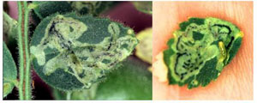
Fig. 1. Leaf mining (Right – leaf mining. Left – larva coming out of the mine) by chickpea leaf miner, Liriomyza cicerina. (Courtesy ICARDA).

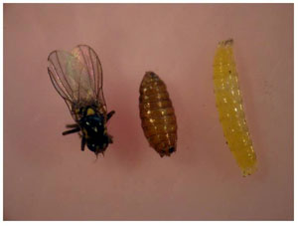
Fig. 2. Adult, pupal, and larval stages of the chickpea leaf miner, Liriomyza cicerina. (Courtesy ICARDA).

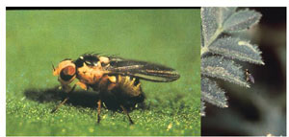
Fig. 3. Adult of Liriomyza cicerina. (Courtesy ICARDA)
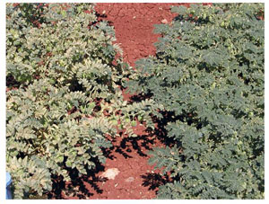
Fig. 4. Varietal reaction to damage by chickpea leaf miner, Liriomyza cicerina. (Courtesy ICARDA)

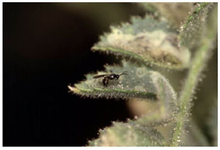
Fig. 5. Parasitoid, Opius monilicornis laying egg inside the chickpea leaf miner, Liriomyza cicerina. (Courtesy ICARDA)
Black Aphid: Aphis craccivora
The black aphid, Aphis craccivora (Hemiptera: Aphidiidae) is an important pest of chickpea in the Indian Subcontinent, and is an occasional pest in the Pacific Northwest USA. Aphis craccivora is also important as a vector of the chickpea stunt disease. It is commonly known as cowpea aphid, black aphid, black legume aphid, groundnut aphid, bean aphid, lucerne aphid, black lucerne aphid, and African bean aphid.

Geographic distribution

The black aphid, A. craccivora is distributed in Europe, Asia, Africa, Australasia and Pacific Islands, North and Central America, and South America. It is widely distributed in the tropics, where it is one of the most common aphid species.

Host range

Aphis craccivora has an extensive host range, and damages several grain legumes including chickpea, lentil, cowpea, groundnut, alfalfa, and other legumes. It also infests Glaricidia sp., Capsella bursa-pastoris, Chenopodium album, Polygonum lapathifolium, and Rumex crispus. Aphis craccivora is a key pest of lentil in Castilla La Mancha (central Spain).

Nature of damage
Both nymphs and adults suck the plant sap from the tender leaves, stems and pods, and mostly colonize the young leaves and growing points, which become characteristically deformed (Fig. 1). Yield can be drastically reduced, and if infestations are early and severe, plants can be killed completely. Infestations during the bloom and early pod stages reduce yield and crop quality by removing plant sap, impairing pod appearance, reducing seed fill, and by the presence of aphid honeydew. Plants with high populations also have reduced ability to fix nitrogen. In many areas, A. craccivora is more important as a vector of viruses than as a direct plant feeder. While feeding, the aphid produces considerable amount of honeydew upon which sooty mold grows. The black sooty mold reduces photosynthesis and may make leaves unpalatable to livestock. The honeydew also makes the plants sticky, which causes problems during harvesting and threshing.
Life cycle
The black aphid, A. craccivora is readily distinguishable from other aphids. It is a relatively small insect, and the adults are usually shiny black, while the nymphs are slate gray. The appendages are usually whitish with blackish tips. The life cycle of A. craccivora passes through nymph to adult stage, which is completed in 8 to 10 days. The aphids are active throughout the year, and a female can produce over 100 nymphs in 15 days. There are several generations in the tropics. Winged, sexual forms of A. craccivora also occur in some regions, e.g., in India, but not in others.
Management
Monitoring. Aphid infestation should be monitored regularly, particularly when the crops begin to flower. Action thresholds are 1 to 2 aphids per leaf, 2 to 3 aphids per stem tip, or 9 to 13 aphids per sweep, if a sweep net is used for sampling.

Cultural Control. Early sowing leads to early canopy closure, which also helps in reducing the spread of viruses in chickpea. Aphid infestation is greater under wider spacing.
Biological control. Aphis craccivora is attacked by several parasites and predators. Ladybirds, Coccinella septempunctata, C. transversalis, C. nigritis, Menochilus sexmaculatus (Fig. 2), and Brumus suturalis; and chrysopids, Chrysoperla spp. are common aphid predators. The parasitoids such as Trixys indicus and Lipolexix scutellaris are important natural enemies of A. craccivora in India. Although parasitism as high as 95% has been documented, aphid population levels can be so high that enough non-parasitized individuals remain to cause significant injury.
Biopesticides. Plant products such as azadirachtin, neem oil, and pyrethrins have shown some suppression of A. craccivora populations, but do not provide effective control of the aphids.
Host plant resistance. A number of genotypes have been reported to be less susceptible to aphid damage. Chickpea varieties with low trichome density or those devoid of trichomes, and low acid exudates are highly susceptible to aphid damage.

Chemical control. Generally, there is no need for aphid control on chickpea in India, but chemical control may become necessary to prevent secondary spread of the chickpea viruses. A number of insecticides such as methomyl, oxy-demeton methyl, and monocrotophos are effective for aphid control. Aphis craccivora has also developed resistance to some commonly used insecticides in India.
Management. Biological control with predatory coccinellids has a considerable potential for management of aphids. Aphids infest lentil fields only at later stages of crop development (podding), where no spray is necessary. If infestation occurs before pod maturity, insecticide sprays may be given. Aphids are attacked by a number of natural enemies, especially coccinellids. Although the larvae and adults feed on aphids, the extremely fast reproduction rate of the aphids prevents the coccinellids from reducing infestation levels sufficiently. Under heavy infestation, application of selective insecticides for aphid control may be necessary.

Selected References
CABI (Commonwealth Agricultural Bureau International). 1983. Aphis craccivora. Distribution Maps of Plant Pests. Map 99. Commonwealth Agricultural Bureau International, Wallingford, UK.
Dhingra, S. 1994. Development of resistance in the bean aphid, Aphis craccivora Koch. to various insecticides used for nearly a quarter century. J. Entomol. Res. 18:105-108.
Kaiser, W. J., Ghanekar, A. M., Nene, Y. L., Rao, B. S., and Anjaiah, V. 1990. Viral diseases of chickpea. Pages 139-142 in: Chickpea in the Nineties: Proceedings of the Second International Workshop on Chickpea Improvement, 4-8 December 1989, International Crops Research Institute for the Semi-Arid Tropics (ICRISAT), Patancheru, Andhra Pradesh, India.
Lal, S. S., Yadava, C. P., Dias, C. A. R., and Nigam, R. 1989. Effect of planting density and chickpea cultivars on the infestation of black aphid, Aphis craccivora Koch. Madras Agric. J. 76:461-462.
Loss, S., Brandon, N., and Siddique, K. H. M. (Eds.). 1998. The Chickpea Bulletin 1326. Western Australian Department of Agriculture, Perth, Australia. 76 pp.
Perez Andueza, G., Mozos Pascual de los, M., and Portillo Rubio, M. 2004. Main pests of lentil (Lens culinaris Medikus) in Castilla La Mancha (central Spain): crop losses and influence on yield parameters. Boletin de Sanidad Vegetal, Plagas 30:763-772.
Reed, W., Cardona, C., Sithanantham, S., and Lateef, S. S. 1987. The chickpea insect pests and their control. Pages 283-318 in: The Chickpea, M. C. Saxena and K. B. Singh, eds. CAB International, Wallingford, UK. pp. 283-318.
Singh, R., and Tripathi, N. 1987. Record of parasitoids from Tarai belt of eastern Uttar Pradesh. J. Aphidol. 1:89-92.
Singh, S. R., and Van Emden, H. F. 1979. Insect pests of grain legumes. Annu. Rev. Entomol. 24:255-278.
Waterhouse, D. F. 1998. Biological Control of Insect Pests: Southeast Asian Prospects. Australian Council of International Agricultural Research (ACIAR) Monograph No. 51.

(Prepared by H. C. Sharma, M. K. Dhillon and J. Romeis)

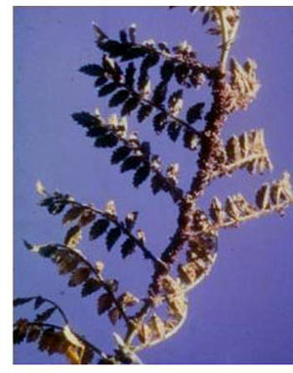
Fig. 1. Black aphid, Aphis craccivora infesting chickpea. (Courtesy ICRISAT)

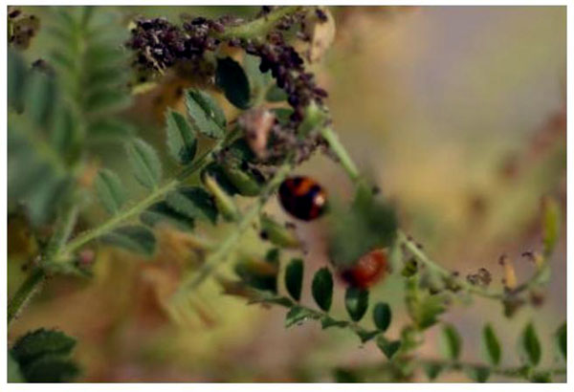
Fig. 2. Coccinellid beetle feeding on Aphis craccivora in chickpea. (Courtesy ICRISAT)

Pea Aphid: Acyrthosiphon pisum
Pea aphid, Acyrthosiphon pisum (Hemiptera: Aphididae), commonly known as pea aphid, green pea aphid, and green alfalfa aphid, is an important pest of lentils. It is a key pest of lentil in Castilla La Mancha (central Spain), and is also an important pest of lentil in India.

Distribution

The pea aphid, A. pisum has a worldwide distribution, and is a major pest of lentil in America, Europe, Africa, Australia, and Asia.
Host range
Many species of grain legumes including pea, lentil, alfalfa, faba bean, Melilotus officinalis, Ononis repens, Sarothamnus scoparius, Trifolium spp., Vicia cracca, etc. are important hosts of pea aphid, A. pisum.
Nature of damage
Both nymphs and adults suck the plant sap from the tender leaves, stems and pods, and mostly colonize the young leaves and growing points, which become characteristically deformed. Yield may be drastically reduced if infestations are early and severe. Aphid infestations during the bloom and early pod stages reduce yield and crop quality by removing plant sap, impairing pod development, reducing seed fill, and by the presence of aphid honeydew. Plants with high aphid populations also have a reduced ability to fix nitrogen. Pea aphids can transmit many viruses including pea enation mosaic virus, even to crops that they rarely feed on, such as cucurbits.
Life cycle
Pea aphid, A. pisum is 3 to 4 mm long, greenish, has long legs, and reproduces parthenogenetically (females produce offspring without mating). The aphid has viviparous colonies (Fig. 1) of wingless females (apterae), which later convert to winged forms for further dispersion. The winged females (alatae) of this aphid are carried by the wind to the host plants. Live female nymphs (no egg stage necessary) are produced throughout the year. Females take 9 to 12 days to complete development. There are three moults, and each female produces up to 150 nymphs. There are 13 to 20 generations per year. Adults may or may not have wings, but produce winged individuals for dispersion if conditions become crowded or plants become desiccated. Sexual forms occur in the fall, and eggs are laid after mating. Populations tend to be lower after cold, snowless winters, or springs with persistent wet weather. The net reproductive rate and post-reproductive period, adult longevity, survival, fecundity, and the lifespan have been found to be significantly longer on lentils than on other crops. Daily nymph production is significantly correlated with minimum temperature.
Management
Monitoring. Start aphid monitoring when plants begin to flower. Action thresholds vary from 1 to 2 aphids per leaf, 2 to 3 aphids per stem tip, or 9 to 13 aphids per sweep, if a sweep net is used for sampling.
Cultural control. No specific cultural practices have been recommended for aphid control in lentil. However, harvesting or spraying nearby alfalfa, vetch, or clover before winged adults are formed in the spring minimizes aphid damage.
Host plant resistance. Varieties differ in their susceptibility to pea aphid damage. Varieties with aphid resistance should be planted in areas endemic to infestations by this aphid. The genotype, French Indigo has high levels of antibiosis, while Spanish Brown has high levels of antixenosis and tolerance to A. pisum.
Biological control. There are many natural enemies such as predatory coccinellids, lacewings, flower fly larvae, predatory midges, and braconid wasps that help reduce aphid numbers. However, under heavy infestation, natural enemies may not provide adequate control. Fungi such as Pandora neoaphidis, can control high aphid populations during warm, humid, and wet weather.
Chemical control. In case of severe infestations, foliar application of dimethoate, pirimicarb or other systemic insecticides provides adequate control.
Integrated pest management. Host plant resistance and biological control with predatory coccinellids has a potential for the management of aphids in lentil. Aphids often infest lentil fields only at later stages of crop growth (podding), where no spray is necessary. If re-infestation occurs before pod maturity, insecticide sprays may be given. Aphids attract a number of natural enemies, especially coccinellids. Although the larvae and adults feed on aphids, the extremely fast reproduction rate of the aphids prevents the coccinellids from reducing infestation levels sufficiently.

Selected References
Andarge, A., and Van Der Westhuizen, M. C. 2004. Mechanisms of resistance of lentil Lens culineris Medicus, genotypes to the pea aphid Acyrthosiphon pisum Harris (Heniptera: Aphididae). Int. J. Trop. Insect Sci. 24:249-254.
Aydin, H., Muehlbauer, F. J, and Kaiser, W. J. 1987. Pea enation mosaic virus in lentil (Lens culinaris). Plant Dis. 71:635-638.
CABI (Commonwealth Agricultural Bureau International). 1982. Acyrthosiphon pisum. In: Distribution Maps of Plant Pests, December 1982, Map 23. Commonwealth Agricultural Bureau International, Wallingford, UK.
Lal, S. S. 1992. Insect pests of lentil and their management: review. Agric. Rev. 13:225-232.
Perez Andueza, G., Mozos Pascual de los, M., and Portillo Rubio, M. 2004. Main pests of lentil (Lens culinaris Medikus) in Castilla La Mancha (central Spain): crop losses and influence on yield parameters. Boletin de Sanidad Vegetal, Plagas 30:763-772.
Wale, M., Jembere, B., and Seyoum, E. 2000. Biology of the pea aphid, Acyrthosiphon pisum (Harris) (Homoptera: Aphididae) on cool-season legumes. Insect Sci. Appl. 20: 171-180.
Weigand, S., Lateef, S. S., El Din Sharaf, N., Mahmoud, S. F., Ahmed, K., and Ali, K. 1994. Integrated control of insect pests of cool season food legumes. Pages 679-674 in: Expanding the Production and Use of Cool Season Food Legumes, F. J. Muehlbauer and W. J. Kaiser, eds. Kluwer Academic Publishers, Dordrecht, The Netherlands.
Yadava, C. P., and Ahmad, R. 2000. Insect pests of lentil and their management. Appl. Entomol. 2:82-95.

(Prepared by J. Romeis, M.K. Dhillon, and R. Ahmad)
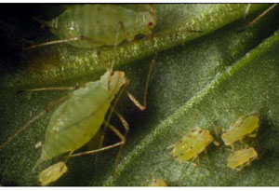
Fig. 1. Pea aphid, Acyrthosiphon pisum infesting lentil. (Courtesy Jorg Romeis)
Lygus bugs: Lygus spp.

Tarnished plant bug, Lygus lineolaris and the western tarnished plant bug, L. hesperus (Hemiptera: Miridae) are pests of lentil in western USA. Feeding by Lygus bugs produces depressed, chalk-colored lesions (chalky spot) on the lentil seeds where the bug has fed. These bugs are pests of lentil throughout the Palouse area (eastern Washington and northern Idaho) in the USA. In years where pea aphid populations are very low, early sprays are not applied and this results in greater damage by the Lygus bugs. Scouting for Lygus bug is critical to prevent damage to the crop. Close examination of the plants is the best way to see Lygus bugs, which are present under the curly leaves of the lentil plants during the daytime, and rarely seen on the visible portions of the crop.

Distribution
Tarnished plant bug, L. lineolaris (Fig. 1) is distributed in North America, Central America, and the Caribbean; while the western tarnished plant bug, L. hesperus (Fig. 2), is distributed in North America, The European tarnished plant bug, L. pratensis, is distributed throughout Europe and Asia (Afghanistan, China, Persia, Turkey).

Host range
Lygus hesperus is a polyphagous pest on several crops and weeds. Alfalfa is the primary host of western tarnished plant bug, L. hesperus, which is also an important pest of sorghum in USA. Lygus lineolaris is polyphagous and attacks a wide range of fruits, vegetables, and ornamentals. Economic losses have been recorded in cotton, alfalfa, snap bean, lima bean, soybean, lentil, tomato, and nursery stock. Lygus rugulipennis damages Vicia sativa, Trifolium pratense, Medicago sativa, red clover, etc. Lygus pratensis damages a wide range of field and garden crops.

Nature of damage
The Lygus bugs puncture the tissue and feed on immature reproductive structures causing "chalky spot syndrome" (physical deformations) on lentil seeds, which increases the prevalence of shriveled, unfilled pods, and seed abortion. Incidence of growing-point injuries by Lygus spp. is a serious problem on cauliflower in Sweden. The bugs are most active during the early-morning, and cause most damage to newly emerging seedlings.

Life cycle

The adult bugs are about 6 mm long and 2.5 mm wide, flattened, oval, and of various colors from pale green to yellowish brown, and have a distinctive triangle or "V" mark about one-third of the distance down the back, just in front of the wings. The legs and antennae are relatively long. The young nymphs are pale-green in color and look like aphids, except that they are more active. Older nymphs are quite variable in color, and are similar to adults. The older nymphs develop prominent black dots on the top of the thorax and abdomen. The adults overwinter in protective hedgerows, fallen leaves, and other plant debris. Emerging in mid-April to late-May, they feed on weed hosts. The eggs are laid on the stems and petioles and the egg incubation period last for about 10 days. The 1st generation adults appear in mid-June to mid-July. They leave the host weeds, and disperse into the adjacent crops. The second generation nymphs feed on the host plants during August, causing economic damage. A smaller third generation may emerge in September.

Overwintering adults of L. lineolaris can be found in dead weeds, leaf litter, under tree bark, in rock piles in fields, timber margins, stream banks, and roadside. Adults become active in early spring and feed on newly developing buds and shoots. Eggs are often deposited in leaf petioles or at the base of the leaf blade, but the preferred location varies with the crop attacked (Fig. 3). Eggs are usually deposited singly, but occasionally more than one egg may be found at an oviposition site. The eggs hatch in about 7 to 10 days. The newly hatched nymph (Fig. 4) is about one mm long, yellowish-green nymphs emerge and begin feeding (Fig. 5). There are five nymphal stages. The life cycle is completed in 3 to 4 weeks. There are 2 to 3 generations per year. Population peaks for adults generally occur in early July, early August, and early September.

Management
Although Lygus bugs are not serious pests of lentil, and do not require any control measures, an understanding of management practices well in advance would be helpful in managing them on lentil as and when they reach economic threshold levels.

Cultural control. Strip cutting is used to limit Lygus migration from forage lucerne to susceptible neighboring crops when the lucerne is harvested. The localized treatment of alfalfa strips significantly reduces the extent of damage on lettuce plots adjacent to the trap crops. Removal of plant materials following seed harvest during late summer does not provide significant control of bugs for the following year. No-tillage encourages population buildup of L. lineolaris in maize and soybean. Alfalafa can be used as a strip cop in cotton to keep L. lineolaris population under check. Some of these practices may be suitably modified to reduce the damage by Lygus bugs in lentil.

Biological control. Several parasitoids (Anaphes iole, Peristenus stygicus, and Leiophron uniformis), and predators (Geocoris punctipes, Orius insidiosus, and Chrysoperla spp.) can be used for biological control of Lygus spp. Anaphes iole is a solitary egg parasitoid of Lygus bugs in North America. Phasia obesa is parasitic on Lygus adults, and P. pallipes, P. relictus, and P. varisae are parasitic on nymphs. Peristenus digoneutis and P. stygicus have been used for biological control of Lygus species in North America.

Host plant resistance. Host plant resistance will be useful for increasing the effectiveness and longevity of other Lygus control measures. Although the Lygus spp. have not been reported as serious pests of lentil, host plant resistance could be an important tool for the management of this pest in crops where it has been reported as a major pest such as cotton. Cotton genotype Arkot A306 has been reported to be resistant to L. lineolaris. The use of Bacillus thuringiensis (Bt) transgenic cotton has reduced insecticide application against bollworm complex, and has also reduced Lygus populations.

Chemical control. Malathion, dimethoate, trichlorfon, and fluvalinate are effective for the control of Lygus spp. Oxadiazine has been reported to be effective in conservation of beneficials in a cotton ecosystem and is safer to farm labor and the environment.

Biopesticides. The entomopathogenic fungus, Beauveria bassiana isolate MK 2001 (1 x 10⁷ conidia ml⁻¹) is highly pathogenic to adults of L. lineolaris (84% mortality). Application of fungal isolate MK 2001, 2 to 4 days before applying the fungicides metalaxyl, mancozeb, or copper oxide synergized the insecticidal effect of this fungus. However, application of fungicides prior to MK 2001 fungal isolate antagonized the insecticidal effect. Beauveria bassiana can be used for the control of L. rugulipennis in the greenhouse. A combination of B. bassiana and the antifeedant chemical, pymetrozine reduced the numbers and damage by L. rugulipennis in cucumber. Some of these measures can be adapted for controlling Lygus bugs in lentil.

Integrated pest management. Adoption of cultural approaches to manage Lygus spp. will be largely influenced by the availability and efficacy of management practices, including insecticides. Sprays of B. thuringiensis in alfalfa have been found to be effective against the first three nymphal instars of L. hesperus, but the adults are tolerant to Bt sprays. Traps baited with live L. rugulipennis females attract conspecific males, which can form the basis for timely control measures. Use of entomopathogenic fungus B. bassiana is quite effective against the tarnished plant bugs. Mowing of alternate rows for weed management, and preventing mirids from migrating from adjoining areas is effective for managing L. rugulipennis. Although several parasitoids and predators can be used for biological control of Lygus bugs, there is a need to develop mass rearing techniques for these natural enemies. A combination of sanitation practices and insecticide applications is quite effective to control the L. lineolaris. Use of insect-nets and yellow chromotropic traps is another effective method of preventing the damage by Lygus bugs. These methods can be modified for use for the control of Lygus bugs in lentil.

Selected References

Bourland, F. M., and Smith, C. W. 2001. Registration of Arkot A306 and Arkot A314 germplasm lines of cotton. Crop Sci. 41:2008-2009.
CABI (Commonwealth Agricultural Bureau International). 1954. Lygus pratensis. Distribution Maps of Plant Pests. Map 39. Commonwealth Agricultural Bureau International, Wallingford, Oxfordshire, UK.
CABI (Commonwealth Agricultural Bureau International). 2000. Lygus lineolaris. Distribution Maps of Plant Pests. Map 604. Commonwealth Agricultural Bureau International, Wallingford, Oxfordshire, UK.
Godfrey, L. D., and Leigh, T. F. 1994. Alfalfa harvest strategy effect on Lygus bug (Hemiptera: Miridae) and insect predator population density: implications for use as trap crop in cotton. Environ. Entomol. 23:1106-1118.
Jacobson, R. J., and Enkegaard, E. 2002. Lygus rugulipennis Poppius (Het., Miridae): options for integrated control in glasshouse-grown cucumbers. Bulletin OILB SROP 25:111-114.
Ramert, B., Hellqvist, S., and Petersen, M. K. 2005. A survey of Lygus parasitoids in Sweden. Biocontr. Sci. Tech. 15:411-426.
Smith, R. A., and Nordlund, D. A. 2000. Mass rearing technology for biological control agents of Lygus spp. Southwestern Entomol. (Supplement) 23:121-127.
Tanigoshi, L. K., Mayer, D. F., Babcock, J. M., and Lunden, J. D. 1990. Efficacy of the beta-exotoxin of Bacillus thuringiensis to Lygus hesperus (Heteroptera: Miridae): laboratory and field responses. J. Econ. Entomol. 83:2200-2206.
(Prepared by Margaret L. Allen)

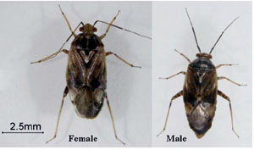
Fig. 1. Lyzus lineolaris adults. (Courtesy Cathe L. Smith)
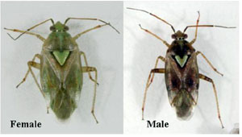
Fig. 2. Lyzus hesperus adults. (Courtesy Cathe L. Smith)
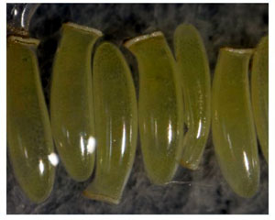
Fig. 3. Eggs of Lygus lineolaris. (Courtesy Cathe L. Smith)
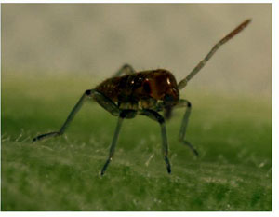
Fig. 4. Lygus lineolaris nymph hatching from the egg. (Courtesy Cathe L. Smith)
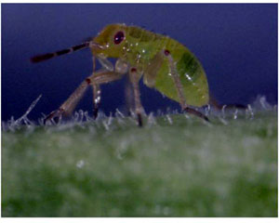
Fig. 5. Young nymph of Lygus lineolaris feeding on host plant. (Courtesy Cathe L. Smith)

Thrips: Frankliniella occidentalis, Kakothrips robustus, and Thrips angusticeps spp.

Several species of thrips including Frankliniella occidentalis, Kakothrips robustus, Thrips angusticeps, and Thrips tabaci (Thysanoptera: Thripidae) damage grain legumes, including lentil.

Geographic distribution
Frankliniella occidentalis (Fig. 1) is commonly known as western flower thrips. The majority of the species under Frankliniella are present either in North or South America, but a few are cosmopolitan. Frankliniella schultzei is known as cotton bud thrips, and is important in Asia as a vector of tomato spotted wilt virus (TSWV). Kakothrips robustus is known as pea thrips, which is widely distributed in Europe. It attacks several crops such as lathyrus, lucerne, mustard, and horse-bean in Poland, Hungary, Romania, Bulgaria, and Czechoslovakia. Thrips tabaci and Thrips angusticeps are commonly known as onion or potato thrips. The genus Thrips comprises of several hundred species, which are polyphagous, and cosmopolitan in distribution. Thrips tabaci and T. angusticeps have been reported as key pests of lentil in Central Spain.

Host range
Frankliniella occidentalis is a polyphagous pest, and has a wide host range including cereals, legumes, ornamentals, and fruit trees (grapes, citrus, peach, plum, strawberries, raspberries, etc.). This species is of worldwide importance as a vector of TSWV in a number of crops. Kakothrips robustus is polyphagous, and infests a number of cultivated and weed hosts. Thrips tabaci and T. angusticeps infest onion, tobacco, cotton, tobacco, peas, brassicas, watermelon, mango, gladiolus, banana, cucurbits, oil palm, etc. Besides infesting cultivated crops, these species also feed on several weed hosts. Thrips tabaci and T. angusticeps are important pests of lentil in Central Spain, and affect the productivity and quality of seeds.

Nature of damage
Most of the Frankliniella spp. prefers flowers (Fig. 2), but in the absence of flowers, they also feed on foliage (Fig. 3). When the populations of thrips are high, the plant terminals may blacken and wither. Feeding by thrips on young leaves results in silvery streaks on the opened leaves, distortion, or curling of leaves. In case of severe infestation, the leaf area is reduced, which indirectly affects photosynthesis and grain yield.

Life cycle
The life history of thrips involves an egg, two active larval instars that feed, followed by two (or three) relatively inactive pupal instars that probably do not feed, and the adults. One or both sexes may be wingless. In most phytophagous thrips, the eggs are inserted into the tissue of green plants. The males are generally haploid and derived from unfertilized eggs. Despite this sex-determination process known as haplodiploidy, many unrelated species have evolved the ability to reproduce in the absence of males. The cytological mechanisms involved are not fully understood, but parthenogenesis is important when the pest species are introduced to new areas. Sexual dimorphism is usually evident and is sometimes remarkable. Males of flower- and leaf-living species are usually smaller than the females, but males of fungus-feeding species are often much larger than females. Many phlaeothripid species produce different sized morphs, with and without wings. These forms often exhibit bizarre patterns of allometric growth, particularly of the forelegs, and as a result, different morphs are considered to represent unrelated species. The adults and larvae of many species of thrips are found only in flowers, where they feed by sucking out the contents of pollen grains, and probably, the cell sap of other flower tissues around the bases of the anthers and on the developing fruits. Some flower-living species also feed on leaves, but most leaf-feeding species are restricted to leaves. Some thrips are associated with very young leaves, and these insects are often very small and active. Under optimum conditions, one generation may be completed in 12 to 15 days. Kakothrips robustus is known to have only one generation a year in England with established diapause. Fully-grown larvae usually enter the soil in mid-summer, pupate early in the following spring, and emerge as adults in late spring. Thrips tabaci and T. angusticeps have 1 or 2 generations in temperate regions and undergo diapause. However, there are multiple generations and no diapause in the tropics.

Management
Cultural practices: Agronomic practices such as adjusting planting date, seed rate, and intercrops play a significant role in suppressing thrips populations. Climatic conditions such as mild winter (10 to 12⁰C night temperatures as in case of southern India), which are unfavorable to crops, are favorable to thrip population build up. Avoiding planting thrip susceptible crops during the vulnerable phase would help in minimizing inputs on plant protection.

Host plant resistance: Resistant sources can play a significant role in the management of thrips in several crops. However, there is no such information on host plant resistance to thrips in lentil.

Biological control: Entomophthora spp. epizootic on T. tabaci were noticed in the Netherlands in glasshouse situation on eggplants. Entomophthora parvispora occurs widely throughout central and southern Europe. However, the fungus has not been successfully multiplied. Since bio-agents have not successfully kept the pest under manageable levels, it has been recommended to use selective chemicals for the management of thrips. Application of the nematode, Steinernema feltiae against F. occidentalis decreased the population, but did not provide adequate control. Introduction of Amblyseius spp. shortly after thrip invasion in cucumber provides satisfactory control of T. tabaci, suggesting the feasibility of biocontrol.

Chemical control: Several researchers have shown efficient management of thrips as well as diapausing populations by foliar and soil application of insecticides. Systemic insecticides such as dimethoate, monocrotophos, and imidacloprid; and insecticides with fumigant action such as dichlorvos have been found to be effective against a range of thrips species. However, several thrips species have been reported to develop resistance to insecticides. There is 30-fold difference in resistance to malathion and 25-fold difference to dichlorvos in western flower thrips in UK. There is no resistance to insecticides in F. occidentalis to abamectin, methiocarb, and pyrazophos in Australia. However, build-up of resistance to chlorpyriphos, dichlorvos, and malathion has been recorded. Acephate, dimethoate, endosulfan, fipronil, methamidophos, methidathion, and spinosad are quite effective for controlling thrips. Resistance to imidacloprid, dimethoate, and thiamethoxam has been observed in T. tabaci in India.

Integrated pest management: Several management strategies have been developed for the management of thrips on several crops such as manipulating sowing dates, proper spacing, intercropping, utilizing resistant sources, use of biocontrol agents, disposal of plant residues, and need based application of pesticides. However, most of these are location specific.

Selected References

Herron, G. A., and James, T. M. 2005. Monitoring insecticide resistance in Australian Frankliniella occidentalis. Pergande (Thysanoptera: Thripidae) detects fipronil and spinosad resistance. Australian J. Entomol. 44:299–303.
Lewis, T. 1997. Pest thrips in perspective. Pages 1-13 in: Thrips as Crop Pests, T. Lewis, ed. Commonwealth Agriculture Bureau International, Wallingford, UK.
McDonald, C. O. 1995. Response of western flower thrips to dichlorovos and malathion in the United Kingdom. Pages 347-350 in: Thrips Biology and Management, B. L. Parker, M Skinner and T. Lewis, eds. Plenum Press, New York.
McLeod, D. M., Tyrrell, D., and Carl, K. P. 1976. Entomophthra provispora sp. nov., a pathogen of Thrips tabaci. Entomophaga 21:307-312.
Mound, L. A. 1976. The identity of the greenhouse thrips, Heliothrips haemorroidalis (Bouche) (Thysanoptera) and the taxonomic significance of spanandric males. Bull. Entomol. Res. 66:179-180.
Palmer, J. M., and Mound, L. A. 1978. Nine genera of fungus-feeding Phlaeothripidae (Thysanoptera) from the Oriental region. Bull. British Mus. Nat. Hist. Entomol. 37:153-215.
Perez Andueza, G., Mozos, P.M. de los, and Portillo Rubio. M. 2004. Main pests of lentil in Castilla La Mancha: crop losses and influence on yield parameters. Boletin de Sanidan Vegetal Plagas 30:763-772.

(Prepared by G. V. Ranga Rao)

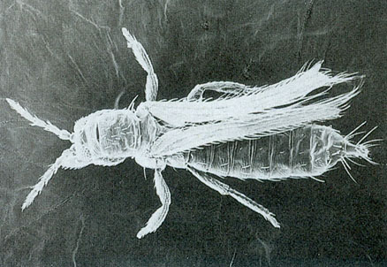
Fig. 1. Western flower thrips, Frankliniella occidentalis adult. (Courtesy ICRISAT)
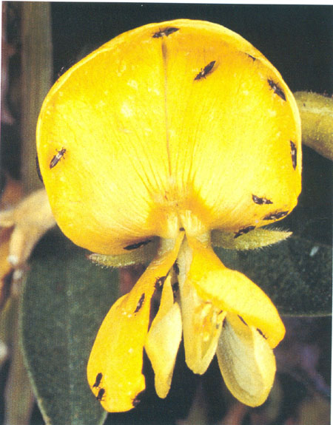
Fig. 2. Western flower thrips, Frankliniella occidentalis feeding on flowers. (Courtesy ICRISAT)
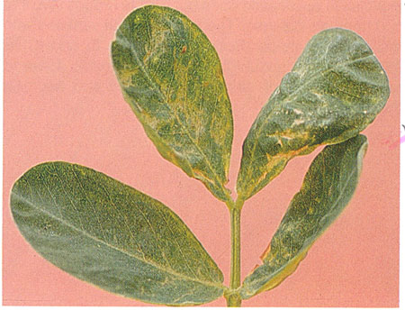
Fig. 3. Western flower thrips, Frankliniella occidentalis, feeding on foliage. (Courtesy ICRISAT).

Green Stink Bug: Nezara viridula

Green stinkbug, Nezara viridula (Hemiptera: Pentatomidae), is a highly polyphagous pest on several grain legumes including lentil. The nymphs and adults suck the sap from leaves and developing pods.

Distribution
Green stinkbug, N. viridula is distributed all over the world. Several authors have depicted eastern Palearctic or Indo-Malayan region as the ancestral home of N. viridula. The N. viridula has also been recorded on soybean in north eastern Brazil, and is spreading in the Neotropical region. It is also known as green vegetable bug, southern green stinkbug, eastern green stinkbug, and pentatomid bug.

Host range
The green stinkbug, N. viridula, is a highly polyphagous pest of many important agricultural crops and weeds. It feeds on several plant species including cotton, sunflower, soybean, mungbean, clover, fababean, lentil, wheat, barley, flax, sugarbeet, okra, aubergine, pepper, tomato, cowpea, cabbage, cauliflower, potato, beans, and peas. Wild crucifers and leguminous plants are alternate hosts of N. viridula. This species has been reported as a minor pest on lentil.

Nature of damage
The nymphs and adults suck the sap from leaves, stems, and pods, resulting in malformation or drying up of the pods (Figs. 1 and 2). In lentil, it sucks the sap from shoots and pods. The N. viridula bugs cause varying degrees of damage from seedling stage where the young growing tips of plants dry up, until crop harvest, especially during reproductive phase, when they feed on the pods.

Life cycle
The adults are 14 to 18 mm long, green and shield-shaped with a small head (Fig. 2). There are five nymphal instars. The first instar nymphs cluster on or near the egg masses, and apparently do not feed. After the first moult, the nymphs begin to disperse and feed on leaves and pods. During the summers, the development period from egg to adult varies between 35 to 37 days, depending on temperature. A constant temperature of 28°C has been reported to be optimal for the growth and development of N. viridula. The egg incubation period ranges from 5 to 7 days. The 1st, 2nd, 3rd 4th, and 5th nymphal instars complete development in 3 to 5, 5 to 7, 7 to 9, 8 to 11, and 11 to 13 days, respectively. The entire life cycle is completed in 37 to 52 days. A female lays an average of 215 eggs (20 to 425 eggs per female). The host - weed phenology, host abundance and diversity, and natural enemies influence the population dynamics of N. viridula. With a reduction in flowering and fruiting stages of crop hosts/weeds, N. viridula migrates to other hosts, and may cause heavy damage.

Management
The green stinkbug is not a serious pest of lentil, and does not require pesticide application to reduce the damage. Management practices would be helpful in minimizing N. viridula damage in lentil when the population density exceeds economic threshold levels.
Cultural practices. The stinkbugs prefer soybean over cotton, and therefore, soybean can be used as a trap crop for attracting stinkbugs. Narrow-row plantings harbor more N. viridula than the wide-row plantings. The nymphal population of N. viridula has been found to be greater in crops with high phosphorus levels, while potassium or magnesium did not affect the population density.
Biological control. The most successful biological control agents are the scelionid egg parasitoids, Trissolcus basalis, and Trichopoda pilipes, which attack adults and large nymphs of N. viridula. Of the egg parasitoids, T. basalis is most important and distributed widely. Trichopoda giacomellii has also been reported to be an important parasitoid on the eggs of N. viridula in Australia. There are a number of predators on N. viridula, but they are nonspecific to this pest. Solenopsis invicta is the dominant predator on eggs and early stage nymphs. Grasshoppers are important egg predators during the reproductive stages of the plant. Trissolcus megallocephalus has been reported as an important egg parasitoid of N. viridula from Egypt. Parasitism by T. giacomellii plays an important role in regulation of the N. viridula populations in Argentina.
Biopesticides and natural plant products. The entomopathogenic fungi, Beauveria bassiana, Metarrhizium anisopliae, and Paecilomyces lilacinus result in high mortality of this insect under laboratory conditions, but are not very effective under field conditions. Sprays of Aglaia odorata, Annona squamosa, A. muricata, and Melia azedarch leaf extracts are moderately effective. Application of the Carica papaya leaf extract results in a significant reduction in N. viridula populations.
Host plant resistance. The hemipterans are difficult to control with insecticide sprays, and host plant resistance may help solve this problem. Since N. viridula is a serious pest at fruiting/podding stage, identification of genotypes with resistance to feeding on pods is important along with the plant traits that make the insects restless on the host plant. At the moment, there are no reports on identification of resistance to green stinkbug in lentil.
Chemical control. Prophylactic insecticide applications result in superior economic outcomes as compared with a strategy based on economic thresholds. Cypermethrin is quite effective for controlling the stinkbugs. Foliar sprays of cypermethrin + dimethoate result in better control of N. viridula as compared to application of neem or Pongamia kernel extracts. Endosulfan and λ-cyhalothrin are also effective for controlling this pest.
Integrated pest management. Field scouting, identification of different stages of the pest and its natural enemies, and knowledge of injury thresholds at different crop stages are important for developing effective management strategies. A management package involving early planting, close spacing, and need-based insecticide application at budding, flowering, or podding stages have been found to be effective in controlling this pest on cowpea, and possibly, can be adapted on lentil with suitable modifications. Biological, cultural, and chemical approaches have been adopted in Brazil to control N. viridula on soybean. No-till system, early-maturing cultivars, and early-planting have been recommended to reduce pesticide use. Use of natural plant products and biopesticides may be explored as a safer alternate to enhance the activity of natural enemies, in addition to identification of genotypes with resistance to N. viridula.

Selected References
Anyim, A. 2003. Effects of insecticidal treatment on the yield and control of major insect pests of soybean (Glycine max (L.) Merrill) in South-eastern Nigeria. Int. J. Agric. Rural Dev. 4:100-109.
CABI (Commonwealth Agricultural Buraux International). 1970. Nezara viridula. In: Distribution Maps of Plant Pests. CAB International, Nosworthy Way, Wallingford, Oxfordshire, OX10 8DE, UK.
Harris, V. E., and Todd, J. W. 1980. Temporal and numerical patterns of reproductive behavior in the southern green stink bug, Nezara viridula (Hemiptera: Pentatomidae). Entomol. Exp. Applic. 27:105-116.
McPherson, R. M., and Bondari, K. 1991. Influence of planting date and row width on abundance of valvetbean caterpillars (Lepidoptera: Noctuidae) and southern green stink bugs (Heteroptera: Pentatomidae) in soybean. J. Econ. Entomol. 84:311-316.
Nabirye, J., Nampala, P., Ogenga Latigo, M. W., Kyamanywa, S., Wilson, H., Odeke, V., Iceduna, C., and Adipala, E. 2003. Farmer-participatory evaluation of cowpea integrated pest management (IPM) technologies in Eastern Uganda. Crop Prot. 22:31-38.
Pitan, O. O. R., and Odebiyi, J. A. 2001. The effect of intercropping with maize on the level of infestation and damage by pod-sucking bugs in cowpea. Crop Prot. 20:367-372.
Sands, D. P. A., and Coombs, M. T. 1999. Evaluation of the Argentinian parasitoid, Trichopoda giacomellii (Diptera: Tachinidae), for biological control of Nezara viridula (Hemiptera: Pentatomidae) in Australia. Biol. Cont. 15:19-24.
Todd, J. W. 1989. Ecology and behavior of Nezara viridula. Annu. Rev. Entomol. 34:273-292.
(Prepared by M. K. Dhillon and R. Singh)

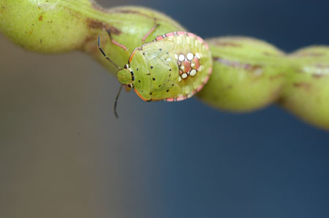
Fig. 1. Nymph of Nezara viridula feeding on the pod. (Courtesy ICRISAT)

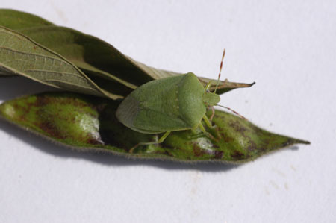
Fig. 2. Adult of Nezara viridula feeding on the pod. (Courtesy ICRISAT)

Integrated Pest Management

Storage pest: Bruchids Callosobruchus maculatus and Callosobruchus chinensis

Bruchids, Callosobruchus chinensis and C. maculatus (Coleoptera: Bruchidae) are one of the most important pests of grain legumes in storage, including chickpea and lentil. Bruchid infestation commences in the field even before the crop harvest, and then they multiply quite fast in storage, resulting in heavy losses. The Callosobruchus species are commonly known as spotted pulse beetle, Oriental pulse beetle, bruchid, bean weevil, bruchid seed beetle, gram bean weevil, southern cowpea weevil, cowpea weevil, etc.

Distribution
Callosobruchus chinensis and C. maculatus are cosmopolitan in distribution, encompassing Australia and Oceania, Europe, Asia, Africa, and the Americas.

Host range
The members of the family Bruchidae have long been reported to destroy the seeds of leguminous plants. They also feed on seeds and flowers of non-leguminous plants belonging to the families Compositae, Malvaceae, Convolvulaceae, Anacardiaceae, Rosaceae, Umbelliferae, Papavaraceae, and Palmae. Among the several species of bruchids attacking edible legumes, C. maculatus and C. chinensis are most destructive, and attack almost all edible legumes, including chickpea and lentil.

Nature of damage
Females of C. maculatus and C. chinensis lay eggs singly on seeds, which are visible to the naked eye (Fig. 1). Bruchids tend to lay eggs singly on a given host and if all the seeds are occupied, then the female starts laying eggs on already egg-laden seeds. The neonate larva bores into the seed beneath the oviposition site, and completes its development within a single seed. Damaged seeds are riddled with adult emergence holes (Fig. 1), which are unfit for human or animal consumption.

Life cycle
The life cycle of bruchids passes through five larval instars (Fig. 2), pre-pupal, pupal (Fig. 3), and adult (Fig. 4) stages. The egg incubation period of C. maculatus in green gram lasts for 3 to 5 days, and the combined larval and pupal period lasts for nearly 19 days. Total development is completed in about 24 days. The adults of C. chinensis and C. maculatus are easily distinguishable with the naked eye (Fig. 5).

Management
Pre-harvest control. Monocrotophos (0.04%), fenvalerate (0.02%), and dimethoate (0.03%) sprays at 45 and 50 days after flowering of pulses reduces C. chinensis damage in stored pigeonpea. Similarly, cowpea protected by spraying malathion (0.05%) at maturity reduces the bruchid damage. At pod maturity, the dehisced pods with exposed seeds are more vulnerable to oviposition by bruchids, and this problem can be avoided by harvesting the crop at physiological maturity.

Hermetic storage. Storing grain legumes in polythene bags with a cotton lining has been found effective against C. maculatus. Even though the adult females could penetrate the polythene bags, the cotton lining posed hindrance for oviposition, leaving the grains safe. Bagged grains encased in polythene sacks are also less damaged by the bruchids.

Solar treatment. High temperatures due to solar radiation have been found to kill developing bruchid larvae in the seeds. Exposing grain legumes to 70 to 80ºC temperature for short durations has been found to be effective in reducing the bruchid infestation. Solar heaters operated at 65°C for 5 min provide 100% control of C. maculatus. Solar heat treatment is being used in India for disinfesting the grains.

Use of inert dusts: Dusts remove the epicuticular lipid layer of the insects and have been used effectively against bruchids. Some of the dusts in use include bentonite clay, hydrated lime, attapulgite dust, limes, clays, synthetic silica, and sand. Treatment of pulses with fly ash also hinders emergence of C. maculatus adults up to 12 months.

Use of traps. Pitfall traps can be used for capturing insects that are active on the grain surface, and in other layers of grain. It also serves as a monitoring or mass trapping tool. Two models are available: standard model (Fig 6a) and the TNAU model (Fig 6b). A standard model has 2 parts, perforated lid (2 to 3 mm) and a cone-shaped bottom portion. A special coating with sticky material on the inner side of cone to hold the trapped insects is essential. The new model has a perforated lid and a cone-shaped bottom, which tapers into a funnel shaped trapping tube. It is made of plastic, and is simple and economical. Another two-in-one trap (Fig 6c) is a combination of probe and pitfall traps, and is designed to increase the trapping efficiency. This trap is also suitable for pulse beetles as they are seen only on grain surface. It does not require coating on the inner surface with sticky materials. Beetles are captured alive in this trap. The release of pheromone by the trapped insects attracts more insects.

Chemical control. Chemical methods such as fumigation with phosphine, methyl bromide, or dusting with primiphos methyl and permethrin are effective against bruchids, but have certain disadvantages such as increased costs, handling hazards, pesticide residue, and possibility of development of resistance. With the proposed ban of fumigants by 2015, there is an urgent need to develop safer alternatives to conventional insecticides and fumigants to protect stored grain from insect pests.

Host plant resistance. The chickpea genotypes CPI 29973, CPI 29975, CPI 29976, NCS 960003, K 902, CM 72, CMN 122, and BG 372 have been reported to be resistant to C. maculatus. Apart from cultivated legume species, wild relatives of several grain legumes have shown high levels of resistance to bruchids. Several varieties have been developed by crossing wild species with that of the cultigens, and the results have been highly promising.

Natural plant products. Neem, Azadirachta indica possesses antifeedant, oviposition repellant, ovicidal, and adulticidal properties against bruchids. Seed treatment with neem leaf powder at 0.5 to 2.0 mg 100⁻¹ g of grain, neem seed kernel powder, neem bark powder, and neem seed oil at 3% have been reported to be effective against bruchids. Neem oil and Pongamia oil reduce seed damage by C. maculates. Use of coconut, mustard, and groundnut oil (12 ml⁻¹ kg) to suppress adult emergence for two consecutive generations has also been recpmmended. Volatile oils of Cymbopogan nardus, C. schoenanthus, Clausena anisata, C. citratus, and Ocimum basilica have oviposition repellent and adulticidal effects. Lantana camara and Parthenium hysterophorus have also been reported to be repellent to pulse beetle in chickpea.

Biological control. Bruchids are attacked by parasitoids belonging to ten families of Hymenoptera and one of Diptera. Important biocontrol agents of bruchids are listed in Table 1.
Table 1. Natural enemies of bruchids.

Biocontrol agent | Species attacked
Anisopteromalis calandrae | C. maculatus  C. chinensis  C. analis
Dinarmus basalis | Callosobruchus spp.
D. acutus | C. maculatus
Uscana lariophaga | Callosobruchus spp.
U. mukerjii | C. chinensis
Pteromalus spp. | C. maculatus
P. cerealellae | C. maculatus  C. chinensis
Eupelmus spp. | C. maculatus
Pyemotes ventricosus | Callosobruchus spp.

Integrated pest management. Prevention of infestation in the field through timely harvest of the crop or insecticide use can be quite useful for reducing bruchid infestation. Optimum drying of the grain, use of solar radiation to kill the bruchids infesting the grain, and storing the grain in polyethylene bags can be used to reduce bruchid infestation. Dusts, neem leaf or kernel powder, and treatment of seed with neem, Pongamia, or other vegetable oils can be used for minimizing the losses due to bruchids. Under severe infestation, the grain should be fumigated to get rid of bruchids infesting the grain. An ideal management schedule would be as follows:
- Spraying monocrotophos or dimethoate at pod formation stage and just before pod maturity to infestation by bruchids in the field.
- Reducing the moisture content of the grains to less that 12% before storage. This can be accomplished by sun drying.
- Using polythene lined bags for storage.
- Treatment of grains with inert dusts such as clay, silica, fine sand, or fly ash.
- Use of pitfall traps as a low cost device for use in households and medium scale storage.
- Treatment of grain with botanicals such as neem oil, neem leaf powder, etc.

Though the above methods are economical, developing varieties with resistance to bruchids through interspecific hybridization and genetic transformation would be helpful in the long run. Use of biocontrol agents, pheromones, and controlled atmosphere storage (CAS) has been found to be very effective, and can be used for minimizing the losses due to bruchids.

Selected References

Durairaj, C. and Muthiah, A. R. 2003. Evaluation of plant oils against pulse beetle in mungbean. Page 246 in: Proceedings of the National Symposium on Pulses for Crop Diversification and Natural Resource Management, 20-22 Dec, 2003, Indian Institute of Pulses Research (IIPR), Kanpur, Uttar Pradesh, India.
Gonzalez-Valenzuela, M., Roche, R., and Simanca, M. E. 1988. Parasitation capacity of Pteromalus sp. in laboratory conditions. Cien. Agric. 33:19-22.
Gupta, H. C., Gupta, I. J., and Sharma, S. N. 1997. Parasitic wasp, Dinarmus acutus (Thompson) and D. basalis (Rondani) (Hymenoptera: Pteromelidae) parasitizing Callosobruchus maculatus (F.). J. Biol. Control. 11:77-78.
Islam, W. 1992. Mating and egg-laying behaviour of Dinarmus basalis (Rondani) (Hymenoptera: Pteromalidae), A larval-pupal parasitoid of Callosobruchus chinensis (Linnaeus) Ann. Entomol. 10:13-16.
Mohan, S., and Fields, P. 2002. A simple technique to assess compounds that are repellant (or) attractive to stored product insects. J. Stored Prod. Res. 38:23-31.
Murdock, L. L., and Shade, R. E. 1991. Eradication of cowpea weevil infestations in cowpea by solar heating. American Entomol. 37:228-231.
Riaz, A., Aslam, M., and Suleman, N. 2000. Evaluation of resistance in different chickpea strains to Callosobruchus chinensis (Linn.) under laboratory conditions. Pak. J. Biol. Sci. 3(6):1033-1036.
Singh, D., and Mehta, S. 1998. Screening of plant materials for repellant and insecticidal properties against pulse beetle (Callosobruchus chinensis) and housefly (Musca domestica). J. Med. Aromatic Pl. Sci. 20:397-400.
Wilkin, D. R., and Green, A. A. 1970. Polythene sacks for the control of insects in bagged grain. J Stored Prod. Res. 6: 97-101.
(Prepared by C. Durairaj and T. Srinivasan)

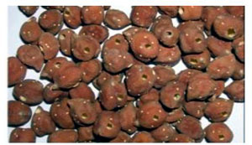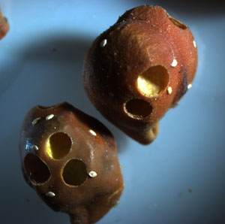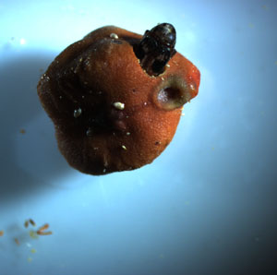
Fig 1. Bruchid damage in chickpea. A: a severely damaged seed lot (Courtesy C. Durairaj); B: solitary white eggs on damaged seeds (Courtesy W. Chen), and C: a beetle emerges from a damaged seed (Courtesy W. Chen).

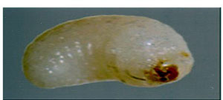
Fig. 2. Fourth instar grub of Callosobruchus chinensis. (Courtesy C. Durairaj)
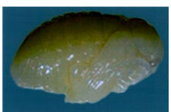
Fig. 3. Pupa of Callosobruchus chinensis. (Courtesy C. Durairaj)
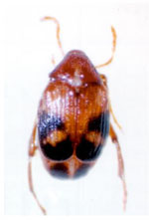
Fig. 4. Adult Callosobruchus chinensis. (Courtesy C. Durairaj)
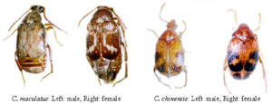
Fig 5. Species identity of bruchids. (Courtesy C. Durairaj)

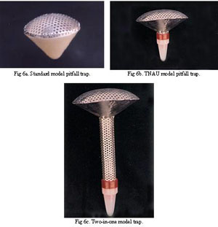
Fig 6. Traps for bruchid management. (Courtesy C. Durairaj)

Pest Management in Chickpea

Chickpea is the third most important legume crop in the world, after dry beans and peas. It is cultivated in 42 countries in South Asia, North and Central America, the Mediterranean Region, West Asia, and North and East Africa. In recent years, it has become an important crop in Australia, Canada, and the USA. Nearly 60 insect species are known to feed on chickpea. The important insect pests damaging chickpea in different regions are: wireworms [false wireworms - Gonocephalum spp.], cutworms [black cutworm - Agrotis ipsilon and turnip moth - Agrotis segetum], termites [Microtermes obesi and Odontotermes sp.], leaf feeding caterpillars [cabbage looper - Trichoplusia ni, leaf caterpillar - Spodoptera exigua, western yellow striped armyworm - Spodoptera praefica, and hairy caterpillar - Spilarctia obliqua], semilooper [Autographa nigrisignia], leaf miners [Liriomyza cicerina and L . congesta], pea leaf weevil - Sitona lineatus, aphids [Aphis craccivora], nodule damaging flies [Metopina ciceri], pod borers [cotton bollworm - Helicoverpa armigera, and native budworm - Helicoverpa punctigera], and bruchids [Chinese bruchid - Callosobruchus chinensis, bean bruchid - Acanthoscelides obtectus, pulse bruchid - Callosobruchus analis, and pulse bruchid - C. phaseoli]. Among the above pests the pod borer, H. armigera and the aphid, A. craccivora are the major pests of chickpea in the Indian subcontinent. In the Mediterranean region, the most important pest is the leaf miner, L. cicerina. Aphis craccivora is important as a vector of the chickpea stunt disease, while C. chinensis is the most dominant pest species in storage. Various components of pest management in chickpea are discussed below.
Population monitoring and forecasting. Efforts have been made to develop a forecasting system, particularly for H. armigera in India. A rule of thumb has been developed to predict H. armigera population using surplus/deficit rainfall in different months in southern India. A combination of surplus rains during the monsoon and deficit rainfall during November indicated low incidence, while deficit rains during the monsoon and surplus rains during November indicated severe attack. Additional information on November rainfall gives precise information on the level of attack (low, moderate, or severe). In Australia, population monitoring with sex pheromone-baited traps is used to detect the onset of immigration or emergence from local diapause. Abundance of H. armigera and H. punctigera as measured by light traps has shown that seasonal rainfall and local crop abundance give a reasonable prediction of the timing of population events, and the size of subsequent generations. Timing of control is determined by field monitoring of larval densities in crops through the period of crop susceptibility. Control is only recommended when larval populations in crops at the post-flowering stage exceed the threshold of 2 to 4 larvae per meter of row. There have been no efforts to study and develop population prediction models for other insects infesting chickpea. There may be need to know the conditions under which the leaf miner, L. cicerina infestations cross the economic threshold levels, and the climatic factors that may predict the onset of heavy infestations.

Host plant resistance. The development of chickpea cultivars resistant or tolerant to insects has a major potential for use in integrated pest management, particularly under subsistence farming conditions in developing countries. More than 14,000 chickpea germplasm accessions have been screened for resistance to H. armigera at ICRISAT, India, under field conditions. Several germplasm accessions (ICC 506EB, ICC 10667, ICC 10619, ICC 4935, ICC 10243, ICCV 95992, and ICC 10817) with resistance to H. armigera have been identified, and varieties such as ICCV 7, ICCV 10, and ICCL 86103 with moderate levels of resistance have been released for cultivation. However, most of these lines are highly susceptible to Fusarium wilt. Therefore, concerted efforts are being made to break the linkage by raising a large population of crosses between the lines with resistance to H. armigera and the lines resistant to wilt.
Efforts are also currently underway at ICARDA to develop varieties with resistance to the leaf miner, L. cicerina. Varieties with low trichome density or devoid of trichomes are highly susceptible to aphid, A. craccivora damage. A number of genotypes/lines have been reported to be less susceptible to aphid damage. High levels of resistance have been observed in desi type chickpeas to bruchids, Callosobruchus spp. Lines showing resistance to bruchids usually have small seeds with a rough seed coat. However, such grain is not acceptable to the consumers. Chickpea seed that is split for dhal is unattractive to ovipositing bruchid females, and therefore, processing the chickpea into split peas or flour immediately after crop harvest can minimize the losses due to these pests.
Cultural manipulation of the crop and its environment. A number of cultural practices such as time of sowing, spacing, fertilizer application, deep plowing, interculture, and flooding have been documented by several workers to reduce insect damage. Inter-cropping or strip-cropping with marigold, sunflower, linseed, mustard, and coriander can minimize the extent of H. armigera damage to the main crop. Strip-cropping also increases the efficiency of chemical control. Hand picking of large-sized larvae can also be practiced to reduce pod borer damage. However, the adoption of cultural practices depends on the crop husbandry practices in a particular agro-ecosystem. Crop rotations do not help manage the polyphagous and highly mobile insects such as Helicoverpa/Heliothis species, although it has been noted that some crops (e.g., alfalfa) are more attractive to the moths. Habitat diversification to enhance pest control has been attempted in Australia. An area-wide population management strategy has been implemented in regions of Queensland and New South Wales to contain the size of the local H. armigera population, and chickpea used as a trap crop plays an important role in this strategy. Trap crops are managed in the same way as commercial crops, but destroyed by cultivation before larvae begin to pupate. The trap crops reduce the size of the local H. armigera population before it can infest summer crops and start to increase in size. As a result, the overall H. armigera pressure on summer crops is reduced, resulting in greater opportunity for the implementation of softer control options, reduced insecticide use, and greater natural enemy activity. Plowing the fields before planting and after crop harvest reduces damage by the Helicoverpa and cutworm, Agrotis ipsilon. The plants at times are able to recover from foliar damage by H. armigera and the cutworms. The black aphid, A. craccivora incidence is greater under drought conditions and wider spacing. Early sowing leads to early canopy closure, which also helps to reduce virus spread in chickpea. Therefore, early sowing and optimum planting densities can be used to minimize aphid infestation. Early-sown crops also escape leafminer damage in West Asia.

Biological control. The importance of both biotic and abiotic factors on the seasonal abundance of H. armigera is poorly understood. Some parasitic wasps have been reported to avoid chickpea probably due to their dense layer of trichomes and the acidic exudates. The egg parasitoids, Trichogramma spp. are almost absent from chickpea ecosystem. The ichneumonid, Campoletis chlorideae is probably the most important larval parasitoid on H. armigera in chickpea in India. Carcelia illota, Goniophthalmus halli, and Palexorista laxa have also been observed to parasitize 3 to 54% larvae on chickpea. Predators such as Chrysopa spp., Chrysoperla spp., Nabis spp., Geocoris spp., Orius spp., and Polistes spp. are the most common in India, attacking Helicoverpa spp. on chickpea and other crops. Provision of bird perches or planting of tall crops that serve as resting sites for insectivorous birds such as Myna (Acridotheris tristis) and Drongo (Dicrurus macrocercus) helps to reduce the numbers of caterpillars.
Braconid wasps such as Microgaster sp., Bracon kitcheneri, and Fileanta ruficanda parasitize the black cutworm, A. ipsilon larvae, while Broscus punctatus and Liogryllus bimaculatus are common predators. A parasitic wasp, Opius sp. feeds on the leafminer larvae in West Asia, but further research is required before this insect can be used for biological control in the field. Coccinellids and chrysopids are common aphid predators, while Trixys indicus and Lipolexix scutellaris are important parasitoids.

Bio-pesticides and natural plant products. The use of microbial pathogens including H. armigera nuclear polyhedrosis virus (HaNPV), entomopahogenic fungi, Bacillus thuringiensis (Bt), nematodes, and natural plant products such as neem, custard apple, and karanj kernel extracts have shown some potential to control H. armigera. HaNPV is a viable option to control H. armigera in chickpea. Jaggery (0.5%), sucrose (0.5%), egg white (3%), robin blue (0.1%), and chickpea flour (1%) are effective in increasing the efficacy of HaNPV. The efficacy of HaNPV in chickpea is increased by the addition of milk powder, and the additive Aminofeed®. Entomopathogenic fungus, Nomuraea rileyi (10⁶ spores per ml) results in 90 to 100% larval mortality, while Beauveria bassiana (2.68 x 10⁷ spores per ml) resulted in 6% damage in chickpea compared to 16.3% damage in the untreated control plots. Formulations of Bt used as a spray are effective to control the H. armigera and semilooper, A. nigrisigna. Spraying Bt formulations in the evening results in better control than spraying at other times of the day. Spraying with neem seed kernel extract (5%) is effective for controlling the leaf miner, L. cicerina, but the persistence is limited.
Chemical control. Management of H. armigera on chickpea and other high-value crops relies heavily on insecticides. Cypermethrin, profenophos, spinosad, methomyl, and indoxacarb are quite effective for H. armigera control on chickpea. Spray initiation at 50% flowering is most effective for the control of H. armigera. Use of indoxacarb in chickpea in Australia is limited to one application with a cut-off date for application to ensure that at least one generation of H. armigera is not exposed to this insecticide before the commencement of its use in summer crops such as cotton and mungbean.
Endosulfan dusts, sprays, or baits are effective for cutworm control. Generally, there is no need for aphid, A. craccivora control on chickpea, but chemical control may become necessary to prevent the spread of the chickpea viruses. A number of insecticides such as methomyl, oxy-demeton methyl, and monocrotophos are effective for aphid control. Endosulfan, dichlorvos, and malathion have been recommended for controlling the semilooper, A. nigrisigna.

Integrated pest management (IPM). The important insect pests damaging chickpea that need to be controlled during different stages of crop growth are cutworms (A. ipsilon), leaf feeding caterpillars (S. exigua, S. praefica, S. obliqua, A. nigrisignia), leaf miners (L. cicerina and L. congesta), aphids (A. craccivora), pod borers (H. armigera and H. punctigera), and bruchids (Callosobruchus spp. and A. obtectus). Control measures may also be undertaken based on pest forecasting by pheromone or light trap catches (5 to 10 males per trap per day). Pheromone or light traps, booby traps, visual scouting, and sweep nets can be used to obtain an estimate of insect infestations to decide the need to initiate control measures. For pod borers, Helicoverpa spp., control measures may be undertaken based on economic thresholds (one egg per plant or 2 - 3 small larvae per meter row). Chickpea cultivars with resistance to insects can play major role in integrated pest management, particularly under subsistence farming. Varieties such as Vijay, Vishal, and ICCV 10 with low to moderate levels of resistance to pod borers can be cultivated in India. Varieties with resistance to leafminer and aphids have also been identified for use in West Asia. High levels of resistance have been observed in desi type chickpeas to bruchids, Callosobruchus spp.
Early plantings generally suffer low damage due to leafminer in West Asia and the Americas. Early sowing leads to early canopy closure, which also helps to reduce virus spread in chickpea. Therefore, early sowing and optimum planting densities can be used to minimize aphid infestation. Plowing the fields before sowing and after crop harvest and flooding reduces the infestation and population carryover of pod borers and soil dwelling insects. Inter-cropping or strip-cropping chickpea with marigold, sunflower, linseed, mustard, and coriander can minimize the extent of H. armigera damage to the main crop. Hand picking of large-sized larvae can also be practiced to reduce pod borer damage. Trap crops are managed in the same way as commercial crops, but destroyed before the larvae begin to pupate.
The ichneumonid, C. chlorideae is the most important larval parasitoid on H. armigera, while Chrysoperla, Nabis, Geocoris, Orius, and Polistes are the common predators attacking Helicoverpa on chickpea and other crops. Provision of bird perches or planting of tall crops that serve as resting sites for insectivorous birds such as Myna and Drongo helps to reduce the numbers of caterpillars. A number of natural enemies have been reported in case of cutworms, aphids, and other foliage feeders. However, except for aphids, natural enemies are not very effective in reducing insect damage under field conditions.
Nuclear polyhedrosis virus (HaNPV) and formulations based on Bacillus thuringiensis can be used for minimizing the damage by Helicoverpa, and possibly other lepidopteran insects (Spodoptera spp.). Neem oil (1%) and neem seed kernel extract (5%) (NSKE, 10 kg per ha) are also effective against lepidopteran insects, leafminer, and the aphids. These can be used alone in rotation with insecticides or in combination with the commonly used insecticides. Endosulfan dusts or sprays or bait have been found to be effective for the control of cutworms. Methomyl, oxy-demeton methyl, malathion, and monocrotophos are effective for controlling leaf feeders and aphids. Cypermethrin, fenvalerate, methomyl, thiodicarb, profenophos, spinosad, and indoxacarb are effective against pod borers and other leaf feeding insects.

Conclusions
Insect-resistant cultivars will form the backbone of integrated pest management in future. The development and deployment of cultivars with resistance to insects would offer the advantage of allowing some degree of selection for specificity effects, so that pests, but not the beneficial organisms are targeted. For pest management programs to be effective in future, there is a need for in-depth understanding of the population dynamics of insect pests to develop appropriate control strategies, combine resistance to insects with resistance to important diseases and cold tolerance, utilization of wild relatives to diversify the genetic basis, and thus, increase the levels of resistance to the target insect pests, identification of quantitative trait loci (QTLs) associated with resistance to insects, develop insect-resistant varieties through genetic transformation using genes with diverse modes of action, and insecticide resistance management.

Selected References
Das, D. K., Trivedi, T .P., and Srivastava, C. P. 2001. Simple rule to predict attack of Helicoverpa armigera on crops growing in Andhra Pradesh. Indian J. Agric. Sci. 71:421- 423.
Dhingra, S. 1994. Development of resistance in the bean aphid, Aphis craccivora Koch. to various insecticides used for nearly a quarter century. J. Entomol. Res. 18:105-108.
Fitt, G. P. 1989. The ecology of Heliothis species in relation to agro ecosystems. Annu. Rev. Entomol. 34:17-52.
King, A. B. S. 1994. Heliothis/Helicoverpa (Lepidoptera: Noctuidae). Pages 39-106 in: Insect Pests of Cotton, G. A. Matthews and J. P. Tunstall, eds. Commonwealth Agricultural Bureau International, Wallingford, UK.
Lal, S. S., Yadava, C. P., Dias, C. A. R., and Nigam, R. 1989. Effect of planting density and chickpea cultivars on the infestation of black aphid, Aphis craccivora Koch. Madras Agric. J. 76:461-462.
Reed, W., Cardona, C., Sithanantham, S., and Lateef, S. S. 1987. The chickpea insect pests and their control. Pages 283-318 in: The Chickpea, M. C. Saxena and K. B. Singh, eds. Commonwealth Agricultural Bureau International, Wallingford, UK.
Romeis, J., and Shanower, T. G. 1996. Arthropod natural enemies of Helicoverpa armigera (Hübner) (Lepidoptera: Noctuidae) in India. Biocont. Sci. Tech. 6:481-508.
Sharma, H.C. (ed.). 2005. Heliothis/Helicoverpa Management: Emerging Trends and Strategies for Future Research. Oxford and IBH Publishers, New Delhi, India. 469 pp.
Sharma, H.C., and Ortiz, R. 2002. Host plant resistance to insects: An eco-friendly approach for pest management and environment conservation. J. Environ. Biol. 23:11-35.
Zalucki, M. P., and Furlong, M. J. 2005. Forecasting Helicoverpa populations in Australia: a comparison of regression based models and a bioclimatic based modeling approach. Insect Sci. 12:45-56.

(Prepared by H. C. Sharma, C. L. L. Gowda, G. V. Ranga Rao, M. K. Dhillon, and M. El Bouhssini)

Pest Management in Lentil
Lentil is an important pulse crop grown in southern Europe, North Africa, Asia (Turkey, Syria, Lebanon, Jordan, and India), the former USSR, and North America. Ethiopia contributes more than 66% of the area and about 60% of the production of lentil in sub-Saharan Africa. Poor crop management and abiotic and biotic stresses reduce grain yields. Among the biotic constraints, insect pests play a major role in yield reduction. About three-dozen insect pests have been reported to infest lentil under field and storage conditions, out of which 21 species have been reported from India. However, only a few of these are economically important, and require control measures. The insect pests feeding on lentil under field conditions include aphids, Sitona weevils, Lygus, stinkbugs, cutworms, thrips, bud weevils, and pod borer. During storage, several species of seed beetles such as Bruchus spp. and Callosobruchus spp. cause severe damage. The pest status of each species largely varies across locations. For example, Aphis craccivora, Etiella zinckenella, and Callosobruchus chinensis have been reported as the major pests of lentil in India, while Sitona crinitus, Bruchus lentis, and E. zinckenella have been identified as the most important harmful insects of lentil in Turkey. Aphids (Acyrthosiphon pisum and A. craccivora), bruchid (Bruchus lentis), thrips (Thrips tabaci and T. angusticeps), and leaf weevils (S. lineatus) are the key pests of lentil in Castilla La Mancha (central Spain). The Lygus bugs are major pests of lentils in the Pacific Northwest USA. Control measures for each species or group of insects (usually related species or genera) are described below.
Cultural practices. The stem weevils, Sitona species emerge from the soil after aestivation, and hence, crop rotation can reduce the likelihood of successful re-colonization and subsequent infestation. However, it may be noted that Sitona weevils are strong fliers and can migrate considerable distances. Weedy fields are more prone to Sitona damage. Thus, early sowing combined with the control of Sitona and weeds, and P application gives higher net returns with virtually no risk of economic loss to the farmers. Cultural control programs for Lygus bugs are only partially effective because the target insect is supported by a variety of hosts. The continuity of plant hosts support Lygus bugs throughout their life cycle. Disturbing habitat by disking near fencerows and mowing roadsides can potentially lower Lygus bug numbers, but may also injure over-wintering populations of beneficial insects. Flooding fields has been recommended as a control measure for the cutworm, Agrotis ipsilon. Deep plowing of fields between the crops turns up larvae and pupae to the soil surface making them susceptible to predators and sunshine. Weed hosts on outlying areas are often preferred sites for oviposition and serve as food for the cutworms during the off-season. Removing volunteer soybean plants from the lentil crop is critical, since volunteer soybean plants serve as a source for thrip outbreaks in lentil.
Host plant resistance. Host plant resistance to aphids has a potential for use in pest management in lentil. The cultivar Yerli Kirmizi shows reduced nodule feeding by Sitona, and increased seed yield over Sazak 91. Isoflavone reductase can be used to select for less susceptibility of lentils to Sitona. However, no sources of resistance to Sitona have yet been found in the lentil germplasm. The CryIII toxin expression in nodules resulted in significant reduction in nodule damage by S. lineatus on Pisum sativum, and S. hispidulus on Medicago sativa, and could be used as a component to produce Sitona-resistant lentils. Early maturing and small-seeded genotypes of lentil are more susceptible to thrips in Bangladesh, but thrips in general are not a major pest of lentil. Host plant resistance can also be used for the control of E. zinckenella in lentil, since some variation in genotypic susceptibility to pod borer has been reported. Short-duration genotypes suffer more damage by E. zinckenella. The genotypes P 927, P 202, and LH 90-39 are resistant to lima pod borer damage, while LL 147 has shown a tolerant reaction.
Biological control. Aphids are attacked by a number of natural enemies, especially coccinellids, which prevent rapid increase and reduce infestation levels sufficiently. Lygus bugs have several natural control agents including a fairy wasp, in the family Mymaridae, that parasitizes the eggs of the bug. The parasitic wasp, Peristenus pallipes attacks Lygus nymphs, but its effectiveness is not well documented. A European species, P. digoneutis has been introduced into alfalfa fields in eastern North America where it parasitizes about 40% of the tarnished plant bugs. One of the few parasitoids of Lygus adults is a tachinid fly, Alophorella sp., and nabid plant bugs, big-eyed bugs, and spiders, which can also be used for biological control of this pest in lentil.
Bio-pesticides and natural plant products. The water extract of Melia azedarach kernels at 50 g L⁻¹ significantly reduced S. crinitus adult damage on lentil leaves for one week, and can be used for minimizing the losses due to lepidopteran pests.

Chemical control. Insect damage in lentil, in general, is not high enough to warrant application of chemical insecticides. However, need-based application of insecticides may be undertaken under heavy insect infestation. In the event of severe aphid infestations before or at flowering, need-based application of dimethoate is quite effective. Dimethoate can be applied for aphids and Lygus bugs at the same time. Seed treatment with imidacloprid reduces bean leaf roll virus (BLRV), faba bean necrotic yellow virus (FBNYV), and soybean dwarf virus (SbDV) in faba bean and lentil. Seed treatment increases yields of susceptible lentil varieties, but not that of the resistant ones. The products with greatest potential for pest control on lentil include bifenthrin, cyfluthrin, imidacloprid, and λ-cyhalothrin. In addition, efforts are being made to develop thiomethoxam as a seed treatment for aphid control.
Carbofuran increases nodule mass by significantly reducing Sitona nodule damage. Chlorpyriphos (720 g a.i. ha⁻¹, malathion 1,300 g a.i. ha⁻¹, or oxy-demeton methyl 265 g a.i. ha⁻¹ can also be applied in case of severe insect infestation. Carbofuran and aldicarb reduce Sitona damage in nodules significantly, and yield increases due to carbofuran are generally higher in early than in the late-sown crop. Seed treatment with furathiocarb effectively controls the damage by Sitona, increase grain and straw yield, and is less disruptive to the environment than foliar insecticide sprays. Treatment for Lygus bugs invariably takes place when treatment for pea aphid is made in the USA. This usually occurs at 50 percent bloom, and the rate of dimethoate used for aphid control is adequate for Lygus control.
Cutworms can be controlled by broadcasting a poison bait (10 kg ha⁻¹) prepared with wheat bran, cotton or groundnut cake, and moistened with water and trichlofon, carbaryl, or parathion in the evening. Insecticides such as phosalone and carbaryl effectively control thrips on lentil. Application of an insecticide for sucking insects (e.g., deltamethrin, malathion, dimethoate, or endosulfan) also provides good control of thrips. Control measures for pod borers, Helicoverpa/Heliothis, Etiella zincknella, and Cydia nigricans are rarely needed. These insects directly affect the seeds and consequently yield, and insecticide application may occasionally be necessary. Application of endosulfan, indoxacarb, methidathion, and deltamethrin. at flowering/early pod setting is quite effective. Technologies for managing H. armigera with biopesticides such as Bacillus thuringiensis, HaNPV, and neem seed kernel extract are also available, and can be used as a viable alternative to synthetic insecticides.

Control of insects in storage. The most serious and frequently encountered insect pests of stored lentils are Callosobruchus chinensis, C. maculatus, Bruchus ervi, and B. lentis. Store the grain in a cool and dry place. The grain should be dried to <12% moisture content, and stored in airtight containers or sealed polythene bags, which can be kept under sunlight for 2 to 3 days to kill the insects that may have infected the seed before storage. Spread a layer of neem leaves, wood ash, or dust on the top of the storage containers to minimize bruchid infestation. The grain may be split before storage (as dhal) to reduce the chances of infestation during storage. Fumigate infested seeds with phosphine before storage, and do not plant infested seeds. Application of two sprays (one before 50% flowering, and second 15 days later) of either of endosulfan, methyl parathion, or any other contact insecticide provides adequate control from bruchid infestation in the field. Stores should be cleaned of all residues of earlier stored products and de-infested with malathion. Stored seeds can be enclosed in a polythene bag and fumigated with phosphine, which controls all insect stages, leaves no residue, and does not affect taste or germination. Mixing seeds with olive oil and salt (5 ml and 20 g kg⁻¹ seed) or neem seed oil (3 ml kg⁻¹ seed) provides good control for a period of 3 to 4 months. A dose of 1 kGy of gamma radiation completely kills C. chinensis within a week, and is a suitable alternative control measure for C. chinensis. The dose is also sufficient for the management of other pests including Tribolium castaneum and Rhizopertha dominica. There are several other non-chemical approaches for controlling species of Callosobruchus. Neem is probably the most accepted alternative to fumigation and chemical control.

Selected References
Bragg, D., and Burns, J. W. 2001. Pea aphid and pea seed weevil control in dry field peas: Effects on yield and yield components from insecticide application timings http://variety.wsu.edu/Updates/2001_Pea_Report.pdf .
El Damir, M., El Bouhssini, M., and Al Salti, M. N. 2000. Effect of Melia azedarach (L.) (Meliaceae) fruit extracts on Sitona crinitus (H.) (Coleoptera: Curculionidae) adults feeding. Arab J. Plant Prot. 18: 64-67.
Islam, M. S., Solh, M.B., and Saxena, M. C. 1985. Effect of fertilization, inoculation, and carbofuran on nodulation, yield, and protein content of lentil [Lens culinaris]. Lens Newslett. 12:32-36.
Lal, S. S. 1992. Insect pest of lentil and their management: review. Agric. Rev. 13: 225-232.
Weigand, S., Lateef, S. S., El Din, N. E. S., Mahmoud, S. F., Ahmed, K., and Ali, K. 1994. Integrated control of insect pests of cool season food legumes. Pages 679-694 in: Expanding the Production and Use of Cool Season Food Legumes, Proceedings of the Second International Food Legume Research Conference on Pea, Lentil, Faba bean, Chickpea, and Grasspea, F. J. Muehlbauer and W. J. Kaiser, eds. Kluwer Academic Publishers Group, Dordrecht, Netherlands.

(Prepared by H.C. Sharma, M.K. Dhillon, and M. El Bouhssini)

