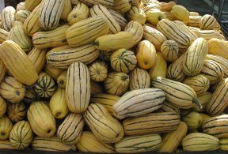
Roasted Delicata Squash Salad
Submitted by Suko T
Original recipe: http://www.101cookbooks.com/archives/roasted-delicata-squash-salad-recipe.html

Ingredients

- 1 pound delicata squash, organic, scrubbed clean
- 1 Tblspn minced fresh herbs (can be a mix of them, summer savory, oregano, marjoram and thyme work well) use more or less to taste
- Handful of toasted sliced almonds, toasted pepitas, or other toasted nuts
- 2 oz crumbled goat cheese or Cotija cheese

Directions

Preheat the oven to 400F / 200C degrees. Cut the delicata squash in half length-wise, and use a spoon to clear out all the seeds. You can leave the peel on these squash (the peel is edible), or you can peel it off if you prefer. Cut into thin (1/4”) slices.

Line a cookie sheet with parchment or silicone baking sheet and spray lightly with cooking spray. Place squash on tray and spray the tops lightly with cooking spray.

Roast for about 15-20 minutes or until squash slices are golden brown and soft but not mushy. Check after 15 minutes to make sure they are not burning or overcooking. Remove from oven and allow to cool for a few minutes.

Combine squash with herbs and almonds and toss to combine. If using a non-melting cheese like cotija, you can toss the cheese in at this point and combine with the rest. Otherwise, sprinkle the cheese on each serving.

