Chocolate Zucchini Cake
From: Elise of Simply Recipes
http://simplyrecipes.com/recipes/chocolate_zucchini_cake/
Submitted by: Marlene H

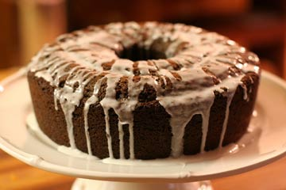

INGREDIENTS
2 1/2 cups regular all-purpose flour, unsifted
1/2 cup cocoa
2 1/2 teaspoons baking powder
1 1/2 teaspoons baking soda
1 teaspoon salt
1 teaspoon cinnamon
3/4 cup soft butter
2 cups sugar
3 eggs
2 teaspoons vanilla
2 teaspoons grated orange peel
2 cups coarsely shredded zucchini
1/2 cup milk
1 cup chopped walnuts or pecans
Glaze (directions follow)

METHOD
Preheat the oven to 350°F.
1 Combine the flour, cocoa, baking powder, soda, salt, and cinnamon; set aside.
2 With a mixer, beat together the butter and the sugar until they are smoothly blended. Add the eggs to the butter and sugar mixture one at a time, beating well after each addition. With a spoon, stir in the vanilla, orange peel, and zucchini.
3 Alternately stir the dry ingredients and the milk into the zucchini mixture, including the nuts with the last addition.
4 Pour the batter into a greased and flour-dusted 10-inch tube pan or bundt pan. Bake in the oven for about 50 minutes (test at 45 minutes!) or until a wooden pick inserted in the center comes out clean. Cool in pan 15 minutes; turn out on wire rack to cool thoroughly.
5 Drizzle glaze over cake.

Glaze: Mix together 2 cups powdered sugar, 3 Tablespoons milk, and 1 teaspoon vanilla. Beat until smooth.

Cut in thin slices to serve. Makes 10-12 servings.

