How to Read
ARS Requested Immigration Documents

Purpose: We’re aware that serving as your Area Office’s Point of Contact is a collateral duty rather than a part of your primary duties. In the interest of saving you time and effort long-term, the purpose of this handout is to help you better review ARS-230 Forms (with specific attention to areas most often improperly completed) prior to submitting them to the Homeland Security Office.

Should you have any questions, please don’t hesitate to ask. We’re here to help!

Reminder: no one within ARS should be completing the ARS-230 for the foreign national.

VISAS
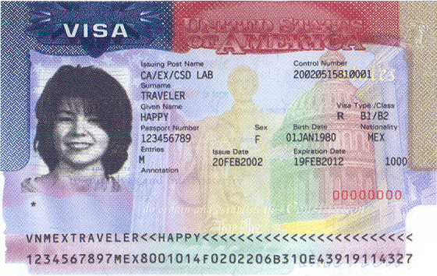

To find the visa type: It’s important to know that nearly all foreign nationals hosted in our facilities are “non-immigrants” (foreign nationals in the United States for a limited period of time). On a Non-Immigrant Visa look at where it says “Visa Type/Class” midway down the visa on the right hand side. Just below the header will be the type of visa. For visas that share classes i.e. B1/B2 we need to know which type was requested, and the foreign national should know which type they requested from their local U.S. embassy or consulate. A B1 Visa is a “Business” visa while a B2 is a “Pleasure” visa. Note: in the example shown above the “R” listed beside the B1/B2 is a code used by the State Department and is not part of the visa type.

Immigrant Visas: Immigrant visas are used by people coming to the United States to live permanently. Prior to 2003 immigrant visas were usually collected at the time of entry into the country. In 2003 the Department of State began issuing immigrant visas on the same stock as non-immigrant visas. They remain the the bearer’s passport after entry.

Visa number: the visa number is the eight digit number in red located in the lower right-hand corner. If the visa was issued prior to 2002, the visa will look slightly different than the picture above but the number is located in the same place. For visas issued before 2000, the number is located at the top of the visa in the center. Like the other two it is also red in color. Visas issued prior to 2000 should be a rarity however, if a foreign national happens to have one (for example an individual who came to the United States as an Immigrant), the number is in six digits in length and located next to the abbreviation for number (no) in blue.

For foreign nationals that were admitted into the United States as Immigrants and have a Green Card see below …

Visa Waiver Program (VWP) Participants: if the foreign national is in the United States under the visa waiver program they should write “visa waiver program” or “VWP” where they are asked to put a visa type. N/A, not applicable, or none should be written where they are asked for the visa number.

Lawful Permanent Residents (Immigrants with Green Cards)
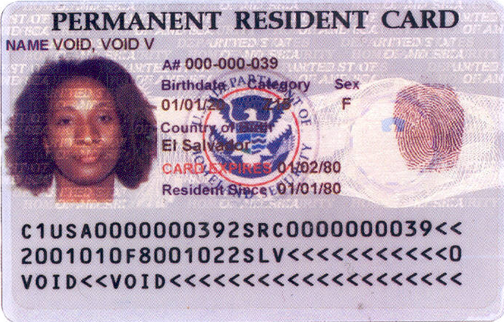
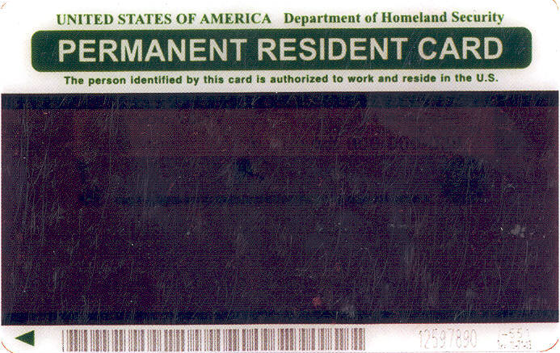
A Permanent Resident Card, Form I-551 (known informally as a Green Card) is issued to Permanent Residents as evidence of alien registration and their permanent status in the US, it is NOT a visa. Accordingly, when foreign nationals are asked to provide visa information on the ARS-230 they should not be putting “Green Card” in the visa field. In order to be granted permission to travel to the U.S. they would have been issued an Immigrant Visa at a U.S. embassy or consulate abroad. We are asking for the number and expiration date from that document (please see visas above). Additionally, we would like for them to provide their immigrant class but if they don’t know it (and they might not), we’re willing to settle for “Immigrant” being entered in the appropriate field.

If an individual has not received their Form I-551 (Green Card) but a request is being processed one of two things will have occurred: 1) their Immigrant Visa will say that they have been processed for an I-551 but that till it arrives that notation will serve as proof of status, or 2) they will be able to provide copies of paperwork submitted to Citizenship and Immigration Services (USCIS).

Card-holders will instinctively try to put the 9-digit number that begins with “A” from the front of their card in the card number box. This however, is NOT the card number but rather their Alien Registration Number (think of it as their case number). There is a box for this number on the ‘230. The box to the immediate right of the Alien Registration Number box is for their Green Card number. If their card was issued before January 1998, it does not have a number; accordingly, they should write N/A in the number box. If it was issued between January 1977 and August 1989 it has neither a number nor an expiration date; please write N/A in the number and expiration date boxes. If it was issued after January 1998 the number is etched into the card on the reverse. It appears in between the card’s barcode and the form designation number (I-551) in the lower right-hand corner.

And we’re still asking for you to send a send Homeland Security copies of the both sides of the Green Card.

I-94 (Arrival and Departure Form)
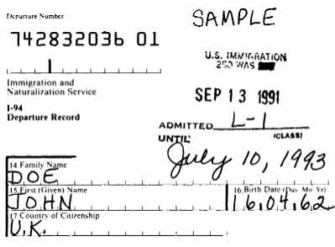

All foreign nationals applying for admission into the United States as non-immigrants are required to complete a Form I-94 (even Visa Waiver participants). An Immigration Officer will keep the arrival section and staples the “Departure” section into the foreign national’s passport. The 11 digit number (twelve counting the space) in the upper left-hand corner is the I-94#.

The form should (though it’s not uncommon for information to be missing) contain the foreign national’s visa type and the date that they are allowed to remain in the U.S. until. In the above sample, John Doe was admitted into the U.S. on an L-1 Visa September 13, 1991. He is allowed to remain in the country until July 10, 1993.

Only those foreign nationals being sponsored for an exchange (J) or student (F) visa whose I-94 lists “D/S” (Duration of Status) are eligible for extension beyond the date listed on their I-94. All other foreign nationals must leave the country or risk being labeled as an “overstay” which would make them ineligible for entry into the U.S. at a later date. Foreign nationals believing that they received an admitted till date on validation must apply to Customs and Border Protection (CBP) to extend or change their non-immigrant status using Form I-539.

DS-2019/I-20

In order to obtain a J-1 (Exchange) Visa or a F-1 (Student) Visa a foreign national must be issued either a DS-2019 or I-20 form respectively. These forms serve as a “sponsorship” letter stating the named individual is being sponsored by the organization whose name also appears on the form.

In order to be granted access to the U.S. a foreign national Exchange Visitor or Student must have in their position a valid J-1 Visa and DS-2019 or F-1 and I-20. The visa itself only needs to be valid long enough for the foreign national to arrive in the country. Once in the country, these forms (DS-2019/I-20) are used to prove legal status. The foreign national is required to provide information about their J-1 or F-1 Visa even if it has expired (please see the section on visa above).

Like the I-94 (above) the DS-2019 or I-20 will receive an immigration endorsement stamp. In this stamp an immigration officer will have hand-written an expiration date. This date should match the date listed on the I-94. Foreign nationals should examine both documents to ensure these stamps match.

When completing an ARS-230 there are separate fields for information about the DS-2019/I-20 and the visa. Individuals should not be putting the “N” number from their DS-2019 or I-20 in the Visa # field but rather the field below it. In addition to the SEVIS Number (the “N” number), we are asking for their school name and code (I-20) or their program sponsor and program number (DS-2019). On both forms this information is contained in Box 2.
DS-2019
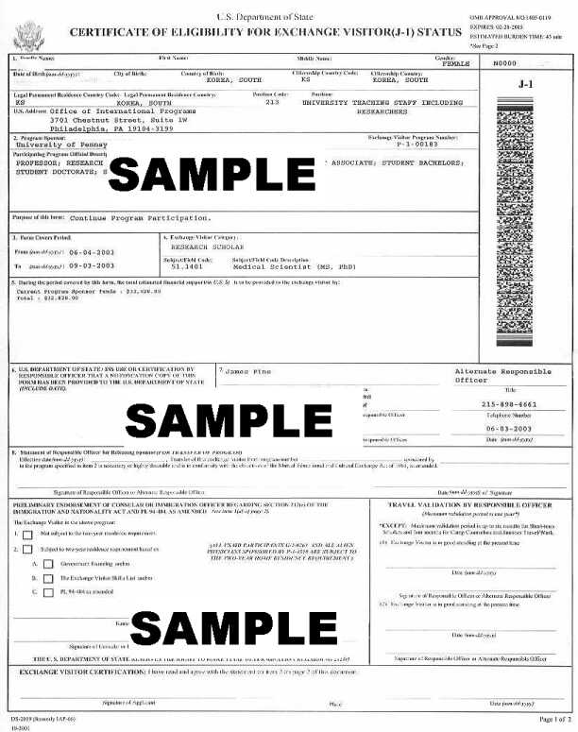

Form I-20
